**Waste to Wow: Home Waste Management Recommendation System - Recycling and Upcycling**

Sonali Arcot, Vidushi Bhati, Siddharth Solanki, and Krishna Sameera Surapaneni

Department of Applied Data Science, San Jose State University

DATA 298B: MSDA Project 11

Dr. Ming Hwa Wang

March 26, 2024

**ABSTRACT**

Approximately 80% of recyclable household waste is incorrectly discarded, contributing to landfill congestion and heightened carbon emissions. This high percentage of improper waste management is partially a result of people not being aware of what materials may be recycled and how to do so. The main goal of the project is to solve this issue by creating a system for categorizing garbage and providing instructions on recycling and safe household waste disposal. Unlike prior research, which primarily concentrated on industrial waste, this project focuses on household waste items. The data, drawn from various sources and expanded to encompass the homegoods category, undergoes meticulous preprocessing, including data annotation and augmentation. To achieve precise identification and categorization of household items into groups such as organic, recyclable, hazardous, and homegoods, cutting-edge models like InceptionResNetv2, YOLOv8, MobileNetv2, ResNet-50, and Xception are employed. Integrated with a Language Model (LLM), the system will furnish recommendations for waste disposal, recycling, upcycling, or donation based on item classification. Key deliverables include classification and object detection models, an intuitive real-time object classification UI, and integration with external resources like the Google Maps API. Technical evaluation metrics cover object detection accuracy (top 1 accuracy, F1 score) and recommendation system effectiveness. Quality will be ensured through user feedback and comparative evaluations, aiming to positively influence sustainable waste management at the household level. The project's potential applications incorporate empowering households with an efficient waste management tool to reduce improper waste disposal, minimize environmental harm, and promote recycling and upcycling, ultimately fostering a more environmentally conscious society and inspiring comprehensive waste management solutions.

**Introduction**

**Project Background and Executive Summary**

***Project Background***

**Background Information.** Global waste production has significantly increased recently, and there are no indicators that it will slow down. Figure 1 shows a significant increase of 204.3 million tons in Municipal Solid Waste (MSW) production from 1960 to 2018 (*National Overview: Facts and Figures on Materials, Wastes and Recycling | US EPA*, 2022). Global production of municipal solid trash is anticipated to rise to 3.4 billion metric tons by 2050, an increase of about 70%. This is brought on by numerous elements, including changing consumer buying patterns, urbanization, economic expansion, and population growth (*Topic: Waste Generation Worldwide*, 2023).

**Figure 1**

*Municipal Solid Waste Generation (in tons from 1960 to 2018)*

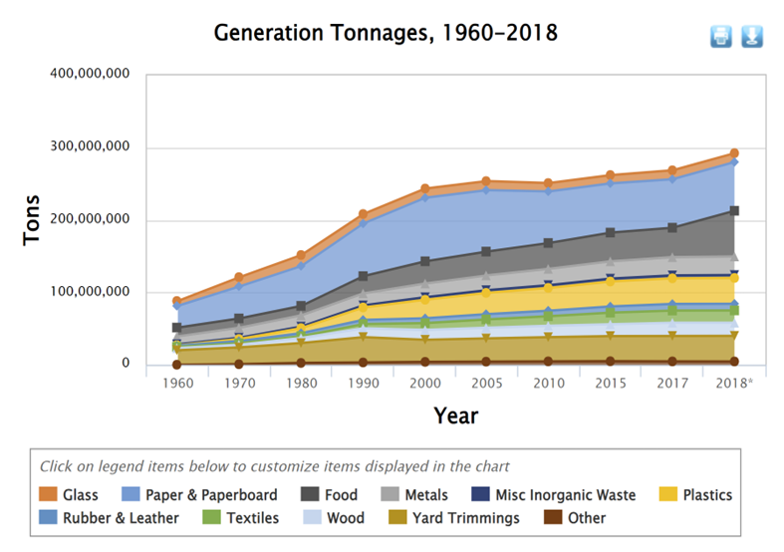

*Note.* A figure showing consistent increase of Municipal Solid Waste from 1960 to 2018. From “National Overview: Facts and Figures on Materials, Wastes and Recycling”, by US EPA, n.d. In the public domain.

Figure 2 shows that despite all other waste management techniques, such as recycling, composting, and incinerating, landfills occupy the majority; around 146.1 million tons of waste went into landfills in 2018 (*National Overview: Facts and Figures on Materials, Wastes and Recycling | US EPA*, 2022).

**Figure 2**

*Municipal Solid Waste Management (in tons from 1960 to 2018)*

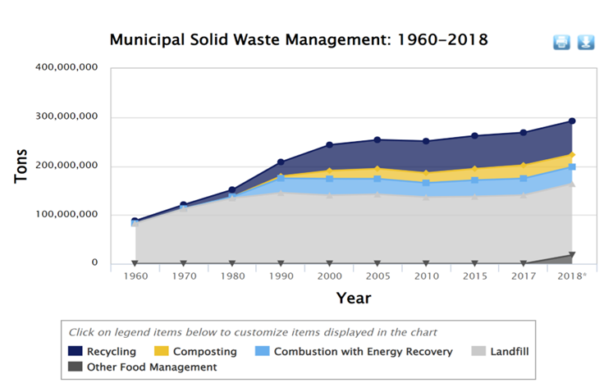

*Note.* A figure showing landfills occupying the majority of waste from 1960 to 2018. From “National Overview: Facts and Figures on Materials, Wastes and Recycling”, by US EPA, n.d. In the public domain.

**Needs and Importance.** On average, an American consumer generates nearly five pounds of trash daily, while a family produces about 18 pounds, resulting in staggering annual figures of 1,642 pounds per person and 6,570 pounds per family. Americans discard enough plastic every 15.5 hours to fill AT&T Stadium, the biggest NFL stadium in the nation. Only a tenth of the plastic is recycled. Most of it goes to landfills or is incinerated. Highly toxic materials such as mercury and dioxin are released during trash incineration, and 42% of all US greenhouse gas emissions result from trash management (Stout, 2022). While some of the waste is indeed recyclable, the issue of confusion regarding recyclable materials and inadequate cleaning procedures can result in contamination, ultimately leading to entire batches of recyclables being directed to landfills (McDonald, 2022). As seen in Figure 3, materials with recyclable potential, such as paper and paperboard, frequently go unutilized (*National Overview: Facts and Figures on Materials, Wastes and Recycling | US EPA*, 2022). For perspective, about 304 million Amazon boxes, mostly recyclable paperboard, go to landfills yearly (McDonald, 2022). A recent online poll by The Harris Poll on behalf of Call2Recycle found that more than 2 in 5 Americans do not correctly sort their recyclables. Hazardous substance contamination of garbage can have disastrous effects. For instance, putting a lithium-ion battery in a dumpster with recyclables could cause a fire that causes a facility to be closed for weeks. In addition, the facility may have to deal with expenses for reconstruction, equipment loss, increased insurance rates, and worker displacement—a situation that many businesses cannot endure. In 2018 alone, 365 fires were reported, many of which were caused by misplaced things making machinery breakdown (*StackPath*, n.d.).

**Target Problem.** Due to unawareness of the types of materials that can be recycled and the proper techniques for doing so among individuals leading to a high percentage of inappropriate waste management, educating the users about reducing material consumption or finding ways to reuse, recycle, and upcycle it becomes imperative.

This study aims to address this problem by developing a system for classifying trash by offering guidelines for reusing, recycling, and recommending safe domestic waste disposal with the help of state-of-the-art technologies such as Object detection, Object classification, large language models, and Google Maps API integrations. The users are able to identify the type of trash and are given options to reuse, recycle, donate, or dispose of it according to the selected category.

**Figure 3**

*Total MSW Landfill by Material, 2018*

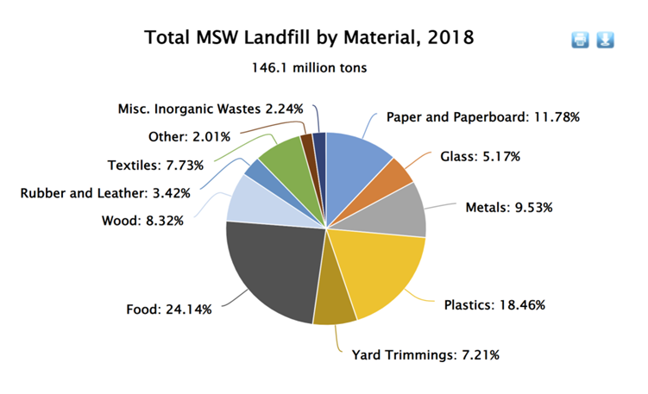

*Note.* A figure showing the proportions of materials that are dumped into landfills. From “National Overview: Facts and Figures on Materials, Wastes and Recycling”, by US EPA, n.d. In the public domain.

**Motivation and Goals.** As part of one's citizen social responsibility, sorting household garbage into several categories should be at the top of one's list of personal responsibilities. It will not only help the municipalities with waste segregation - lessening time, money, and resources spent- but will also help the environment by reducing pollution, minimizing landfills, and strengthening the economy by effectively creating new recycled products (Fernandes, 2020). This project empowers households with an effective waste management tool to guide users for proper waste disposal and encourage recycling and upcycling, which will help minimize environmental harm and create a more environmentally conscious society while ensuring economic growth.

***Project Approaches and Methods***

The research has unfolded through multiple phases, as outlined in this section.

**Data Collection.** To address the significant issue of mismanaged household waste, data collection forms the foundation of this project. The data is primarily gathered from diverse online repositories like Trashbox, Mendeley, Kaggle. These platforms offer images of daily household waste items in various categories like organic waste, recyclable waste and so on. Recognizing the existing gaps in the data, the team further enriched these datasets by introducing a novel category: Homegoods, which encompasses items such as furniture, clothing, and Shoes.

**Data Preparation.** The gathered data, although valuable, has undergone rigorous preprocessing to make it apt for training purposes. This involved a meticulous process of data annotation, whereby each item in the dataset has been meticulously labeled for object detection if mislabeled. Data augmentation techniques are applied to diversify and increase the dataset, enhancing its ability to train the subsequent deep learning models efficiently and transfer learning is used to leverage knowledge gained from one task to improve performance on a different, yet related, task (for object detection). Other preprocessing techniques such as data labeling, data normalization, data cleaning, and feature engineering were employed to transform the collected data into a format that can be used by selected deep learning models.

**Feature Selection.** To ensure precise categorization of waste into different categories, features that assist in distinguishing between waste categories like organic, recyclable, hazardous, homegoods and their subcategories like cardboard, paper, plastic under recyclable, batteries, syringes under hazardous and so on were emphasized. Specific attributes of the waste items, including material, size, shape, and color, were crucial in this step and techniques like PCA and L1/L2 regularization were applied to select relevant features for the next step.

**Modeling.** The heart of this project lies in the use of cutting-edge deep learning models. Notable models like YOLOv8, Xception, MobileNetV2, ResNet-50 and are being implemented for the project. These models are trained on the prepared dataset to identify and categorize household waste accurately. The emphasis is on ensuring high accuracy and precision, with periodic model evaluations using metrics such as mAP and F1 score.

**Deployment.** An intuitive user interface (UI) will be developed, offering real-time classification of objects to be discarded. The UI will not only classify the waste but will also provide personalized recommendations based on object detection results. Integrated with the Google Maps API and a Large Language Model (LLM), users will be equipped with relevant disposal methods, recycling centers, DIY upcycling projects, or donation centers based on the identified category of the waste item.

**Maintenance and Monitoring.** Continuous monitoring will ensure the system remains updated, efficient, and relevant. Feedback mechanisms will be established to capture user experiences, making iterative improvements to the system. Maintenance will include regular updates to the dataset, refining the models, and ensuring the recommendation system remains robust and effective.

***Expected Project Contributions and Application*s**

The cutting edge system, grounded in advanced models like inceptionresnetv2, YOLOv8, Xception, and MobileNetv2, is set to usher in a new era of household waste management. By accurately identifying and classifying domestic waste, this tool will mitigate the common household dilemma of determining the proper disposal method for varied waste items.

The tool's centerpiece is its intuitive real-time object detection and classification UI, integrated seamlessly with a Large Language Model (LLM). This integration ensures that, post-classification, households are provided with coherent and tailored recommendations on waste disposal, recycling, upcycling, or even donation avenues. The guidance, framed in user-friendly language, ensures that the recommendations are both actionable and easy to understand, making sustainable waste management approachable for users of all ages and backgrounds.

Furthermore, a supplementary feature leveraging platforms like Google Maps will guide users to the closest appropriate disposal or recycling centers, ensuring efficient and safe waste processing and reducing environmental footprints.

Communities and local neighborhoods, as they pivot towards environmentally-conscious practices, will find this tool invaluable. By educating residents and advocating for best waste management practices, the system can be a catalyst for grassroots eco-movements. With the emphasis purely on the household level, the project is poised to redefine everyday waste habits, reduce environmental degradation, and champion the cause of sustainability right from our homes' confines.

**Project Requirements**

***Functional Requirements***

The research aims to detect, classify, and suggest the best practices for recycling or upcycling waste items. It operates based on several pivotal functional requirements. The system is adept at processing a diverse array of waste, subsequently categorizing each object into relevant subcategories such as cardboard, paper, battery, syringe, chair. From there, it identifies the broader category each subcategory falls under: organic, recyclable, hazardous, or homegoods.

The tool's design prioritizes user-friendliness and aesthetic appeal. A central feature on the primary screen will be an easy-to-spot image upload option, facilitating users to swiftly detect trash items in real-time. Upon image submission, the tool will promptly determine the item's category, offering recommendations for efficient disposal or reuse based on that classification. For instance;

If the item is deemed Recyclable; Guidance on potential reuse or upcycling methods will be provided, utilizing LLM. An alternative will be suggested for locating disposal facilities nearby for bulky quantities, as seen when relocating homes and dealing with abundant packaging waste.

For Hazardous items; Recommendations will be given for nearby disposal outlets, such as pharmacies for expired medicines or specific county-designated hazardous disposal locations.

If identified as Homegoods; Directions to local donation or recycling centers will be given. Users will also receive advice on repurposing strategies and so on.

To ensure optimal results, the system handles images captured under varied lighting conditions, backgrounds, and from different angles. A robust database of trash images, captured from a multitude of angles, is essential for precise identification. It's also imperative that users can effortlessly navigate the system, obtaining precise results swiftly.

The user interface will be designed for simplicity and intuition, allowing users to effortlessly capture their waste items and receive accurate handling recommendations. Flexibility is key; the system should be able to integrate novel features and keep abreast with the latest

information on recycling and donation hubs. It's essential to have a modular framework, ensuring ease of updates and feature additions without compromising system efficiency.

To determine the system's effectiveness, the performance metrics of the various models integrated are evaluated against a benchmark model. This allows the system to weigh the effectiveness of each model, ultimately selecting the most competent ones, ensuring precision and optimal performance.

***AI-Powered Requirements***

This project uses many different object detection and classification models to find the optimal accuracy for the custom dataset that is proposed in this study. To achieve good accuracy with less computational requirements, transfer techniques are done on pre-trained models.

**Object Detection and Classification Models.** Object classification's main goal is to determine a particular object's class label inside an image. It does not offer any details regarding the object's location. An object classification model's output is a single class label that designates the category of the object that is visible in the image. Bounding box coordinates are not present. These models are frequently employed for tasks like picture classification when identifying particular items within an image is not the primary objective but rather determining what the entire image represents. An Object Detection model on the other hand, can have multiple objects within an image bounded by multiple boxes. This project has implemented models such as YOLOv8, MobileNetV2, Xception, ResNet-50, inceptionresnetv2 for classification purposes.

**Hybrid Model.** The project may also look into the possibility of combining two or more models to better the accuracy, such as inceptionresnetv2.

**Large Language Models**. An open source Large Language Model(LLM), such as Llama 2 will be implemented to provide recommendations for the proper utilization or disposal of the household waste item according to its category. For example, LLM will act as a recommendation system for recommending how to reuse, recycle or where to donate or dispose of a particular item.

**Location Search API**. For some items, the recommendation system may suggest places to safely dispose of or donate that item. To achieve such functionality, Google Search API will be explored and used.

***Data Requirements***

The data related to household garbage is very limited. The data for this project is collected from various sources as the prevalent datasets do not contain every category of household items. Users may want to know how to dispose of their household items, such as furniture, clothes, and shoes. Such items are valuable in terms of recycling, but it may not be appropriate or possible to put them in the recyclable bin. For such items, other options, such as nearby donation centers, will be suggested. Unlike prior research, where datasets were confined to limited items that could be classified as either recyclable or compostable, this research aims to add a new category of household items that was missing earlier. The main categories are biodegradable, recyclable, hazardous, and householdgoods. There are four datasets that are used to create this unified new dataset. The total data storage required is 15 GB when the data is uncompressed. The details about the size and features of these datasets are mentioned in the Data Collection Approach Section.

**Project Deliverables**

Table 1 shows the list of deliverables that are required for this project with their due date. The initial deliverable, the Project Proposal, offers a comprehensive overview of the project's aims, scope, methods, and anticipated results. This is followed by three essential planning tools: the Work Breakdown Structure (WBS), Gantt Chart, and PERT Chart to structure the project effectively. The subsequent trio of deliverables — the Data Management Plan, Data Collection Plan, and Data Exploration Plan — delve into the intricacies of data. These detail the strategy for data acquisition, storage, management, and the specifics of the data to be gathered and its analysis approach.

**Table 1**

*Deliverables Including Reports, Prototypes, Development Applications, and/or Production Applications*

| **Deliverable** | **Description** | **Due Dates** |
| --- | --- | --- |
| Project Proposal | Document outlining the objectives, scope, methodology, and expected outcomes for the project | 09/06/2023 |
| Work Breakdown Structure (WBS) | A hierarchical decomposition of the project's tasks into smaller, more manageable components following CRISP-DM methodology | 10/10/2023 |
| Gantt Chart | A visual representation of the project schedule, showing the start and end dates of every task and their dependencies. | 10/10/2023 |
| PERT Chart | A network diagram that displays the sequence of tasks and their dependencies, as well as the estimated durations and critical path. | 10/10/2023 |
| Project Management Plan | A document that describes how the project is managed, including a project schedule, milestones, and resource allocation plan. | 10/10/2023 |
| Data Collection Plan | A document that outlines the specific data that were gathered and how it was collected. | 10/10/2023 |
| Data Exploration | Performing Exploratory Data Analysis on the retrieved data using data visualization and statistical analysis. | 10/24/2023 |
| Data Cleaning and Preprocessing Code | Code to perform data cleaning and preprocessing tasks, such as removing duplicates, filling in missing values, and transforming data types. | 10/24/2023 |
| Modeling | Code to build models using YOLOv8, MobileNetV2, Xception, ResNet-50 for trash detection and classification. | 10/24/2023 |
| Performance Metrics | Defining the key performance indicators that were used to evaluate the efficiency of the models. | 10/24/2023 |
| Model Evaluation and Selection Report | A document that describes the process of selecting the best-performing detection and classification models and the evaluation criteria used. | 11/07/2023 |
| Production-Ready Models | Final versions of the detection and classification models that are optimized for production use. | 11/07/2023 |
| Final Project Report | A document that summarizes the project's objectives, methodology, findings, and conclusions. | 11/28/2023 |
| Project Presentation | A presentation that summarizes the key aspects of the project, including the problem statement, methodology, findings, and conclusions. | 12/05/2023 |

*Note*. The table outlines the primary deliverables of the project, providing a brief description of each.

For data refinement, the Data Cleaning and Preprocessing Code is set to tackle data preprocessing and transformation. This paves the way for the Classification Models deliverable, which aims to construct classifiers that correctly sort trash objects into one of the four categories: recyclable, organic, homegoods, and hazardous. To gauge the models' effectiveness, the Performance Metrics deliverable pinpoints the essential KPIs. The Model Evaluation and Selection Report then provides insight into the choice of top-performing detection and classification models and the metrics that influenced these decisions.

Transitioning towards the project's culmination, the Production-Ready Classification Models will be the finalized, optimized models ready for real-world application. The project wraps up with the Final Project Report, encapsulating everything from objectives to conclusions, and the Project Presentation, a succinct recap of the project's pivotal elements. These deliverables are designed to guide the project to fruition, serving as a beacon for the team.

**Technology and Solution Survey**

Olugboja and Wang (2019) were inspired to create an automated system that can quickly and accurately sort waste while taking up less time than a manual approach would. The technology allowed for the recycling and conversion of the usefully separated trash into fuel and energy, which is helpful in developing the economy. The Convolutional Neural Network(ResNet-50) and Support Vector Machine (SVM) methods were combined in this research to help separate the accumulated garbage. Convolutional Neural Networks and Support Vector Machines dealt with recognition and classification. The proposed method was developed based on the ResNet-50 pre-trained model. The features from the penultimate layer were passed to the Multi-Class SVM model, where the classification took place based on the features extracted. For this project, Gary Thung and Mindy Yang's trash image dataset was used. There were 1989 photographs in this little dataset, which were classified into glass, paper, plastic, and metal categories. Due to the limited size of the photos, a data augmentation method was used during the pre-processing stage. The diverse orientations of the waste materials led to the selection of this method. Some techniques used were random image translation, random picture scaling, and random image shearing. With this method, the dataset size was maximized. The average training accuracy was 94.5%, and testing accuracy was 87%, providing a more accurate separation process. Future work entails fine-tuning some parameters for the categorization of more items.

Li et al. (2022) proposed a multimodal cascaded convolutional neural network (MC-CNN) for the identification and categorization of domestic garbage images. To get the detections, MC-CNN integrated three sub-networks (Faster-RCNN, DSSD, and YOLOv4). Additionally, the authors used a classification model stacked with the detection part to assess if the detection results were accurate in order to minimize the false-positive predictions. They created an extensive waste image dataset (LSWID) of 30,000 residential waste multilabel images and 52 categories to train and test MC-CNN. Small target recognition is made easier by the layers of feature extraction of YOLOv4's feature pyramid down-sampling design and Mosaic data augmentation approach during training. Candidate regions are generated using Faster-RCNN, which then moves or classifies them. In order to capture both deep and shallow feature maps, DSSD integrates contextual information, solving the overlap issue. The model converged after 40,000 iterations, and the testing set's accuracy increased to 85%. The results indicated that the suggested strategy performed well regarding the model's size and detection time, with an average improvement of more than 10% in detection precision performance. Future work suggested gathering more images and improving waste segregation accuracy and sorting.

To overcome the challenges of low detection rates, false positive rates, and slow speed in existing trash detection algorithms, Liu et al. (2022) proposed a new trash detection model, i-YOLOX. A substantial dataset of real-life images is gathered. The i-YOLOX model's feature extraction structure includes a light operator involution. The purpose of this improvement is to adaptively extract channel information and build long-distance correlations among features in the input data. A convolutional block attention module (CBAM) is introduced to the feature extraction network to identify comparable trash features, which results in improved feature extraction. This CBAM improves the model's capacity to concentrate on important details. Improvements in the classification and regression of obtained feature layers are made possible because of the involution residual head shape in the detection head, which lowers gradient disappearance and speeds up model convergence. On TrashNet, the method performed reasonably well with both detectors and classifiers. Regarding mAP, parameter reduction, and Framerate improvement, the results demonstrate that the i-YOLOX model performs better than the baseline approach. According to the experimental findings, the i-YOLOX model's mean average precision (mAP) has increased by 1.47% compared to the baseline algorithm. The frame rate (FPS) is increased by 40.4%, while the total amount of parameters is decreased by 23.3%. In the future, the authors proposed to enrich their dataset and reduce model complexity to faster computations.

Malik et al. (2022) study demonstrated fine-tuning of the EfficientNet-B0 model in order to increase classification efficiency and accuracy for region-specific litter photos. The researchers created a customized model that was optimized for a given location by fine-tuning the EfficientNet-B0 model for images specific to certain demographic regions. Thirty-four categories of solid waste classes made up the training dataset. The EfficientNet-B0 model was integrated with a Convolution Neural Network (CNN) for training, and the model's ROC over the dataset was examined. The EfficientNet-B0 model yielded a similar accuracy to the EfficientNet-B3 model at about 84% but required a lot fewer parameters. The model would need to be expanded to identify subclasses within the same waste class, and concerns with using the model in smart city initiatives would need to be addressed.

Wu et al. (2022) proposed a novel accessible benchmark dataset named HGI-30 for household rubbish picture classification in order to overcome the difficulty of garbage image classification caused by complicated backdrops, fluctuating illuminations, various angles, and altering shapes. In addition, HGI-30 was created to address the lack of reliable household garbage datasets, and it consisted of 18,000 photos of 30 distinct types of household waste. The dataset's simulation of various lighting scenarios, backdrops, angles, and shapes provided a more challenging and realistic environment for studying trash image classification. The authors tested various classification models on the unlabeled dataset, including VGG16, MobileNet, Resnet50, DenseNet, Xception, and EfficientDet. With 93.2% accuracy, EfficientDet outperformed the competition. Additionally, they tested out object detection techniques, including SSD, YOLOv3, YOLOv4, and Faster RCNN, wherein Yolov4 performed the best. Future work suggests an expansion of categories and quantities of trash datasets and implementing new algorithms and models.

The study conducted by Jin et al. (2023) addresses the critical issue of sustainable waste recycling through the development of a novel deep learning-based machine vision system for garbage detection and classification. They utilized the Huawei Garbage Classification Challenge Cup dataset (HUAWEI-40), comprising 14,683 images across four waste categories. Leveraging the MobileNetV2 architecture, they introduced a convolutional attention module to enhance feature extraction and employed transfer learning to improve the model's generalization capacity. This effort resulted in a significant performance boost, with the original MobileNetV2 achieving an accuracy of 71.4% and the improved model reaching an impressive 90.7% accuracy. The deployment of the model on edge devices, such as Raspberry Pi, demonstrated its practicality with an accuracy of 89.26%. Furthermore, the authors explored the potential of GAN-based dataset enhancement, achieving even higher accuracy at 91.98%. In pursuit of further advancements, they proposed integrating YOLOv5 to enable the identification of multiple objects within an image. The study sheds light on the importance of addressing the computational challenges associated with real-time garbage classification, which is a pivotal aspect of sustainable waste management and recycling. Previous research in this domain has primarily focused on artificial neural network selection, often overlooking the computational cost issue, thus hindering the seamless integration of detection models into edge hardware. This work presents a promising avenue for advancing the field and addressing the pressing need for efficient waste management solutions.

In the research conducted by Yuan and Liu (2022), a compelling approach to trash classification is presented, utilizing a hybrid deep learning model based on deep transfer learning. Their work demonstrates the significance of effective waste sorting for recycling and sustainability efforts. Leveraging the TrashNet dataset, encompassing a diverse range of trash types, the authors employed a two-stream convolutional neural network (CNN) architecture. The upper stream of the model was designed to classify images into two broad categories, MPP (metal, paper, and plastic class) and CGT (cardboard, glass, and trash class). Subsequently, the lower stream of the model further refined the classification by identifying subcategories within the trash class based on the upper stream's results. The results were impressive, with an accuracy of 97.9% in category MPP, 99.2% in category CGT, and an overall accuracy of 98.5%. The proposed model's effectiveness was further validated using Class Activation Maps (CAM), which highlighted the model's attention to critical regions within the images during classification. While the study showcases remarkable performance in trash classification, the authors also acknowledged the potential for further improvement, particularly in extending the model's applicability to classify medical waste and introducing additional classes like domestic and medical waste. However, it's important to note that the current research is not real-time, indicating a potential avenue for future work to enhance the model's efficiency in practical waste management scenarios. Overall, this research contributes significantly to the field of waste classification and recycling by presenting a robust deep learning framework for accurate and detailed trash sorting.

The study presented by Tatke et al. (2021) showcases a valuable contribution to the field of computer vision and deep learning for waste management. Leveraging two datasets, the Garbage Classification Dataset from Kaggle and the Garbage In Images (GINI) Dataset, the study addresses the pressing need for efficient garbage sorting. Their experimentation with various models revealed interesting insights. The simple CNN with Adadelta Optimizer achieved an impressive accuracy of 93.56%, demonstrating the efficacy of a well-designed convolutional neural network. However, more complex models like VGG16 and ResNet50 did not perform as well, suggesting that model complexity is not always synonymous with improved performance in garbage classification tasks. Additionally, the inclusion of HOG+SVM as a benchmark highlights the importance of selecting appropriate algorithms for specific tasks, as it achieved a comparatively lower accuracy of 47.25%. The authors acknowledged the potential for further refinement in data augmentation and image processing techniques and emphasized the need for a more diverse and extensive dataset to enhance the model's performance. This study underscores the ongoing pursuit of more accurate and efficient garbage classification methods, emphasizing the room for exploration and improvement in this critical domain of waste management.

The research presented by Ji et al. (2023) introduces GenRec, a pioneering large language model for generative recommendation, and evaluates its performance on real-world datasets from Amazon and MovieLens. The results achieved by GenRec showcase its potential to significantly enhance recommendation systems. On the MovieLens 25M dataset, GenRec outperforms the baseline model P5 with notable improvements, including HR@5 increasing from 0.0688 to 0.1034 and NDCG@5 improving from 0.0464 to 0.0716. Similar promising trends are observed on the Amazon Toys dataset, with GenRec surpassing P5 in HR@5, HR@10, and NDCG@10 metrics. These findings highlight the effectiveness of leveraging text-based item information and the semantic richness of item names for recommendation, suggesting that GenRec has the potential to revolutionize the field of recommendation systems by offering more personalized and satisfying user experiences. The researchers' intentions to further refine sequence generation, incorporate complex user data, and explore the performance of GenRec with different large language models underscore their commitment to pushing the boundaries of recommendation system capabilities.

The work presented by Bao et al. (2023) introduces the TALLRec framework, which addresses the critical challenge of aligning Large Language Models (LLMs) with recommendation tasks. Their results indicate a significant leap in recommendation performance, especially in the few-shot training setting, where TALLRec outperforms both traditional and recent LLM-based methods. Notably, LLM-based methods and traditional techniques tend to perform suboptimally in this setting, often close to random guessing, with AUC values around 0.5. TALLRec, on the other hand, demonstrates rapid recommendation capabilities even with fewer than 50 training samples. Cross-domain evaluations also highlight TALLRec's versatility, as models trained on movie data performed comparably on book data. These results underscore the potential of the TALLRec framework to enhance recommendation systems and its ability to efficiently leverage pre-trained language models for improved performance. The authors' future plans, including exploring more efficient methods, aligning LLMs directly with recommendation tasks, managing multiple recommendation tasks simultaneously, and exploring generative recommendations, further emphasize their commitment to advancing the field of recommendation systems.

Kunwar (2023) also had significant technological advancement, drawing data from the trashnet dataset, which comprises 2,527 images spanning six categories, the research thoroughly examined several cutting-edge CNN models, among which Inception V3, MobileNet V2, and Resnet 50 are notable mentions. Through rigorous evaluation metrics, such as accuracy score and F1 score, both InceptionResNetV2 and Xception distinguished themselves by attaining a commendable accuracy rate of 92%. Further solidifying its applicability, MWaste has been actualized as a real-time mobile application adept at classifying waste into six distinct groups. An intriguing feature of this application is the incorporation of gamification techniques, exemplified by leaderboards, designed to engage and incentivize users. As a roadmap for its evolution, there are aspirations to refine classification precision, foster collaborations with regional recycling entities, and amplify the dataset breadth. This research and its tangible application underscore the potential and efficacy of using deep learning models for practical, real-world challenges in waste management.

Poojary et al. (2022) sets a definitive benchmark, drawing from the UCI ML garbage type dataset, which comprises 2,527 images across 12 features, the research meticulously divided the data into training, validation, and testing sets, ensuring a balanced distribution. With the employment of models such as InceptionV3 and Public-Garbage Net, the study showcased that CNNs achieved the highest accuracy of 97%, with the InceptionV3 model standing out as the most proficient. In contrast, ANNs yielded a 95% accuracy, and transfer learning techniques trailed at 88%. Despite these robust findings, the study identified potential enhancements, indicating that broadening the waste variety in the dataset could optimize model performance. Additionally, the exploration of a broader array of machine learning and deep learning techniques was proposed as a promising avenue for refining waste classification and management solutions.

The study by Ramsurrun et al. (2021) also offers notable insights. The research employed the TrashNet dataset and examined the efficacy of Convolutional Neural Networks (CNN) alongside three classifiers: SVM, Sigmoid, and SoftMax. Remarkably, the VGG19 model combined with the SoftMax classifier emerged as the leader, boasting an accuracy rate of approximately 88%. It was observed that the SoftMax classifier consistently superseded both SVM and Sigmoid classifiers. Furthermore, when juxtaposed with findings from other studies, the results remain competitive, a noteworthy achievement considering the absence of model fine-tuning in this research. Looking ahead, the emphasis is on amplifying model accuracy and pivoting towards the integration of real-time detection via IoT devices, aiming to elevate its practical application in waste management.

Rismiyati et al. (2020) presents significant findings by utilizing the TrashNet dataset, which encompasses 2,527 images segmented into six garbage types, the research delved into transfer learning techniques employing models such as VGG16, ResNet-50, and Xception. Among the assessed models, the Xception architecture emerged as the most efficacious, registering an accuracy of 88% complemented by commendable average precision and recall rates of 83% and 84%, respectively. The study underscores the model's supremacy in the context of garbage classification. Anticipating future advancements, the emphasis is on refining the Xception model's accuracy and exploring avenues for its hardware integration, signifying potential shifts in waste management paradigms.

The research by Ekundayo et al. (2021) leverages the WasteNet dataset, comprising 33,520 images spread across seven recyclable waste classes. Several models, including MobileNetV2, VGG19, DenseNet201, ResNet152V2, and InceptionResNetV2, were evaluated for their efficacy. The results elucidated that InceptionResNetV2 secured the highest accuracy rate of 90%; however, it also manifested the highest latency at 1000 ms. In contrast, models like MobileNetV2 and DenseNet201 struck an optimal balance, considering metrics like accuracy, latency, and model size. While InceptionResNetV2 remains apt for scenarios where accuracy takes precedence, MobileNetV2 and DenseNet201 cater to a broader spectrum of applications. As a foresight into further enhancements, there's potential in refining these models and employing a statistical methodology to discern the optimal model based on a range of metrics. Incorporation of advanced object detection models, such as Faster R-CNN or YoloV5, holds promise for augmenting the detection capabilities and enriching user experience. Such integrations merit deeper explorations to discern the premier model for comprehensive waste detection.

Pandita et al. (2022) embarked on the critical task of employing machine learning to streamline waste management processes. Utilizing a dataset comprised of 2,400 images spanning six different classes of recyclable trash, advanced models like ResNet-50 and YOLO were deployed. Comparative analysis revealed that while YOLO emerged superior in scenarios with multiple objects, ResNet-50 showcased higher proficiency when classifying frames containing a solitary object. This endeavor accentuates the burgeoning role of machine learning in enhancing waste management, pointing towards a paradigm shift where manual interventions are minimized, leading to time conservation. The trajectory of future research is inclined towards honing the algorithms for elevated classification precision, while also incorporating the capability for simultaneous detection and classification of diverse objects within a singular frame. Envisaging broader application avenues, there's emphasis on enlarging the category spectrum and undertaking meticulous data annotation to enrich the predictive accuracy of the models.

Alawi et al. (2021) delved into the application of Convolutional Neural Networks (CNN) for the categorization of solid waste. Utilizing a Kaggle dataset containing 22,564 images, distributed among Recyclable and Organic classes, several pre-trained CNN models, including AlexNet, DenseNet, and SqueezeNet, were examined. Notably, DenseNet-121 surfaced as the superior model, boasting elevated levels of accuracy, precision, recall, and F1 score, distinctly overshadowing the performance metrics of models like SqueezeNet-V1.0. An impressive achievement underlined in the study was the surpassing accuracy levels exceeding 94% by DenseNet, a feat attributed to its architectural advantage of dense connections, which act as a deterrent to overfitting. Such advancements indicate a promising shift towards heightened accuracy in waste classification, with prospective research set to emphasize augmenting the dataset and refining model configurations, alongside an exploration into sophisticated techniques like image segmentation to further escalate precision during the waste processing phase.

In this research, Lee (2021) evaluated the efficacy of various deep learning models in classifying waste materials, specifically focusing on metal, plastics, and cardboard. Upon examining models like VGG19, VGG16, Inception_v3, Xception, and MobileNet, the Inception_ResnetV2 stood out, delivering a commendable accuracy of 78.4%. The study's pivotal aspect involved optimizing the aforementioned model using different optimizers. Here, Nadam showcased superior performance, reaching an accuracy of 82.4%, distinctly higher than Adam's 78.4%. Further investigations into learning rates revealed an optimal rate of 0.01, pushing accuracy to an impressive 83.43%. The plotted training and validation loss graphs underscored the significance of incorporating early stopping to avert overfitting and augment the learning efficiency in such models. With this foundation, prospective endeavors in this domain are poised to broaden the dataset, incorporate cutting-edge optimization strategies, and diversify the waste classification categories, furthering the goal of effective environmental conservation.

Han (2021), a deep learning approach using MobileNetV3_Lite was employed for efficient garbage detection. Drawing from a dataset sourced via web crawlers, the model's performance was benchmarked using Mean Average Precision (mAP) as the evaluation metric. Notably, after meticulous fine-tuning of a pre-trained model, an impressive mAP of 89.89 was achieved. The study further spotlighted a resource-efficient design, which utilized a mere 8.95% of the memory in contrast to YOLOV3-MobileNetV3, thereby facilitating rapid deployment without compromising the mAP. This optimized model was adeptly deployed on an NVIDIA Jetson Nano, evidencing real-time garbage detection capabilities. The resultant accuracy rates were remarkable, standing at 94.56% for category classification and 90.91% for quantity detection. Looking ahead, there exists potential to elevate the real-time performance of such systems and diversify object recognition beyond mere garbage. An avenue worth exploring is optimizing the model further for deployment on even more constrained embedded devices, broadening its scope of application.

Table 2 shows the summary of the Technical Literature Survey. It shows the comparison between different papers with respect to datasets, models, performance and future work.

**Table 2**

*Comparison of Technical Solution and Survey*

| Paper | Dataset | Models (proposed ***) | Performance of Recommended Solution | Future Work |
| --- | --- | --- | --- | --- |
| Olugboja and Wang (2019) | Trashnet | ResNet50+SVM | 87% accuracy | Fine-tuning and Categorizing more items |
| Li et al. (2022) | Large scale waste identification dataset (30000 images with 52 categories) | Multimodal cascaded CNN with subnetworks (Faster-RCNN, DSSD, YOLOv4) | 85% accuracy | Gathering more images, improving segregating accuracy. |
| Liu et al. (2022) | Trashnet | i-YOLOX with convolutional block attention module(CBAM) | mAP is increased by 1.4% from baseline YOLO-tiny. FPS increased by 40.4% and parameters reduced by 23.3%. | Enrich dataset and reduce complexity of model. |
| Malik et al.(2021) | fine-tuned imageNet dataset into 34 categories | fine-tuned EfficientNet-B0 | 84% accuracy similar to the EfficientNet-B3 model but with less parameters | expanded to identify more subclasses. |
| Wu et al.(2022) | HGI-30 dataset with 18000 images and 30 classes | Classification - EfficientDet  Detection- YOLOv4 | EfficientDet - 93.2% accuracy  YOLOv4 performed best among others | Expansion of categories and implementing new models. |
| Jin et al. (2023) | HUAWEI-40  14,683 images with 4 categories | MobileNetV2 | Original MobileNetV2 - 71.4% (770 ms)  Improved - 90.7 % (600 ms) | Identify multiple objects from an image. |
| Yuan and Liu (2022) | TrashNet | Two streams of CNN: MPP (metal, paper, and plastic class) and category CGT (cardboard, glass, and trash class) | Accuracy - 97.9 % in category MPP, 99.2 % in category CGT, and 98.5 % in total class | Adding classes domestic and medical waste to the upper stream. The current research is not real-time. |
| Tatke et al. (2021) | Garbage Classification Dataset from Kaggle - 2467 images GINI dataset | CNN, VGG16, ResNet50, HOG+SVM | ResNet50 ( Adadelta Optimizer) performs the best at 95.93% accuracy | Data augmentation and image processing still need to be refined. |
| Ji et al. (2023) | MovieLens dataset, Amazon Toys dataset | GenRec, P5 | GenRec performs significantly better than the baseline model P5. | Refining Sequence Generation by developing more sophisticated prompts to enhance the model's understanding. |
| Bao et al. (2023) | MovieLens100K benchmark dataset, BookCrossing dataset | TALLRec, LLM-based models, Traditional recommendation  models | TALLRec significantly outperforms both traditional and recent LLM-based methods in the few-shot training setting. | There's potential in aligning pre-trained language models directly with the recommendation task to leverage its potential better. |
| Kunwar (2023) | Trashnet dataset, containing 2,527 images across six categories. | Inception V3, MobileNet V2, Resnet 50 etc. | InceptionResNetV2 and Xception achieved the highest accuracy of 92%. | Future plans include improving classification accuracy, collaborating with local recycling firms, and expanding the dataset. |
| Poojary et al. (2022) | UCI ML garbage type dataset with 12 features and 2,527 images | InceptionV3 and Public-Garbage Net | On the test dataset, CNNs achieve 97% accuracy, outperforming ANN's 95% and transfer learning's 88%, with InceptionV3 being the most effective. | The authors advise expanding waste variety in the dataset and exploring advanced learning techniques for better waste classification and management. |
| Ramsurrun et al. (2021) | TrashNet dataset. | CNN with VGG19 and SoftMax classifier | SoftMax outperformed SVM and Sigmoid, with untuned VGG19-SoftMax achieving a competitive 88% accuracy compared to other studies. | Future efforts will target enhanced model accuracy and real-time detection via IoT for practical use. |
| Rismiyati et al. (2020) | TrashNet dataset. | Transfer Learning techniques on the TrashNet dataset using VGG16, ResNet-50, and Xception | The Xception model excels in garbage classification, achieving 88% accuracy with 83% precision and 84% recall. | Future work will focus on improving the Xception model's accuracy and implementing it in hardware. |
| Ekundayo et al. (2021) | WasteNet, is introduced, which consists of 33,520 images across seven classes of recyclable waste. | MobileNetV2, VGG19, DenseNet201, ResNet152V2 and InceptionResNetV2 | InceptionResNetV2 boasts 90% accuracy with 1000 ms latency, while MobileNetV2 and DenseNet201 provide a balanced performance in accuracy, latency, and size. | Models can be enhanced using statistical selection based on multiple metrics, and integrating advanced detectors like Faster R-CNN or YoloV5 may improve waste detection and user experience. |
| Pandita et al. (2022) | Images of recycled trash spanning six different classes | ResNet-50, YOLO | YOLO performs better in multi-object scenarios and ResNet-50 excels when there is a single object in a frame | refining the algorithms for even higher classification accuracy, expanding the number of categories and further annotating data |
| Alawi et al. (2021) | Kaggle dataset(22564 images-Recyclable and Organic) | AlexNet, DenseNet,SqueezeNet | DenseNet-121 emerges as the best-performing model, achieving high accuracy, precision, recall, and F1 score | expanding the dataset with a larger variety of waste images, refining the model through improved hyperparameter tuning |
| Lee (2021) | garbage collection (kaggle dataset) | VGG19, VGG16, Inception_v3, Xception, and MobileNet | Inception_Resnet_V2 outperformed others with the highest accuracy of 78.4% | expand the dataset to improve model accuracy, explore more advanced optimization techniques, and extend waste classification to include a wider variety of waste categories |
| Han (2021) | images are downloaded through web crawlers | MobileNetV3_Lite | high accuracy rate of 94.56% for category classification and 90.91% for quantity detection was identified | enhance the model's real-time performance further |

**Literature Survey**

Namoun et al. (2022) examined 42 articles that were published between 2010 and 2021 to provide an overview of machine learning, and deep learning works that concentrate on garbage production and treatment in smart cities. The survey studied all aspects related to garbage management systems, including demographics, regions, waste management stages, target outcomes, waste datasets, AI-ML-DL models used. The survey finds that around 83% of the papers used only one dataset; only 9.5% of the papers did waste classification, while most of them, around 26.19%, focused on waste generation; 88% of the papers used trained datasets, while 7% used real-time data. The research further analyzed that around 53% of the papers implemented deep neural network-based algorithms. The study showed CNN models achieved the highest accuracy. Using transfer learning, the VGG16 model yielded the highest accuracy. Most models used only one dataset, which can be a limitation. ANNs can be further optimized to give better results. There is a lack of end-to-end waste management solutions.

Tiyajamorn et al. (2019) implemented an AlphaTrash solution that used an IR sensor located within the main compartment to detect user input rubbish. The anticipated type of rubbish was produced when a convolutional neural network analyzed the camera-captured image. A driver motor is then instructed to relocate the main compartment to sit above the appropriate trash can based on the trash classification. The improved GooLeNet (Inception v1) implementation approach, coupled with routines for analyzing camera and sensor data, was used in this research. The GooLeNet was changed in the final stages to include a greater number of thick layers that would increase the classification capabilities' level of complexity. With roughly 1,100 photographs for each of the five categories, the dataset used in the experiment for training the classifier consisted of about 5,700 images obtained from AlphaTrash's trash compartment. A total of 50 trash photos, each representing a different form of trash—metal waste, organic waste, paper waste, plastic waste, and general rubbish—had been evaluated to depict typical real-world trash. The experiment's results showed an average accuracy of 94%, which was higher than the human average accuracy.

T. Wu et al. (2023) reviewed convolutional neural network (CNN) applications in intelligent waste identification and recycling (IWIR), stressing the absence of industry-wide standards and benchmarks for datasets and models utilized in this area. It examines the fundamentals of CNNs, open-source datasets, cutting-edge CNN models, and important CNN applications in IWIR, including the identification of recyclable materials, the detection of trash pollution, and the classification of solid waste. A total of 796 publications were obtained for the review on CNN applications for image-based waste recognition (IWIR), of which 355 remained after screening. The review highlighted significant contributions to dataset development, model improvement, and IWIR application expansion. The examined research was divided into three categories: solid waste classification, garbage pollution detection, and identification of recyclable materials, with additional classifications determined by waste materials and the environment. The best-performing CNN models for classification, object identification, and segmentation tasks were counted from 30 research that examined picture datasets. Out of many classification models, such as ResNet, Inception, and VGGNet, Custom CNNs were the most used. For object identification, YOLO was the most used, and among segmentation Mask R-CNN topped the list. The Trashnet dataset was the most popular dataset, and DenseNet combined with SVM achieved the highest testing accuracy with this dataset. Classification is the primary research area in IWIR, followed by object identification and segmentation. The latter two activities, however, are anticipated to gain in popularity going forward as more relevant datasets become available.

The comprehensive review by Terven and Cordova-Esparza (2023) delves into the evolution of the YOLO (You Only Look Once) object detection framework, tracing its development from the original YOLOv1 to the latest iteration, YOLOv8. YOLO has been a pivotal player in the field of computer vision, and the authors focus on YOLOv8, which offers five scaled versions to cater to various use cases. This model stands out for its versatility, supporting multiple vision tasks, including object detection, segmentation, pose estimation, tracking, and classification. YOLOv8 introduces significant enhancements, including changes in the CSPLayer, now referred to as the C2f module, which combines high-level features with contextual information for improved accuracy. It adopts an anchor-free model with a decoupled head for objectness, classification, and regression tasks, employing advanced loss functions like CIoU and DFL for bounding box prediction. The results on the MS COCO dataset test-dev 2017 highlight YOLOv8's impressive performance, with YOLOv8x achieving an AP of 53.9% on an image size of 640 pixels, surpassing YOLOv5. Moreover, YOLOv8 maintains remarkable speed and efficiency, operating at 280 FPS on an NVIDIA A100 with TensorRT. This review underscores the continuous innovation in the YOLO series and its continued relevance in the realm of object detection and segmentation.

In the systematic review conducted by Vidhya (2023), a comprehensive examination of machine learning approaches for trash classification reveals the dynamic landscape of this field over the past four years. Traditionally, trash classification relied on sensor-based methods, but recent advancements have seen a shift towards the adoption of deep learning algorithms. The review highlights the diverse range of deep learning models applied in this domain, including DenseNet, VGG-19, NASNetLarge, CNN, ResNet, MobileNet, and more. Notably, the study underscores that deep learning models consistently outperform traditional machine learning approaches in terms of efficiency. MobileNet, while frequently used, tends to offer slightly lower accuracy compared to other deep learning counterparts. Interestingly, the combination of multiple pre-trained models has shown promise in enhancing classification performance, albeit at the cost of increased computational resources. Hybrid approaches that leverage different models or techniques tend to offer improved accuracy. Convolutional neural networks and their variants emerge as the dominant models for trash classification, consistently achieving over 90% accuracy. However, some, like MobileNet and ResNet, require longer training times. As the field progresses, there is a pressing need to develop models that can efficiently classify trash types within minimal computational timeframes, ensuring practical feasibility in real-world waste management scenarios.

The research conducted by Ahmed et al. (2023) presents a significant contribution to sustainable waste management through a deep learning approach to recyclable products classification. Leveraging a dataset created by Yousefi in 2021, consisting of 5000 images of garbage and waste items in the Middle Eastern region, particularly Saudi Arabia, the study focuses on five categories: paper, plastic, glass, metal, and others. The application of Convolutional Neural Networks (CNN) in combination with popular architectures like MobileNetV2, DenseNet169, and ResNet50V2 yielded promising results. Notably, ResNet50V2 achieved the highest accuracy at 98.95%, outperforming the other models and previous studies on the same dataset. This study underscores the effectiveness of deep learning models, especially ResNet50V2, in waste item classification, demonstrating their potential for optimizing waste sorting processes. To further enhance model robustness, the authors propose expanding the dataset through data augmentation and merging data from various sources, as well as exploring fusion and ensemble learning techniques, highlighting the continuous pursuit of improved waste management solutions and the critical role of deep learning in this domain.

The research paper "Using YOLOv5 for Garbage Classification" by Wu et al. (2021b) introduces a significant advancement by employing the YOLOv5 object detection network, termed as GC-YOLOv5. Utilizing a constrained dataset consisting of 650 images, this study astonishingly achieves a 99% accuracy rate during testing on the dataset. However, when deployed in a real-time scenario, the model's performance dipped, garnering an accuracy rate slightly above 80%. This discrepancy between the controlled testing environment and real-world application underscores the need for additional fine-tuning, specifically optimized for real-time deployment conditions.

Yang et al. (2021b) makes a noteworthy contribution as well. Deploying the GarbageNet model on the comprehensive HUAWEI Cloud Garbage Classification Challenge dataset, which spans 43 distinct categories of common wastes, this study yielded an impressive accuracy of 96.96%. Such a high accuracy rate underscores the model's capability in identifying a vast range of waste items from disposable snack boxes to paper bags. Yet, even with this commendable achievement, there remains an avenue for further enhancement. The model has the potential to be refined to detect multiple garbage items within a single image simultaneously, thus broadening its applicability in real-world waste classification scenarios.

Qin et al. (2022b) delineates a novel approach. This research embarks on the Trashnet dataset, emphasizing foreground garbage information against simple backgrounds, and further expands its horizons by introducing "Trashnet_select", a derivative dataset curated from Trashnet through specific conditions and augmentations. Furthermore, datasets such as MSRA-B, MSRA 10K, and the comprehensive DUTS are harnessed for saliency network training and data fusion. Central to the study's methodology are models like Salinet, a saliency detection network, Segnet, a lightweight segmentation network employed for saliency detection, and Inception V3, connected to Salinet for image classification. Crucially, the research's results manifest that the synergy between saliency detection and image classification considerably bolsters the model's generalization performance and robustness, particularly against intricate backgrounds. This integrated framework, when juxtaposed with other renowned models like Yolo V3, faster rcnn, and LIO, demonstrates superior performance, thereby underscoring its efficacy. Experimental outcomes further elucidate the pivotal role of data fusion in amplifying garbage segmentation competencies against complex backdrops.

The study by Komathi et al. (2023) explores the use of image classification techniques to swiftly categorize trash in bins, even with the inherent variability in garbage attributes. The YoloV5 model is employed, achieving a 92% accuracy rate, and it's further noted that increasing the training data could enhance accuracy. The system's processing time of 0.13 seconds supports real-time applications, and it attains an impressive mean average precision (mAP) of around 0.950. Performance evaluation indicates the proposed system's superiority in accuracy and speed compared to the existing approach. YOLOv5's compact size aids deployment on embedded devices, and data labeling's pivotal role in improving AI and machine learning algorithms is underscored.

In response to the escalating issue of increasing domestic garbage production and limited landfill capacity in China, this paper by Li et al. (2020) discusses the urgent need for accurate garbage classification as an essential step towards environmentally friendly waste management. It highlights the saturation of China's largest landfill, the JiangCunGou landfill, well ahead of its planned lifespan and its subsequent closure in 2019. The paper emphasizes the significance of precise garbage classification in the context of non-recyclable domestic waste incineration for power generation. Drawing inspiration from successful waste classification initiatives in other countries, such as Shanghai's 2019 regulations and Beijing's implementation of domestic garbage classification in 2020, the paper introduces a novel garbage classification system based on the Mask Scoring RCNN algorithm. This system utilizes a newly created dataset aligned with Beijing's garbage classification criteria to accurately identify and categorize waste through photographic recognition, ultimately contributing to more sustainable waste management practices in the face of China's burgeoning waste production and landfill challenges. Furthermore, the paper acknowledges the advancements in computer vision technology, particularly the evolution of the Mask Scoring RCNN algorithm, as a crucial tool in addressing the complex task of garbage classification.

This experiment by Kang et al. (2020), the objective was to enhance the accuracy and speed of garbage classification technology. The approach employed a combination of image processing, machine learning, and related technologies. The study focused on multi-label image garbage classification, which resulted in notable improvements in recognition accuracy and speed compared to single-label image classification. While the recognition efficiency in the test set was initially low, ongoing efforts are being made to enhance it further. However, it was noted that some garbage items with less distinctive characteristics presented challenges in achieving satisfactory recognition rates. To address this, future research will prioritize data mining and the utilization of manually annotated datasets for refinement and correction. Additionally, specialized training methods will be explored to address the identification challenges associated with certain types of garbage.

DINO (DETR with Improved deNoising Anchor Boxes) was introduced by Zhang et al. (2022b) as a novel model addressing issues like slow training convergence in DETR. DINO incorporates improvements from prior DETR-like models, showcasing superior performance and scalability by setting a new COCO test-dev leaderboard record with 63.3 Average Precision. The paper outlines DINO's architecture, including its backbone, multi-layer Transformer encoder and decoder, and unique contributions like contrastive denoising training and mixed query selection. Ablation studies validate the effectiveness of these enhancements, demonstrating significant performance gains over previous DETR-like models. DINO's success is highlighted by achieving the best results on public benchmarks, surpassing state-of-the-art models on the COCO leaderboard after pre-training on the Objects365 dataset with a SwinL backbone.

In the research work by S. Liu et al. (2023), the authors aim to advance the field of visual intelligence by developing a robust system for open-set object detection, defined as the detection of arbitrary objects specified by human language inputs. They introduce the concept of "Grounding DINO," an extension of the DINO closed-set detector that incorporates language information at multiple phases, leveraging a Transformer-based architecture. This approach facilitates the integration of multi-level text information into the algorithm through grounded pre-training. Grounding DINO is positioned as a strong open-set detector with advantages over existing models, offering improved object detection performance and simplified model design due to its end-to-end optimization without hard-crafted modules like NMS. The paper highlights the importance of language for unseen object generalization and contrasts its proposed model with GLIP, emphasizing the benefits of a stronger closed-set detector for achieving superior open-set detection. The authors propose three feature fusion approaches in the neck, query initialization, and head phases, enhancing model performance on existing benchmarks. Additionally, the paper extends the evaluation of open-set detection to include Referring Expression Comprehension (REC) datasets, a scenario often overlooked in previous work. Experimental results on various datasets, including COCO, LVIS, ODinW, and RefCOCO/+/g, demonstrate the effectiveness of Grounding DINO in open-set object detection tasks, outperforming competitors and establishing a new state of the art on the ODinW zero-shot benchmark. The contributions include the introduction of Grounding DINO, a deep fusion strategy for open-set object detection, and the extension of evaluation to REC datasets, providing a comprehensive assessment of the model's performance across different scenarios.

***Summary of Literature Survey***

These studies explore various aspects of garbage production and treatment. Notable findings include the prevalence of single dataset usage in about 83% of the papers, with a focus on waste generation in approximately 26% of them. Deep neural networks, particularly CNN models, are widely utilized, with transfer learning improving accuracy. One study implemented an AlphaTrash solution achieving 94% accuracy in trash classification. Another comprehensive review emphasizes the dominance of deep learning models like CNNs in trash classification, while a separate study uses deep learning to classify recyclable products with promising results. However, real-world deployment challenges are highlighted, suggesting the need for fine-tuning and optimization for practical applications. Overall, these studies reflect the growing interest in using AI and deep learning to address waste management challenges, but also point to areas for further research and development. Qin et al. (2022b) introduce a novel method that combines saliency detection with image classification to enhance model performance, particularly against complex backgrounds. Komathi et al. (2023) employ the YOLOv5 model for real-time trash categorization with impressive accuracy and speed, emphasizing the importance of data volume in improving AI algorithms. Li et al. (2020) address China's growing garbage production and landfill capacity issues by proposing a garbage classification system using the Mask Scoring RCNN algorithm, aligned with local criteria, to contribute to sustainable waste management. Finally, Kang et al. (2020) employ a multi-label image classification approach to improve the accuracy and speed of garbage recognition, acknowledging the challenges posed by less distinctive garbage items and highlighting the need for further data refinement and specialized training methods. These studies collectively reflect the diverse efforts to optimize waste management through advanced technology and innovative methodologies.

**Data and Project Management Plan**

**Data Management Plan**  
***Data Collection Approaches***

Collecting Data constitutes the most essential aspect of this project. The lack of thorough garbage data is the motivation behind creating a comprehensive dataset that contains not only items that are biodegradable, hazardous, and recyclable but also household items. As mentioned earlier, the proposed main categories are biodegradable, recyclable, hazardous, and householdgoods. These categories are further subdivided into smaller categories such as paper, cardboard, glass, metal, plastic, trash, medical waste, electronic waste, clothes, shoes, and furniture. To create this comprehensive dataset, four datasets are utilized. Images of paper, cardboard, metal, glass, plastic, medical waste, and electronic waste are taken from the TrashBox dataset (Kumsetty et al., 2022). For biodegradable items, the Mendeley dataset is utilized (Nnamoko, 2023). Clothes and shoes are taken from the Garbage Collection Dataset with 12 classes (Garbage Classification (12 Classes), 2021). The furniture data is pulled from the Furniture Identification workshop held by IECSE and Vision (Gurumurthy & Manga, 2020). The data from these datasets are merged and augmented to create a diverse and comprehensive image dataset.

The primary source of data for this project is the Trashbox Dataset. This dataset is selected as it consists of more categories of waste than TACO and TrashNet datasets, which are very popular datasets for image classification of Trash. TrashBox (Kumsetty et al., 2022) consists of 17785 waste object images that are categorized into seven classes ( plastic, paper, glass, cardboard, metal, medical waste, e-waste) as seen in Figure 4. Figure 4 also shows the distribution of the number of images in each class of the TrashBox dataset.

**Figure 4**

*Image Count Distribution in TrashBox*

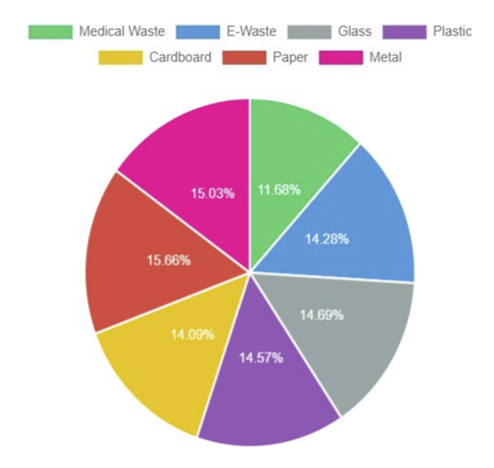

*Note.* Source (Kumsetty et al., 2022)

Some of the samples can be seen in Figure 5. The size of the dataset is 4+ GB in the compressed zip format. Each of the classes can be explained below:

* Plastic containing 2669 images of bags, bottles, containers, cups, cigarette butts with plastic filter
* Paper containing 2695 images of TetraPak, Newspapers, Paper cups, Paper Tissues
* Glass containing 2528 numbers of images
* Cardboard containing 2414 numbers of images
* Metal containing 2586 images of Beverage Cans, Food Grade Cans, Scrap from Construction, etc.
* Medical waste containing 2010 images of Medicines(Pills & Drugs), Surgical Gloves and Masks, Syringes
* E-waste containing 2883 images of Electronic chips, Smartphones, Appliances, Laptops, Electrical wires, chords, and cables

**Figure 5**

*Screenshot of TrashBox Dataset*

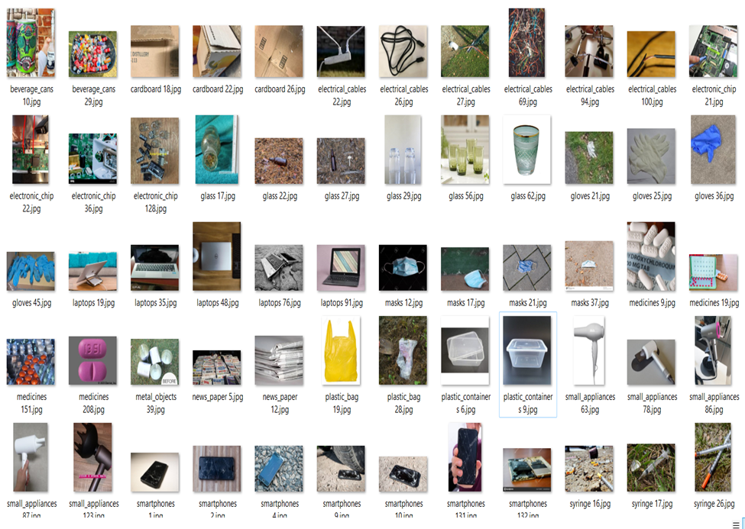

*Note:* Source (Kumsetty et al., 2022)

Figure 6 shows the Garbage Classification dataset with 12 classes that are used to extract biological, clothing, and shoe-related images. This dataset has 12 categories: paper, metal, plastic, biological, brown glass, green glass, white glass, batteries, trash, clothes, and shoes (*Garbage Classification (12 Classes)*, 2021). A total of 15150 images takes 257 MB in size. Nnamoko (2023) created a dataset with organic and recyclable categories. Organic comprised 13,880 images and recyclable comprised 10,825 images out of 24705. This dataset are used to extract organic waste images. This dataset contains many incorrect images that need to be cleaned. Figure 7 shows the screenshot of the Nnamoko dataset. It contains many types of biodegradable waste items. This dataset is 258 MB in size.

**Figure 6**

*Screenshot of Dataset Containing Clothes and Shoes Waste (Garbage Classification Dataset)*

**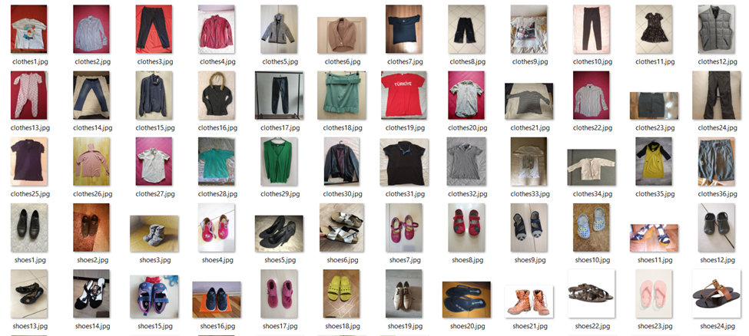***Note:* Source (Garbage Classification (12 Classes), 2021)

**Figure 7**

*Screenshot of Dataset with Organic Household Waste*

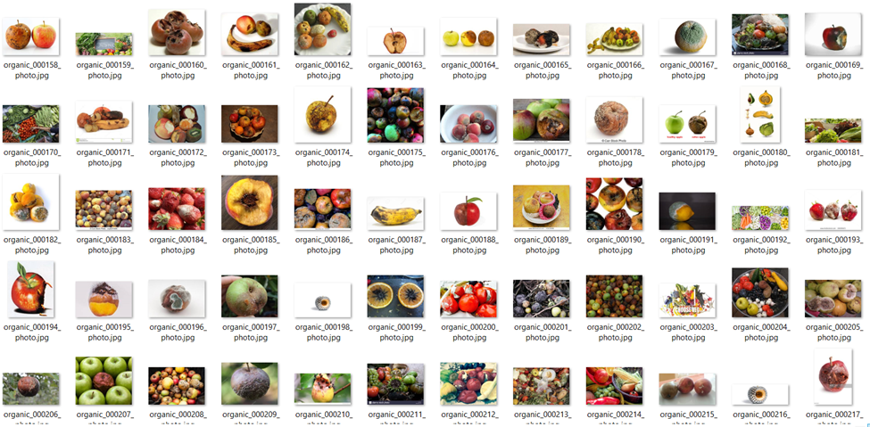

*Note:* Source (Nnamoko, 2023)

The Furniture Identification Dataset was hosted as the last step of a two-day workshop on DL and CNN introduction through PyTorch (Gurumurthy & Manga, 2020). The dataset consisting of several 3-D images is 58 MB in size and has five types of furniture items such as Sofa, Chair, Bed, table, and Swivel chair. This dataset is the subset of Intel sponsored the dataset RF100 - Roboflow 100 Multi-domain Object Detection benchmark (Roboflow, n.d.). The total number of furniture images is 692. Figure 8 shows the screenshot of the furniture identification dataset.

The datasets were merged, and augmentation techniques were applied. Annotation tools, such as CVAT and Grounding Dino were utilized for labeling and annotating the datasets. The datasets are kept on the one drive provided by SJSU for easy access among the team members. All these datasets are open source and free to use for research purposes.

**Figure 8**

*Snapshot of Furniture Identification Dataset*

**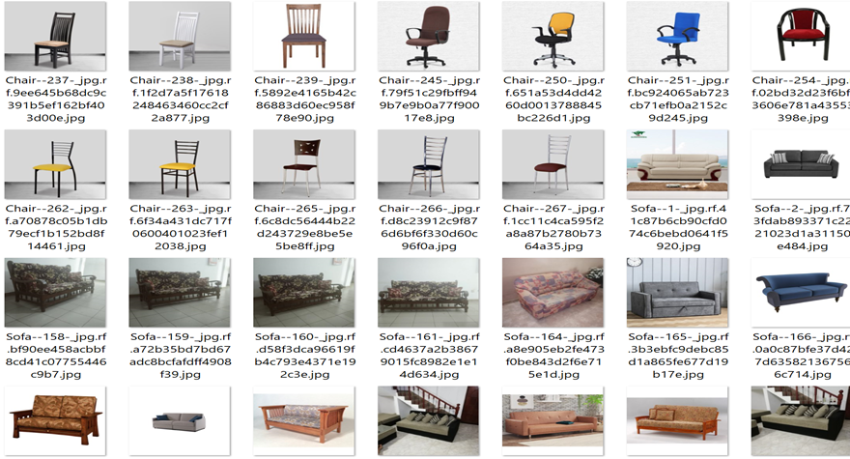***Note.* Source (Gurumurthy & Manga, 2020)

***Data Management Methods***

To successfully collect, organize, analyze, and retrieve picture data linked to a variety of garbage produced by households, effective data management is essential. In order to ensure the acquisition of high-quality images, thorough data management procedures are first used. Important metadata, such as timestamps and locations, are captured in order to give valuable context and protect data integrity. Given the potentially large amount of image data used for this project, suitable storage options are carefully selected to handle the data's size, and precautions for data backup are taken to guard against any possible loss. For systematic organization, a standardized naming scheme and folder hierarchy are created, making it easier to retrieve and analyze data. Furthermore, strong security regulations are upheld to prevent unauthorized access, protecting the confidentiality and integrity of the information for garbage categorization. The project's ability to make wise decisions based on high-quality image data while maintaining the security and dependability of the dataset is, in short, made possible by excellent data management.

***Data Storage Methods***

For this research, managing a vast array of image datasets sourced from diverse platforms is crucial. The foundation of the data storage methodology lies in ensuring easy access, seamless collaboration, and data security.

Immediately after procuring image datasets from multiple origins, they are initially stored on a designated machine. This is an interim step to guarantee data integrity and to prepare for subsequent data management processes. To make certain that all participants have unfettered access to the data and to foster effortless collaboration, this research transitions the data to OneDrive. Upon uploading the datasets to OneDrive, a shared link is disseminated amongst the team, thus democratizing access and simplifying collaborative efforts.

Before diving into the analysis and model training phase, the datasets must be pristine and of the highest quality. For this purpose, custom scripts and tools tailored for image data are deployed. These tools assist in detecting any corrupt images, duplicates, or those that don't align with the project's objectives.

Given the nature of the project and the potential size of the image datasets, it becomes necessary to adopt a systematic organization approach. Each dataset is categorized based on its source and type and structured within separate folders in OneDrive. This organization aids in streamlining the data retrieval process, especially when specific datasets are required for different modeling approaches or analysis tasks.

To safeguard the work against potential data loss and to ensure version control, an automated workflow is set up. This workflow detects changes or additions to the datasets on OneDrive and creates periodic backups, ensuring data redundancy.

This well-thought-out approach to data storage and management equips the team with a streamlined mechanism for handling vast amounts of image data. It ensures that the project progresses without data-related hindrances, and sets the stage for this research to create a solution that truly transforms waste into something remarkable.

***Data Usage Mechanisms***

**Data Management.**The efficient orchestration of data and a successful project team collaboration form the basis of this research. This section outlines the strategy used for these two facets.

***Data Collection and Metadata Production.*** The study largely relies on primary datasets, particularly TrashBox, Mendeley Data's Waste Classification Dataset, and Kaggle's Garbage Classification dataset. Recognizing representational gaps for household garbage, extra data are combined to provide a "homegoods" category to the dataset.

***Data Quality.*** The reliability of the data is crucial. After being combined, the datasets go through a thorough cleaning procedure. Each data point is enhanced by removing redundancies and using annotation tools like CVAT, LabelMe, and Labelimg. The dataset's breadth is expanded using augmentation techniques, assuring its durability for the upcoming modeling phase.

***Data Archiving and Sharing.*** The team utilizes OneDrive, facilitated by SJSU, as a centralized data repository. This collaborative platform ensures that every team member has immediate access to the latest version of the dataset, streamlining collaborative efforts.

***Data Storage and Backup.*** Alongside primary storage, an intrinsic backup mechanism is established using the GitHub repository. This not only provides an added layer of data security but also ensures recoverability, shielding the project against unforeseen data losses.

**Team Collaboration.** For this aspect, each member of the team brings their expertise to the table and divides the tasks equally and carefully which are listed in Table 3 below.

**Table** **3**

*Data Management Tasks and Owners*

| **Role** | **Owner** | **Task** |
| --- | --- | --- |
| Data Collection and Metadata Production | Krishna Sameera Surapaneni | Leading the data collection effort, Sameera combines datasets, spots any gaps in the information, and plans the addition of the homegoods category. |
| Data Quality | Siddharth Solanki | Siddharth delves deep into the realm of data quality. In order to ensure that the dataset is ready for further analysis, he supervises the annotation and augmentation procedures. |
| Data Archiving and Sharing | Sonali Arcot | Facilitating seamless data access, Sonali manages the team's shared data archives on OneDrive and ensures ethical data sourcing and usage. |
| Data Storage and Backup | Vidushi Bhati | In charge of data backup and storage, Vidushi strengthens data security, oversees redundancy procedures, and makes sure there is effective team communication. |

**Project Development Methodology*****Data Analytics with Intelligent System Development Cycle***

In the world of software development, there are various methods and models used to manage projects. These include well-known approaches like Jira, Scrum, R&D, Agile, Waterfall, and CRISP-DM. This project chose the waterfall Model, which divides the development process into different phases, for this particular project. There is no overlap between phases in this model’s sequential execution of each step. With duties including requirement gathering, design, implementation, testing, deployment, and continuing software maintenance, each phase is very specific and clearly defined. This work also integrates the CRISP-DM approach into the Waterfall life cycle. CRISP-DM is a widely used method in data mining across various industries. It's known for its adaptability and practicality when applying analytics to complex business challenges. This approach consists of six key elements:

**Business Understanding.** This phase revolves around understanding the project’s business goals, analyzing the environment, setting project objectives, and forming a project strategy.

**Data Understanding.** In this stage, locating, gathering, and analyzing the datasets happens. Data is described and explored, and the Quality of the data is ensured.

**Data Preparation.** Data goes through a comprehensive preparation process, including selection, cleaning, construction, integration, and formatting. This phase can often be the most time-consuming.

**Modeling.** Multiple modeling methodologies are chosen, test designs are developed, models are built, and they are rigorously evaluated in this phase.

**Evaluation.** The evaluation phase plays a crucial role in determining the next steps. It involves assessing which model best aligns with the business requirements.

**Deployment.** The Deployment phase entails organizing the model’s deployment, keeping track of its effectiveness, producing a final report, and carrying out a project evaluation. It’s crucial to remember that depending on the exact requirements of the project, the intricacy and particulars of each phase can vary greatly.

The details of these phases are explained in detail in the following section.

***Planned Development Processes and Activities***

A well-known framework for directing the data mining and machine learning process is the Cross-Industry Standard Process for Data Mining (CRISP-DM). It contains numerous stages and can be used to make sure that this project involving garbage segregation using deep learning techniques is well-structured and adheres to the best practices. CRISP-DM aligns with all the stages of project development that this project plans to implement. Utilizing the CRISP-DM model, the following development processes and activities have been planned for this research.

**Business Understanding.** The increasing global concern surrounding improper waste management and the environmental impact thereof has led to the inception of this research. Issues such as landfills reaching capacity, increased carbon footprint, and the depletion of natural resources due to the non-reuse of recyclables underline the importance of this endeavor.

***Business Objectives.*** The primary objective is to leverage state-of-the-art technology to categorize waste more effectively. By accurately predicting the categories, the project aims to streamline waste management processes, promote recycling, and minimize environmental harm starting at the household level.

***Assess Situation.*** The existing waste segregation adopted by households across the country is largely manual and often non-existent, with minimal predictive capabilities, leading to inefficiencies in waste disposal, recycling, and reuse processes.

***Determine Project Goals.*** The project's objectives revolve around the classification of waste items into categories such as organic, recyclable, hazardous, and home goods. This will involve using deep learning models and integrating varied data sources to improve waste management and motivate households to adopt waste recycling and upcycling.

***Produce Project Plan.*** The plan involves the collection, preprocessing, and exploration of waste data, modeling to predict waste types and subsequent integration of Large Language Model and Google API for suggesting appropriate recycling and upcycling methods. The Graphical User Interface will go through rigorous testing to ensure it is seamless and ease to use.

**Data Understanding.** Data sources for this project will comprise images of items encompassing a variety of waste categories. These categorized images will be used for model training and testing to ensure optimal results.

***Collect Initial Data.*** Data will be sourced from various online sources like kaggle, data mendeley as well as image based datasets like TrashBox.

***Describe Data.*** Post-collection, the data will be thoroughly analyzed to determine its structure, attributes, and patterns. This will set the stage for further preprocessing and modeling activities.

***Explore Data.*** Through techniques such as data visualization and statistical analysis, underlying trends, patterns, and anomalies within the collected data will be identified.

***Verify Data Quality.*** Ensuring high-quality data is paramount. The datasets will be scrutinized for missing values, outliers, or discrepancies, and requisite corrective actions will be undertaken.

**Data Preparation.** To make the raw data amenable to modeling, it will be selected, cleaned, constructed, integrated, and formatted as per project requirements.

***Data Selection.*** Relevant datasets will be identified and chosen based on the project's requirements, ensuring that the most pertinent and accurate information is used for modeling.

***Clean Data.*** All gathered data will undergo a cleansing process to eliminate anomalies, discrepancies, and missing values, thereby ensuring the integrity and reliability of the datasets.

***Construct Data.*** Here, new variables or attributes may be constructed based on existing data to enhance the model's predictive power. For instance, deriving metrics related to waste density or categorizing waste types could be part of this step.

***Integrate Data.*** Data from various sources will be amalgamated into a unified dataset. This is crucial for a holistic view of the waste management landscape, allowing the models to leverage a comprehensive data pool.

***Data Transformation.*** This step involves normalizing, scaling, or performing other transformations on the data to make it suitable for the chosen modeling techniques.

***Format Data.*** To ensure compatibility with different modeling algorithms, the data may need to be formatted or restructured. This could include operations like one-hot encoding for categorical variables or reshaping datasets for time-series forecasting.

**Modeling.** The modeling phase will explore various machine learning and deep learning algorithms suitable for waste classification and prediction. Post-training, these models will be validated for accuracy and efficiency.

***Select Modeling Techniques.*** Models such as CNNs for image recognition, time-series forecasting for waste generation predictions, and clustering algorithms for waste categorization will be explored.

***Generate Test Designs.*** A testing framework will be established to assess each model's performance, utilizing techniques like cross-validation to ensure the model's robustness and generalizability.

***Build Model.*** Optimal hyperparameters will be determined for each model, ensuring that they cater to the nuances and specifics of the waste management domain.

***Model Parametric Assessment.*** In this step, the models will be scrutinized based on their hyperparameters. Rigorous tuning will be performed to optimize these parameters, ensuring that the models deliver peak performance. The best parameters will be chosen for each model, enhancing their predictive accuracy and efficiency.

**Evaluation.** Models will be rigorously evaluated based on metrics like accuracy, precision, recall, and F1-score to ascertain their suitability for deployment.

***Evaluate Results.*** Performance of the models will be cross-validated, laying the groundwork for the subsequent deployment phase.

***Review Process.*** Each phase of the project, from data collection to modeling, will be subjected to periodic reviews to ascertain alignment with project goals.

***Determine the Next Steps.*** Post model validation, the best models will be integrated into the larger waste management framework, followed by extensive testing to ensure real-world efficacy.

**Deployment.** The finalized models and systems will be deployed using containerization platforms, ensuring scalability and ease of integration.

***Plan Deployment.*** Automated deployment pipelines will be established, facilitating continuous updates and enhancements as more data becomes available.

***Plan Monitoring and Maintenance.*** Monitoring tools will be put in place to oversee the deployed models and systems, ensuring that they operate optimally and adapt to changing waste management trends.

***Produce Final Report.*** Upon project completion, a detailed report encapsulating all findings, methodologies, results, and recommendations will be compiled.

***Review Project.*** A comprehensive project review will be undertaken to measure success against the set objectives and to glean insights for future initiatives.

**Project Organization Plan**

***Work Breakdown Structure (WBS)***

The Work Breakdown Structure is described as a hierarchical breakdown of the work to be performed by the project team, focusing on deliverables (*Work Breakdown Structure*, n.d.). A Phase-based Work Breakdown Structure (WBS) can be effectively integrated with the CRISP-DM (Cross-Industry Standard Process for Data Mining) framework for this Garbage Waste Management project employing deep learning techniques. The WBS provides a structured approach to organizing the project's tasks and deliverables into manageable phases, aligning with CRISP-DM's iterative data science process. In the initial phases, such as Business Understanding and Data Understanding, the WBS outlines tasks related to stakeholder engagement, data collection, and dataset assessment. As the project progresses through the CRISP-DM phases of Data Preparation, Modeling, Evaluation, and Deployment, the WBS delineates activities specific to deep learning model development, training, evaluation, and system deployment. This integration ensures a synchronized and well-coordinated approach, enabling project teams to effectively manage the complexity of the Garbage Management System while adhering to best practices in deep learning. It streamlines the workflow, enhances project organization, and facilitates clear communication among team members, ultimately contributing to the success of the Garbage Segregation project. Figure 9 shows the work breakdown structure.

**Figure 9**

*Work Breakdown Structure*

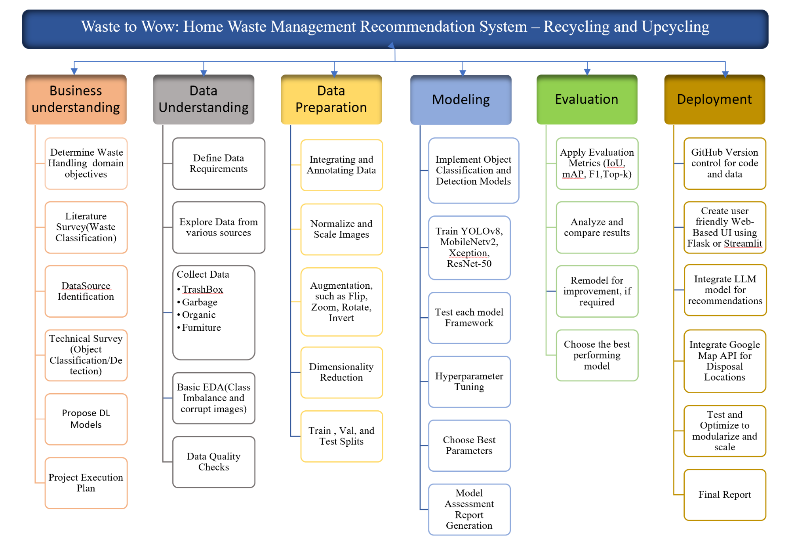

**Project Resource Requirements and Plan**

***Hardware Requirement***

Given the complexities of image processing and machine learning activities involved in classifying various forms of domestic waste, a machine with sufficient processing power and speed is required for a smooth project workflow. Table 4 contains information about the system's CPU, GPU, and other relevant components.

**Table 4**

*Hardware Requirements*

| **Hardware** | **Configuration** | **Memory** |
| --- | --- | --- |
| CPU | 11th Gen Intel Core i9-11950H | 24MB Cache |
| GPU | NVIDIA GeForce RTX 3080 | 16GB |

*Note.* The system also has 64GB memory and 1TB SSD.

***Software Requirement***

Numerous software programs and libraries that are often used in the data science field can be easily installed, updated, and managed using the Anaconda platform. For this project alone, a customized environment is built using Anaconda. It supports all of the Python tools, libraries, and IDEs. Anaconda is used to set up Jupyter Notebooks, Visual Studio, Spyder, and PyCharm. For debugging, displaying run-time variables, and code tracking, these IDEs would be helpful. This project will use Python 3.10.11 as the programming language. Table 5 shows the list of the software that may be required for the project.

**Table 5**

*Configuration of Software*

| **Team’s Laptop Operating System** | Windows 10 Pro 64 |
| --- | --- |
| **Google Collaboratory’s VM** | Linux(Ubuntu) |
| **Anaconda Navigator** | 2.4.0 |
| **Integrated Development Requirement(IDE)** | Visual Studio Code 1.78.1/ PyCharm |
| **Jupyter Notebook** | 6.4.12 |
| **Python** | 3.10.11 |

There will be several Frameworks, libraries and APIs that will be used for this project. Given the scope and objectives of the project, various software libraries and tools are being leveraged to facilitate data processing, model development, and visual representation. At the outset, data management and analysis are handled using Pandas, which provides the convenience of structured data frames, and NumPy, essential for array-based computations. The emphasis on providing interpretable insights makes visualization libraries like Seaborn, Matplotlib, and Plotly indispensable. These tools, especially Seaborn built atop Matplotlib, provide a rich array of visualizations to dissect and interpret relationships in the data. Diving deeper into the project's core, the advanced models, namely YOLOv8, Xception, MobileNetV2, inceptionresnetv2, and ResNet-50, necessitate specialized software dependencies. Both TensorFlow and Keras emerge as pivotal. TensorFlow, with its vast computational capabilities, forms the bedrock for deep learning, while Keras, with its high-level interface, simplifies the deployment of models like Xception, MobileNetV2, inceptionresnetv2, and ResNet-50. Object Classification and Detection libraries, such as Open-CV and YOLO will be utilized. For integration with a large language model, LLama 2 7B API will be used. To incorporate Google Maps functionality, Google Maps API will be used. It is essential to note that these software specifications might undergo alterations based on any future changes in the project's scope or to incorporate state-of-the-art advancements in the respective libraries. Table 6 shows the libraries, packages, and frameworks that will be used in the development of the project.

**Table 6**

*Proposed Libraries, Frameworks in the Project*

| **Libraries, Package** | **Purpose** | **Version** |
| --- | --- | --- |
| Pandas | Data frame creation and management | 2.1.1 |
| NumPy | Array operations | 1.26.0 |
| Seaborn | Data visualization | 0.13.0 |
| Matplotlib | Plotting data | 3.8.0 |
| Keras | Deep learning model development | 2.12.0 |
| TensorFlow | Backend for deep learning | 2.14.0 |
| Scikit-Learn | Test Design Sets | 1.1.3 |
| OpenCV | Object Detection/Classification | 4.8.0 |
| YOLO | Object Detection | version 8 |
| LabelImg | Labeling, annotating images | 1.8.6 |
| Flask/ TensorFlow Lite/Streamlit | for UI Deployment | 2.3.2/2.14.0/1.27.2 |

***Tools and Licenses***

For this research, a comprehensive suite of tools has been curated to ensure efficient workflow and robust outcomes. JIRA stands as the central tool for task management, prioritization, and tracking project milestones. For data manipulation, visualization, and analysis, Jupyter Notebook and Google Colab are employed, offering a dynamic and interactive environment tailored to handle large datasets.

One Drive serves as the primary storage solution, ensuring data integrity and enabling seamless collaboration. Communication, an essential pillar for the success of any project, is facilitated via Zoom, ensuring that all stakeholders remain aligned and updated.

The integration of the Google Maps API offers geospatial insights, crucial for waste management recommendations like Disposal or donation centers. Llama 2 LLM, another key integration, provides the user with ideas and techniques for optimal waste upcycling such as DIY projects.

Visualization and interactive data representation are made possible through Tableau, enhancing the understanding of waste trends, recycling rates, and other critical metrics. Grammarly will also be extensively used during the course of this research as a writing assistant to check for irregularities in spelling, and grammar and for potential plagiarism detection.

Finally, GitHub serves as the code repository, ensuring version control, collaborative coding, and transparent documentation throughout the development cycle.

While the above tools form the foundational tech stack for the project, adaptations, and modifications might occur based on the evolving needs of this project. Future phases could see the introduction of additional tools or modifications in existing tool licenses as the project scope undergoes changes. Table 7 showcases all the tools and licenses which will be used for this project.

**Table** **7**

*Tools and Licenses*

| **Tools** | **Usage** | **Cost** |
| --- | --- | --- |
| JIRA | Project management and task tracking | Free Tier |
| Google Colab Pro | Cloud-based Python development environment | Paid |
| Jupyter Notebook | To test sections of code on local machines | Free |
| One Drive | Cloud storage for collaboration and data sharing | Free for SJSU students |
| Zoom | Remote communication and collaboration | Free for SJSU students (Unlimited meeting duration for 2+ attendees) |
| Google Maps API | Geospatial insights and mapping for recommending local donation and disposal centers | Open Source |
| Llama 2 API | Large Language Model, used for recommending methods and techniques for upcycling waste materials | Open Source |
| Tableau | Data visualization and interactive representation | Free |
| Microsoft 365 | To create report, presentations and to view data in Excel | Free for SJSU students |
| Grammarly | Writing assistant for checking spelling, grammar, and plagiarism | Paid |
| Github | Version control, code repository, data backup, and deployment | Free |

***Project Cost and Justification***To ensure cost-effectiveness and encourage transparency, the research endeavor makes an effort to use open-source or freely available tools in the majority of its operations. Due to their widespread acceptance and low cost, well-known tools like Llama, Google Maps API, GitHub, and Jira have been integrated into the project workflow. However, specific funding allocations have been made to guarantee the project's smooth development and uphold the highest standards of accuracy and presentation.

**Computing resources.** The team initially intends to use Google Colab for its model computations, but given the complexity and processing requirements of some advanced models like Yolov8 and MobileNetv2, it is possible that more powerful computing resources will be required. To prevent this, a budget of $50 has been set aside in case Google Colab Pro needs to be upgraded. This would guarantee continuous model training and evaluation sessions by providing increased RAM and priority GPU access.

**Documentation Quality Assurance.** It is essential to guarantee the project reports' originality, compatibility with formatting standards, and linguistic quality. A $144 yearly membership to Grammarly's premium plan has been purchased to help with this quest. The project's written outputs will be subjected to stringent grammar checks, plagiarism detection, and APA formatting requirements with the help of this technology, ensuring they satisfy academic standards.

**Project Schedule**

***Gantt Chart***

The Gantt chart is a useful tool for simplifying project planning and scheduling. It depicts task timelines, including start and conclusion dates as well as the personnel in charge. Furthermore, it depicts task interdependencies, allowing for a thorough project overview.

Each task is continuously monitored and its progress is regularly updated during the project's execution. This proactive strategy enables for the early identification of potential delays and the assessment of prospective resource requirements. The project is divided into six overarching epics, each of which is further divided into a number of storylines and smaller tasks.

**Business Understanding.** This is the initial phase with 8 stories. These stories include understanding the project background, evaluating project requirements, and preparing for the presentation and report submission. It marks the first sprint of the project. Each story has subtasks assigned to specific team members, and their progress is tracked. Figure 10 shows the business understanding phase of this project.

**Figure 10**

*Business Understanding Phase*

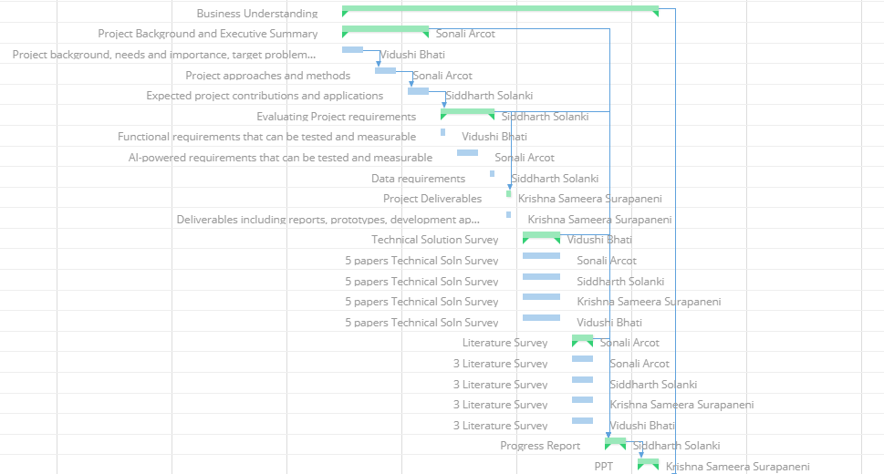

**Data Understanding**. The second phase focuses on exploring and collecting the necessary data, as well as ensuring data quality through checks. Subtasks within this phase include tasks like checking image size and random sampling. Figure 11 shows the tasks and dependencies in the second phase of the project.

**Figure 11**

*Data Understanding Phase*

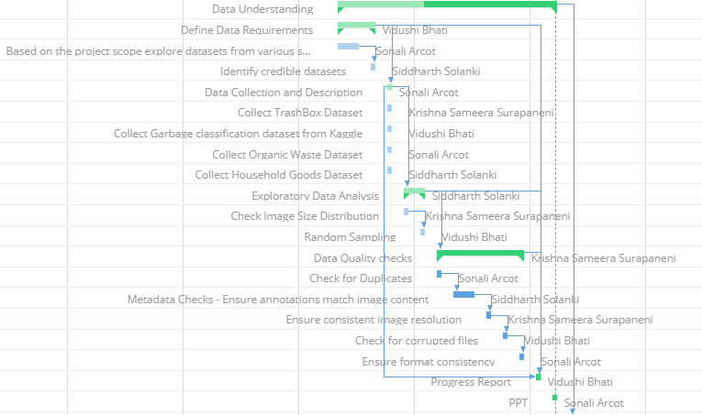

**Data Preparation.** In the third sprint, data is cleaned and transformed. This involves tasks like resizing and scaling images and data augmentation. The goal is to ensure that the data is appropriately prepared for modeling. The tasks and dependencies for the data preparation sprint are shown in Figure 12.

**Figure 12**

*Data Preparation Phase*

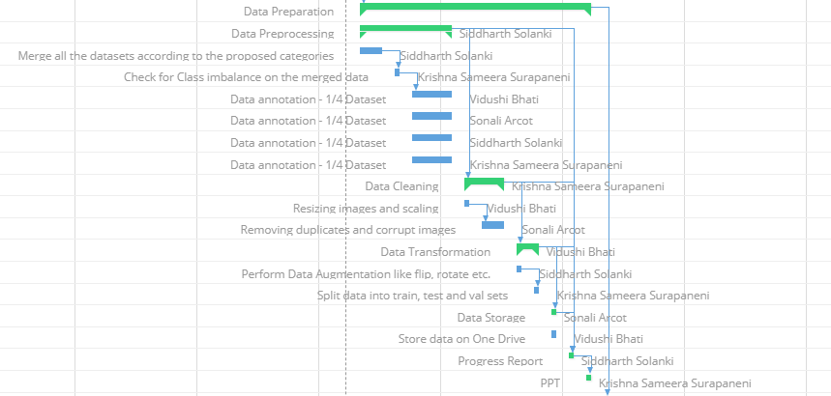

**Modeling.** The fourth phase utilizes the transformed data to train and test models. Hyperparameter tuning is also performed, leading to the selection of the best parameters for each model. Figure 13 shows the tasks to be performed in the modeling phase.

**Figure 13**

*Modeling Phase*

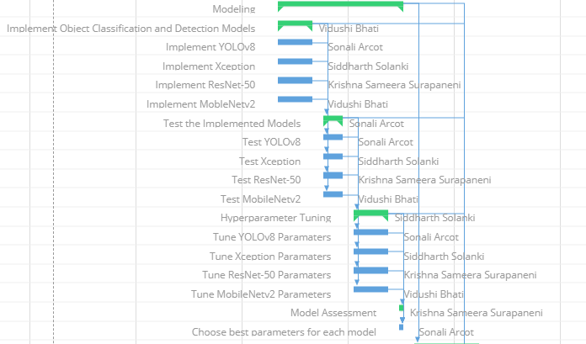

**Evaluation.** In this phase, evaluation metrics are applied to assess model performance. The results of each model are analyzed to choose the best-performing one, ensuring alignment with the project's business objectives. Figure 14 shows the evaluation phase of the project.

**Figure 14**

*Model Evaluation Phase*

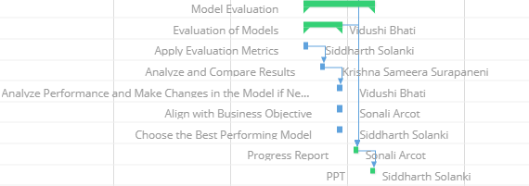

**Deployment.** The final phase integrates the LLM (likely referring to a machine learning model) and the Google Maps API. It concludes with the submission of the project's final report.

***Pert Chart***A PERT chart (Program Evaluation Review Technique) is a graphical tool used in project management to illustrate and assess the tasks involved in the completion of a specific project. It displays the work flow and sequence, allowing project managers to estimate schedules, identify dependencies, and highlight important pathways.Figure 15 depicts the PERT activity list wherein the tasks and their dependencies are mentioned.

The PERT chart depicted in Figure 16 is task-oriented, which means that its major focus is on the project's specific tasks or activities rather than the resources or persons required to perform them. Each task is depicted in this chart with its start and end dates, as well as dependencies indicating which activities must come first. This style of chart clarifies the sequence and interrelationship of tasks, assisting teams in prioritizing and executing tasks efficiently in order to stay on track and meet project deadlines.

In Figure 15, the dependencies of subtasks in the project are mentioned. Mentioning a few activity-dependent activity pairs for this research: The task, ‘Identify credible datasets’ is dependent on it’s predecessor task, ‘Based on the project scope explore datasets from various sources’. Similarly, the activity ‘Check for Class imbalance on the merged data’ is dependent on ‘Merge all the datasets according to the proposed categories’ and so on. To ensure maximum productivity of the members on the team and utilize time in an optimum manner, multiple tasks which have no dependencies are scheduled to run in parallel.

**Figure** **15**

*PERT Activity and Dependency List*

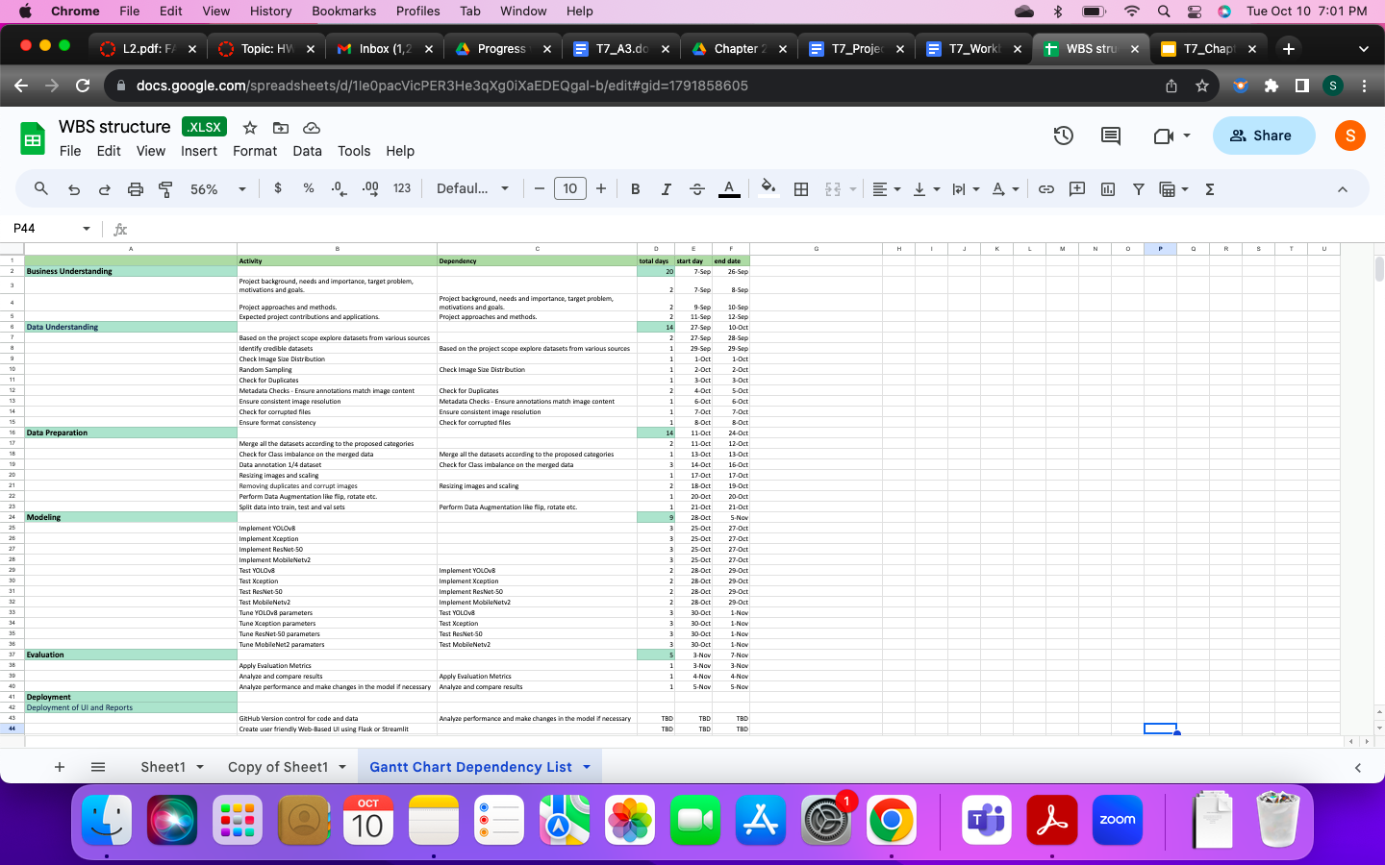

**Figure 16**

*Pert Chart*

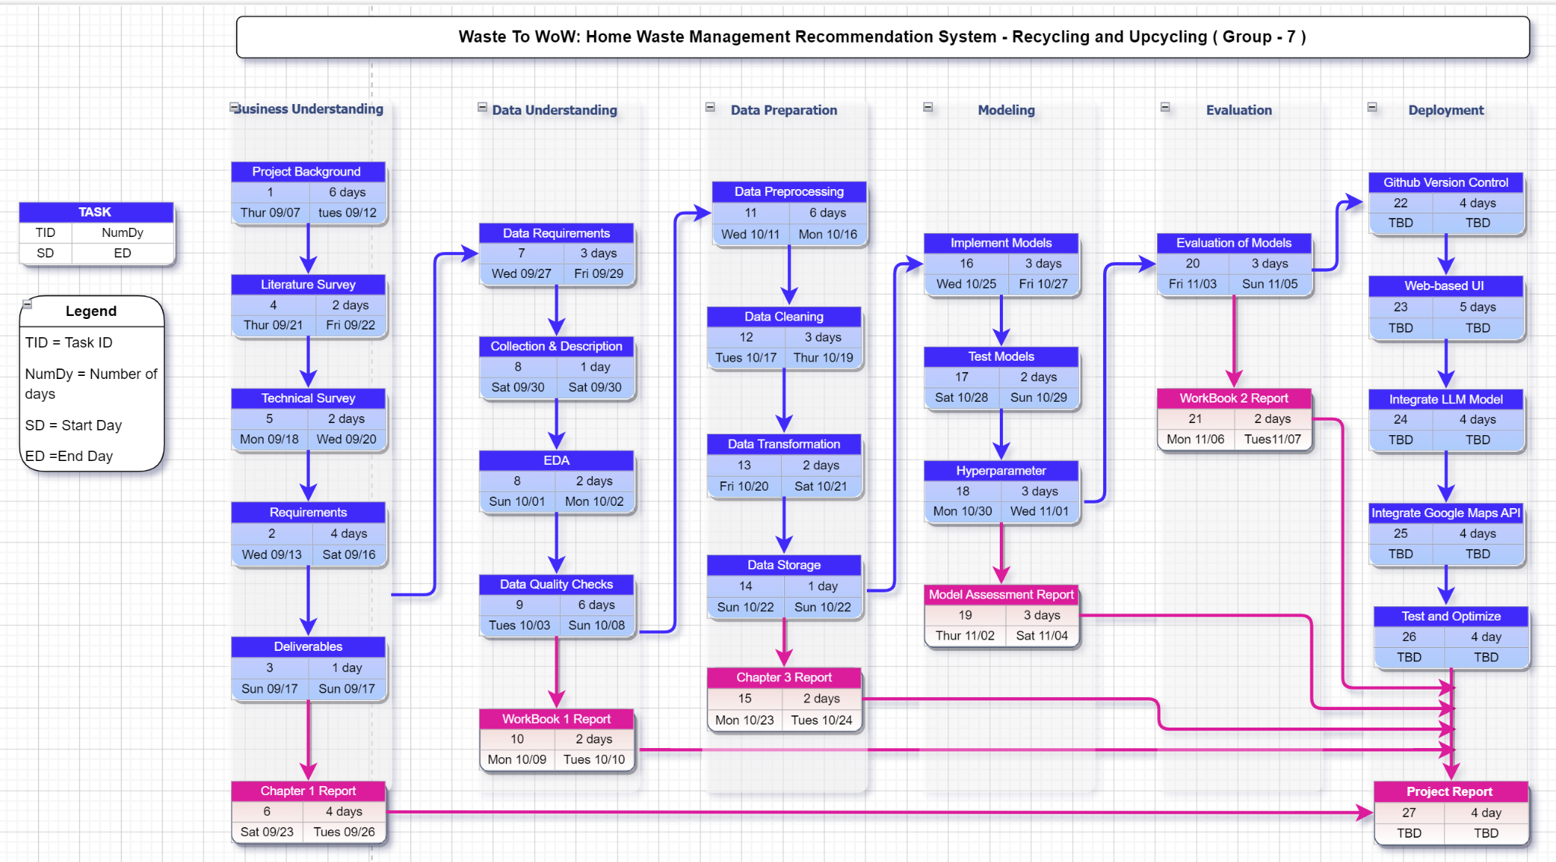

**Data Engineering**

**Data Process**

Data processing and good data use are critical for obtaining important insights and information, particularly in sectors with a tangible influence on society and the environment, such as waste management. The first step in this data collection method is to acquire image data from different relevant datasets. The TrashBox dataset (Kumsetty et al., 2022) in particular contains photos of various home garbage such as paper, cardboard, metal, glass, plastic, medical waste, and technological waste. The Mendeley dataset was used for biodegradable goods (Nnamoko, 2023). Meanwhile, visual data on clothing and shoes is retrieved from the Garbage Collection Dataset with 12 classes (Garbage Classification (12 Classes), 2021). Last but not least, furniture-related data is gathered from IECSE and Vision's Furniture Identification workshop (Gurumurthy & Manga, 2020).

Following the consolidation of all datasets, the next phase focuses on rigorous data preprocessing. Given the variety of sources, maintaining data uniformity and consistency is critical. Steps will be done to sanitize the data using Python libraries. These processes include deleting corrupt files, checking and deleting duplicate files, checking for irrelevant images, tagging photos as needed, adding data by augmentation to increase the volume and diversity of the collection, and ensuring consistent formatting across the whole dataset. Such rigorous preprocessing establishes a solid platform for later analytics, resulting in clearer and more accurate insights as well as classification on home trash management.

The focus shifts to analytics and machine learning once the preprocessed datasets are in place. The models chosen reflect the project's goal of delivering precision and efficiency. This venture's models are InceptionResNetv2, YOLOv8, MobileNetv2, and ResNet-50. These models have been acknowledged for their abilities in object recognition and classification tasks, which are precisely aligned with the project's objectives. To improve the model's performance and avoid overfitting, the complete dataset will be systematically divided: 80% will be put aside for training, while the remaining 20% will be divided equally, with 10% set aside for testing and 10% for validation.

The final stage of the data process is visualizing the statistics of the class wise data. These visualizations can help make sure that the data is consistent and ready for the next phase of the research; modeling. The entire workflow of the project is shown in Figure 17a. and the data engineering process has been shown in Figure 17b.

**Figure 17**

*Workflow Of Waste to Wow*

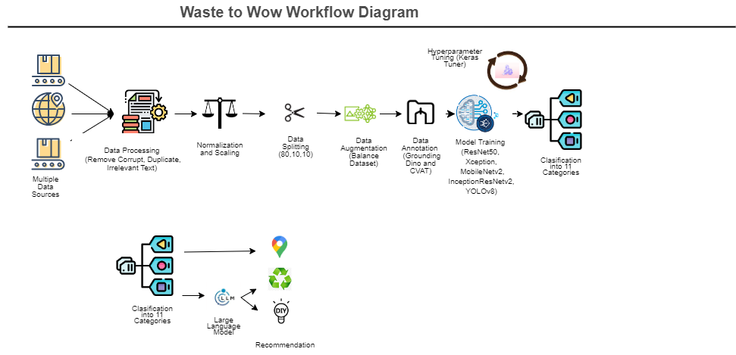

(a)

*Data Engineering Process Flow Plan*

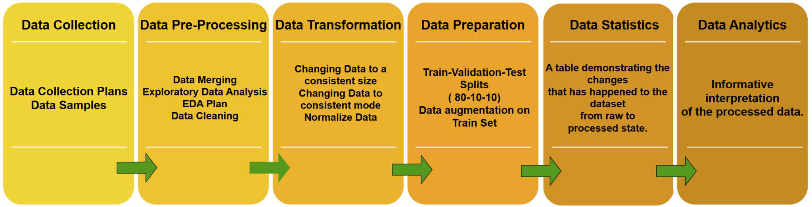

(b)

**Data Collection**

After having a thorough understanding of the project and its goals, the data that would be needed by the project was determined. A total of four datasets were consulted to get the appropriate dataset for this project. The datasets used were Trashbox, Mendeley and Kaggle. Figure 18 represents the data collection plan for household goods.This household dataset was accessible and available for research and further analysis. This dataset contains the household furniture items. Figure 19 shows a few images from all the classes present in the original dataset.

**Figure 18**

*Data Collection Plan - Household Goods*

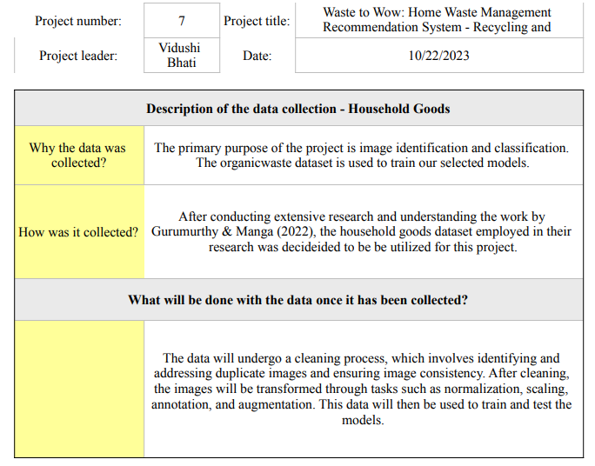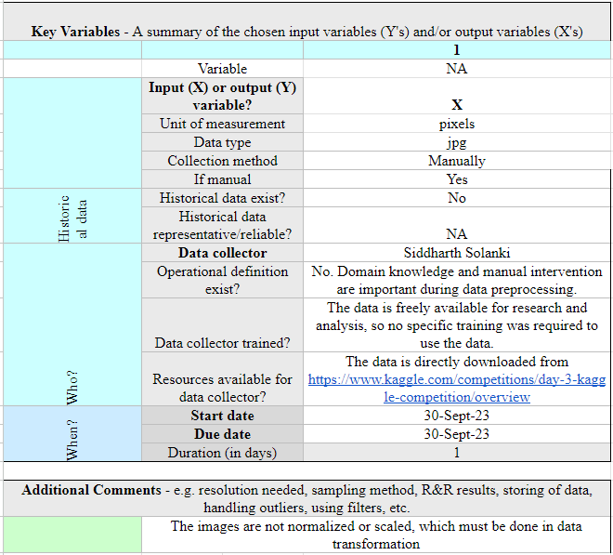

**Figure 19**

*Snapshot of Images from Household Dataset*

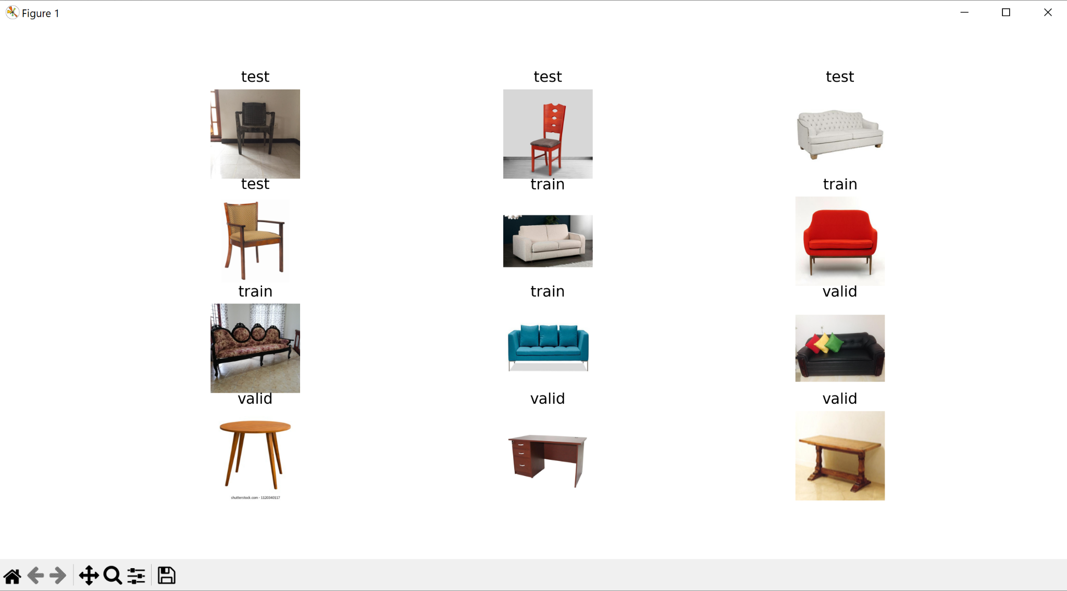

Figure 20 represents the data collection plan for the Garbage Classification dataset. This dataset originally comprised 12 different classes of data including paper, cardboard, biological; but for this project only clothes and shoes classes were taken into consideration. Figure 21 shows a few images from all the 12 data classes in the garbage dataset.

**Figure 20**

*Data Collection Plan - Garbage Classification*

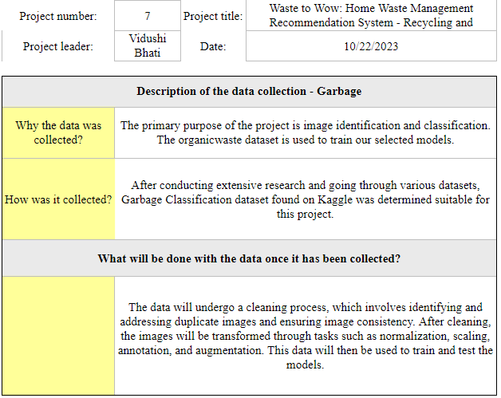

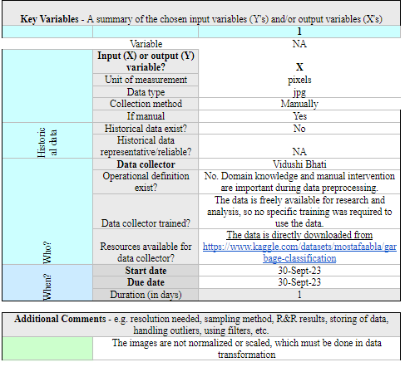

**Figure 21**

*Snapshot of Images from All the 12 Classes in Garbage Collection Dataset*

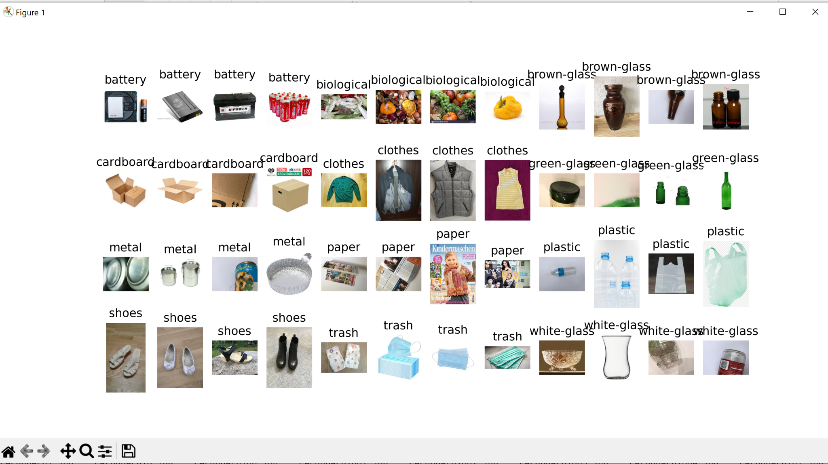

Figure 22 represents the data collection plan for the trashbox dataset. This dataset has a total of eight classes out of which seven were considered for this project. This dataset contains data collected over a period of time form 2021 to 2023. Figure 23 shows a few images from all the seven classes present in the dataset.

**Figure 22**

*Data Collection Plan - Trashbox*

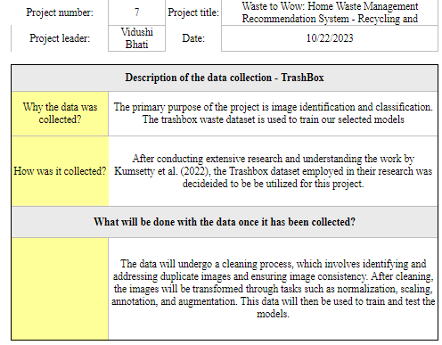

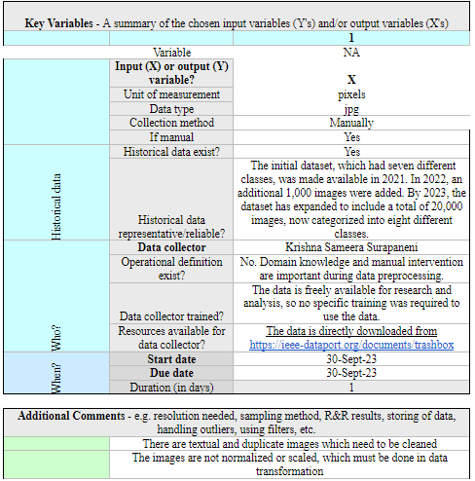

**Figure 23**

*Snapshot of Data from Trashbox*

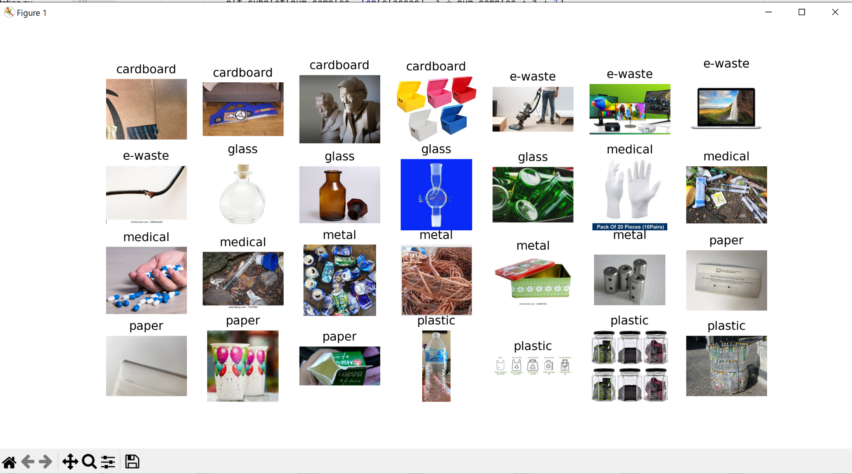

Figure 24 shows the data collection plan for organic data. This data was collected from the Mendeley website. It originally had both organic and recyclable data, but only the organic data was collected for this project*.* Figure 25 shows a few images from the Mendeley dataset.

**Figure 24**

*Data Collection Plan - Organic*

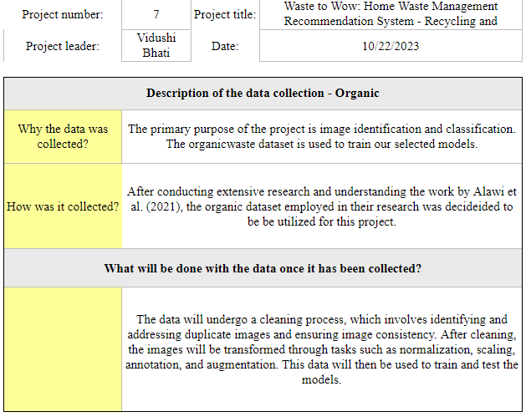

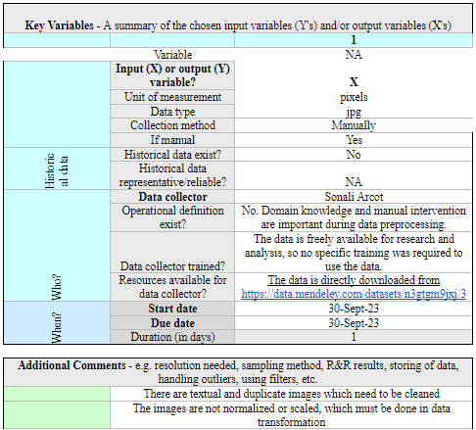

**Figure 25**

*Snapshot of Images from Mendeley Dataset*

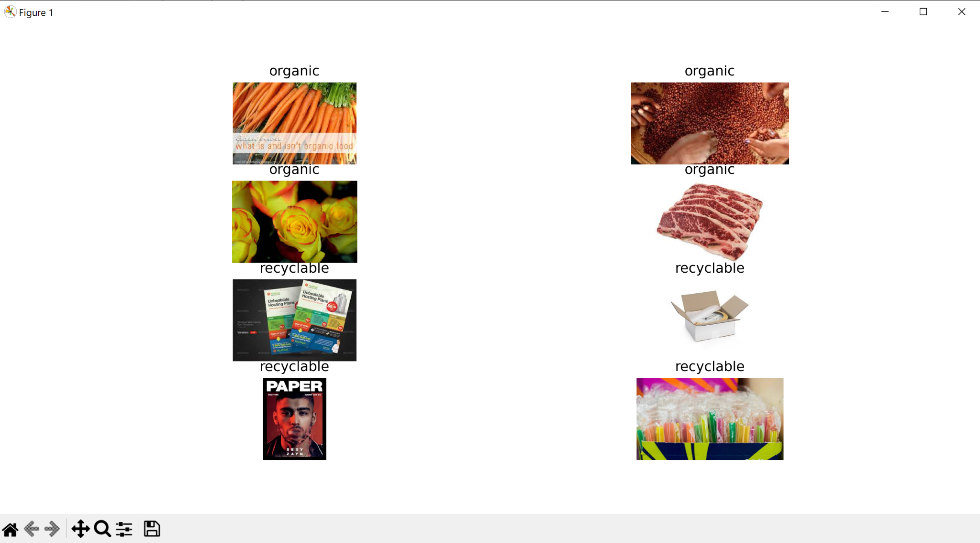

**Data Pre-processing**

***Data Exploration Plan***

This project takes into consideration 11 categories. The data sources are different for each of the categories. Figure 26 shows the Trashbox dataset with seven categories. Figure 27 shows a furniture dataset, with images of chair, sofa, and tables, available in train, validate, and test dataset. The images were taken from all three train, test, and validation folders and put into another folder, named furniture. A total of 692 images were moved to the new folder. Figure 28 shows 12 class garbage collection dataset. Only clothes and shoes folders were extracted from this dataset. Figure 29 shows the mendeley dataset with just two categories - Organic and Recyclable. Only the Organic category was extracted from this dataset and moved into the biowaste folder. The data from different sources are put into a folder containing 11 classes of folders. Figure 30 shows the final dataset that is created using all other datasets. The combined classes consist of 35,975 images with 2.52 GB size. Figure 31 shows five randomly chosen images from each of the classes - biowaste, cardboard, clothes, e-waste, furniture, glass, medical, metal, paper, plastic, shoes. Figure 32 shows the count of images in each of the classes and Figure 33 shows its distribution pictorially. The final dataset will go through a series of cleaning processes - finding and removing Corrupt images, finding and removing Irrelevant images with quotations and texts, finding and removing Duplicate images. Once this dataset is cleaned, it will go through the process of transformation - Normalizing and Scaling of images, Data Annotations, and Data Augmentation. After transformation, the data will be split into train, validation, and test sets.

**Figure 26**

*TrashBox Dataset Seven Categories*

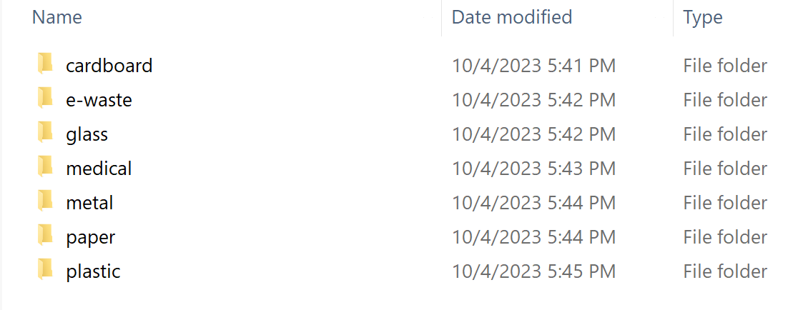

**Figure 27**

*Furniture Dataset*

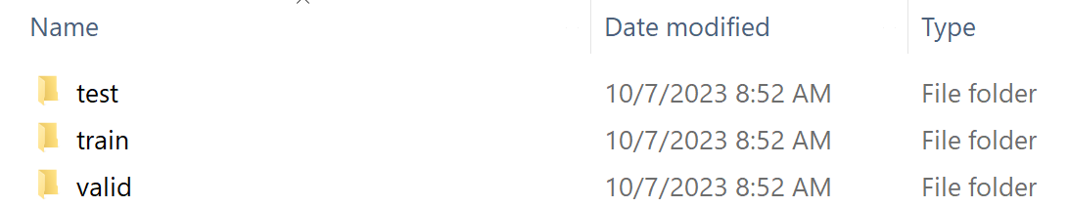

**Figure 28**

*12 Classes Garbage Collection Dataset*

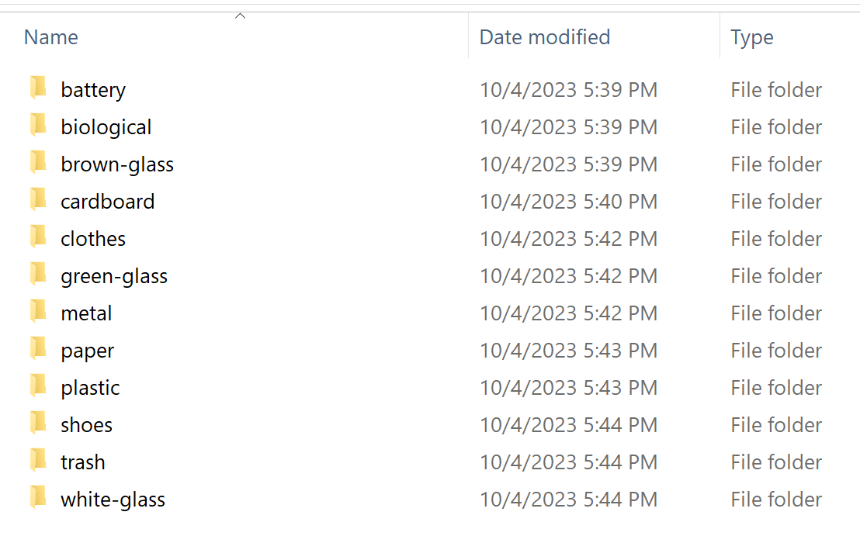

**Figure 29**

*Mendeley Dataset*

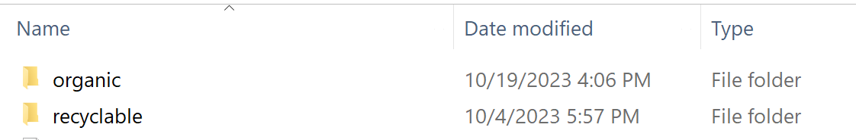

**Figure 30**

*Final 11 Categories Dataset*

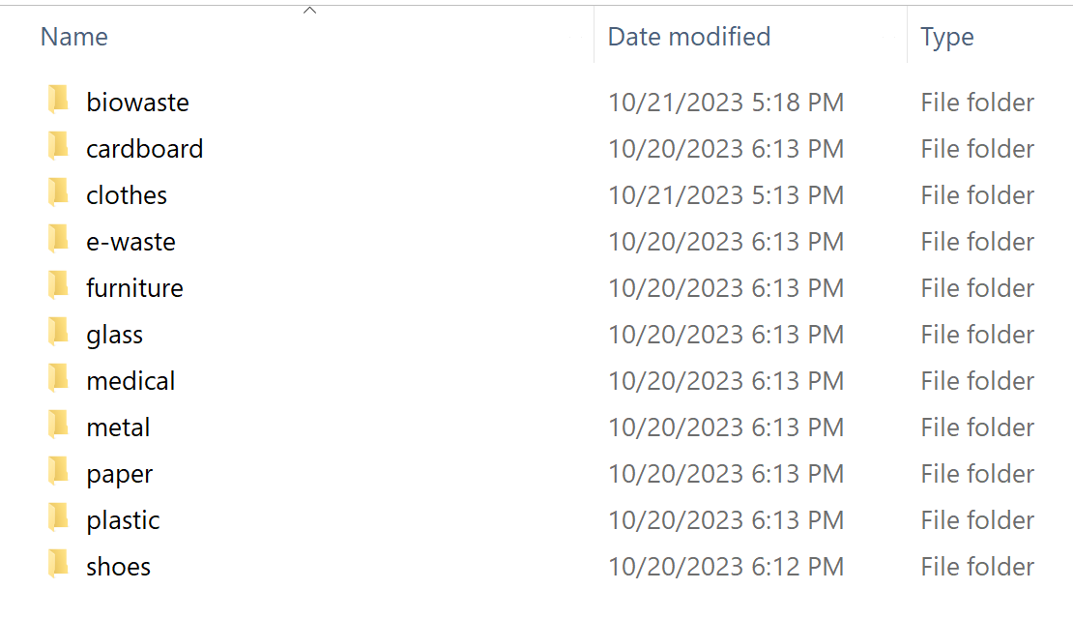

**Figure 31**

*Randomly Selected Five Images Of Each Category*

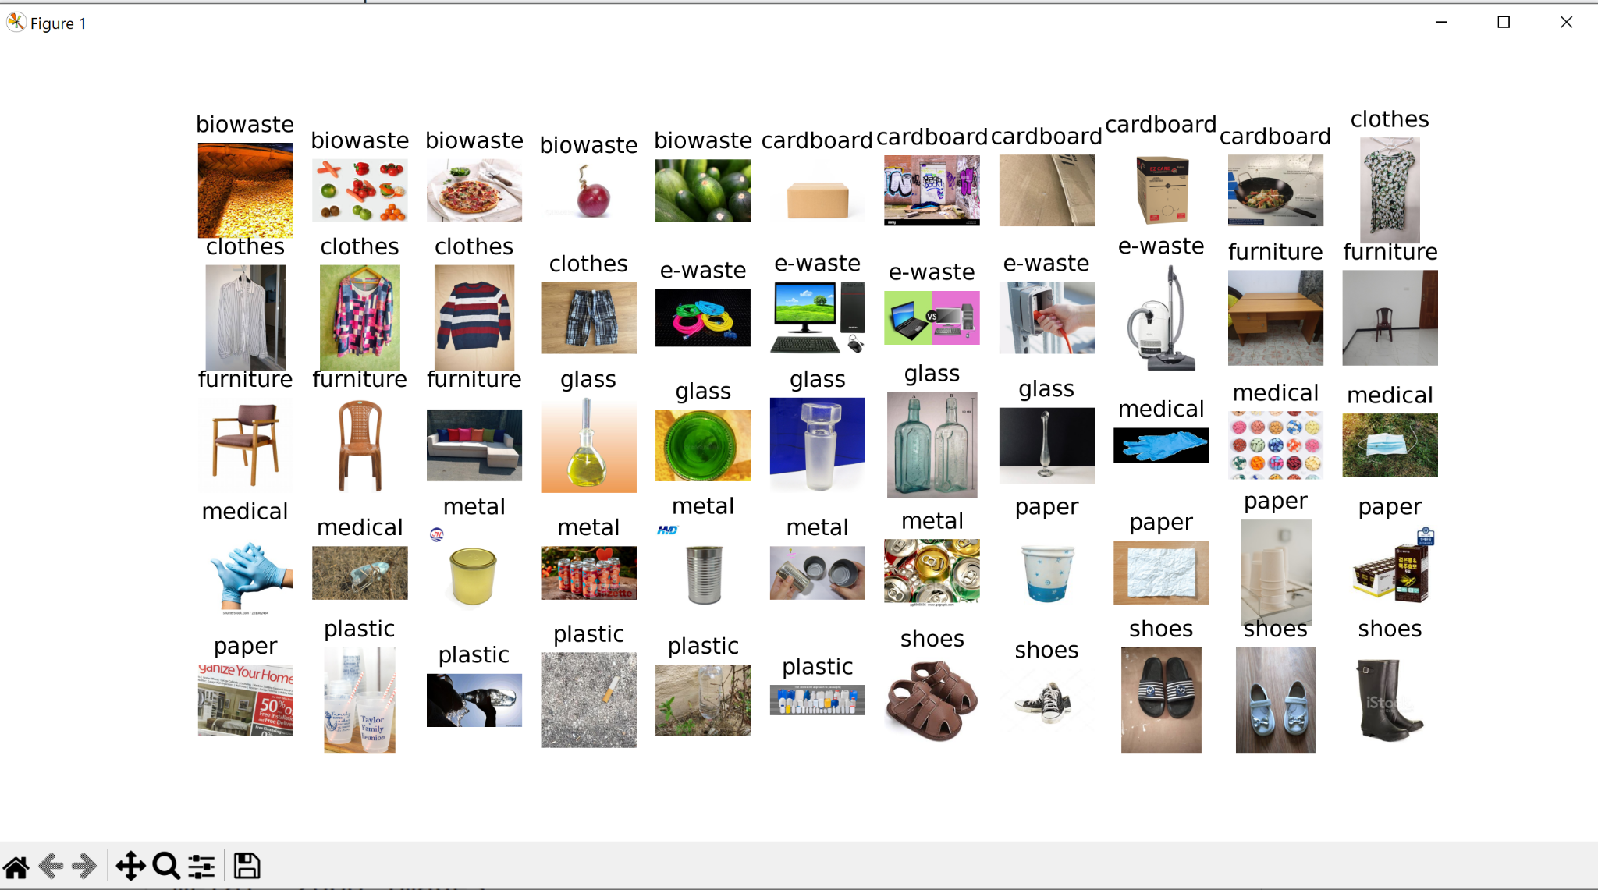

**Figure 32**

*Final Dataset Class Distribution*

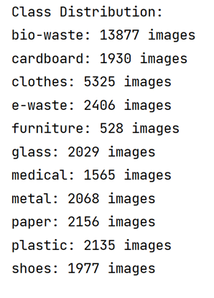

**Figure 33**

*Pictorial View of Class Distribution*

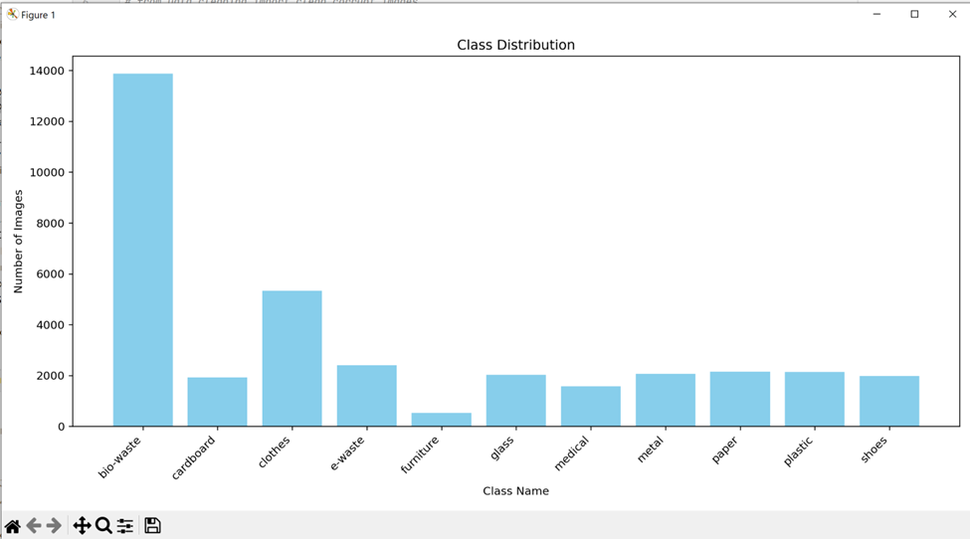

Figure 34 and Figure 35 shows the raw data image resolutions or dimensions in two dimensions and three dimensions respectively. Most of the height and width of the images 2000 and 1000 respectively.

**Figure 34**

*2D Distribution of Image Dimensions*

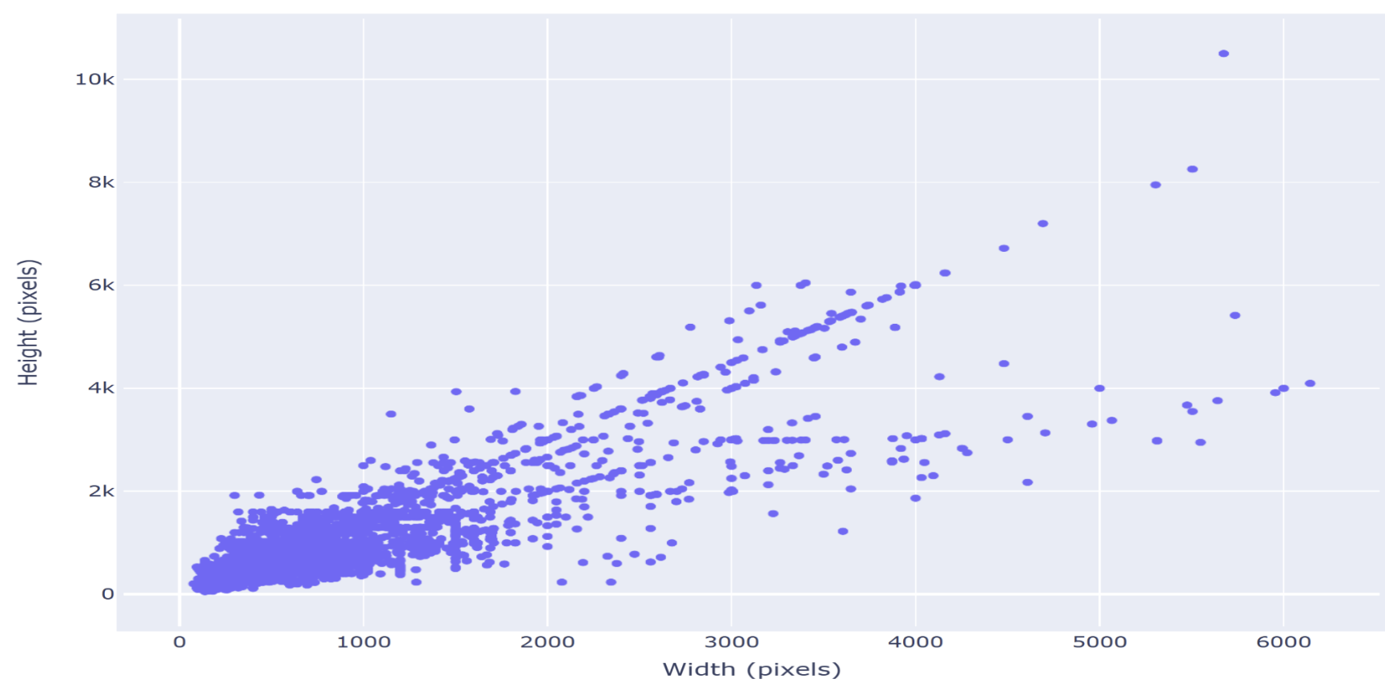

**Figure 35**

*3D Representation of Distribution of Image Dimensions*

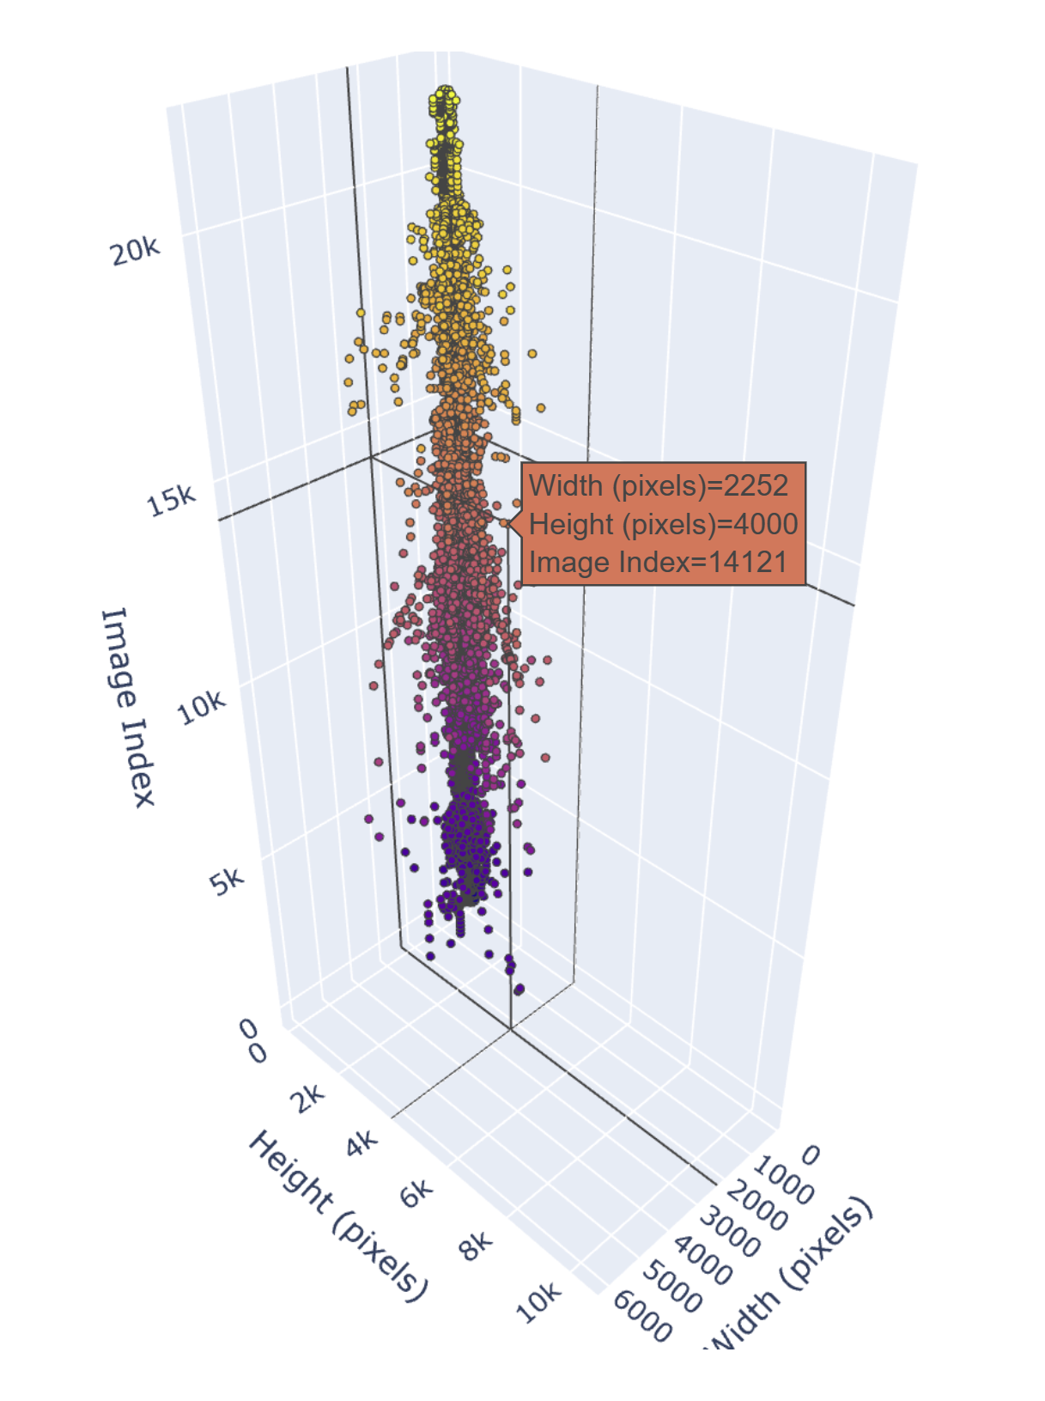

***Handling Corrupt Images***

The first step in preprocessing is removing any unnecessary files that cannot be used for modeling. The dataset is cleaned by removing all the files that have image type as None or files whose image type is not accepted by Tensorflow - ["bmp", "gif", "jpeg", "png"]. In order to do that, a script is run over each folder consisting of images belonging to a class, which checks for any corrupt images and moves them to a separate folder to manually analyze these files before deletion. This corrupt_images folder is later deleted. This is to get an idea of the number of corrupt files from the raw dataset before getting rid of them. The Figure 36 below shows which images were corrupted and moved to the ‘corrupt_image’ folder. Figure 37 shows the screenshot of those images. As can be seen, Plastic, paper, metal, glass, cardboard, e-waste, and medicine have many corrupt images, amounting to 1223.

**Figure 36**

*Output After Corrupt File Detection*

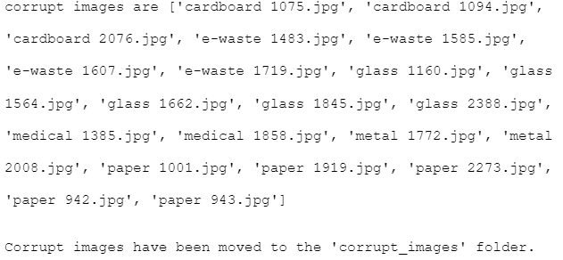

**Figure 37**

*Snapshot of Corrupt Images*

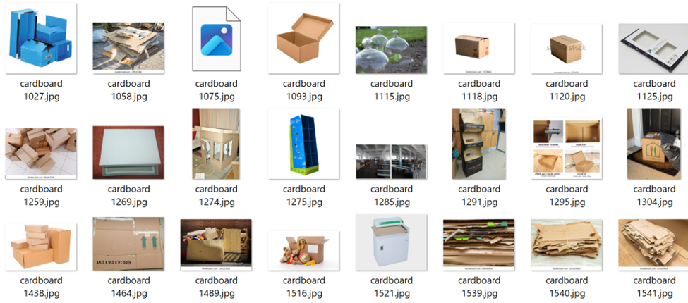

Figure 38 demonstrates that 1223 images were corrupt. As can be seen from the above output, the corrupted images were from cardboard, e-waste, glass, paper, medical, and metal classes.

**Figure 38**

*The Corrupt Image Count*

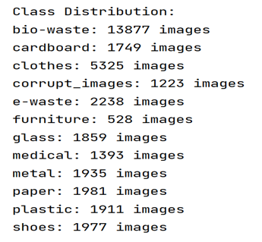

The intermediate folder created in order to store the corrupt images is shown in Figure 39 below.

**Figure 39**

*Corrupt Image Folder*

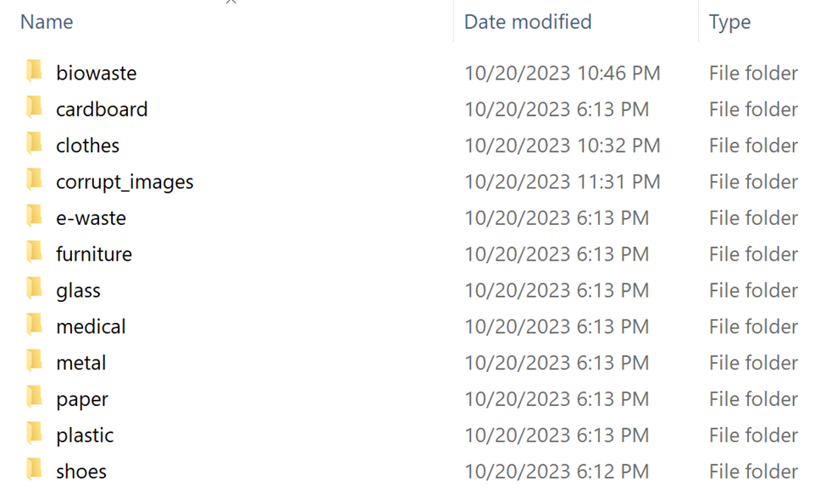

The class distribution of the updated set of folders, which represents the number of images per class, is represented in Figure 40. As observed, there are just 1223 corrupt images out of 35,975 images. After the analysis is done, this folder is discarded as seen in Figure 41.

**Figure 40**

*Corrupt Images Visualization*

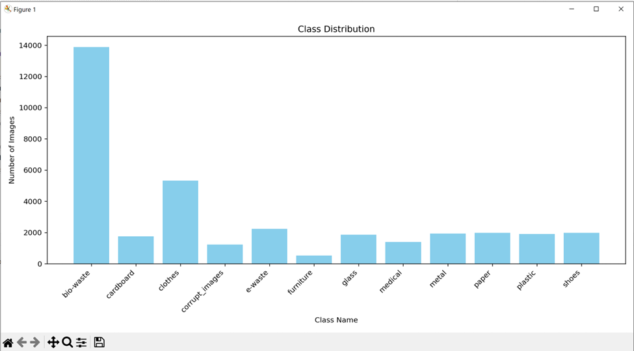

**Figure 41**

*Corrupt Image Folder Delete Output*

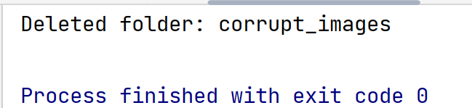

***Sample 2500 Images (Biowaste and Clothes)***

In the class distribution visualized in Figure 40, it is observed that some classes have more images than others. These classes are identified and images are sampled in order to get a better balanced dataset. Per class, 2500 images is chosen to be a good threshold to keep that can be used for the modeling phase. All the numbers of images per class hover around 2000-2100 but there are two classes that are more than 2500. Biowaste has 13877 images and Clothes has 5325 images. These classes are undersampled to get to 2500 images using random sampling and discarding extra images. For the purpose of this research, random sampling is conducted in order to get a smaller subset of images. This method is chosen over stratified, cluster or other types of sampling because of the nature of the data. For other classes where the number of images are less than 2500 threshold oversampling techniques will be applied later. Figure 42, shows the original size of the biowaste and clothes folder.

**Figure 42**

*Original Biowaste and Clothes Data Size*

|  |  |
| --- | --- |

Randomly sampled images are kept in intermediate folders to verify as shown in the screenshot of the output in Figure 43. Figure 44 shows the added sampled clothes and biowaste folders.

**Figure 43**

*Intermediate Folders Containing 2500 Samples*

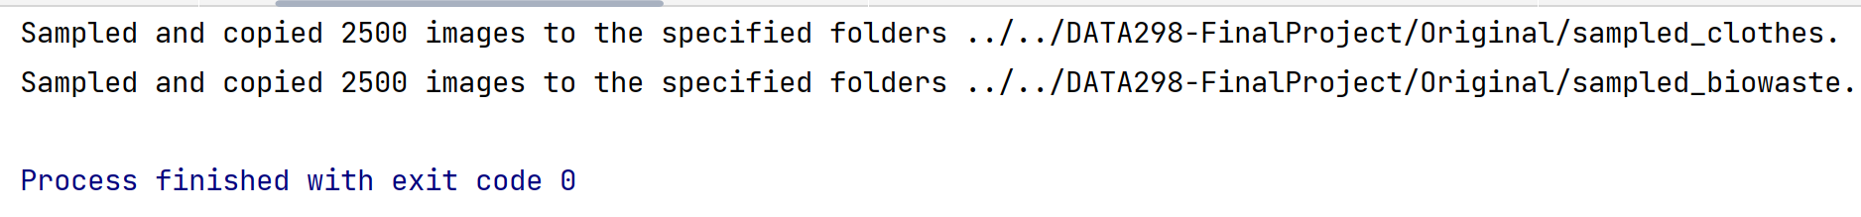

**Figure 44**

*Sampled Folder Distribution With Respect to Other Classes*

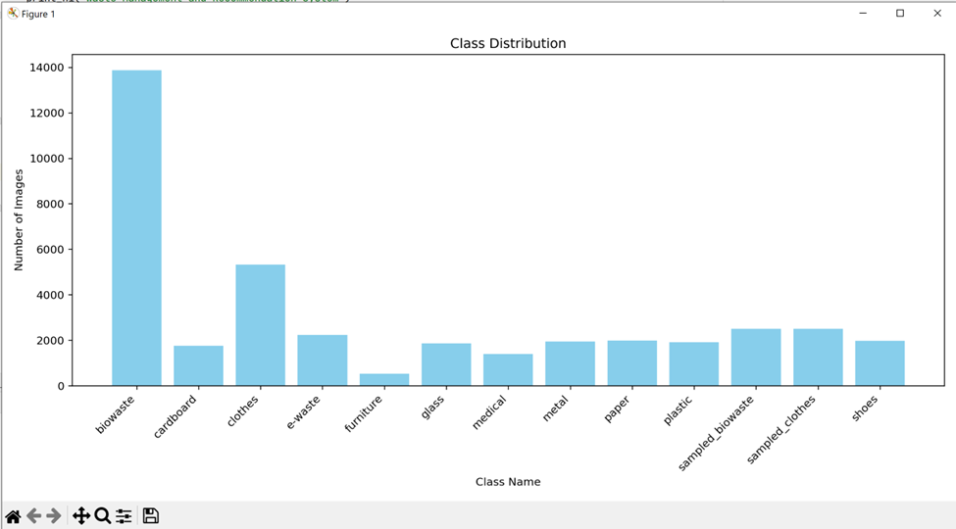

Original Clothes and Biowaste are deleted after sampling is done and the intermediate folders are renamed with the original folder names as shown in Figure 45. Figure 46 shows the class distribution after the earlier steps. Now classes look more balanced. Figure 47 shows the both class folder sizes after sampling.

**Figure 45**

*Original Folders deleted and Intermediate Folders Renamed*

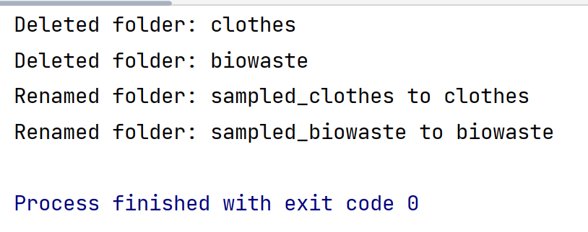

**Figure 46**

*Class Distribution After Undersampling of Two Classes*

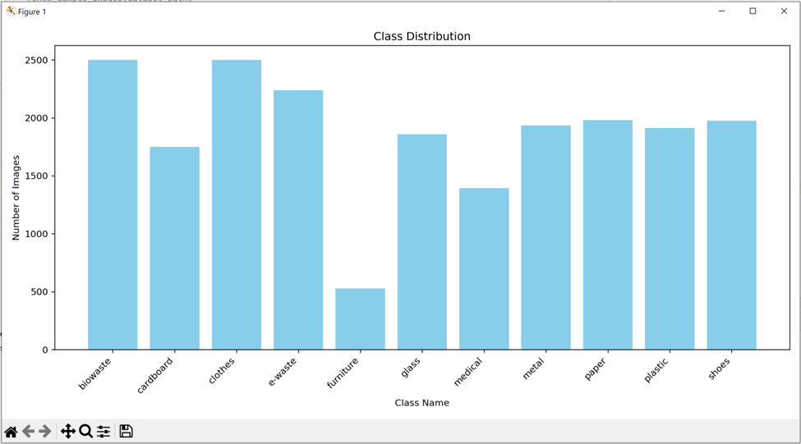

**Figure 47**

*Biowaste and Clothes Data Size After Sampling*

|  |  |
| --- | --- |

***Remove Images With Text***

Exploratory data analysis phase of the research gave some insights on how the data should be cleaned and preprocessed. One of the drawbacks identified from the raw dataset of biowaste was the pictures having text related to organic matter. This is mainly because the authors had scraped the web for images related to the word ‘organic’, which returned a few images that are not exactly useful for the purpose of object detection and classification. In order to remove these images before further preprocessing, a script is run that uses the pytesseract package in order to detect text in an image and remove any identified images. Figure 48 shows samples of some irrelevant images. The pytesseract package is applied to all the classes to find out if there are any other classes with irrelevant images containing texts. Table 8 shows three columns - first showing class distribution before applying the pytesseract package, second column showing the class distribution after removing images with texts, and the last column shows the distribution of text images per class.

**Figure 48**

*Few Samples of Irrelevant Text Images in Biowaste Class*

|  |  |
| --- | --- |
|  |  |

**Table 8**

*Distribution of Classes Before and After Text Removal*

| Output Before Text Removal | Cleaned Images | Images With Texts |
| --- | --- | --- |
|  |  |  |

After close inspection of all the images in the ‘images_with_text’ folder, it was noticed that except for biowaste all other classes’ images were relevant and the extracted texts were from cardboard boxes, metal containers, papers, clothes, etc. Those images need not be discarded but keeping these for modeling purposes would in fact enhance the diversity of data and performance of models. Therefore, only textual images from biowaste class were considered and deleted. Upon running this dataset on model later on some of the images were captured as in incorrect format by the model and hence had to be removed. The image header was read and the incorrect type was captured. The following images were removed as shown in figure 49 and the distribution is shown in figure 50 and visualized in Figure 51.

**Figure 49**

*Images With Corrupt Image Header*

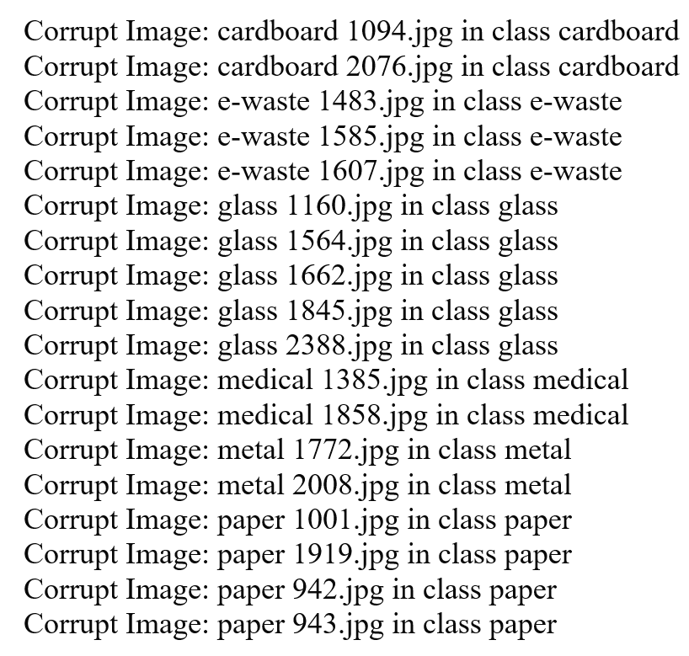

**Figure 50**

*Class distribution After Removing Text From Biowaste and Other Corrupt Images*

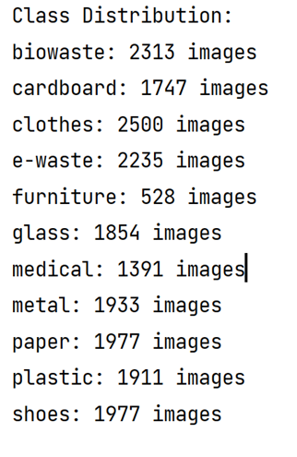

**Figure 51**

*Class Distribution Bar Chart*

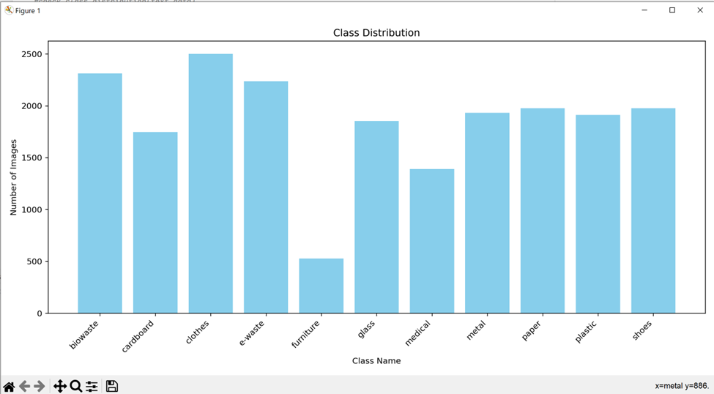

***Removing Duplicate Images***

The current Dataset has many images that are duplicates and need to be removed as it will not be an added help to the model performance. ImageHash package is used for identifying duplicates. This script compares photos using the perceptual hash (phash) from the imagehash library. Two photos are regarded as possible duplicates if they share the same phash value. Figure 52 shows the Output in the terminal showcasing the sets of Duplicate Images. Figure 53 shows few samples of the duplicate images from cardboard and glass classes. Figure 54 shows duplicate samples from paper and shoes classes.

**Figure 52**

*Duplicate Images Sets*

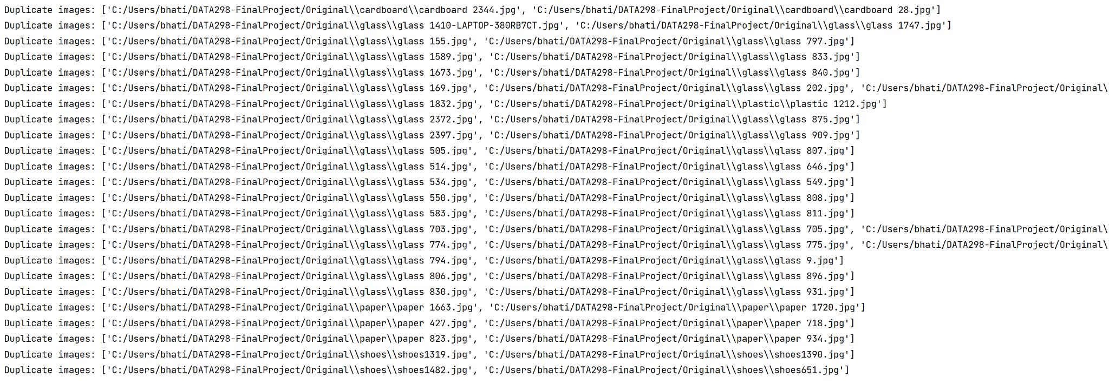

**Figure 53**

*Few Samples of Duplicate Images From Cardboard, Glass, and Paper Class*

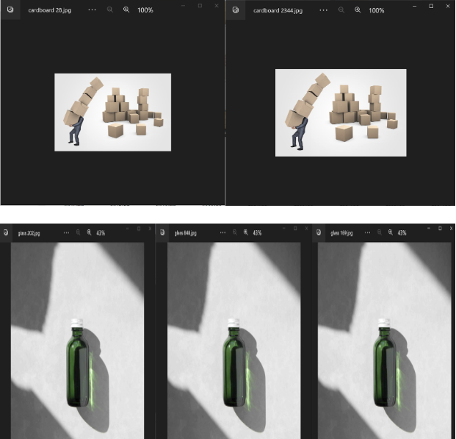

**Figure 54**

*Few Samples of Duplicate Images From Paper and Shoes Class*

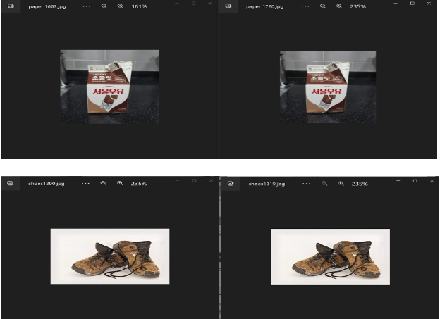

The distribution of classes after removing duplicates is shown in Figure 55 and the bar chart shown in Figure 56.

**Figure 55**

*Before with Duplicates and After Removing Duplicates*

| **Before With Duplicates** | **After Removing Duplicates** |
| --- | --- |
|  |  |

**Figure 56**

*Bar Chart After Removing Duplicates*

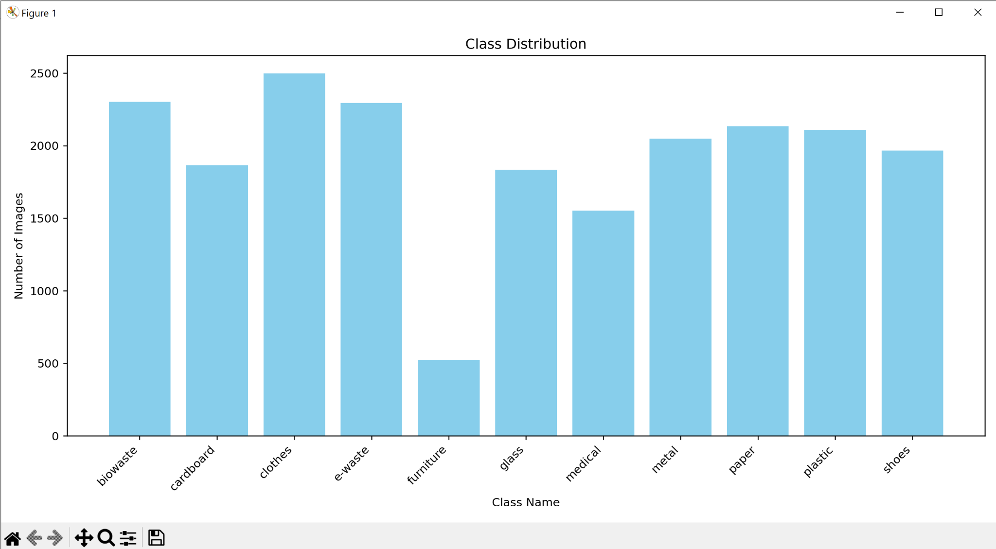

**Data Transformation**

***Normalizing and Scaling images***

Normalization is an important step before the data is utilized by the model. It helps with consistency, prevents model bias, and facilitates faster convergence. Figure 57 shows the statistics of each class before normalization is applied. For normalizing, the following steps are done. Each image in the dataset is converted to the common RGB format if it has an alpha channel, which denotes transparency. To keep the dataset's three-channel format constant throughout, this conversion is necessary. Each image is cropped to a 416x416 target resolution. This is the high resolution accepted amongst the models that are planned to use so in order to maintain resolution in the highest quality possible for each of the models. The Image.BOX filter is used for the resizing, which modifies the image's dimensions by applying a Box sampling technique. The image's original pixel values, which ranged from 0 to 255, are adjusted to fit inside the [0, 1] range. Initial scaling was done as 416x416 but later it was changed according to the requirements of different models employed. For Xception and InceptionResnetv2, images were scaled to 299x299. Resnet50 and Mobilenetv2 accepted 224x224 as input images. The input image size for YOLOv8 was 640x640.By doing this, picture data is guaranteed to scale consistently, a crucial preprocessing step for many machine learning applications that promotes more seamless model training and convergence. After normalization, the statistics per class can be seen in Figure 58. It also validates that even after scaling the size of height, width, and pixel values, the mean distribution and standard deviation per class remains same and no data is lost. Figure 59 shows the 3D representation of the resized images.

**Figure 57**

*Data Statistics Before Normalization*

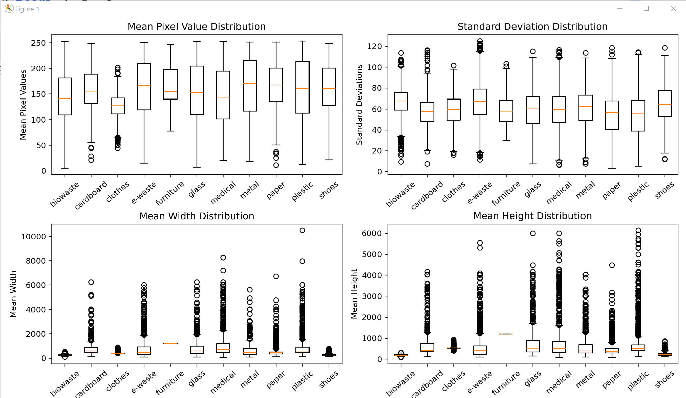

**Figure 58**

*Class Statistics After Normalization*

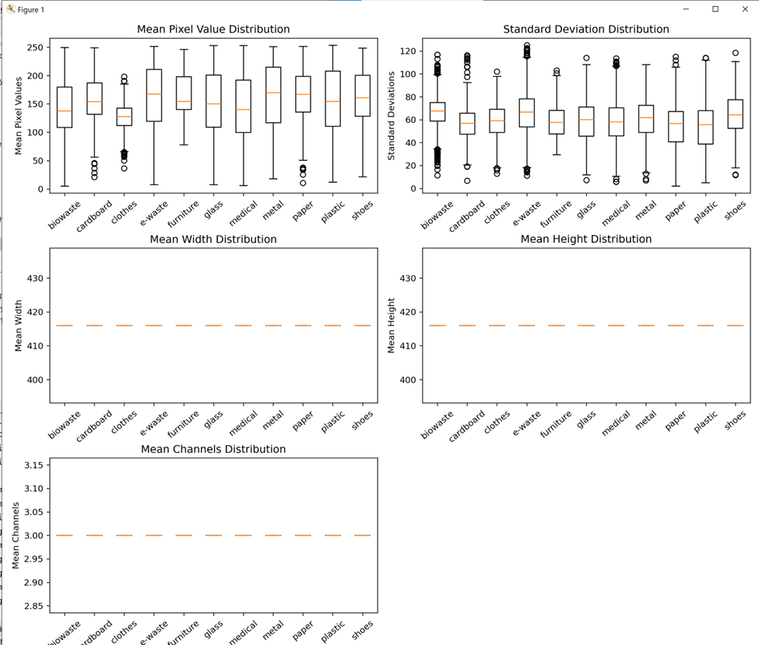

**Figure 59**

*3D Visualization After Resizing*

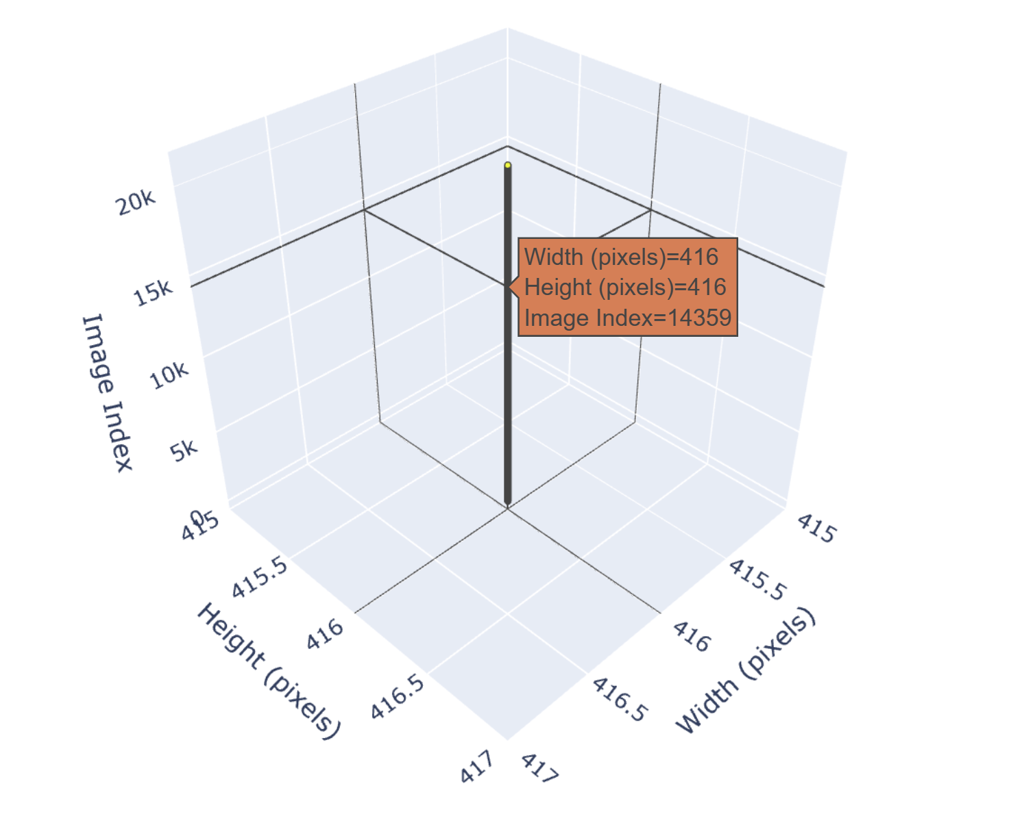

***Annotating Images***

For data annotations, a state-of-the-art model for object detection, Grounding Dino, was used. Grounding Dino combines the capabilities of grounding along with DINO, a transformer-based model initially developed for Natural Language Processing tasks but later used in computer vision tasks owing to its impeccable effectiveness. In the framework of DINO, grounding describes the model's capacity to connect (or "ground") abstract ideas or textual descriptions with concrete visual elements or objects in the images (S. Liu et al., 2023). Grounding Dino is a model with two encoders and a single decoder. DINO’s self-attention mechanism focuses on different parts of the image to associate the context and relationships between different objects within the image and link or ground specific visual features with abstract concepts. Considering the global context or the entire scenery of the image and not just the local features, the model can detect objects even in cluttered environments. It is a powerful zero-shot detector that can detect unknown objects or categories utilizing human language without having to train on those categories, relying on the understanding from relationships between the seen and the unseen data classes through the usage of semantic embeddings that allow model to bridge the gap between training classes and unseen classes. The model has an image backbone to extract visual features from the input images and text backbone to process input texts to extract semantic features. These features pass through the neck, which is the feature enhancer that enhances and aligns features from text and image backbones and make them compatible for fusion. The enhanced features are passed through a query selection module that utilizes the semantic embeddings from the text backbone to generate initial queries for the transformer decoder. To direct the model's attention to the pertinent regions in the image, these queries are made to be specific to the ideas addressed in the text. Cross-Modality Decoder is used for refinement of the box predictions around the detected objects leveraging both textual and visual features. Transformer Decoder has a cross-attention mechanism in which the language-guided module's initialized queries engage with the fused text-image features. The position, size, and class of the bounding boxes are iteratively improved during this process to precisely match the text's descriptions of the objects (Zhang et al., 2022b).

Figure 60 shows the overall model of Grounding Dino (S. Liu et al., 2023).

Grounding Dino was very effective in detecting objects from all the classes by giving relevant prompts according to each of the 11 classes. Figure 61 shows some of the detections using Grounding Dino. The labels generated were stored in the YOLOv8 format. Although Grounding Dino detected objects in more than 1200 images of each class, the e-waste class had the maximum number of missing detections. Out of 2500 e-waste images, it could detect only 91 images. Therefore, to mitigate the bias in the detection model, e-waste images in the dataset were manually labeled using CVAT tool.

**Figure 60**

*Overall Grounding Dino Framework*

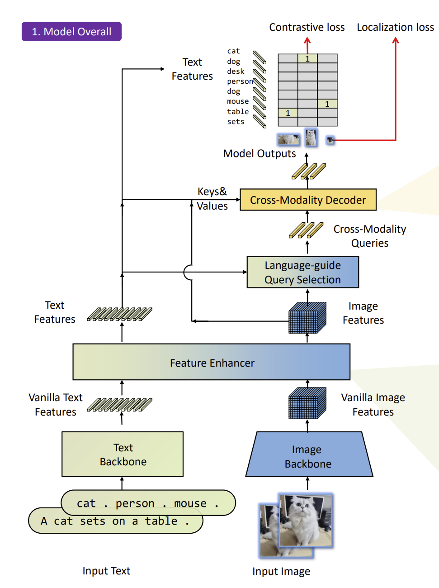

**Figure 61**

*Metal and Cardboard class detections by Grounding Dino*

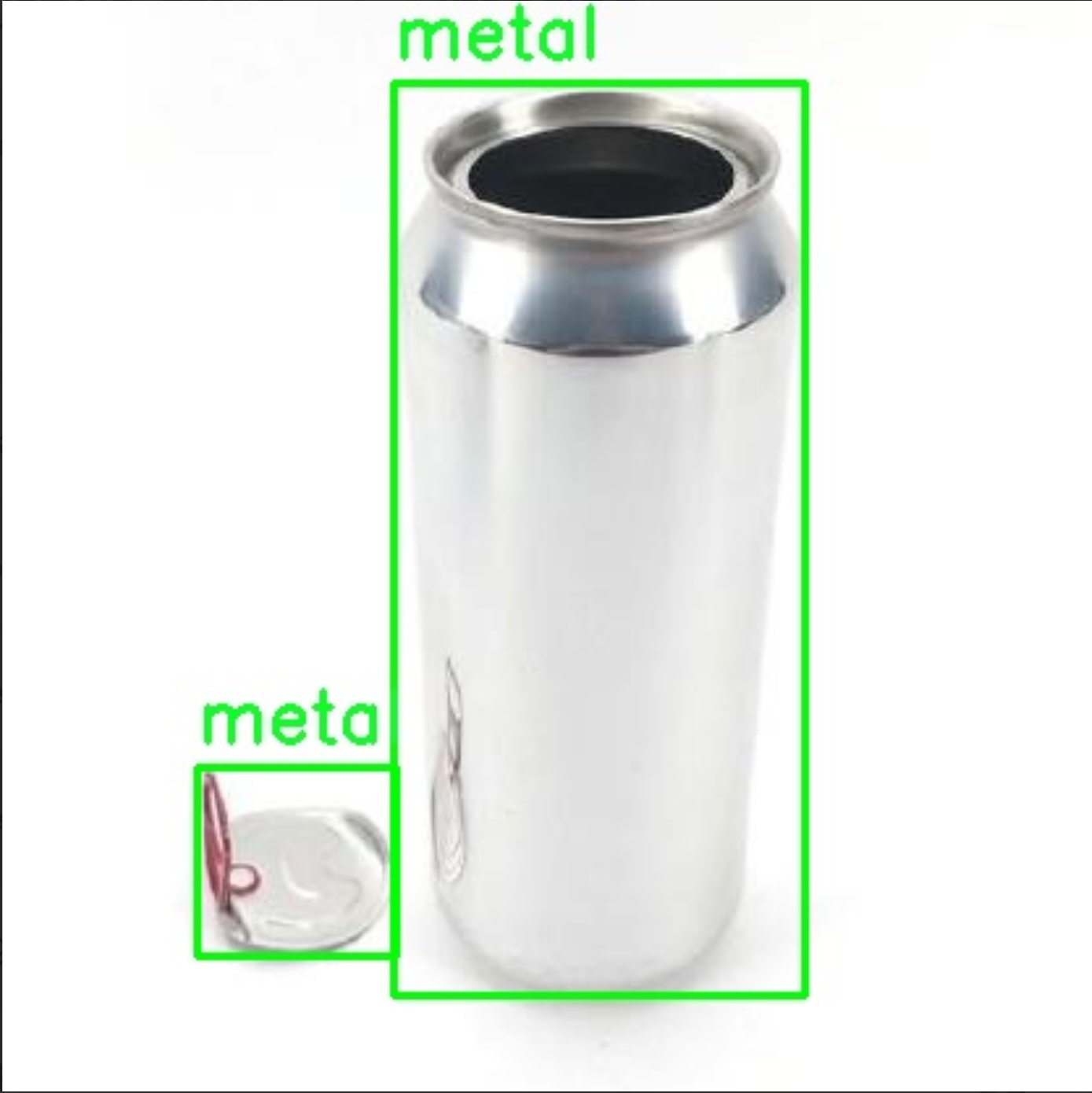 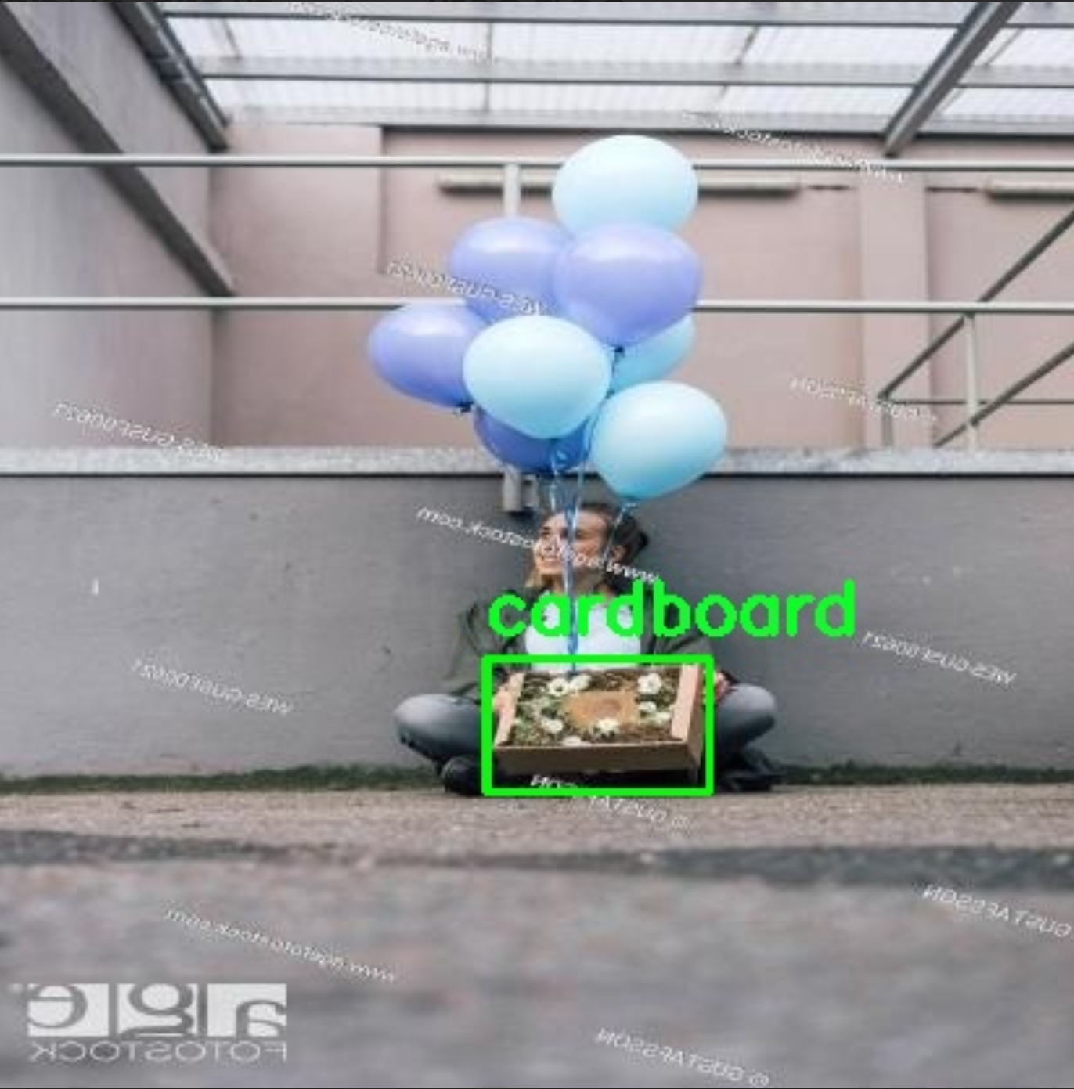

CVAT is an open data annotation platform which allows multiple members of a team or organization to divide annotation tasks of a particular set of images. For the purpose of this research, each member of the team received an equal number of images to annotate. Both tag annotation which classifies an entire image as belonging to a particular label, and bounding boxes for objects in an image were created. The former is used for image classification while the latter helps in object detection. The nature of the models that will be used in this research were taken into consideration before coming up with a plan on how to annotate the images for optimum use in each model. To first do the proof of concept, it is decided to start with the annotation of 100 images per class to generate ground truth for the dataset which is crucial for supervised learning. The dataset was subsampled for 100 images per class, a total of 1100 images for annotations to be done. Few examples of annotations are shown in Figure 62, 63, 64. Here, the individual boxes inside the image represent the manual bounding boxes created and the tag on the left top corner is the label assigned to the image itself.

**Figure 62**

*Label Annotations for Medical, Paper, and Plastic*

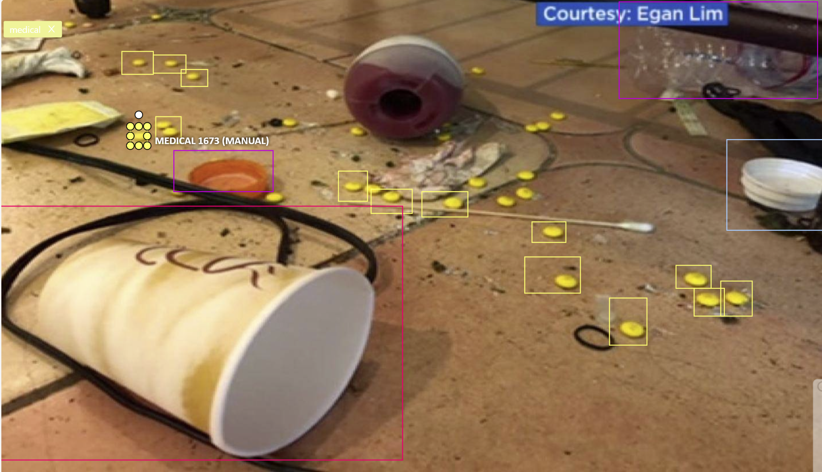

**Figure 63**

*Label Annotation for Metal Class*

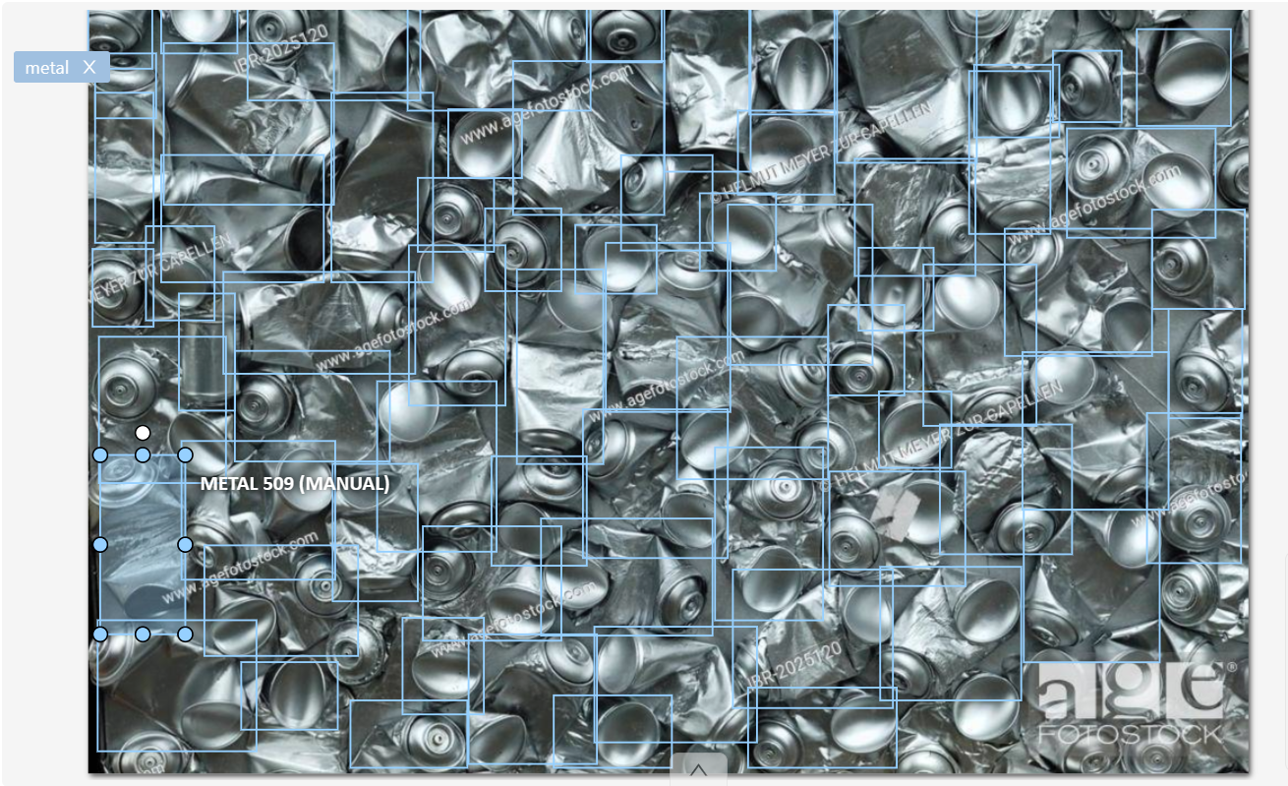

**Figure 64**

*Label Annotations for Medical Waste*

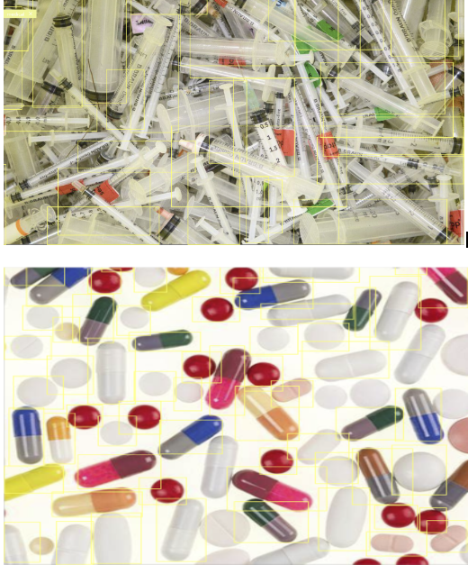

Once the annotations are complete, they are exported in the required format for each pre-trained model based on what kind of input data is accepted. Some of the formats that CVAT allows the data to be exported in, is shown in Figure 65. For this research, there are two proposed annotations format - first one is ‘CVAT for images 1.1’, that is applicable for all the models and is in the XML format and the second annotations format is ‘YOLO 1.1’ ,as shown in Figure 66, that is applicable to the YOLOv8 model and is present in the .txt format.

**Figure 65**

*Exporting Annotation Formats*

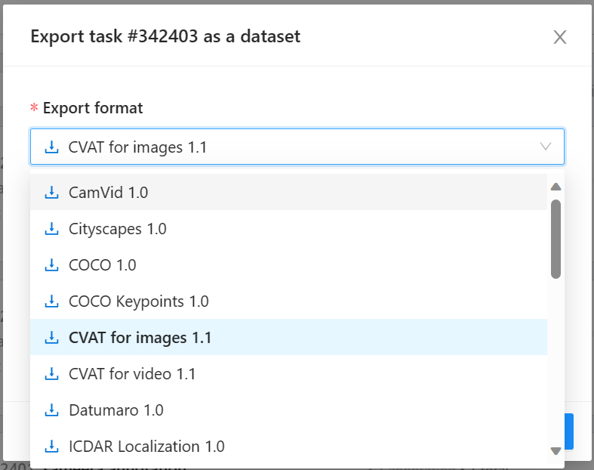

**Figure 66**

*Exportation of Annotations in YOLO 1.1 Format*

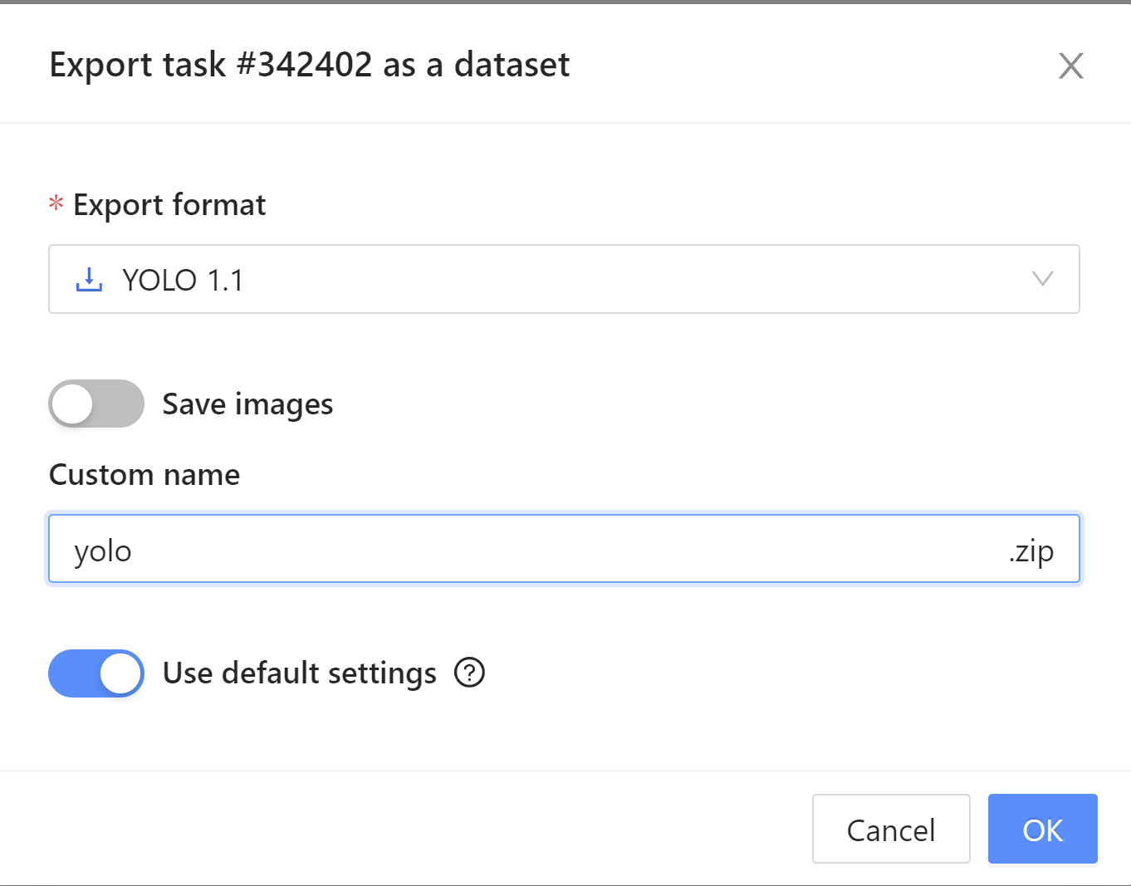

***Data Augmentation***

After all the images are cleaned, preprocessed, and normalized, it needs to be made sure that every class has an equal number of images in order to avoid class imbalance. As the target number of images per class is decided to be 2500 by the research team, data augmentation is performed in order to increase the number of images to make sure no class has more than 2500 images. Some of the methods used for augmentation are: flip, rotate, blur and resize. The important step for data augmentation is that it is done on training data. So, the train, validation and test splits are to be performed before data augmentation can be applied on the training set. Figure 67 shows the normalized data that has been split into train, validation, and test folders using 80% training data, 10% validation data, and 10% test data. Table 9 shows the class distribution after train, validation, and test splits.

**Figure 67**



**Table 9**

*Train, Validation, and Test Class Distributions*

| **Train Class Distribution** | **Validation Class Distribution** | **Test Class Distribution** |
| --- | --- | --- |
|  |  |  |

Data Augmentation is done on the training data and an intermediate ‘augmentedData’ folder is created to put those many images that are required for the particular category as shown in Figure 68. For example, if biowaste has 1842 images, to make it to 2500, 658 images are generated in the augmentedData folder. Figure 69 shows the class distribution of the intermediate augmentedData folder.

**Figure 68**

*Intermediate Augmented Data Folder Creation*

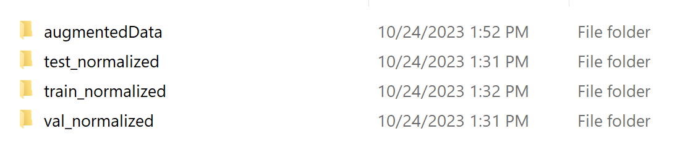

**Figure 69**

*Class Distribution of Augmented Data*

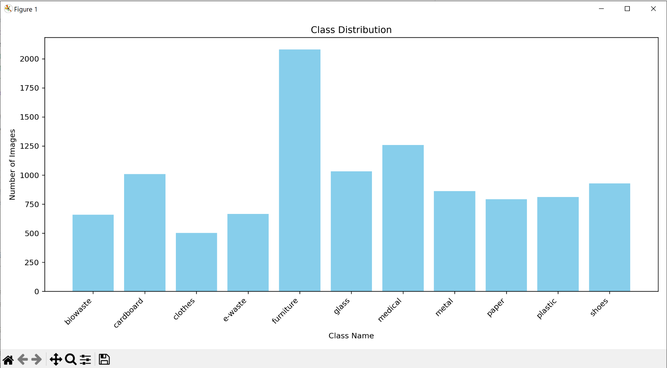

As seen in Figure 70, the augmentedData folder after moving the data to the training set is deleted. The training data after augmentation has 2500 images in each category as shown in Table 10. Figure 71 shows the class distribution of the training dataset after data augmentation.

**Figure 70**

*Output Of Augmented Data Merging With Training Data*

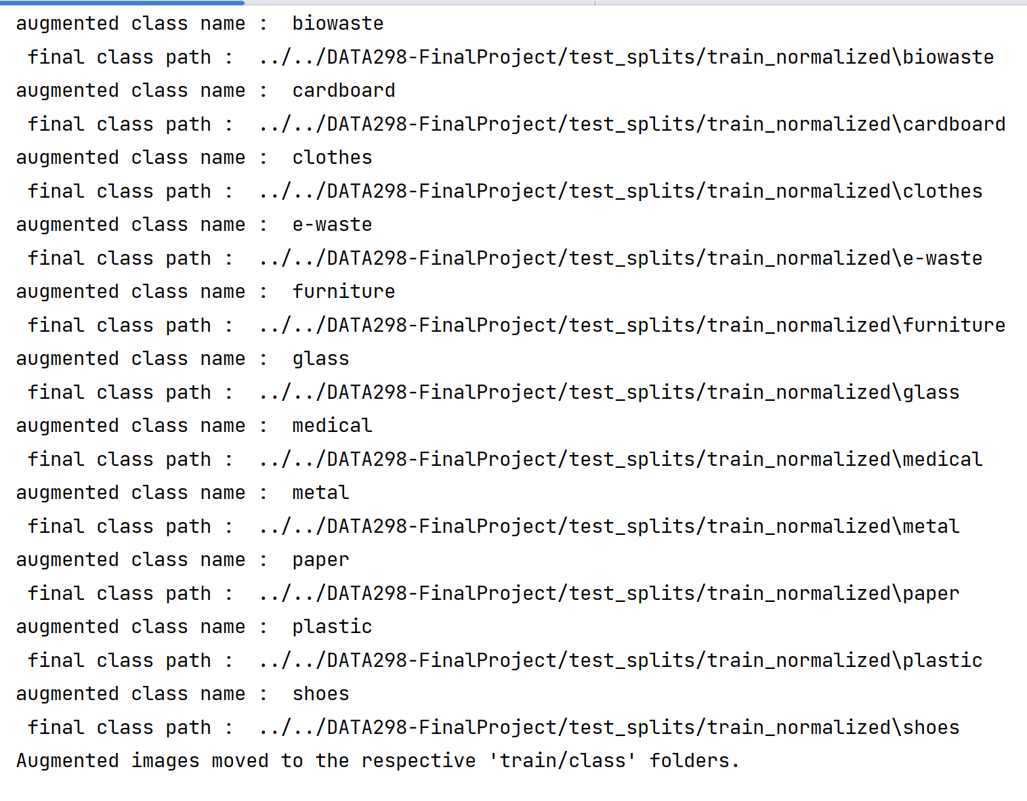

**Table 10**

*Class Distribution Before Augmentation and After Augmentation*

| **Training Data Before Augmentation** | **Training Data After Augmentation** |
| --- | --- |
|  |  |

**Figure 71**

*Train Class Distribution After Data Augmentation*

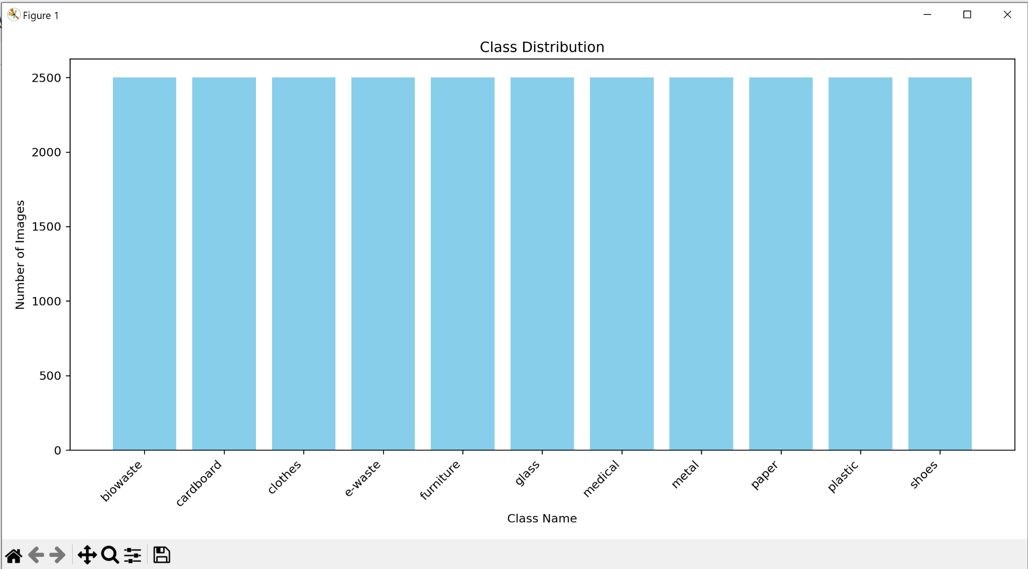

**Data Preparation**

This research requires 31,730 images to be manually annotated which is a highly laborious task and will require time and effort from the team in order to get started with the modeling phase of the project. Random sampling is used to divide the dataset with the same reasoning as mentioned in the data pre-processing phase of the research and the plan from previous experience of working with image data, is to divide the dataset into the following proportions.

***Training Data***

The training dataset is used to train the machine learning model. It's the primary dataset on which the model learns patterns, relationships, and structures and provides the foundational knowledge to the model. Without it, the model wouldn't have any data to learn from. A substantial portion of the available data, in this research 80% is allocated to this dataset to give the model ample information to learn from. A total of 27500 images across all categories are assigned training tasks. Augmentation has been applied to the training data and each of 11 classes have 2500 images amounting to 27500 images in total.

***Validation Data***

Once the model is trained,it needs to tune and optimize its parameters to ensure it's not just memorizing the training data (overfitting) or being too generalized (underfitting). The validation dataset serves this purpose. It's used to evaluate the model during the training process, allowing for adjustments and fine-tuning. Without a validation dataset, there is a risk of tuning the model solely based on the training data. This could lead to a model that performs excellently on training data but poorly in real-world scenarios. The validation set acts as a 'practice exam' for the model before the final test. 10% of the processed data will be set aside for validation. The validation set has 1994 images across all 11 categories. This data set has an uneven number of images in each class as augmentation is not applied to this set.

***Test Data***

After training and validating, the model's final evaluation is performed on the test dataset. This dataset is kept entirely separate from the previous stages and provides a final, unbiased performance metric. It's like the 'final exam' for the model. The test dataset offers an impartial assessment of the model's capabilities on unseen data. Without it, it wouldn't be clear how the model might perform in real-world scenarios, away from the data it was trained on. It also provides the test accuracy of the model on unseen data which gives an insight into the model’s performance. Like the validation dataset, 10% of the data is kept aside for testing. The testing set has 2001 images across all the categories. Similar to the validation dataset, this dataset also has an uneven number of images in each class as data augmentation is not applied to this test dataset.

Table 11 shows the number of images in each class across training, validation, and test sets.

**Table 11**

*Class Distribution of Train, Validation, and Test Set*

| **Train Dataset** | **Validation Dataset** | **Test Dataset** |
| --- | --- | --- |
|  |  |  |

**Data Statistics**

The raw dataset samples have undergone a lot of changes that are logged in this section of the report. The statistics of the data after each step is discussed and the following table contains details related to this. Four sources of data are used for the purpose of this project and integrated in order to get a consolidated dataset with classes required based on the problem statement. The statistics of each of the source dataset is represented in table 12.

Once the categories that will be extracted from the sources are identified, the images go through rigorous preprocessing in order to have consistency across the dataset. After the data exploration plan is created and steps to clean and preprocess the data are identified, the raw data is first checked for any corrupt files and these are removed as they are not usable for the modeling phase and would either lead to errors in the script, or skew the prediction results. Once the corrupt images are eradicated, the class distribution of categories having more than 2500 images are undersampled. The data exploration phase shows that maximum classes have a distribution between 1800 - 2500 images. Using these statistics, 2500 is chosen as the number of images per class that will be used for the modeling phase. Once done, images with text are identified in each of the classes. Selected display of samples of images from each class during the data exploration phase showed that there are few images especially in the biowaste category that have text related to organic matter and are not useful for image classification or object detection. In order to handle these images, the pytessearct package is used to identify images with text and deleted post identification.

Another very important step in cleaning image data is to get rid of duplicate images. Image duplication plays an important role as some models assign weights to classified images and error in misclassification is used as a metric to refine the model performance. Duplicate images could skew this error either to give higher accuracy results, or lower accuracy results both misrepresenting the actual performance of the model. In order to not have bias in the results, the duplicate images are removed. The class distribution of images after pre-processing is also shown in the table below. Next, move is to transform images which includes first normalizing and scaling the data. The details on how it was conducted are mentioned in the Data Transformation section of the report. Next the team manually annotated the data for each class. It is a supervised learning project and based on the models used, both tag annotations and bounding boxes are created. Post annotation, the images per class will be augmented in order to get the same class distribution across categories.

After the images are consistent across classes, they will be split based on the proportions decided by the team for training, validation and testing. The number of images per class is mentioned in table 12.

**Table 12**

*Statistics of Data at Every Stage*

| **Stage** | **Methods** | **Statistics of Dataset and Classes** |
| --- | --- | --- |
| Raw data |  | Garbage Classification Dataset: 15,515 Files, 238 MB  Trashbox Dataset: 28,564 Files, 4.24 GB  Waste Classification Dataset: 24,708 Files, 210 MB  Furniture Dataset: 692 Files, 53.5 MB |
| Pre-processing data | Corrupt Images handled  Undersampling of classes with more than 2500 images  Images with text handled (biowaste class)  Duplicate images handled | Class Distribution:  biowaste: 2303 images  cardboard: 1692 images  clothes: 2499 images  e-waste: 2137 images  furniture: 525 images  glass: 1685 images  medical: 1382 images  metal: 1914 images  paper: 1962 images  plastic: 1887 images  shoes: 1967 images |
| Data Transformation | Normalizing and Scaling  Data Annotation  Data Augmentation | Class Distribution of Augmented Training:  biowaste: 2500 images  cardboard: 2500 images  clothes: 2500 images  e-waste: 2500 images  furniture: 2500 images  glass: 2500 images  medical: 2500 images  metal: 2500 images  paper: 2500 images  plastic: 2500 images  shoes: 2500 images |
| Data Preparation | For Training | Total number of images: 27500 images |
|  | For Testing | Total number of images: 2001 images |
|  | For Validation | Total number of images: 1994 images |

***Image Statistics***

Figure 72 shows the distribution of image size. Most of the images are 15000 to 25000 MB in size. There are few images which are very large in size. It may be due to higher resolution of the images.

**Figure 72**

*Distribution of Image Size*

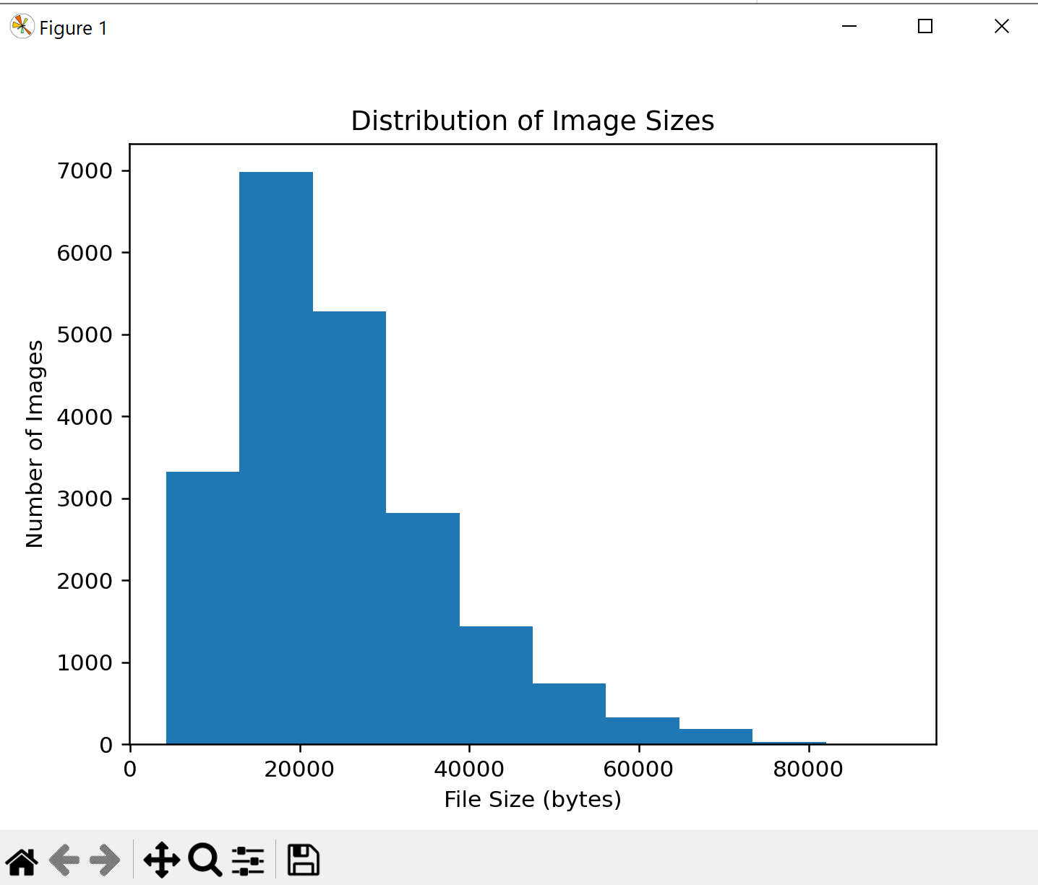

Figure 73, Figure 74, and Figure 75 shows the class distribution of Training dataset, Validation Dataset, and Test Dataset.

**Figure 73**

*Bar Chart of Train Split Distribution*



**Figure 74**

*Bar Chart of Validation Class Distribution*

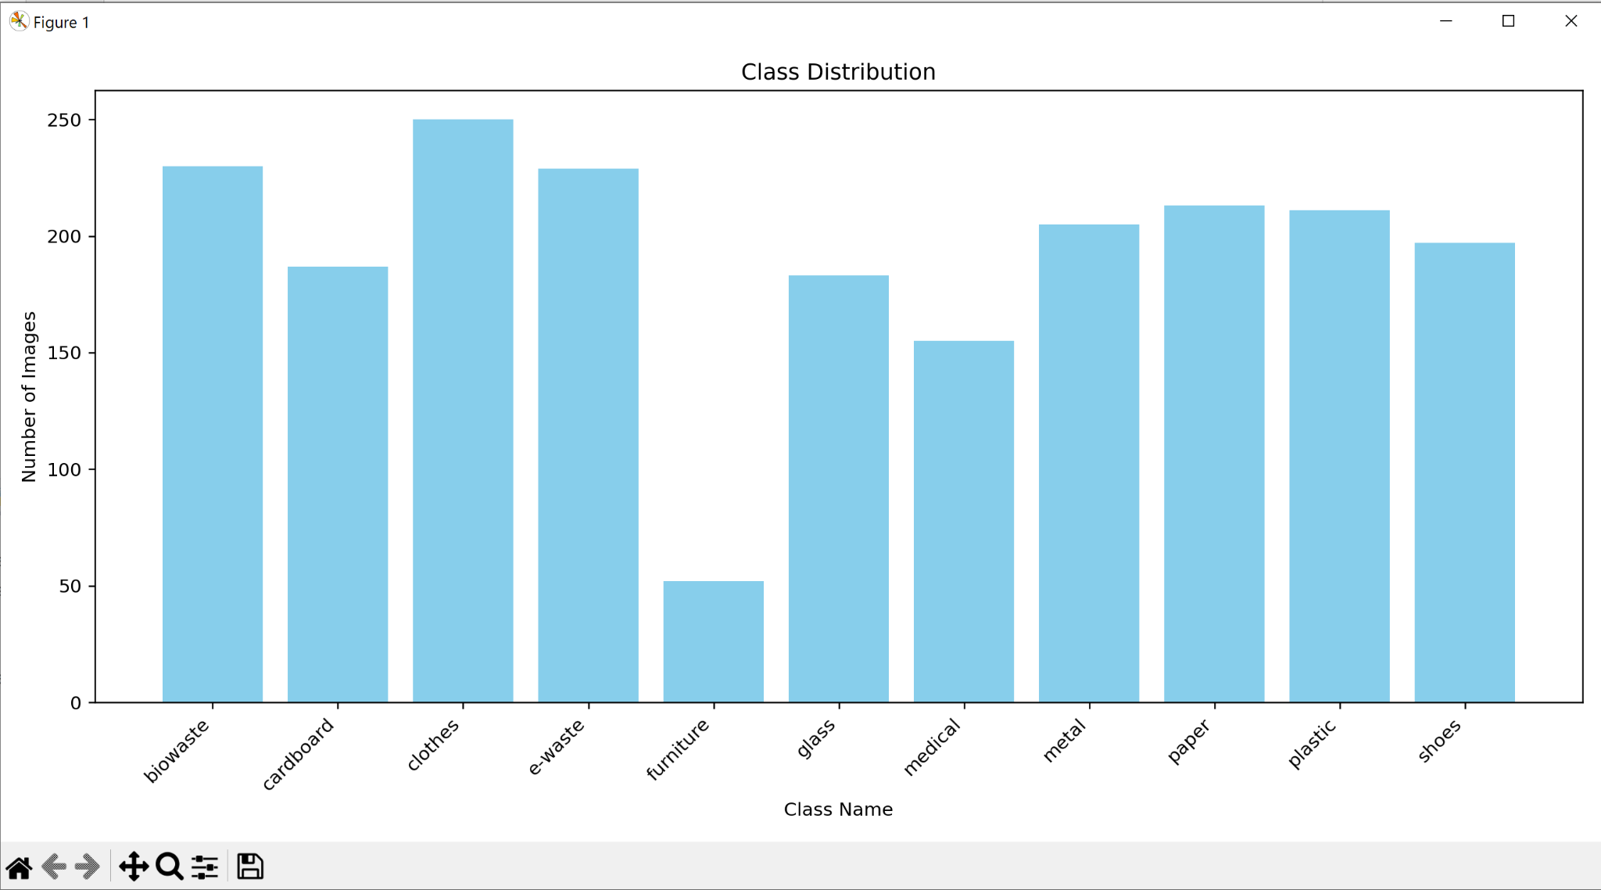

**Figure 75**

*Bar Chart of Test Class Distribution*

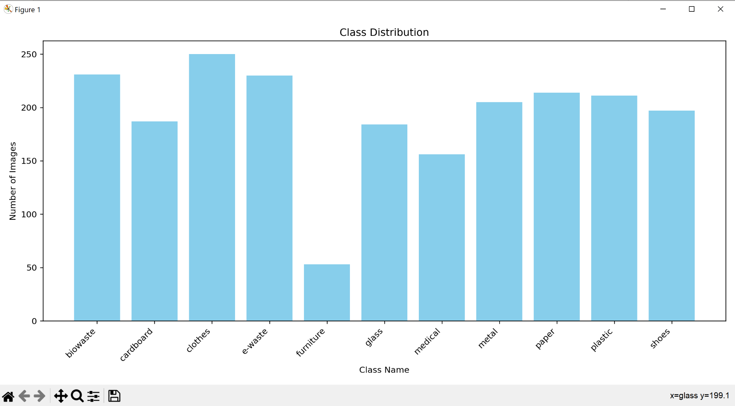

Figure 76, Figure 77, and Figure 78 shows the image samples from Training, Validation, and Test Set.

**Figure 76**

*Final Train Samples*

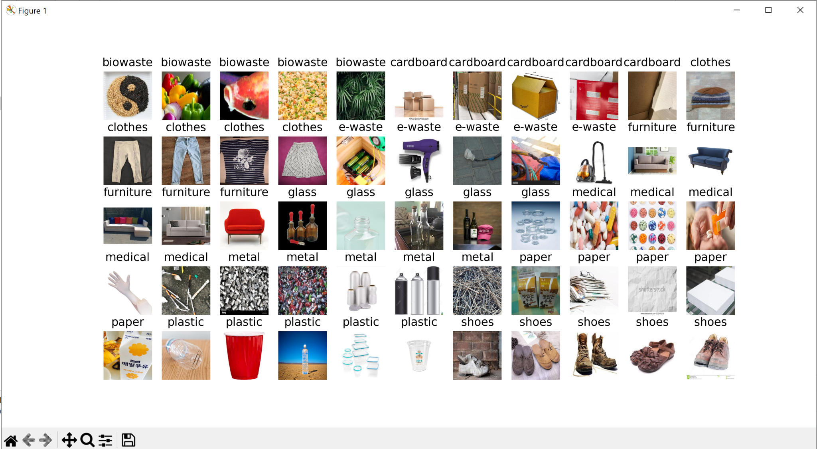

**Figure 77**

*Final Validation Samples*

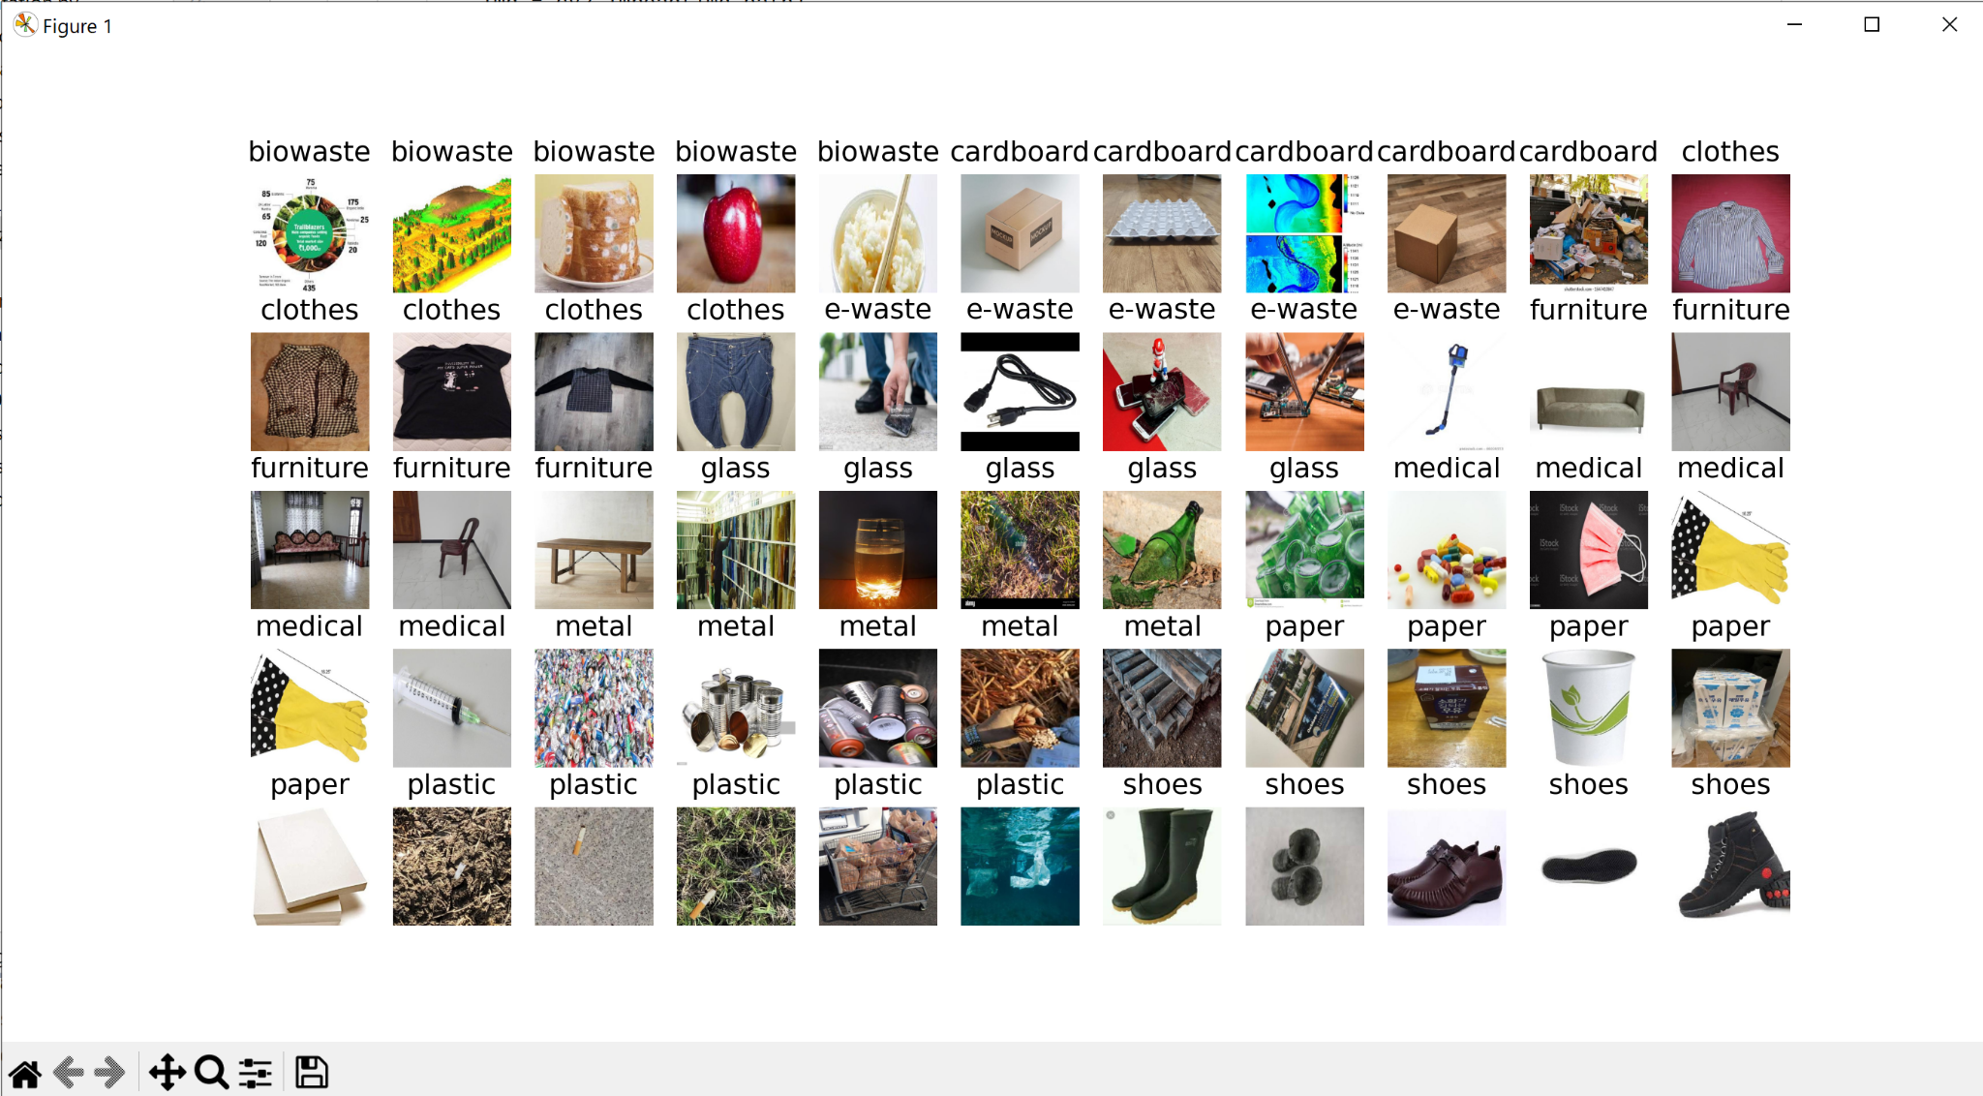

**Figure 78**

*Final Test Samples*

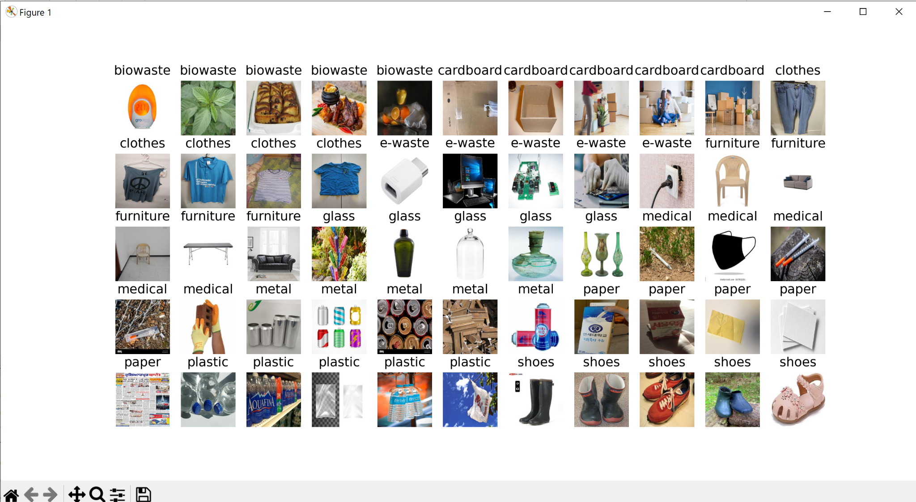

**Modeling**

**Model Proposals**

The Models chosen for this project are InceptionResNetv2, MobileNetv2, Xception, ResNet50 (Residual Network with 50 Layers), and YOLOv8 (You Look Only Once version 8). These models have been proven to be effective and have given consistent results with respect to image classification.

***MobileNetV2***

The advent of neural networks has catalyzed significant advancements in machine learning, particularly for image recognition tasks. While the pursuit of accuracy often leads to complex and computationally intensive models, MobileNetV2 emerges as a groundbreaking architecture, specifically designed for mobile and embedded devices. This model, presented in the paper by Sandler et al. (2018), achieves a fine balance between computational efficiency and accuracy, marking a notable advancement in computer vision models tailored for mobile applications. The primary innovation of MobileNetV2 lies in its unique layer module, the inverted residual with a linear bottleneck, which efficiently processes low-dimensional compressed representations.

The development of MobileNetV2 was influenced by preceding breakthroughs in deep neural architecture optimization for balancing accuracy and performance. From early architectures such as AlexNet, VGGNet, GoogLeNet, and ResNet, this evolution has advanced through a range of techniques such as connectivity learning, network pruning, and algorithmic architectural exploration, which includes genetic algorithms and hyperparameter optimization (Sandler et al., 2018). MobileNetV2 builds upon these developments, particularly by learning from its predecessor, MobileNetV1, while incorporating enhancements that significantly boost accuracy in mobile applications.

**Depthwise Separable Convolutions.** A core component of MobileNetV2 is the use of depth wise separable convolutions. This method significantly lowers computational cost without sacrificing performance efficacy. It divides a regular convolution into a depthwise convolution and a pointwise convolution. The model utilizes 3x3 depthwise separable convolutions, leading to an 8 to 9 times reduction in computational cost compared to standard convolutions (Sandler et al., 2018).

**Linear Bottlenecks.** The concept of linear bottlenecks is another cornerstone of MobileNetV2. It operates on the premise that neural network activations form low-dimensional manifolds that can be embedded in low-dimensional subspaces. By using linear transformations, MobileNetV2 captures these manifolds, reducing dimensionality and maintaining information integrity, especially in the presence of non-linear transformations like ReLU (Sandler et al., 2018).

**Inverted Residuals.** MobileNetV2 introduces the inverted residual structure, where shortcuts are connected between the bottlenecks. Compared to conventional residual connections, which connect layers with increasing channel numbers, this architecture is different. The inverted residuals not only improve gradient propagation but also enhance memory efficiency, a critical aspect for mobile and embedded applications (Sandler et al., 2018).

**Model Architecture.** The MobileNetV2 architecture comprises an initial convolution layer followed by 19 residual bottleneck layers. These layers use ReLU6 non-linearities and are structured with a constant expansion rate throughout the network. Because of the architecture's introduced scalability, various performance needs can be met by adjusting the width multipliers and input image resolution. The network's efficiency is highlighted by its low computational cost and parameter usage, adaptable to various resolutions and multiplier settings (Sandler et al., 2018). The model architecture along with a comparison of existing models as presented in the paper have been referenced in Figure 79.

**Figure 79**

*Comparison of Other Model Architectures with MobileNetV2*

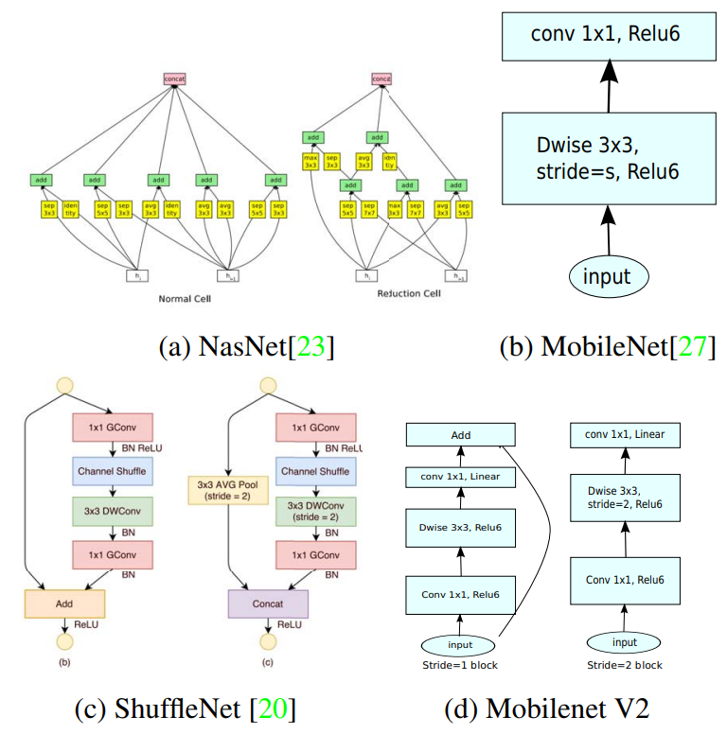

*Note.* Source: ( Sandler et al., 2018)

A notable feature of MobileNetV2 is its memory-efficient inference capability. This efficiency is achieved through the model's structure, which minimizes the need for storing large intermediate tensors, thereby reducing main memory access. Such design considerations are particularly beneficial for embedded systems with limited memory resources (Sandler et al., 2018).

**Experiments and Applications.** MobileNetV2 demonstrates its prowess through various experiments, including ImageNet classification, object detection using SSD and SSDLite, and semantic segmentation with DeepLabv3. These experiments showcase the model's capability in achieving high accuracy with significantly fewer parameters and lower computational complexity compared to other architectures (Sandler et al., 2018).

The model show a critical step forward in designing neural networks for mobile and resource-constrained environments. It’s efficient architecture, characterized by depthwise separable convolutions, linear bottlenecks, and inverted residuals, sets a new standard for performance and efficiency in mobile vision applications.

***ResNet-50***

Deep Convolutional Neural Networks (CNNs) have significantly influenced image classification, with network depth being a pivotal factor. However, training deeper networks often leads to the vanishing/exploding gradient problem. ResNet-50 emerged as an innovative response to these challenges, employing a residual learning framework to facilitate the training of networks far deeper than those previously feasible.

ResNet-50, a 50-layer deep network, addresses the prevalent challenges in training deeper neural networks. Its novel residual learning framework effectively combats the degradation problem, a critical hindrance in prior architectures. Research by He (2016) aims to unpack the structural nuances and operational principles of ResNet-50, underlining its efficacy in image recognition tasks.

**Core Principle.** ResNet-50 revolutionizes the approach to deep network architecture by adopting a residual learning framework. This framework shifts from learning direct mappings to learning residual functions relative to layer inputs, a key distinction from traditional methods.

**Building Blocks.** A novel construction element called ResNet-50 is introduced. It is made up of shortcut connections that omit one or more levels. As seen in Figure 80, these connections carry out identity mapping by adding their outputs to the stacked layer outputs.

**Figure 80**

*Building Blocks*

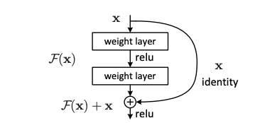

*Note*. Source: (He, 2016)

**Structural Design.** The design of ResNet-50 adheres to specific guidelines: maintaining the same number of filters for layers with identical output sizes and doubling the filters while reducing the feature map size by half. This structural blueprint is compared with a 34-layer plain network in Figure 81.

**Figure 81**

*Examples of Network Architectures With Different Number of Layers*

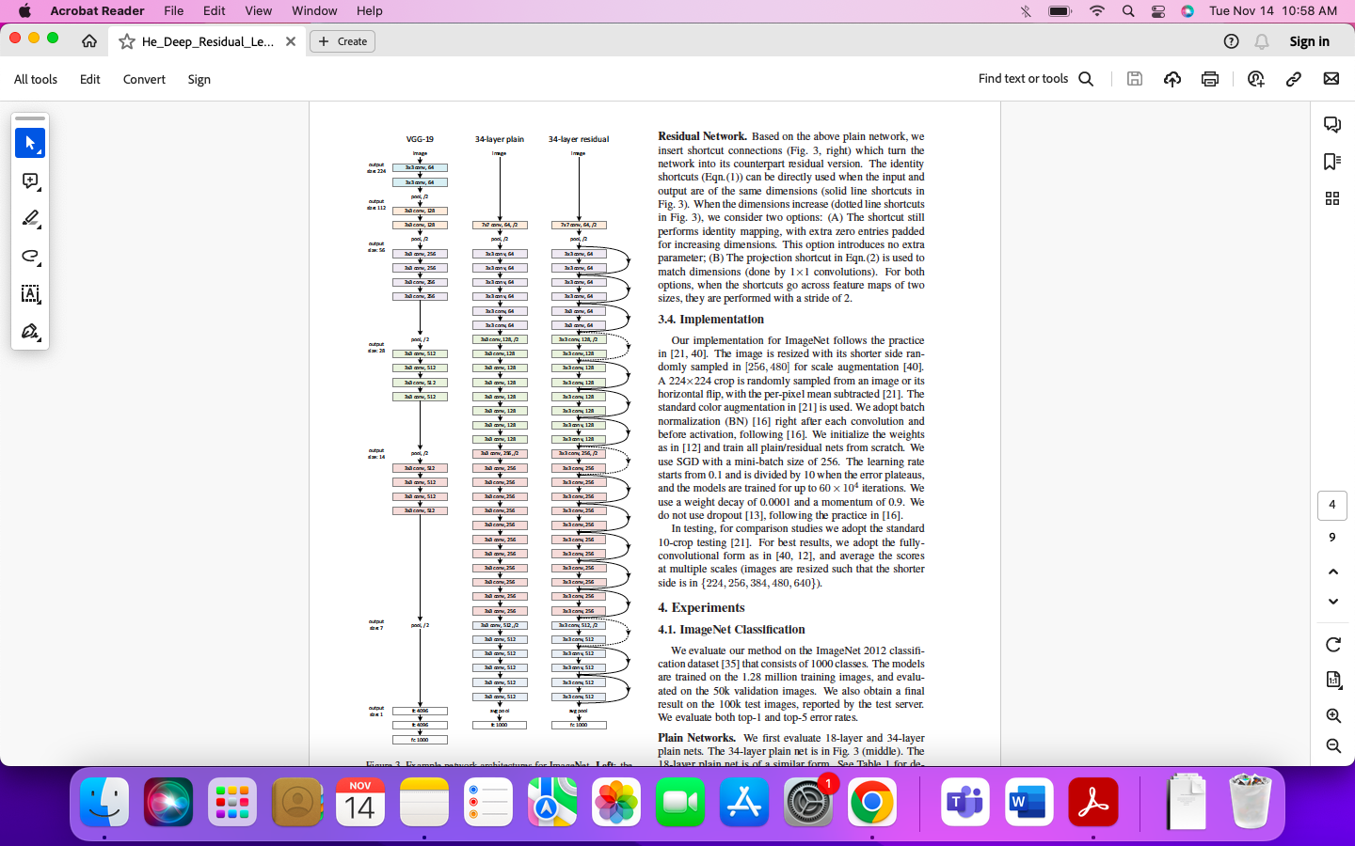

*Note*. Source: (He, 2016)

**Identity Mapping and Dimension Matching.** In scenarios where the dimensions of input x and the function F(x) differ, ResNet-50 employs projection shortcuts, typically via 1x1 convolutions, for dimension matching, while maintaining identity mapping wherever possible.

**Addressing Degradation Problem.** At the heart of ResNet-50's design is the solution to the degradation problem—where deeper networks perform worse than shallower ones. ResNet-50's residual blocks facilitate the learning of identity mappings, thereby mitigating this issue.

***Xception***

The Xception model represents a noteworthy advancement in deep learning, specifically designed to capture intricate hierarchical features in images. Unlike traditional convolutional neural network architectures, Xception utilizes depth wise separable convolutions, contributing to its efficiency and effectiveness in image recognition tasks. The model, proposed by François Chollet, draws inspiration from the inception module but distinguishes itself by separating spatial and channel-wise information. This architectural approach significantly reduces the number of parameters while preserving expressive power, allowing Xception to achieve a remarkable balance between accuracy and computational efficiency. Xception's capability to capture fine-grained details and intricate patterns makes it well-suited for challenging image classification tasks. Its success in the ImageNet Large Scale Visual Recognition Challenge, where it outperformed traditional architectures, underscores its suitability for a diverse range of computer vision applications. (Chollet, 2017)

**Hierarchical Feature Extraction.** Xception's ability to extract hierarchical characteristics from photos stems from its foundational idea of depth wise separable convolutions. The model must be able to identify minute details and patterns in various garbage kinds in order to classify waste images. The architecture of Xception is ideal for this purpose because of its capacity to extract hierarchical features in an effective manner. The many textures, forms, and sizes of garbage photos may be captured in an effective manner with the use of Xception's hierarchical feature extraction. (Wu et al., 2022)

**Transfer Learning.** Xception can make use of the knowledge gathered from a variety of objects and scenes because it was trained on ImageNet. Because the model can inherit features from ImageNet pre-training related to generic object recognition, textures, and forms, this is advantageous for classifying rubbish images. Because garbage in the HGI-30 dataset is diverse, it could resemble different items in ImageNet, which is why transfer learning is very useful. (Wu et al., 2022)

**Model Architecture.** A major development in convolutional neural networks specifically designed for image classification tasks is the Xception architecture. The three main sections of this architecture are the entering flow, the middle flow (which is repeated eight times), and the exit flow, as shown in Figure 82. Interestingly, batch normalization comes after every convolution and separable convolution layer in these flows. Xception stands out for using depthwise separable convolutions throughout, where each separable convolution layer has a depth multiplier of 1, signifying no depth expansion. This design decision maintains expressive strength while improving computing efficiency. Each module has residual connections that surround it, making it easier to train deeper networks. Skip connections and global average pooling also help to achieve a balance between the complexity of the model and its accuracy. (Chollet, 2017)

**Figure 82**

Architecture of Xception

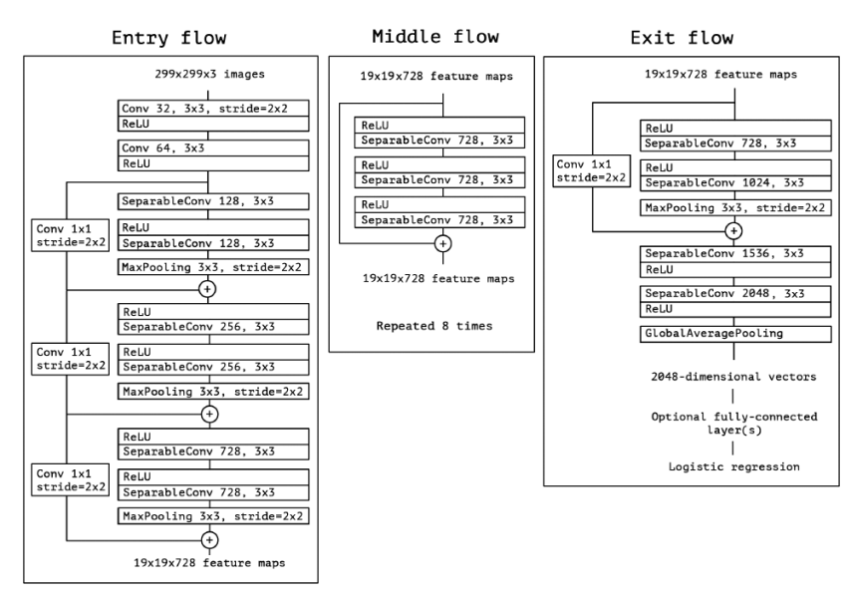

*Note:* Source: Chollet (2017)

***InceptionResNetv2***

**Literature Survey.** Zhao et al. (2021) addressed the problem of detecting domestic garbage in complicated multi-scenarios. The dataset was created by capturing pictures using a Nikon camera from various places such as grass, dormitory, and pavement. The authors proposed Skip-YOLO for detecting garbage that focuses on similar features. To retrieve high-dimensional feature maps, this model combined multi-feature fusion using the YOLOv3 method and dense blocks. First, by enhancing the shallow information in images, the large-size convolution kernel expanded the field of reception of the model. Secondly, dense convolutional blocks extracted the high-dimensional feature mappings of junk. Encouraging the exchange of deep high semantics and shallow low semantics information increased the sensitivity of comparable characteristics in the identical type of garbage. To anticipate the kind and location of waste, the multiple-scale high-dimensional feature mappings were finally merged and transmitted to the YOLO layer. Results stated that there was a 22.5% increase in overall detection precision and an 18.6% rise in average recall rate when compared to the YOLOv3. It effectively identified household trash in intricate multi-scenes when compared qualitatively. Furthermore, their method mitigates the issue of deeper residual block overfitting resulting in more generalized performance of the model.

Ghatkamble et al. (2022) realized that an integral component of waste management is hand-picking, or the human division of waste into its various components. In order to expedite the process, an automated garbage classification system was suggested in their work. They developed a novel approach that utilizes image processing techniques, the diagnosis of waste management images. The proposed method was trained, adjusted, and tested using the YOLOv5 public waste management dataset. They also proposed the concept for the adoption of an architectural design for a garbage can that was smart and comprised numerous sensors and a microprocessor. The proposed system took advantage of Bluetooth connectivity and the Internet of items to monitor items. The dataset they used was majorly Trashnet along with other datasets. Nine categories with 17,073 images were used for identification. Results are shown in Figure 84. YOLO performed the best with around 98.30% accuracy. Future work included expanding the amount of trash categories that the new deep-learning algorithm could be used to categorize.

Alfatmi et al. (2023) developed a system that an electronic waste recycling company could use to encourage its clients to properly recycle their e-waste and increase client understanding for each disposal in order to address the issue of e-waste recycling. They developed an Android application that leveraged You Only Look Once version 7 in order to detect the type of trash. Three separate steps comprised the complex back-end process: the Image Detection Model, the Object Analysis Model, and the Component Analysis Model. The first step,

**Figure 83**

*Results of different models on 80% training and 20% Test set*

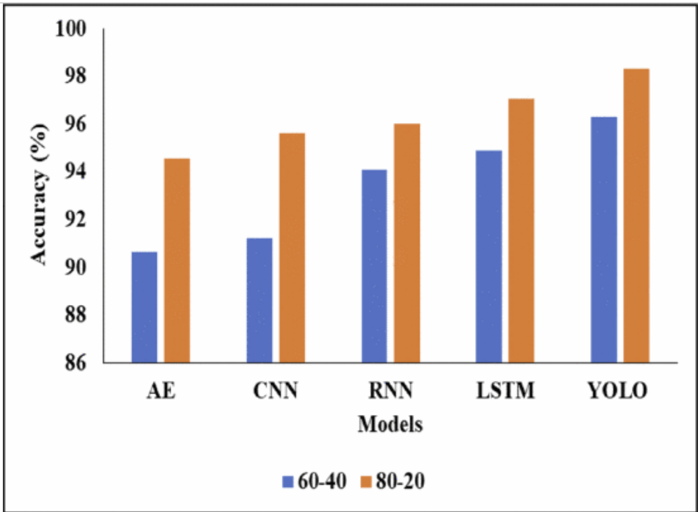

*Note.* Ghatkamble et al. (2022)

The Image Detection Model, used the powerful Yolo Algorithm to identify the kind of equipment the user has uploaded, such as a laptop, a smartphone, or a keyboard. A more thorough grasp of the electronic trash being disposed of was made possible by the second stage, the Object Analysis Model, which digs deeper into the specifics of the discovered equipment and provides more information like the brand and model. The device's components were examined in the third and final stage by the Component Analysis Model, which compared each one to a reliable dataset to determine whether parts were recyclable and non-recyclable. The numerical results were not discussed in the paper. Their system focused on application development to dispose of electronic waste. They concluded that their electronic waste recycling system offered a waste management strategy that is economically feasible, environmentally responsible, and sustainable.

De Carolis et al. (2020) emphasized on the abandoned trash that is scattered in public city areas or on highways in the countryside or suburbs. Their work focused on creating software that could analyze live video streams in order to identify and report on the existence of abandoned rubbish. They used Google images and LabelImg for annotating the data. A refined YOLOv3 network model was utilized for the purpose of garbage identification and classification. They performed Data Augmentation and hyperparameter tuning. They experimented with different learning rates. The results had a problem of too many bounding boxes for the same object. They merged all the bounding boxes if they belonged to the same class. The average Precision was 68%, Average Recall was 69%, and mAP@50 was 59.7%. Future goals consisted of increasing the dataset with more images and more classes to be able to detect on different devices.

**Figure 84**

*Comparison Between all the Models using only TrashNet*

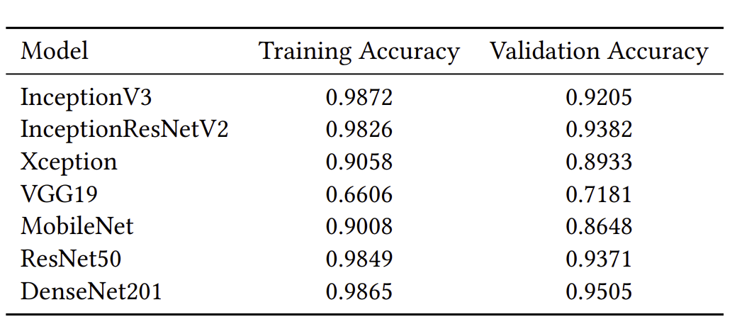

*Note*. Poudel and Poudyal (2022)

Poudel and Poudyal (2022) worked on the classification of trash using several pre-trained models. They used Standford’s TrashNet Dataset consisting of six classes. The CNN models trained and fine-tuned by them were VGG19, MobileNet, InceptionV3, InceptionResNetV2, DenseNet201, ResNet50, and Xception. Figure 83 shows the results between all the models. They predicted waste images where the results showed that DenseNet, Inceptionv3, and InceptionResNetv2 performed the best. But Inceptionv3 showed some overfitting issues. In future they propose to include more epochs and images for better learning.

Aral et al. (2018) used several deep learning models to classify recyclable waste. The Trashnet dataset was analyzed in their study using the DenseNet169, Densenet121, MobileNet, Xception, and InceptionResnetV2 architectures, while the optimizers for the neural network models were Adam and Adadelta. In comparison with Adadelta, Adam offered higher test accuracies, according to the results of their investigation. Also, because of the Trashnet dataset's small sample size, the data augmentation procedure was used to improve classification accuracy. After conducting testing, DenseNet121 with fine-tuning and a 95% test accuracy rate yielded the best results. With a test accuracy of 94%, the InceptionResNetV2 model with fine-tuning also demonstrated a comparable success rate.

***InceptionResnetV2***

InceptionResNetV2 is a deep convolutional neural network (CNN) architecture that combines elements from the Inception architecture and residual connections from ResNet. It was designed to address challenges in training very deep neural networks and aims to improve accuracy and convergence speed. Convolutional neural networks-based Inception-ResNet-v2 model has 164 layers and is trained on over a million photos from the ImageNet collection with 1000 different class categories. Szegedy et al. (2016) proposed Inception-ResNet architecture after inception networks were shown to deliver great results at relatively low computational cost. They utilized residual connections with inception network to witness the better performance of the model to accomplish 3.08% top-5 error on the test dataset using ImageNet data.

Szegedy et al. (2016) discussed the architecture of Inception-ResNet. The architecture consists of several units such as Inception modules, Residual Connections, Residual Blocks, Auxiliary Classifiers. Inception modules, also known as GoogleNet blocks, are the building blocks of the InceptionResNetV2 architecture. These modules use multiple parallel convolutional filters with different receptive fields to capture features at different scales. The architecture includes various Inception modules (Inception-A, Inception-B, Inception-C) to efficiently capture and process information from different spatial resolutions. When designing a layer, if different kinds of filters with convolution of same output dimensions or pooling layers of same output dimensions using padding and stride are stacked together and added using the different channel dimension of each, the resultant inception module output would have same height and width but more channel dimension. This will allow the network to learn on the combination of different filters and know which one will be more useful in extracting information instead of users deciding to choose the filters on their intuition. This can be computationally expensive, so bottleneck layers of 1x1 convolutions are introduced which significantly reduce the number of computations. Shrinking down the volume doesn’t hurt the performance if the 1x1 convolutions are applied within reasonable limits. Residual connections (skip connections) are introduced to help with the training of very deep networks. They allow the gradient to flow directly through the network without vanishing or exploding, facilitating the training of deeper models. Residual connections are applied within each Inception module. InceptionResNetV2 includes reduction blocks that use a combination of convolution and max-pooling to reduce spatial dimensions while increasing the number of filters. This helps in reducing computational complexity. Auxiliary Classifiers are attached to the intermediate layers during training for intermediate predictions. These auxiliary classifiers help mitigate the vanishing gradient problem and provide additional regularization. Figure 85 shows the overall schema of Inception-ResNetv2. The figures shown after Figure 85 are the different components of the schema. Figure 86 shows the stem of the schema. Figure 87 shows the Inception-ResNet-A Module. Figure 88 and Figure 89 show the Reduction A Module and the number of filters for the reduction module.

**Figure 85**

*Inception-ResNetv2 Schema*

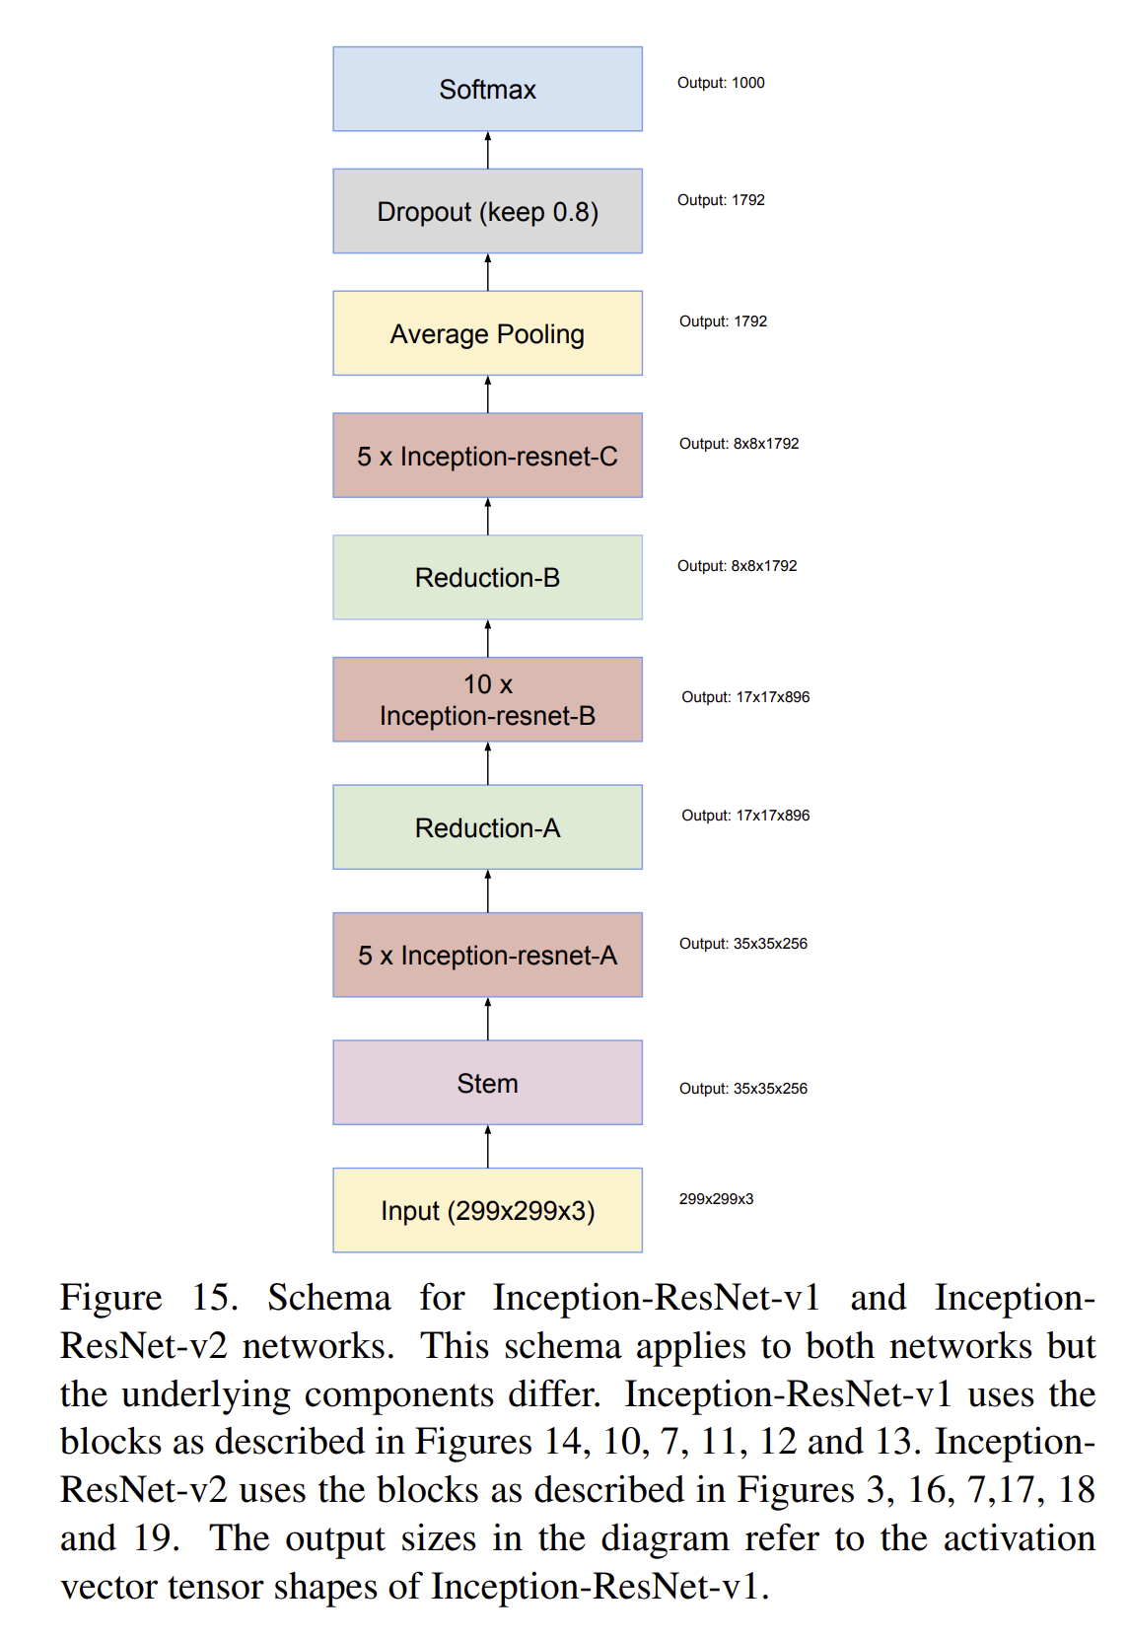

*Note*. Source: (Szegedy et al, 2016)

**Figure 86**

*Stem Part of Inception-ResNetv2*

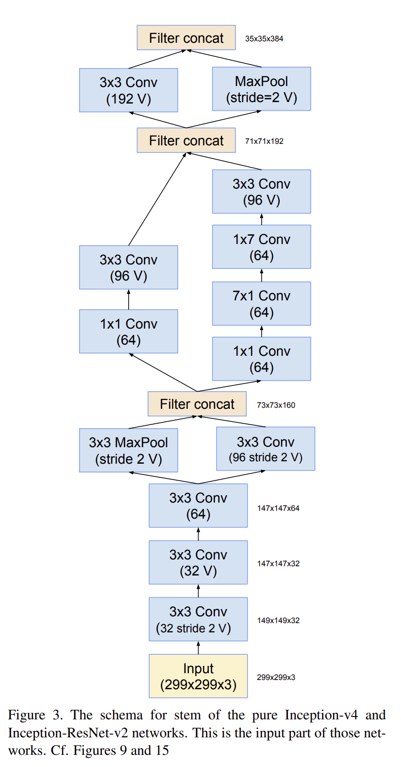

*Note*. Source: (Szegedy et al, 2016)

**Figure 87**

*Inception-ResNet-A module*

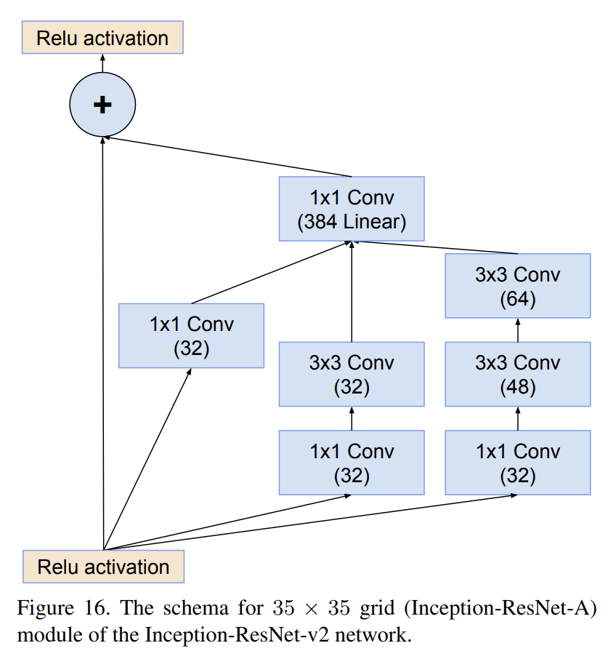

*Note*. Source: (Szegedy et al, 2016)

**Figure 88**

*Reduction Module*

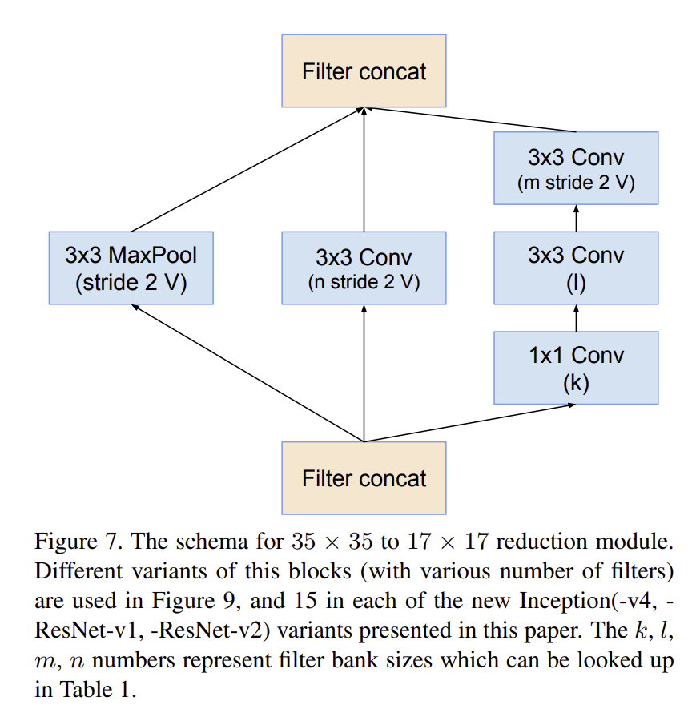

*Note*. Source: (Szegedy et al, 2016)

**Figure 89**

*The Number of Filters for Reduction Module*

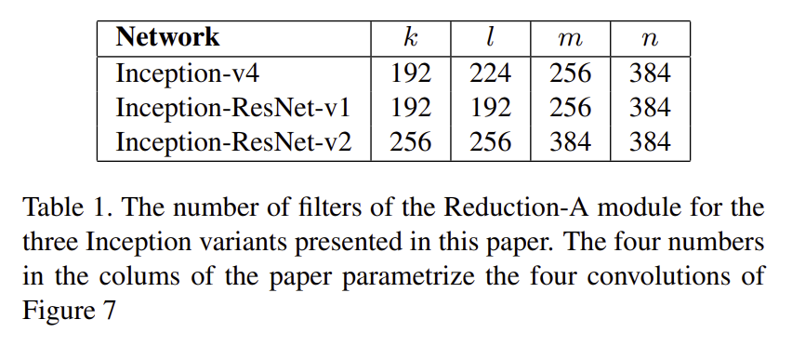

*Note*. Source: (Szegedy et al, 2016)

Figure 90 shows the Inception-ResNet-B module. Figure 91 shows the Reduction B module. Figure 92 shows the Inception-ResNet-C module. Inception-A, Inception-B, and Inception-C modules efficiently capture and process information from different spatial resolutions whereas reduction blocks use a combination of convolution and max-pooling to reduce spatial dimensions while increasing the number of filters which helps in plummeting computational complexity.

**Figure 90**

*Inception-ResNet-B Module*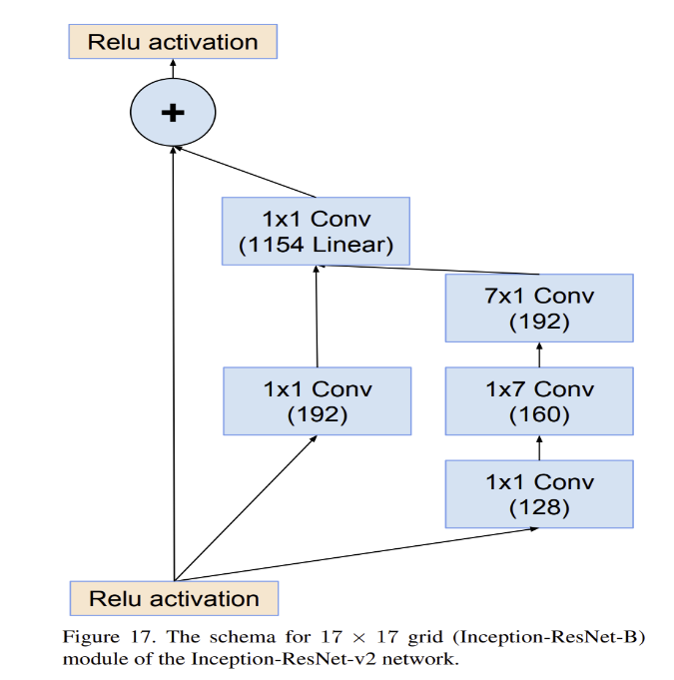

*Note*. Source: (Szegedy et al, 2016)

**Figure 91**  
*Reduction B module*

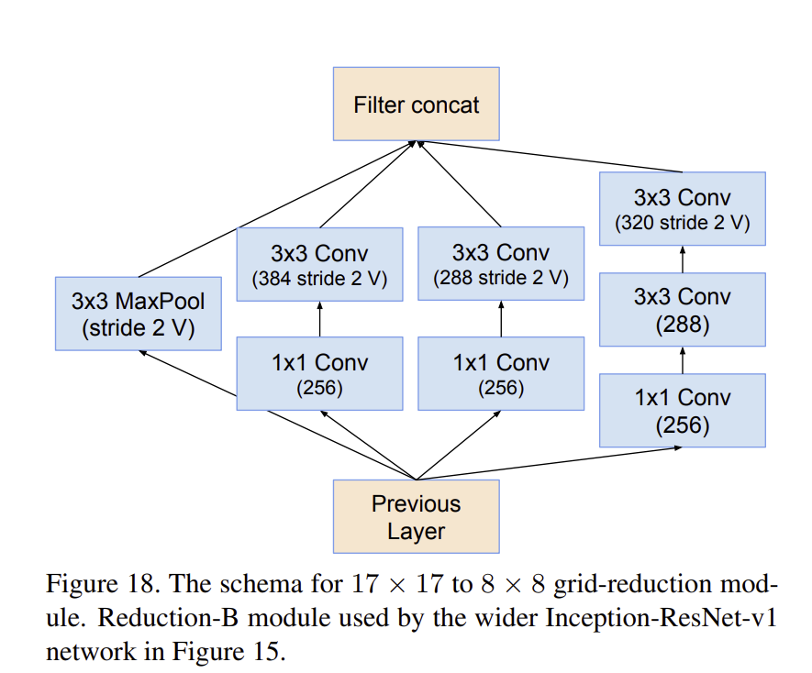

*Note*. Source: (Szegedy et al, 2016)

**Figure 92**

*Inception-ResNet-C Module*

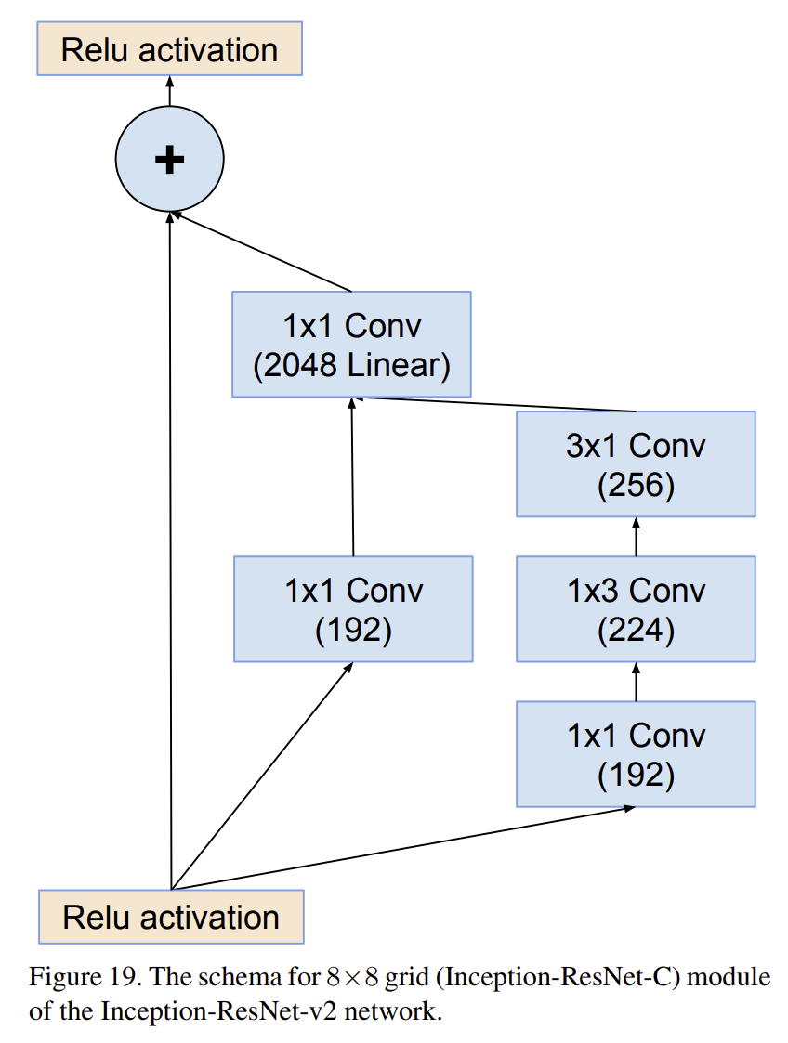

*Note*. Source: (Szegedy et al, 2016)

**Hyperparameter Tuning.** There are many hyperparameters that can be used to enhance the performance of InceptionResNetv2.

***Batch Size.*** The number of data samples processed in one iteration. Affects the speed and memory usage during training.

***Epochs.*** One pass through the entire training dataset. Establishes the number of times the training dataset will be processed by the learning algorithm.

***Dropout.*** A regularization technique where randomly selected neurons are ignored during training, reducing overfitting.

**Activation.** A function applied to each neuron, introducing non-linearity to the model. Common choices include ReLU, sigmoid, and tanh.

***Learning Rate.*** A hyperparameter determining the size of the steps during optimization. Controls the influence of new information on the model's weights.

**Optimizer.** An algorithm that adjusts the model's weights during training to minimize the loss function. Examples include Adam, SGD, and RMSprop.

**Hidden Layer Units.** The number of neurons in a hidden layer. Determines the capacity and complexity of the neural network.

Early Stopping Patience: The quantity of training epochs that are terminated to avoid overfitting if there is no improvement.

Early Stopping restore_best_weights: Whether to restore the model weights from the epoch with the best value of the monitored quantity during early stopping. Helps keep the best-performing model.

***YOLOv8***

As a one-stage detector, YOLO completes both object recognition and classification in a single network run. YOLO is typically more accurate and faster. YOLO models are frequently very tiny and quick, which makes them easier to deploy and faster to train, especially to edge devices with low computational capacity, when approaching the detection problem as a single shot regression method for recognizing bounding boxes. Ultralytics released YOLOv8 in January 2023 with five scaled flavors – YOLOv8n(nano), YOLOv8s(small), YOLOv8m(medium), YOLOv8l(large), and YOLOv8x(extra large). Numerous vision tasks, including object identification, segmentation, posture estimation, tracking, and classification, are supported by YOLOv8.

Terven and Cordova-Esparza (2023) presented a comprehensive guide on the evolution of YOLO series of algorithms. Figure 93 shows the YOLOv8 architecture. YOLOv8, like its predecessor, has been built upon Backbone, Neck, and Head.

The task of extracting valuable characteristics from the incoming image falls to the backbone. With lower-level characteristics (like edges and textures) collected in the previous layers and features at a higher level (like object pieces and semantic knowledge) extracted in the deeper levels, the backbone collects hierarchical features at multiple scales.

The neck serves as a transitional structure that joins the head and backbone. It gathers and enhances the features that the backbone has extracted, frequently concentrating on improving the semantic and geographical information at various scales.

The head is the last part of an object detector, and its job is to forecast things based on the information the neck and backbone supply. Typically, it is composed of multiple task-specific subnetworks that carry out pose estimation, segmentation, classification and localization. Predictions are produced for each potential object candidate by the head using the features that the neck has provided. Ultimately, a post-processing stage, such as non-maximum suppression (NMS), removes redundant predictions and keeps only the most reliable detections.

To increase detection accuracy, the C2f module (cross-stage partial bottleneck with two convolutions) combines contextual information with high-level features. YOLOv8 processes object detection, classification, and regression tasks independently using an anchor-free model with a decoupled head. By allowing each branch to concentrate on its own role, this architecture enhances the overall accuracy of the model. The sigmoid function was employed as the function of activation for the objectness scores in the YOLOv8 output layer, which indicates the likelihood that an object is present in the bounding box. To express the objects' odds of belonging to each potential class, it employs the softmax function for the class probabilities. Bounding box loss is handled by YOLOv8 using the distribution focused loss (DFL) and complete intersection over union (CIoU) loss functions, while classification loss is handled by binary cross-entropy. The object detection performance has increased as a result of these losses, especially for smaller items. Tested on the MS COCO dataset, YOLOv8x ran at 280 FPS on an NVIDIA A100 with TensorRT and a picture size of 640 pixels, achieving an AP of 53.9% (as opposed to 50.7% for YOLOv5 on the same input size).

**Figure 93**

*YOLOv8 Architecture*

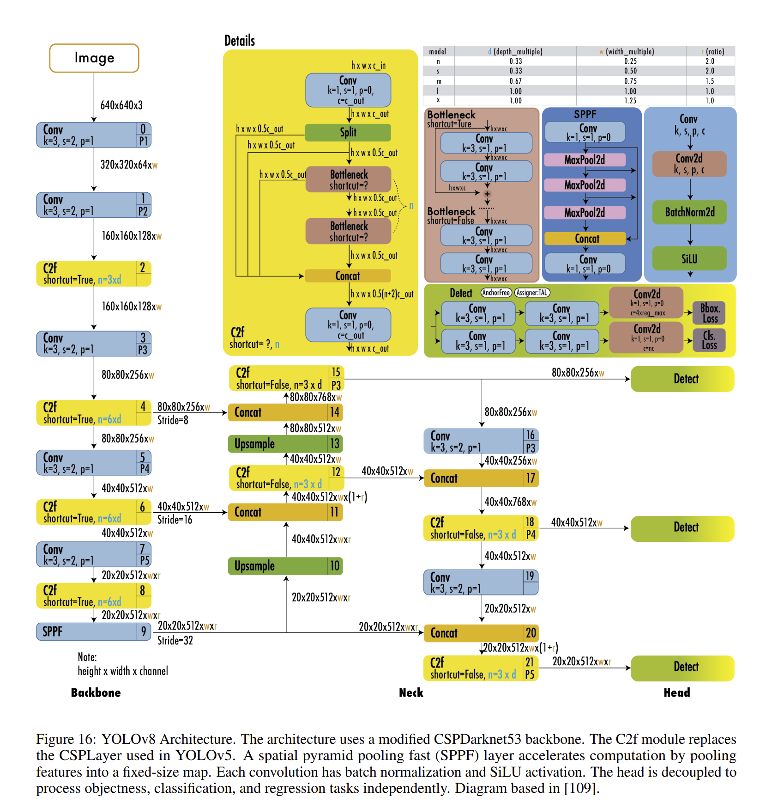

***YOLOv8 (You Look Only Once Version 8)***

**Hyperparameter Tuning.** There are many hyperparameters that are placed in the yaml file from where the model can be tuned. Some of the hyperparameters are as follows:

**Learning Rate (lr).** The learning rate controls the step size during the optimization process. It determines how much the model's weights should be updated during each iteration.

**Batch Size.** This parameter defines the number of training examples utilized in one iteration. YOLOv8 processes images in batches, and the batch size is a key hyperparameter that influences the model's training speed and memory requirements.

**Image size.** These parameters define the input size of the images during training. YOLOv8 requires square images, and the width and height determine the dimensions of the input.

**IoU Threshold.** The overlap between the ground truth and anticipated bounding boxes is measured using the intersection over union (IoU) technique. What degree of overlap is deemed a "correct" detection during evaluation is determined by the IoU threshold.

**Number of Classes.** This hyperparameter specifies the number of classes the model is trained to detect. YOLOv8 can be customized for different object detection tasks with varying numbers of classes.

**Number of Epochs.** Total Number of Periods. One whole run through the whole training dataset is referred to as an epoch. How many times the model is trained on the whole dataset depends on the number of epochs.

The YOLO series of object detection models have created a niche by providing great results at a very impressive real-time speed (Terven and Cordova-Esparza, 2023). With the addition of classification and pose tracking in YOLOv8 in January 2023, this research proposes to see how classification can be done by the YOLOv8 algorithm.

**Model Supports**

This project has used transfer learning on the pre-trained models for classification. Figure 94 gives a basic overview of the architecture. In general, all the layers of the pretrained models are frozen except for the output layer. The output of the penultimate layer is fed to the global-average pooling layer which is followed by the dropout layer (dropout rate: 20%). Dropout layer is then connected to the fully connected layer with 32 units and ReLU activation function and then followed by a dropout layer with 20% dropout. The output layer is the softmax layer, with 11 classes as the possible outputs.

**Figure 94**

*Classification Model Architecture*

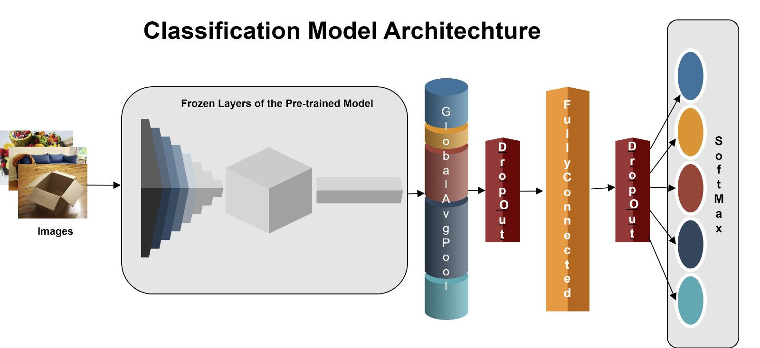

***MobileNetV2***

**Environment, Platform, and Tools.** The computational environment, platforms, and tools utilized in the training, testing, and assessment of a deep learning model built on the MobileNetV2 architecture are described in this section of the research paper. The focus is on the hardware and software configurations, and the specific tools and libraries employed in the project. The details provided here are essential for understanding the context and replicability of the research.

**Hardware Configuration.** The model training, especially with a deep learning architecture like MobileNetV2, benefits significantly from a powerful GPU and substantial RAM for efficient computation. The specific hardware setup used for training the model has been detailed in Table 13.

**Table 13**

*Hardware Configuration – MobileNetV2*

| **Component** | **Specification** |
| --- | --- |
| **CPU** | 11th Gen Intel(R) Core(TM) i5-1155G7 @ 2.50GHz 2.50 GHz |
| **GPU** | Intel(R) Iris(R) Xe Graphics |
| **RAM** | 16.0 GB (15.8 GB usable) |

In idle state, the system configurations were captured which is presented in Figure 95. While this does not depict what the running code for model training used, it gives an insight into the number of cores that were used as multiprocessing was performed to ensure maximum resource utilization.

**Figure 95**

*Hardware Configuration During Idle State – MobileNetV2*

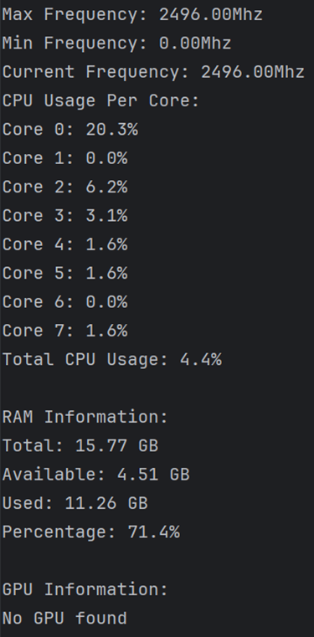

**Software Configuration.** The integrated development environment (IDE) for this project is PyCharm, a versatile and user-friendly environment for Python development, providing tools and features that facilitate efficient coding, debugging, and deployment of Python applications. The code is run on Windows operating system. The details are captured in Table 14.

**Table 14**

*Software Configuration – MobileNetV2*

| **Component** | **Specification** |
| --- | --- |
| **OS** | Edition - Windows 11 Home  Version - 22H2 |
| **IDE** | PyCharm 2023.2.4 |

**Tools.** In the development of this model, a range of specialized software tools and libraries were employed to facilitate the development, training, and evaluation. These tools were selected because of their robust functionalities, which are essential for data management and processing, neural network architecture construction and optimization, model performance visualization, and outcome evaluation. The Table 15 provides an overview of the tools and libraries utilized, along with their primary purposes and the specific functions or methods that were applied in the context of this project.

**Table 15**

*Tools – MobileNetV2*

| **Library/Tool** | **Purpose** | **Functions/Methods Used** |
| --- | --- | --- |
| **TensorFlow** | Primary deep learning framework | Keras API, ImageDataGenerator, MobileNetV2, GlobalAveragePooling2D, Dense, Dropout, Model, EarlyStopping, ModelCheckpoint, ReduceLROnPlateau |
| **Keras Tuner** | For optimizing the hyperparameters of neural networks | RandomSearch |
| **NumPy** | Array processing for numbers, strings, records, etc. | Random seed setting |
| **Matplotlib** | Plotting library for Python and its numerical extensions | Plotting training & validation accuracy and loss |
| **Scikit-learn** | Machine learning library for Python | classification_report, confusion_matrix |

**Data Flow Diagram.** Figure 96 illustrates a comprehensive deep learning workflow, integrating various components and data flows that correspond to the stages of training the MobileNetV2 model. The ImageDataGenerator class is used to prepare and augment image data from the training, validation, and testing directories, beginning with data preprocessing. This stage ensures that the model receives varied and normalized input data, enhancing the model's ability to generalize. Central to the diagram is the MobileNetV2 architecture, a lightweight but powerful neural network designed for efficiency in mobile applications. It utilizes depthwise separable convolutions to reduce computational load while maintaining high accuracy. The GlobalAveragePooling2D layer follows, condensing feature maps to a single vector per map, reducing dimensionality and preparing the data for the final classification layers. Dropout is applied next as a form of regularization, randomly disabling a subset of neurons to prevent overfitting.

Subsequent to the pooling layer are the Dense layers which serve as fully connected layers where the actual classification is computed, based on the features extracted by the preceding layers of the network. The Keras Tuner block represents the hyperparameter optimization process, where different configurations of the neural network are tested to find the most effective combination of parameters, such as the learning rate or the number of neurons in the dense layer. The training process is regulated by several callbacks: EarlyStopping prevents overfitting by halting the training when the validation loss stops improving, ModelCheckpoint saves the best model weights during training, and ReduceLROnPlateau decreases the learning rate when a metric has plateaued, ensuring the model continues to learn efficiently.

Post-training, the model evaluation phase involves computing the loss and accuracy on the test set to quantify the model's performance. The model's predictions are then used to produce a confusion matrix and a classification report that offer comprehensive details on the classification accuracy for each class. Finally, the visualization component, using libraries like matplotlib, illustrates the model's learning progression over imet by plotting accuracy and loss of training and validation. This graphical representation is crucial for interpreting the model's behavior during training and making decisions about potential adjustments or improvements.

**Figure 96**

Data Flow Diagram - MobileNetV2

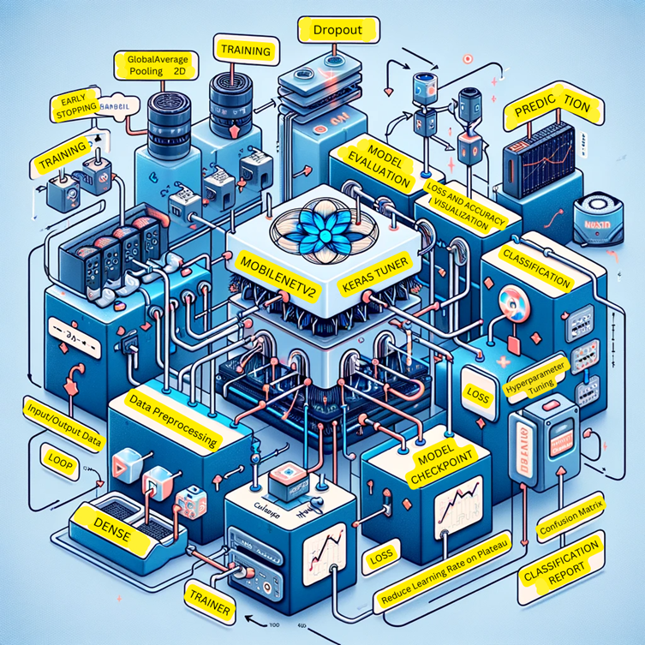

***ResNet50***

This section provides an overview of the hardware, software, and tools used in the training, testing, and evaluation of a deep learning model, specifically focusing on a project utilizing TensorFlow and Keras for image classification with the ResNet-50 architecture.

**Hardware Configuration.** In deep learning projects utilizing complex models such as ResNet-50, efficient hardware is essential. A powerful CPU is crucial for tasks like data pre-processing and augmentation, while a dedicated GPU significantly accelerates training by efficiently handling extensive matrix operations. Additionally, ample RAM is vital for managing large datasets and supporting the computational demands of deep learning algorithms, ensuring smooth data processing and effective model training. This combination of CPU, GPU, and sufficient RAM is key to optimizing the performance and efficiency of deep learning tasks.

The effectiveness and performance of deep learning models are significantly influenced by the hardware selection. For this model, the following hardware configuration was employed as shown in Table 16.

**Table 16**

*Hardware Configuration*

| **Component** | **Specification** |
| --- | --- |
| CPU | 9th Gen Intel(R) Core(TM) i5-9300H @ 2.40GHz |
| GPU | Nvidia GeForce GTX 1650 4 GB |
| RAM | 16 GB DDR4 (15.8 GB Usable) |

**Software Configuration.** The choice of operating system in a deep learning project is crucial as it affects the ease of setup and compatibility with various tools, while the use of Jupyter Notebook as an Integrated Development Environment (IDE) provides an interactive platform widely favored in machine learning. Jupyter Notebook uniquely facilitates the integration of code execution, documentation, and visualization, streamlining the development process from initial coding to final results analysis.

The software environment is equally important, providing the necessary platform for developing and executing the model. The configuration used for this model is stated in Table 17.

**Table 17**

*Software Configuration*

| **Component** | **Specification** |
| --- | --- |
| Operating System | Windows 11 |
| IDE | Jupyter Notebook |

**Tools and Libraries.** TensorFlow serves as the core framework, utilizing its ResNet50 architecture and various Keras API layers for model construction and training. Keras Tuner is employed to fine-tune the model's hyperparameters through the RandomSearch algorithm, enhancing performance. NumPy ensures reproducibility in model training by providing consistent random number generation. Matplotlib aids in visualizing training and validation metrics for performance tracking, while Scikit-learn is used for evaluating the model's accuracy and generating classification reports and confusion matrices, critical for assessing the model's predictive capabilities as shown in Table 18.

**Table 18**

*Tools and Libraries*

| **Library** | **Purpose** | **Function/Methods Used** |
| --- | --- | --- |
| TensorFlow | Primary deep learning framework | keras.applications.ResNet50, keras.layers.GlobalAveragePooling2D, keras.layers.Dense, keras.layers.Dropout, keras.Model, keras.callbacks.EarlyStopping, keras.callbacks.ModelCheckpoint, keras.callbacks.ReduceLROnPlateau |
| Keras Tuner | For optimizing the hyperparameters of neural networks | RandomSearch |
| NumPy | Array processing for numbers, strings, records, etc. | np.random.seed |
| Matplotlib | Plotting library for Python and its numerical extensions | plt.plot, plt.title, plt.ylabel, plt.xlabel, plt.legend, plt.show |
| Scikit-learn | Machine learning library for Python | classification_report, confusion_matrix |

**Data Flow Diagram.** In Figure 97, it starts with the Data Preprocessing Unit where raw data is subjected to essential preprocessing steps, including image resizing, normalization, and augmentation via TensorFlow's ImageDataGenerator class. Such preprocessing is instrumental in bolstering the model's generalizability and preventing overfitting. Subsequently, the Model Building Unit takes charge, employing the ResNet50 architecture, a pre-trained neural network provided by TensorFlow, which is then adapted by integrating custom layers—GlobalAveragePooling2D, Dense, and Dropout—to suit the specific requirement of classifying images into 11 distinct classes, all encapsulated within TensorFlow's Model class.

As it progresses, the Training Architecture becomes the focal point, engaging in an iterative learning process from the training data, batch by batch, facilitated by the train_generator object. This structured data feeding ensures exposure to diverse data permutations. Concurrently, the Hyperparameter Tuning process unfolds, utilizing Keras Tuner's RandomSearch to meticulously calibrate hyperparameters like the number of neurons in the Dense layer and the learning rate—parameters that are pivotal for the model's efficacy.

Upon the culmination of training, the Model Evaluation Unit steps in to gauge the model's prowess using datasets unseen during training, with the evaluate method shedding light on vital performance metrics such as loss and accuracy. The Reporting phase follows, where a classification report detailing precision, recall, and f1-scores for each class, alongside a confusion matrix, provides a nuanced insight into the model's predictive accuracies and misclassifications.

The Model Prediction stage then tests the model's aptitude in generalization by making predictions on new, unseen data, a definitive measure of its real-world applicability. Finally, in the Model Persistence phase, the trained model is saved, ensuring that it can be readily redeployed for future predictions without retraining—a critical step for practical deployment. This systematic and methodical approach ensures a seamless transition from data preparation to model deployment, encapsulating the complexities of machine learning pipelines in image classification tasks.

**Figure 97**

*Data Flow Diagram: ResNet-50*

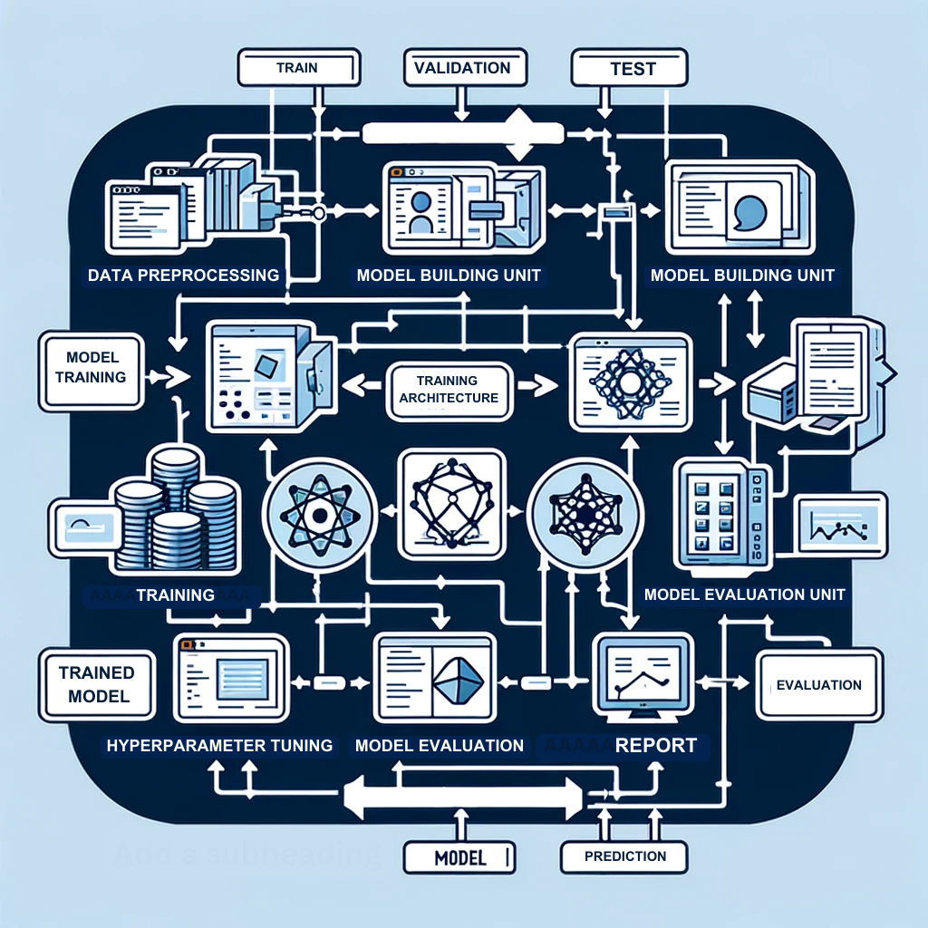

***Xception***

**Hardware Configuration.**The model training process, especially for complex architectures like Xception, benefits significantly from a robust GPU and substantial RAM to ensure efficient computation. Table 19 shows the hardware configuration used for this model.

**Table 19**

*Hardware Configuration*

| **Component** | **Specification** |
| --- | --- |
| CPU | 11th Gen Intel(R) Core(TM) |
| GPU | Intel(R) UHD Graphics 620 |
| RAM | 16.0 GB |

**Software Configuration.** For the software configuration, Google Colab, a cloud-based platform, is employed as the integrated development environment (IDE). The code for Xception is run on a Windows operating system. Table 20 displays the software configuration.

**Table 20**

*Software Configuration*

| **Component** | **Specification** |
| --- | --- |
| OS | Windows 11 |
| IDE | Google Colab |

**Tools and Libraries.** A few key libraries and tools have specific responsibilities to play in the creation and assessment of machine learning models. Neural network model building and training are made possible by TensorFlow, the main deep learning framework. A high-level interface for defining and training models is made possible by TensorFlow's use of the Keras API, while the Xception architecture is specifically tailored to convolutional neural networks used for image classification applications. TensorFlow's GlobalAveragePooling2D layer and Dense layer both contribute to the final classification and feature extraction process. In the meantime, the strong charting package Matplotlib serves the aim of producing a range of visuals, assisting in the thorough examination and understanding of data patterns and model performance. The confusion_matrix method, which is enhanced by the machine learning library for Python Scikit-learn, allows one to calculate a confusion matrix in order to predict accuracy of the classification model. When combined, these resources offer a unified and potent environment for the creation, assessment, and illustration of deep learning and machine learning models. Table 21 describes the tools and libraries used for this model.

**Table 21**

*Tools and Libraries*

| **Library/Tool** | **Functions and Methods** | **Purpose** |
| --- | --- | --- |
| TensorFlow | Keras AP, Xception, GlobalAveragePooling2D, Dense | Primary deep learning framework |
| Matplotlib |  | Plotting library for Python |
| Scikit-learn | Machine learning library for Python | classification_report |

**Data Flow.** Data is first gathered and feature-engineered in order to get it ready for the model. Three subsets are then created from this processed data: training, validation, and testing. By modifying its parameters in response to the training data, the model gains the ability to forecast during the training phase. To avoid overfitting and optimize the model parameters, the validation data is utilized. The Xception architecture is specifically utilized to improve the model's predictive accuracy after the model creation phase. To make sure the model is learning correctly, the performance of the model is assessed by examining the training data. Ultimately, an independent dataset is used to test the model's efficacy in order to produce testing results that offer an objective evaluation of the model's predictive potential. Figure 98 shows the data flow of this model.

**Figure 98**

*Data Flow for Xception Model*

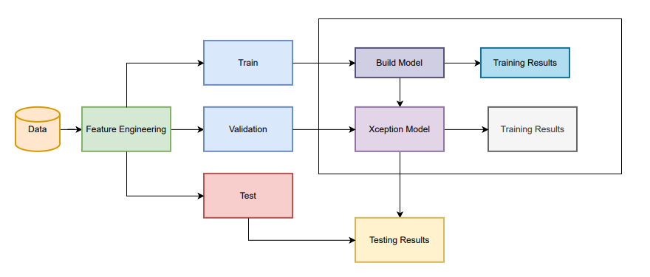

***InceptionResNetv2 and YOLO***

**Environment, Platform, and Tools.** This portion of the research describes the computational environment such as hardware and software requirements, tools and licenses used in the training, testing, and evaluation of InceptionResNetv2 model. InceptionResNetv2 is a very deep model with 164 layers with 55 million parameters whereas YOLOv8m has 218 layers with 25846129 parameters. As these are computationally expensive models, they require powerful GPU (Graphic Processing Units) to speed up the training times.

**Hardware Configuration.** Table 22 shows the hardware configuration used for building the model. To be able to work on two models, both the local system and Google Colab Pro was used. Table 23 shows the Hardware configuration used for training and evaluating the YOLOv8 model. Figure 99 shows the GPU information on Google Collab. Figure 100 shows the system configuration of the local machine in idle state.

**Software Configuration.** Table 22 shows the software configuration.

**Table 22**

*Hardware Configuration for InceptionResNetv2*

| **Processor** | 11th Generation Intel® CoreTM – i9-11950H Processor with vProTM (2.60 GHz, up to 5.00 GHz with Turbo Boost, 8 Cores, 16 Threads, 24 MB Cache) |
| --- | --- |
| **GPU** | NVIDIA® GeForce RTXTM 3080 with Max-Q 16GB |
| **Memory** | 64 GB DDR4 3200MHz (2x32 GB) |
| **Storage** | 1 TB Ple SSD Gen4 |

**Table 23**

*Hardware Configuration for YOLOv8*

| **Processor** | Intel® Xeon® CPU @ 2.00Ghz |
| --- | --- |
| **GPU** | A100 SXM4 |
| **Memory** | 40 GB |
| **Storage** | 54 GB |

**Figure 99**

*GPU Specification on Google Collab*

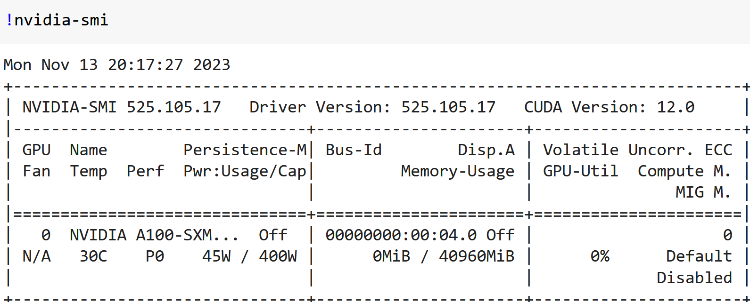

**Figure 100**

*System Configuration Used to Train InceptionResNetv2*

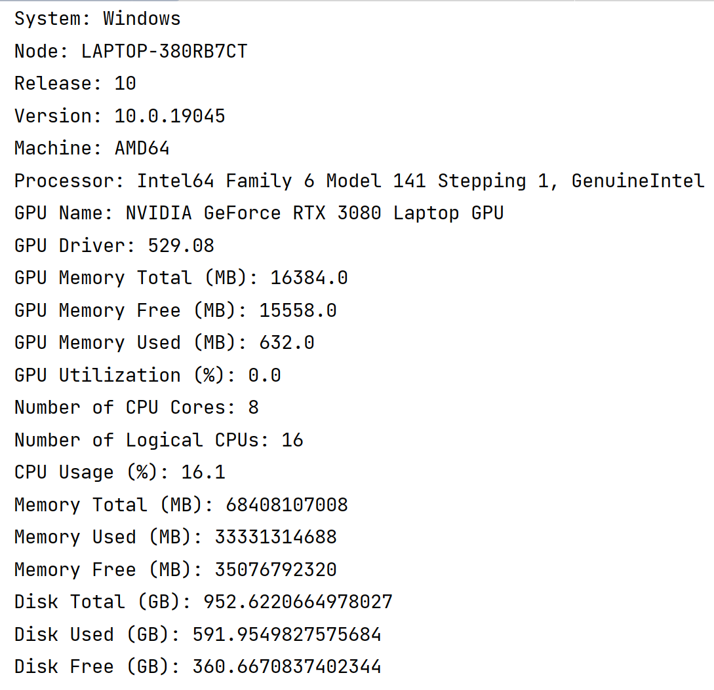

**Table 24**

*Software Configuration*

| **Operating System** | Windows 10 Pro 64 |
| --- | --- |
| **Integrated Development Requirement (IDE)** | PyCharm 2022.2.2 (Edu) |
| **Google Collaboratory Notebook Python** | 3.10.12 |

**Tools – Libraries and Methods Used.** A range of niche software tools and libraries were used in the development, training, and assessment phases of this model's production. These tools were chosen because of their strong features, which are essential for jobs like managing and processing data, building and refining neural network design, visualizing model performance, and assessing results. Table 25 provides an overview of the utilized tools and libraries, including their main uses as well as the features or techniques utilized for this project. Google Drive was used to handle all the data to be used for training and evaluation on Google Collab.

**Table 25**

*Tools and Libraries Used*

| **Tools** | **Package** | **Method** | **Usage** |
| --- | --- | --- | --- |
|  | os | Getcwd, chdir, path.join | Get and change directories, navigating through different paths |
| Google colab | drive | mount | To mount drive |
| Ultralytics | YOLO | Train, val, and predict, task = classify, detect | Training ,validation, and predictions for classification and detection |
|  | Glob | glob | For carrying list of all image paths |
|  | IPython.display | Image | To view images from a path with specific size. |
|  | Numpy | Random_seed | For reproducibility |
|  | Tensorflow | Keras API, ImageDataGenerator, InceptionResNetV2, GlobalAveragePooling2D, Dense, Dropout, Model, EarlyStopping,ModelCheckpoint, ReduceLROnPlateau | For building InceptionResNetv2 architecture |
|  | Keras_tuner | RandomSearch | For Hyperparameter tuning |
|  | sklearn.metrics | classification_report, confusion_matrix | For plotting classification report and confusion matrix |
|  | Matplotlib.pyplot | plot | For plotting training and validation accuracies and losses |

**InceptionResNetv2 - Model Architecture and Data Flow.**This section details the implementation of the models applied in this research. In the dataset setup, the code establishes directories for training, validation, and test datasets, specifying image size of 299 and batch size of 32. To facilitate data preprocessing, ImageDataGenerators are configured for each dataset, employing appropriate preprocessing functions tailored for the InceptionResNetV2 model. The architecture incorporates the principles of both the Inception architecture and residual connections, making it suitable for various computer vision tasks. In the model architecture section, the build_model function for Keras Tuner is defined. This initializes a RandomSearch tuner to create the model architecture. The objective is to maximize validation accuracy. The tuner conducts a maximum of 10 trials, with one execution per trial. It uses the predefined directory to store the tuning logs and results. The build_model function utilizes a pre-trained InceptionResNetV2 base model augmented with a Global Average Pooling layer and a dense layer, the latter having a variable number of units as a hyperparameter. The output layer is designed with 11 units and employs softmax activation for multi-class classification. Hyperparameter tuning is achieved through RandomSearch from Keras Tuner, optimizing for validation accuracy. Figure 101 shows the search space summary of the tuner. To monitor and optimize the training process, EarlyStopping, ModelCheckpoint, and ReduceLROnPlateau callbacks are implemented. Better convergence during training can be attained and the learning process can avoid becoming trapped in local minima by using the ReduceLROnPlateau callback. Subsequently, the model is trained using the best hyperparameters, and the training history is stored. Evaluation involves assessing the trained model on the test dataset, printing test loss and accuracy. Predictions are generated, and a classification report along with a confusion matrix is printed to assess model performance. The process at the end generates plots illustrating training and validation accuracy, along with training-validation loss over epochs, providing a visual representation of the model's learning dynamics. Figure 102 shows the generic data flow of the InceptionResNetv2 model.

**Figure 101**

*Snippet of Tuner Search Space Summary*

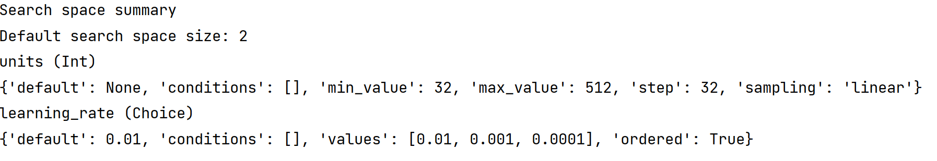

**Figure 102**

*Data Flow Diagram of InceptionResNetv2*

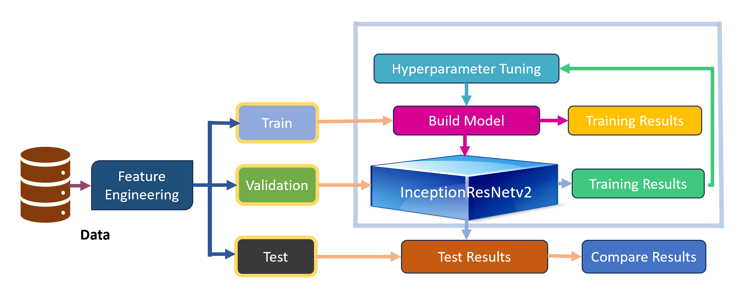

**YOLOv8 - Model Architecture and Data Flow.** The YOLO series of algorithms was primarily built for the purpose of object detection. Recently, on January 23, the makers incorporated a classification feature. Since all other models used in this case study are classification models, YOLO was used as a classification model as well as detection model. One more reason to use YOLO for classification model was that YOLO classification model was trained on ImageNet dataset similar to all other models such as InceptionResNetv2, MobileNetv2, Xception, ResNet-50. So, a similar comparison can be made. YOLO detection has been trained on the COCO dataset. This research uses YOLO as a detection model also on the subsampled Waste Dataset to see how the model performs on a different dataset. YOLOv8 is an anchor free detection model unlike its predecessors. The YOLOv8 model does not require anchors. This means that rather than predicting an object's distance from a known anchoring box, it predicts an object's center directly. The YOLO models of the past were notably problematic when it came to anchor boxes, which could represent the distribution of the boxes in the target benchmark instead of that of the customized dataset. Reduced box predictions from anchor free detection expedites Non-Maximum Suppression (NMS), a challenging post-processing procedure that sorts through potential detections following inference. The authors of YOLOv8 have provided a user-friendly interface to train, validate, and predict the image data using YOLOv8 different flavors of models. This study has used YOLOv8 small for classification and YOLOv8 medium for object detection. YOLOv8 was chosen for classification as it has a lesser number of 225 layers, 11166560 parameters to be used on the entire dataset. YOLOv8 medium was chosen for detection as it has a greater number of 295 layers with 25902640 parameters to be used for training a subset of dataset for detection. The training done on a custom dataset optimizes the parameters of the model for it to classify and detect objects accurately. The modes used are train, val, and predict for training the custom dataset, validating it, and providing predictions respectively. The task provided by YOLOv8 can detect, classify, segment, track, and pose. The classification and detection tasks have a specific way of keeping train, test, and validation folders. Numerous hyperparameters and configurations utilized throughout the training process are included in the YOLO models' training settings. The accuracy, speed, and performance of the model are affected by these settings. The most important training parameters are weight decay, momentum, learning rate, and batch size. The selection of the optimizer, loss function, as well as dataset composition can also have an effect on the training procedure. To optimize performance, meticulous experimentation and tuning are required with these variables.

Figure 103 shows a section of the yaml configuration file where different hyperparameters can be set. Figure 104 shows a very basic data flow diagram of the YOLO model.

**Figure 103**

*A Snippet of a Part of Configuration File Containing Hyperparameters*

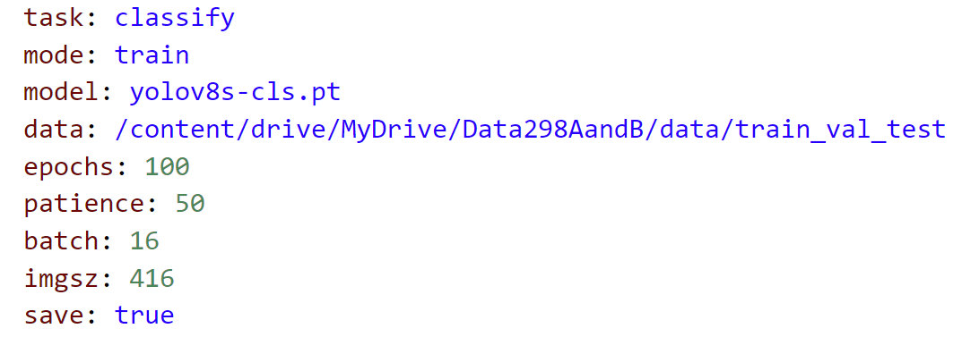

**Figure 104**

*Basic Flow of YOLO Model*

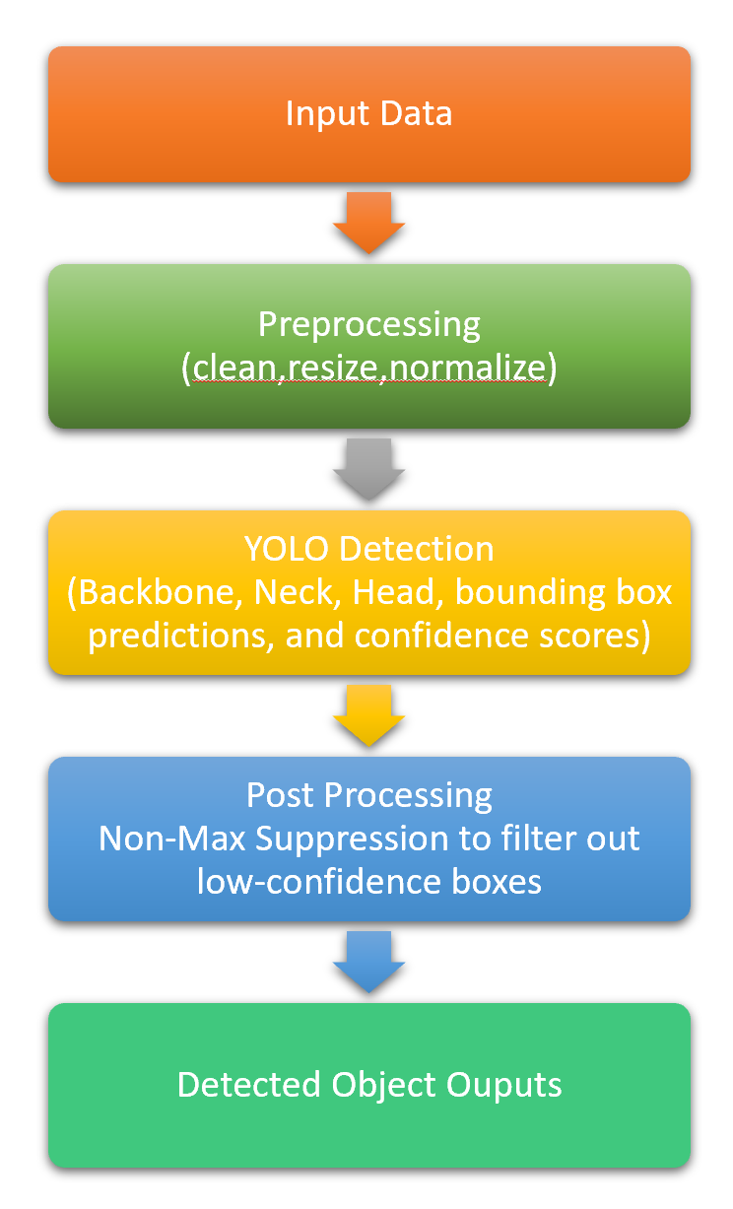

**Model Comparison and Justification**

The landscape of deep learning models for image processing tasks is diverse, with each model offering unique advantages tailored to particular applications. The MobileNetV2 model is distinguished by its deployment in mobile settings, where computational efficiency is crucial. This model takes advantage of depthwise separable convolutions within its CNN framework to ensure a balance between performance and computational load, making it ideal for mobile devices. However, its streamlined design may not capture the intricacies required for more complex image classification tasks, as it consists of 88 layers and 3.47 million trainable parameters.

On the other end of the spectrum, the Xception model is designed for a broad range of image classification challenges. It employs an extremely deep architecture that relies on depthwise separable convolutions to achieve a high level of detail and accuracy in pattern recognition. With its 71 layers and a substantial 22 million parameters, Xception is a powerhouse, although it requires significant computational resources.

InceptionResNetV2 represents a sophisticated blend of Inception modules with residual blocks, targeting complex image classification scenarios. This hybrid model is celebrated for its accuracy and capability to handle intricate visual patterns, supported by a vast network of 164 layers and 55 million parameters. Despite its high performance, the model's computational and memory demands are considerable, positioning it for use in systems where these resources are not limiting factors.

ResNet-50, a model known for mitigating the vanishing gradient problem, is also geared towards general image classification. It utilizes residual blocks to facilitate training of deep networks. Its architecture allows for effective deep learning with 50 layers and 25.6 million parameters, though deeper variants could strain computational resources.

In the realm of object detection, classification, segmentation, and pose tracking, the YOLOv8 Medium and YOLOv8 Small models stand out with their Darknet architecture. The YOLOv8 Medium is designed for improved accuracy, at the expense of increased computational requirements. In contrast, the YOLOv8 Small focuses on swift inference and reduced computational expense, with a trade-off in the form of slightly lower accuracy. The specifications for layers and parameters in these models vary according to the specific model implementation. These comparisons are listed in Table 26.

**Table 26**

*Model Comparison and Justification*

| **Model** | **Targeted Problem** | **Features** | **Approach** | **Strengths** | **Limitations** | **# of Layers** | **Trainable Parameters** |
| --- | --- | --- | --- | --- | --- | --- | --- |
| **MobileNetV2** | Mobile image classification | Depth wise separable convolutions | CNN-based lightweight architecture | Low computational cost, suitable for mobile applications | May not perform as well as larger models on complex tasks | 88 | 3.47 million |
| **Xception** | General image classification | Depthwise separable convolutions | Extreme depth with linear separability | Captures complex patterns, outperforms traditional CNNs | Requires more computational resources | 71 | 22 million |
| **InceptionResNetV2** | General image classification | Inception modules, residual blocks | Hybrid of Inception and ResNet | High accuracy, handles complex visual patterns | Computationally expensive, may require more memory | 164 | 55 million |
| **ResNet-50** | General image classification | Residual blocks | Residual learning | Effective on deep networks, mitigates vanishing gradient | Deeper variants may become computationally expensive | 50 | 25.6 million |
| **YOLOv8 Medium** | Object detection,Classification, Segmentation, Pose Tracking | Darknet architecture | One-stage object detection | Improved accuracy compared to YOLOv8 small | Moderately higher computational cost than YOLOv8 small | 225 | 11.6 million |
| **YOLOv8 Small** | Object detection,Classification, Segmentation, Pose Tracking | Darknet architecture | One-stage object detection | Faster inference, lower computational cost | Reduced accuracy compared to larger YOLOv8 models | 295 | 2.6 million |

**Model Evaluation Methods**

***Confusion Matrix***

A confusion matrix is a particular kind of table arrangement that makes it possible to visualize how well an algorithm performs, usually one that involves supervised learning. In the matrix, the instances in a predicted class are represented by each column, and the instances in an actual class are represented by each row, or vice versa. The reason for the name is that it makes it simple to determine whether the system is misidentifying one class as another, or confusing two classes.

It is a powerful tool because it not only shows if the model is getting predictions right, but also the types of errors it is making. The basic terms used in a confusion matrix are:

**True Positives (TP).** These are scenarios where it is predicted yes (the event or condition occurred), and they actually did happen.

**True Negatives (TN).** The prediction is no, and no event or condition occurred.

**False Positives (FP),** also known as Type I error: The prediction is yes, but no actual event or condition happened.

**False Negatives (FN),** also known as Type II error: The prediction is no, but the event or condition did happen.

In terms of equations, the most commonly derived metrics from the confusion matrix are the ones that are used to create the Classification Report. These metrics are mentioned below.

**Accuracy.** It measures how often the classifier makes the correct prediction. The confusion matrix’s total of all its elements is the ratio of accurate predictions to total predictions..Figure 105 shows the formula to calculate accuracy. (Manna, 2022)

**Figure 105**

*Accuracy Formula*

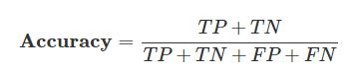

**Precision.** It tells us the proportion of positive identifications that were actually correct. It is a metric for the accuracy of a classifier. A high number of False Positives may also be indicated by a low precision. Figure 106 shows the formula to calculate precision. (Manna, 2022)

**Figure 106**

*Precision Formula*

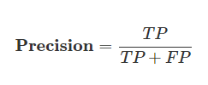

**Recall (Sensitivity or True Positive Rate).** It tells us the proportion of actual positives that were identified correctly. It is a metric for the comprehensiveness of a classifier. Recall is low when there are a lot of False Negatives. Figure107 shows the formula to calculate recall. (Manna, 2022)

**Figure 107**

*Recall Formula*

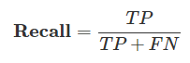

​

**F1 Score.** The F1 Score is the 2*((precision*recall)/(precision+recall)). It is sometimes referred to as the F Measure or the F Score. It communicates the harmony between recall and precision.

F1 Score = 2×Precision+Recall / Precision×Recall

​

These metrics are computed for multi-class classification problems, extending the concept of TP, FP, TN, and FN to each class.

**Model Validation and Evaluation**

***MobileNetV2***

A confusion matrix and classification report are used to quantitatively evaluate the effectiveness of the MobileNetV2 model for waste segregation. These tools are essential for comprehending the model's capacity to classify each type of waste correctly.

**Confusion Matrix.** The actual versus expected classifications are tabulated in the confusion matrix. In the matrix, the instances in a predicted class are represented by each column, and the instances in an actual class are represented by each row, or vice versa. Off-diagonal elements are those that the classifier incorrectly labels, whereas diagonal elements show the number of points for which the predicted label and the true label are equal. The confusion matrix's diagonal values indicate the number of correct predictions; the higher the values, the better.

In Figure 108, the matrix is a square matrix where each dimension is the number of classes, indicating that the model is evaluated on a multi-class classification task. The model seems to perform well on several classes with high true positive rates (the diagonal values), such as for class 2 (clothes) with 247 correct predictions, and class 10 (shoes) with 191 correct predictions. However, there are notable confusions between certain classes, for instance, class 1 (cardboard) is often misclassified as class 0 (biowaste), as indicated by the 139 instances in the corresponding off-diagonal cell. The model accurately identified 210 cases of "biowaste," misclassifying 3 as "cardboard," 2 as "clothes," and so forth.

**Figure 108**

*Confusion Matrix – MobileNetV2 model*

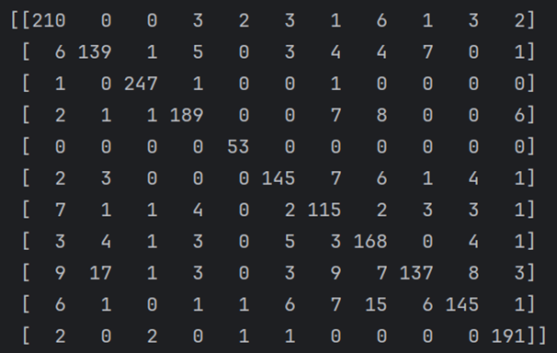

**Classification Report.** The classification report in Figure 109 provides key metrics about the accuracy of the classifier in predicting each class. These metrics are F1-score, precision and recall.

***Precision****.* Calculated as the number of positive outcomes divided by the total number of true positives + the number of false positives, these statistics show how accurate positive forecasts are. For instance, 'clothes' have a precision of 0.97, suggesting that when the model predicts an item is 'clothes', it is correct 97% of the time.

***Recall (Sensitivity)****.* Evaluates the classifier’s capacity to locate every positive sample. It is computed by dividing the total number of affirmative outcomes by the total of the affirmative and false negative outcomes. 91% of the 'biowaste' instances are correctly identified by the model, according to the recall of 0.91 for the term.

***F1-Score****.* a weighted harmonic mean of recall and precision where 1.0 represents the best score and 0 represents the worst. It is particularly useful when the class distribution is uneven. With high F1-scores of 0.98 and 0.95 for "clothes" and "shoes," respectively, these terms demonstrate a good balance between recall and precision.

***Support.*** The number of actual occurrences of a certain class or category in the dataset. This is used to weigh the metric scores, providing insight into the class distribution of the data.

**Figure 109**

*Classification Report – MobileNetV2 model*

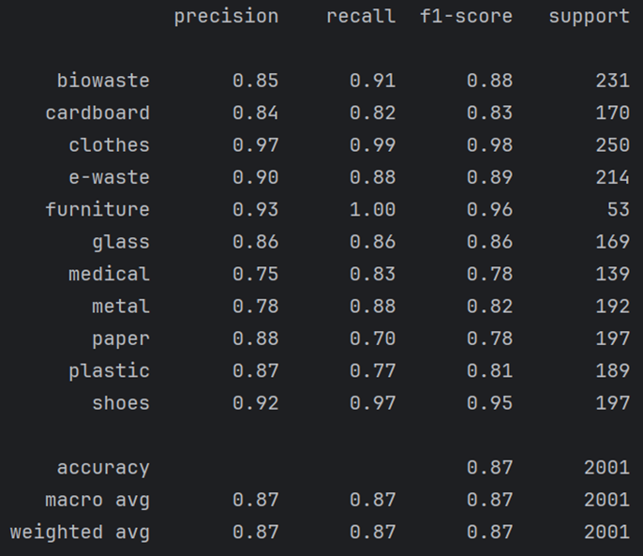

With an overall accuracy of 0.87, the model accurately predicts the class labels 87% of the time. An overview of the overall performance across all classes is also given by the macro and weighted averages of precision, recall, and F1-score.

Given the high number of classes and the inherent difficulty in differentiating between various types of waste materials, these results indicate a robust model performance but it could be better for a different model architecture.

***ResNet-50***

The evaluation of a machine learning model is as crucial as its design and training. It offers perceptions on the effectiveness and generalizability of the model. For the image classification model based on the ResNet-50 architecture, two primary evaluation methods were used: the classification report and the confusion matrix.

**Classification Report.** The classification report provides a comprehensive summary of the precision, recall, f1-score, and support for each class in the dataset as given in Figure 110.

**Figure 110**

*Classification Report*

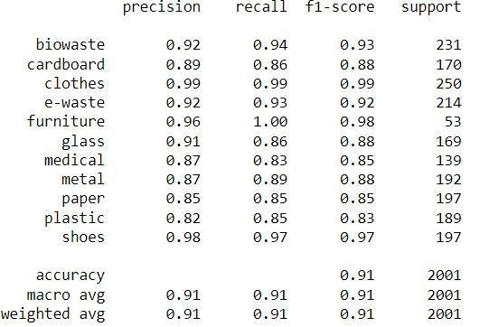

***Support****.* Notably, the classes 'clothes' and 'shoes' achieve the highest precision and recall, suggesting that the model can distinguish these items with high accuracy. However, 'plastic' has lower precision and recall, which may point to a need for more training data or reevaluation of feature representations for this class. The overall accuracy of the model stands at 0.91, alongside a weighted average f1-score of 0.91, demonstrating the model's robust performance across diverse classes.

**Confusion Matrix**. Instances of a predicted class are shown in Figure 111.

**Figure 111**

*Confusion Matrix*

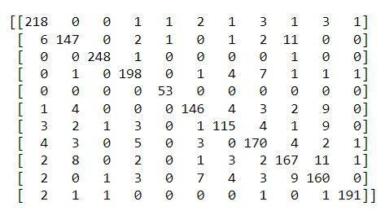

The confusion matrix complements the classification report by providing a visual understanding of the model's performance. For instance, 'biowaste' is mostly classified correctly, with only a few instances confused with 'glass' and 'paper'. There are confusions observed between 'glass' and 'plastic', indicating potential similarities in their feature space that the model struggles to differentiate. These insights could direct efforts to improve the model further by focusing on distinguishing features between commonly confused classes.

***Xception***

**Classification Report.** The model shows recall and high precision for clothes and furniture. and exhibits lower precision and recall in the ‘medical’ category It maintains an overall accuracy of 0.77 and a weighted average f1-score of 0.77, demonstrating strong and consistent performance across various classes. Figure 112 shows the classification report of this model.

**Figure 112**

*Classification Report*

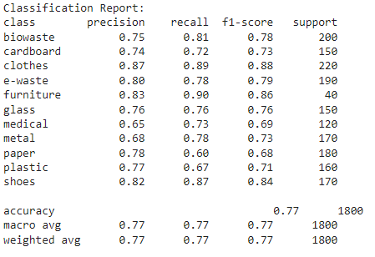

***InceptionResNetv2***

Confusion matrix and Classification report are one of the most crucial tools to analyze the performance of InceptionResNetv2. These tools provide a detailed and comprehensive evaluation of a classification model's performance, going beyond simple accuracy by showing the number of correct and incorrect predictions and give insight into which classes are accurately performing or underperforming.

**Confusion Matrix.** In the context of an InceptionResNetV2 classification model for a waste dataset with 11 classes, the confusion matrix has a dimension of 11x11. The diagonal elements are True Positive samples that are accurately classified. Off-diagonal entries are the number of times the class has been mis-classified with another class. Figure 113 shows the confusion matrix for the InceptionResnetv2 model. For example, in the figure, cardboard has been misclassified as biowaste eight times. Furniture, Shoes, Clothes, Biowaste perform better than others with zero misclassification for Furniture, three for shoes, and two for clothes in total. However, there are many cases of misclassifications where cardboard has been identified as paper 12 times, paper has been identified as plastic 11 times, e-waste has been mis-classified as medical eight times.

**Figure 113**

*Confusion Matrix of 11 Classes for InceptionResNetv2*

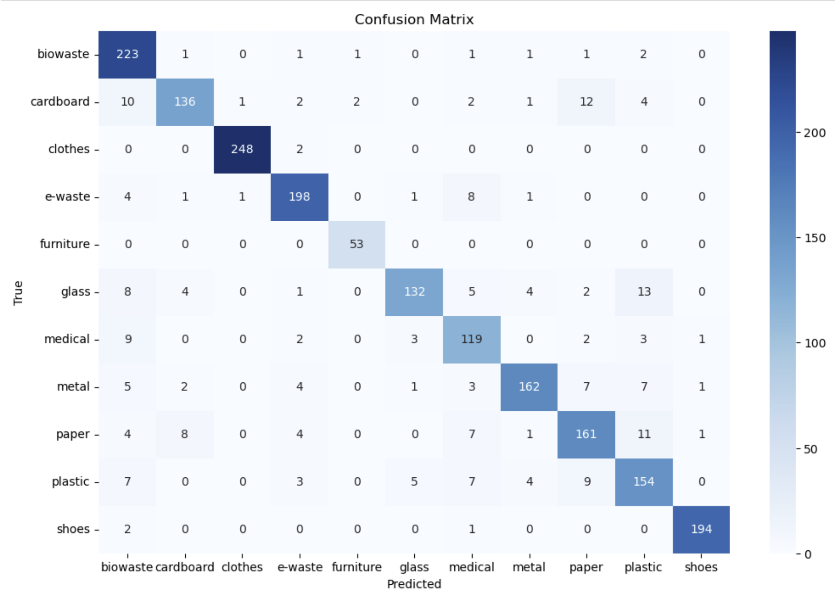

**Classification Report.** Figure 114 provides the classification report using InceptionResNetv2. For the waste categorization model InceptionResNetV2, the report consists of:

***Precision.*** For furniture class precision is 0.97, that means out of all the instances predicted as furniture 97% of times were actually furniture. Quality or accuracy of positive estimates of the model can be inferred from this.

***Recall.*** Recall for shoes is 0.98 which tells that out of all samples of shoes the model is able to classify 98% of them.

***F1-Score.*** Clothes, Shoes, and Furniture classes demonstrate a good balance of recall and precision with 0.99,0.98, and 0.97 respectively.

***Support.*** *C*lass distribution can be seen and metrics can be analyzed.

**Figure 114**

*Classification Report*

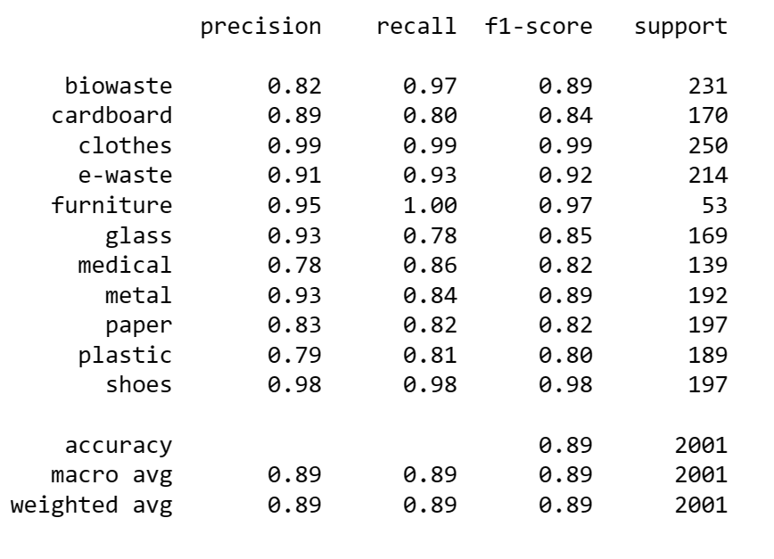

***YOLOv8***

A newly developed YOLOv8 small model has been trained to do classification tasks on the waste dataset. Model was trained for 100 epochs. Figure 115 shows the confusion matrix generated as the result of the model. As seen in the figure, furniture class has no misclassification, Clothes, and Shoes classes have three and six cases of misclassifications.

**Figure 115**

Confusion Matrix

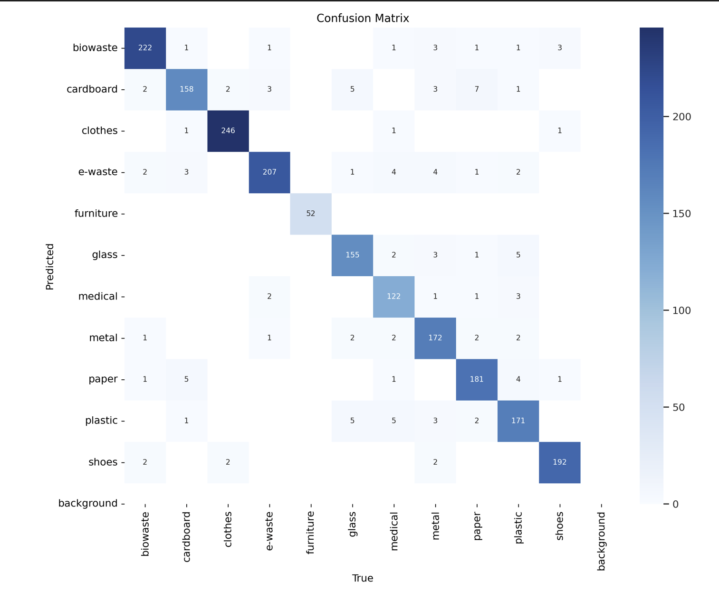

Since YOLOv8 classification has been recently developed, it doesn’t give access to F1-score, Precision, and Recall score. The interface provides the confusion matrix as an image. However, training can be analyzed using a result file where loss, top 1 and top 5 accuracies are given at each iteration. Figure 116 shows sample validation batch labels and Figure 117 shows its corresponding predictions. Figure 118 shows accuracies of Top 1 class and Top 5 Class during training. Figure 119 shows a few samples of prediction.

**Figure 116**

*Sample of Validation Batch Labels*

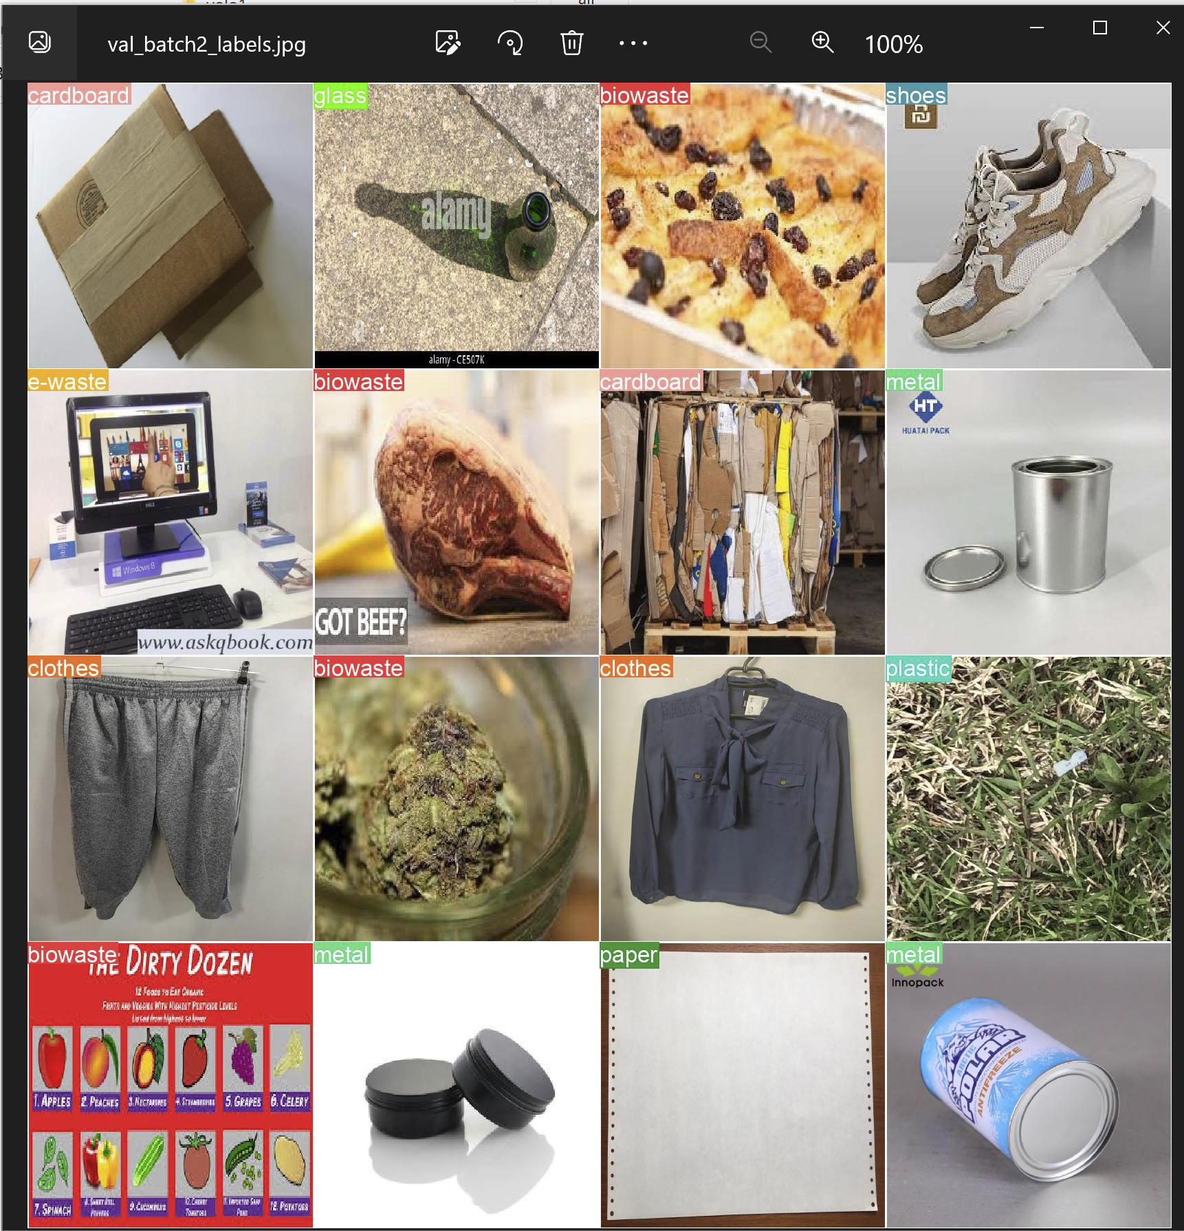

**Figure 117**

*Sample of Validation Batch Prediction*

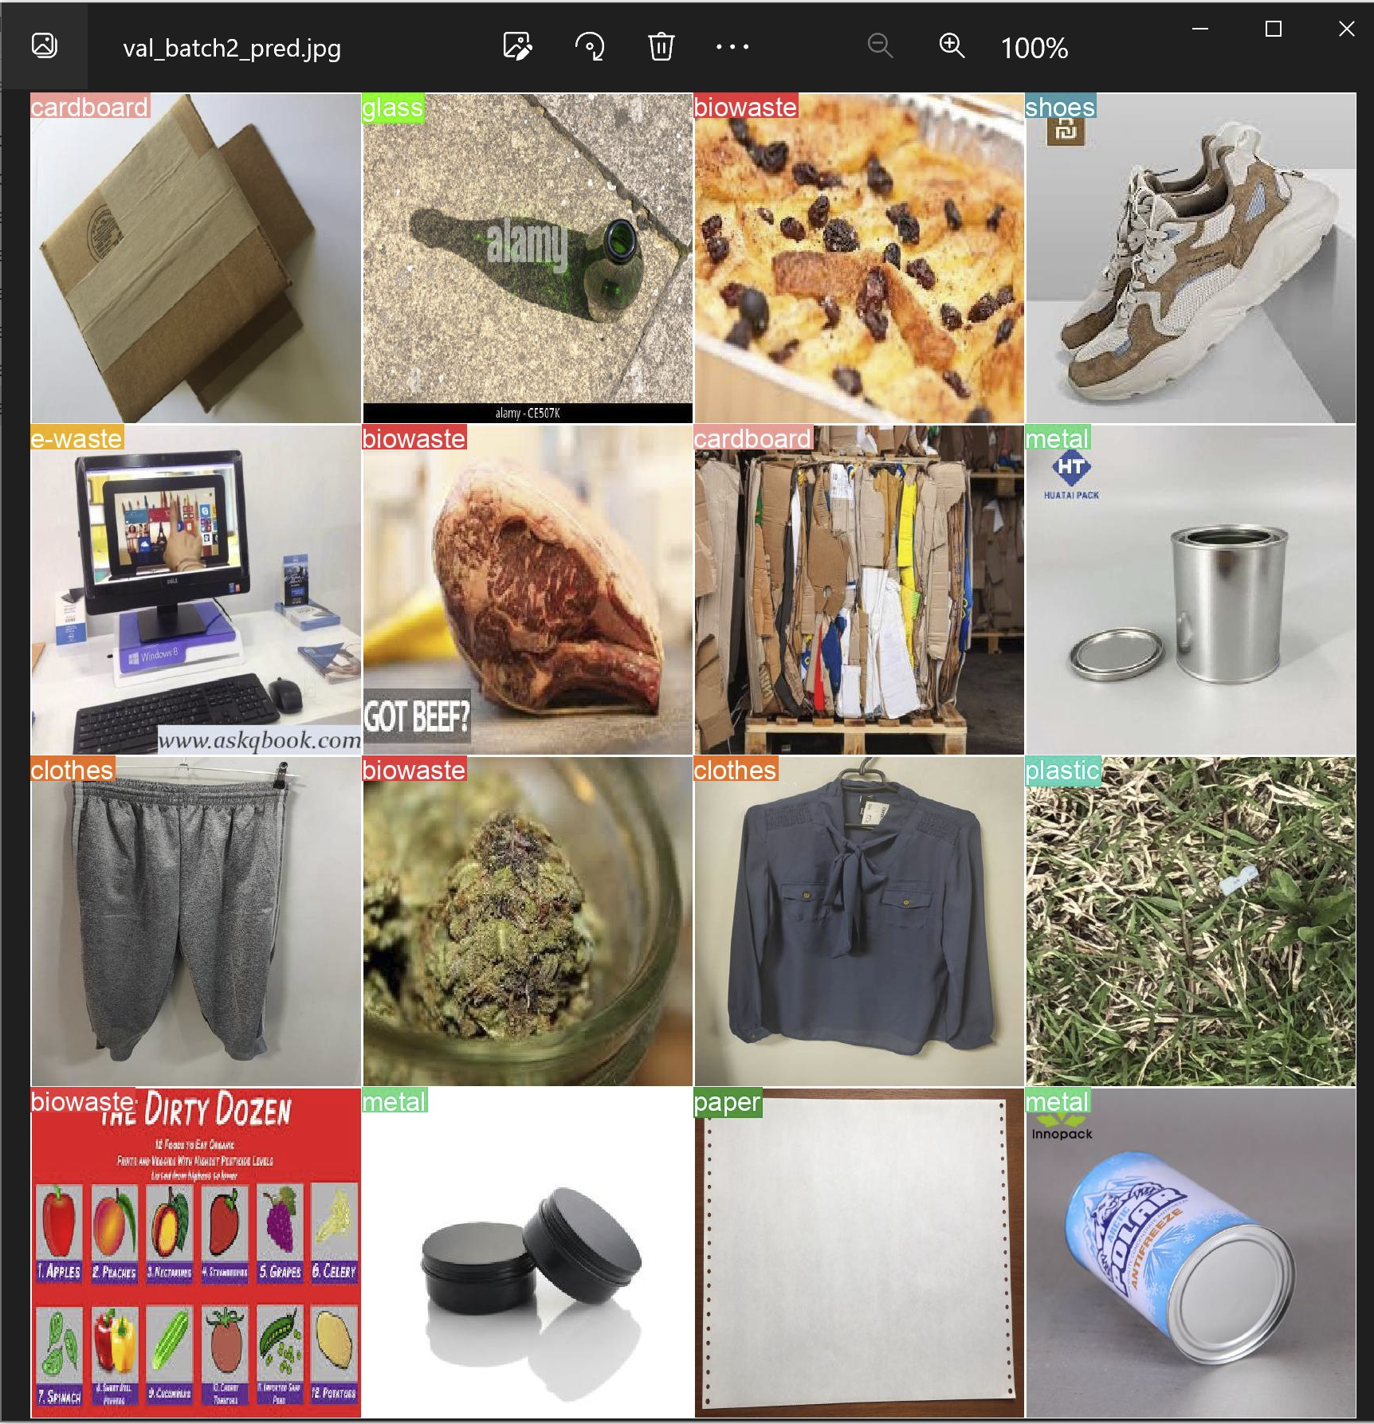

**Figure 118**

*Accuracies Top 1 and Top Five*

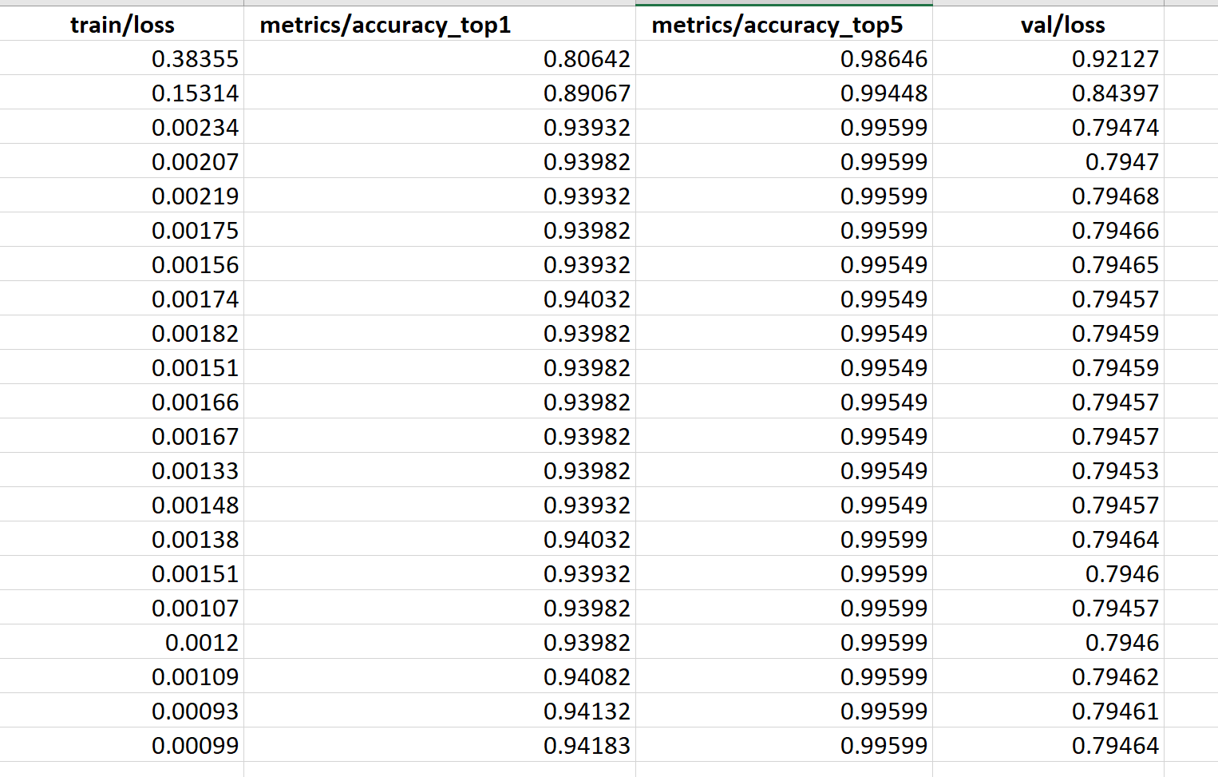

**Figure 119**

*Few Samples of Predictions*

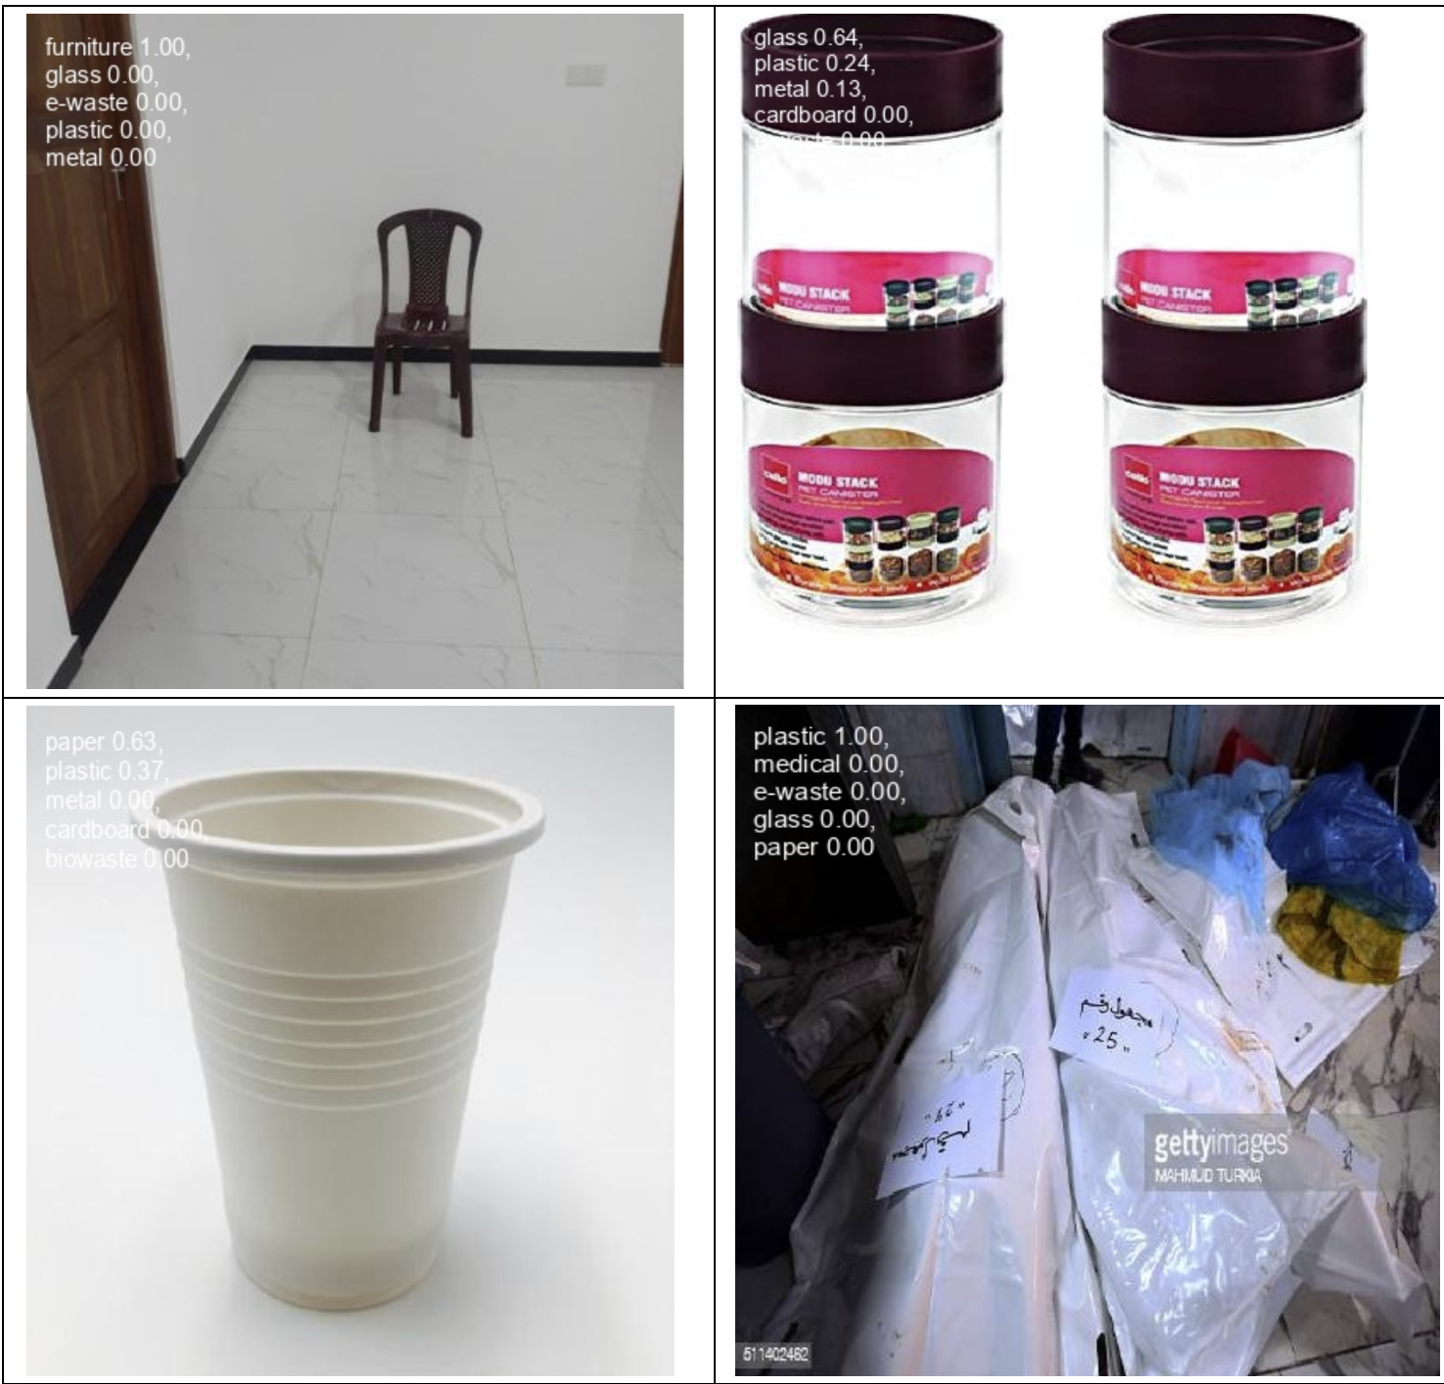

Conventional accuracy measures such as Top1 and Top5 accuracies were calculated. Top1 accuracy evaluates the number of times the model gave correct predictions about its most confident class. Top5 accuracy is generally used in scenarios with multiple classes. It measures the proportion of test images for which the correct label is among the model’s top five predicted classes. Figure 120 and Figure 121 show the training and validation loss of the YOLOv8 nano model. The following Table 27 shows the results obtained from these two models. YOLOv8 small performed better than the nano models. Larger flavors of YOLOv8 models could have been tried for higher accuracy, but computation and inference times may be worse for them. The YOLOv8-n model took around 1.05 hours to train on 100 epochs. The YOLOv8-s model took 1.28 hours on 100 epochs to train.

**Table 27**

*Results Obtained for YOLOv8-n and YOLOv8-s*

| **Model** | **Top1** | **Top5** | **Inference speed(ms)** |
| --- | --- | --- | --- |
| YOLOv8-n | 91.3% | 99.4% | 0.3 |
| YOLOv8-s | 94.2% | 99.6% | 0.7 |

**Figure 120**

*The Training Loss for YOLOv8 Nano Classification Model.*

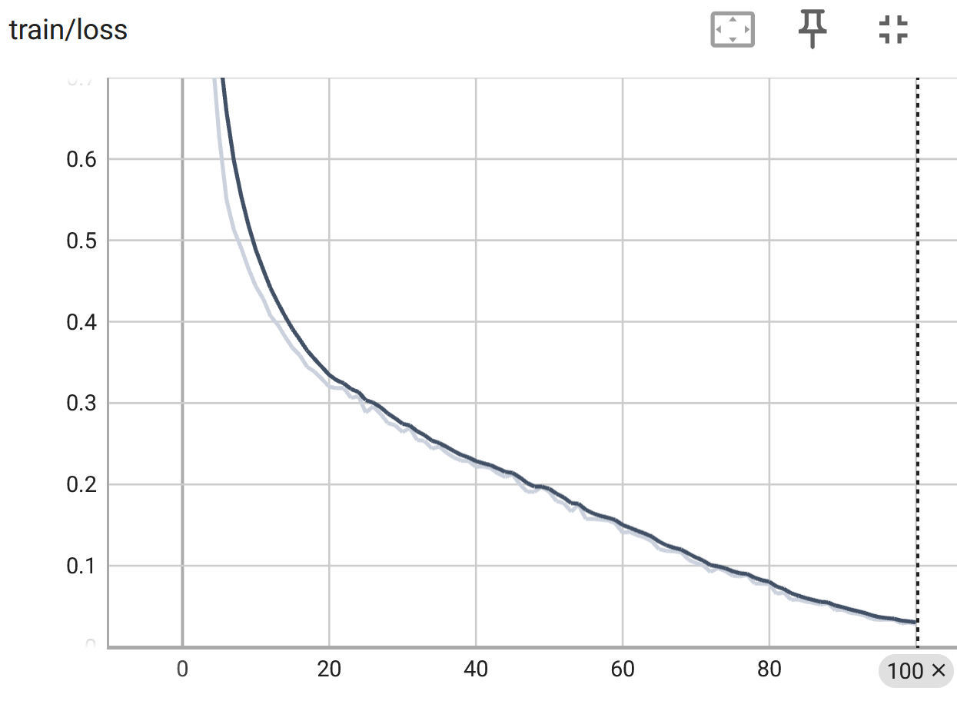

**Figure 121**

*The Validation Loss for YOLOv8 Nano Classification Model.*

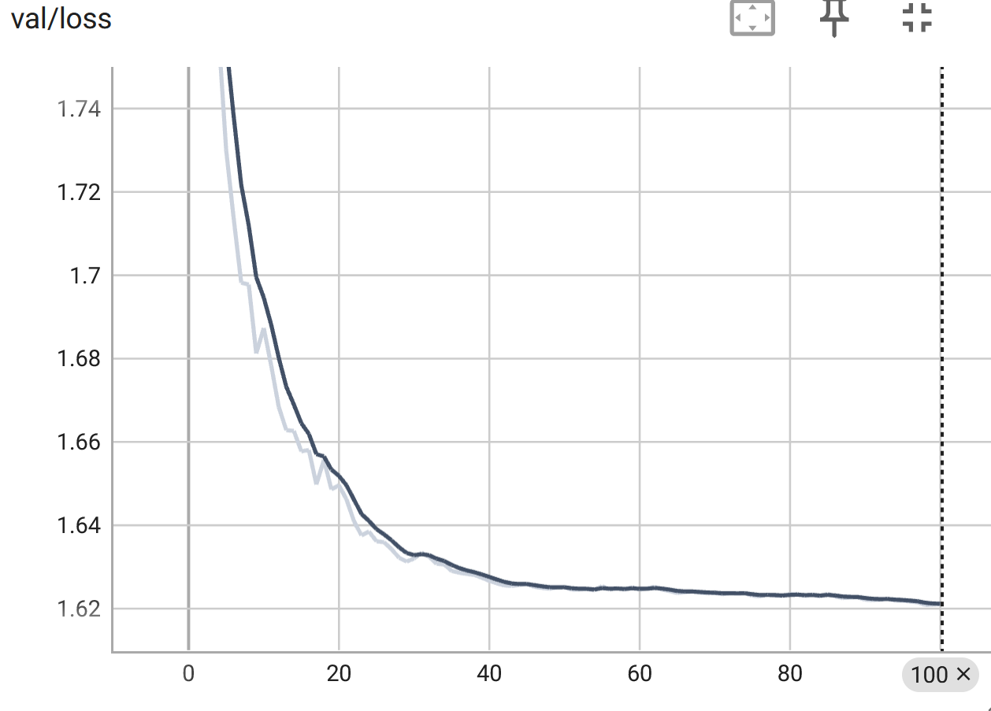

***YOLOv8 Object Detection***

A small subset of data has been applied to perceive the YOLOv8 object detection capabilities. Detection models are pre-trained on the COCO dataset. The number of epochs used for training is 400 with image size as 640. The YOLOv8 F1-curve facilitates the visualization and analysis of the precision vs. recall trade-off at various confidence levels, which helps in choosing the right confidence threshold for a particular task. F1 score of 0.54 achieved by the model across all classes at a specific confidence threshold of 0.395. A model's capacity to strike a balance between precision (accuracy of positive predictions) and recall (ability to catch all relevant instances) is measured by the F1 score, which is the harmonic mean of precision and recall. The confidence score is 0.395. Each prediction in object detection tasks such as YOLO has a corresponding confidence score that represents the model's level of trust in that prediction. These confidence scores are subject to a threshold, and during inference, predictions with confidence scores below the threshold are frequently filtered out. The annotated images were trained again on the YOLOv8-m medium model. This time the YOLOv8-m model was trained on 100 epochs with image size 640. This time mAP50 was 0.628 and mAP50-95 was 0.607. The model did not work for the e-waste category as there were only six instances of e-waste in the database. The model returned 0 for all the metrics – Precision, Recall, mAP50, mAP50-95. Therefore, more images for e-waste were scrapped from Google to increase the performance of the model. The model was trained on YOLOv8-small for 400 epochs and image size 640. It took 12.156 hours to train. It achieved a mAP50 of 0.745 and mAP50-95 of 0.699 with inference time as 1.7ms but since the e-waste images had entirely different backgrounds as opposed to other classes, the real-time detection was not identifying other classes properly. Grounding Dino was tuned for each specific class to detect all kinds of objects that were getting undetected before. 2500 images for each class were detected by Grounding Dino except for two classes for which few of the objects got undetected. Finally, the YOLOv8-s small model and the YOLOv8-m medium model were again trained with these annotated classes by Grounding Dino. The mAP50 for small model was 0.812 and mAP50-95 was 0.75 and it took 1.84 hours to train on a dedicated high end Nvidia RTX Geforce 4090 machine with 32 GB vRAM and 128 GB RAM while running on Docker container. The mAP50 for medium model turned out to be 0.827 and mAP50-95 as 0.773 showing consistency in the performance of the model across all the thresholds and classes. Figure 122 shows the confusion matrix. Figure 123 shows the Precision-Recall curve of the YOLOv8-m medium model. The training time took 21.637 hours on Google Collab and on the validation set, it took 2.7ms time for inferencing. Clothes, Furniture classes performed very well with precision and recall more than 97% and 93% respectively. Table 28 shows the different results on different flavors of YOLOv8. Figure 124 shows some samples of predictions done.

**Figure 122**

*Confusion Matrix of Detection YOLOv8-m Medium Model*

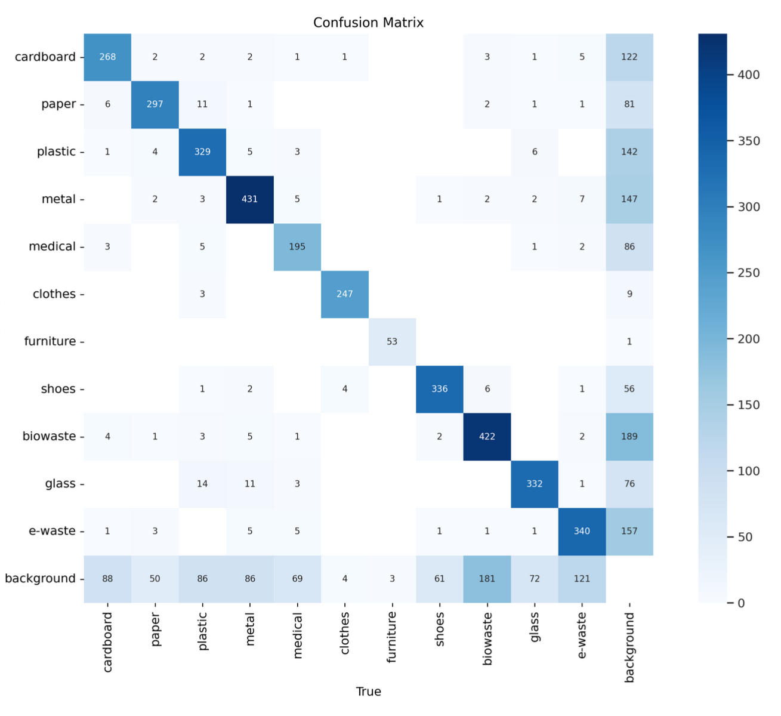

**Figure 123**

*Precision Recall Curve of YOLOv8-m Medium Model*

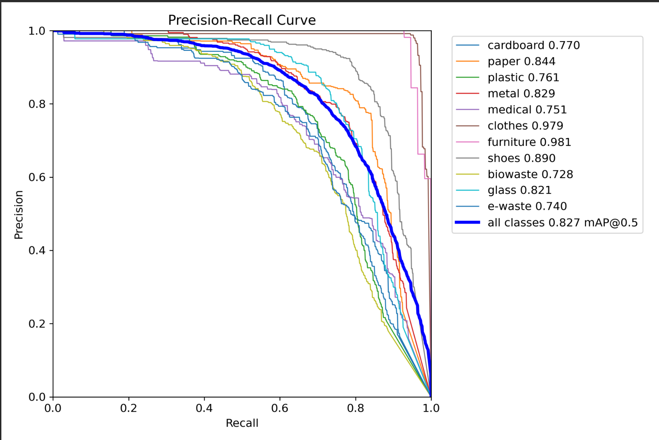  
**Table 28**

*The mAP50 and mAP50-95 for Different YOLO Object Detection Models*

| **Model** | **mAP50** | **mAP50-95** | **Inference time(ms)** |
| --- | --- | --- | --- |
| YOLOv8-m (1100 images) | 0.579 | 0.409 | 0.6 |
| YOLOv8-s | 0.745 | 0.699 | 1.7 |
| YOLOv8-s | 0.812 | 0.75 | 1.4 |
| YOLOv8-m | 0.827 | 0.773 | 2.7 |

**Figure 124**

*Sample of Predictions Done by YOLOv8-m Medium Model*

|  |  |  |
| --- | --- | --- |
|  |  |  |
|  |  |  |
|  |  |  |

Table 29 shows the results of F1-score for all the models implemented. It is observed that YOLOv8-s has the highest F1-score while ResNet50 and YOLOv8-n have an F1-score of 0.91and 0.92 respectively outperforming the other models.

**Table 29**

*Classification Models Results Comparison*

| **Model** | **F1-Score** |
| --- | --- |
| ResNet50 | 0.91 |
| Xception | 0.87 |
| MobileNetv2 | 0.87 |
| InceptionResnetv2 | 0.88 |
| YOLOv8-n | 0.92 |
| YOLOv8-s | 0.93 |

**Data Analytics and Intelligent System**

**System Requirements Analysis**

***System Boundaries, Actors and Use Cases***

The household waste management system is meticulously designed to efficiently categorize waste into distinct groups, including organic, recyclable, hazardous, and homegoods, with the aim of fostering proper disposal practices. Beginning with comprehensive data preprocessing from various sources, the system advances through model development stages for waste classification and object detection. These sophisticated models seamlessly integrate with a recommendation system, furnishing tailored suggestions for waste disposal methods. Complementing this functionality is a user-friendly interface facilitating real-time waste classification and recommendation generation, ensuring accessibility across diverse user bases. Furthermore, the system's integration with external resources such as waste disposal facilities and recycling centers significantly bolsters its effectiveness in promoting sustainable waste management practices, thereby addressing critical environmental concerns. Across a spectrum of institutional settings spanning hospitals, universities, libraries, and office buildings, the waste management system extends its utility to users seeking to effectively manage household waste. Through collaborative efforts, these stakeholders optimize waste management practices and champion environmental sustainability initiatives tailored to the unique requirements of diverse settings, thereby fostering a culture of responsible waste management across institutional landscapes.

***High-level Data Analytics and Machine Learning Functions and Capabilities***

The project employs sophisticated data analytics and machine learning (ML) techniques to develop an intelligent garbage classification and waste management system aimed at addressing the prevalent issue of improper household waste disposal. Utilizing diverse image datasets sourced from platforms such as Mendeleyand TrashNet, alongside meticulous preprocessing including data annotation and augmentation, the system undertakes precise identification and categorization of various household waste items into distinct groups including organic, recyclable, hazardous, and homegoods.

Leveraging advanced ML models such as Xception, InceptionResNet, ResNet-50, MobileNetv2, and YOLOv8, the system ensures accurate classification of garbage materials. Data analytics for the project is structured across four key phases: elicitation, analysis, specification, and validation & verification. During the elicitation phase, ML functions are trained specifically on garbage-related characteristics, ensuring focused processing and training for accurate garbage classification. Subsequently, the analysis stage is driven by performance metrics encompassing accuracy, misclassification rates, and predicted probabilities to evaluate the efficacy of the system. Requirements specification dictates uniformity in data collection and processing, necessitating consistent formats, sizes, and resolutions for training data collected from various sources.. Continuous validation of requirements ensures alignment between training data and real-world scenarios, while runtime data analysis facilitates system performance monitoring, necessitating regular retraining of ML systems to adapt to evolving datasets.

Upon classification of garbage materials into distinct categories, the system furnishes tailored recommendations for disposal methods, recycling, upcycling, or donation, thus promoting environmentally conscious waste management practices at the household level. Key deliverables include a suite of garbage classification models, an intuitive real-time garbage classification user interface, and seamless integration with external resources such as the Google Maps API. Technical evaluation metrics encompass garbage classification accuracy, including top-1 accuracy and F1 score, alongside the efficacy of the recommendation system. User feedback mechanisms and comparative evaluations ensure the quality and effectiveness of the system, aiming to mitigate improper waste disposal, reduce environmental impact, and foster sustainable waste management practices within households.

**System Design**

The proposed system architecture, the frontend and backend components work seamlessly to provide efficient waste management solutions for households. In a typical scenario, a user interacts with the system through a user interface connected to a camera-equipped device, such as a smartphone or tablet. The captured image of household waste is then transmitted to the backend system, where it undergoes classification through YOLOv8. These algorithms precisely identify the waste item's category, such as hazardous, biodegradable, recyclable, etc. Additionally, a Language Model (LLM) is integrated to provide recommendations to dispose, recycle, upcycle etc. based on the waste classification. Once processed, the system delivers the recommendations and classifications back to the user interface, displaying them alongside the waste image. Connectivity features are leveraged to integrate with external resources, such as the Google Maps API, for accessing safe disposal locations. Figure 125 shows the overall system design for the project.

**Figure** **125**

*Basic System Design*



***System Supporting Platforms and Cloud Environment***

The intelligent garbage classification and waste management system rely on OneDrive and Google Drive as primary platforms for data storage and management, ensuring accessibility, collaboration, and data integrity.

**Data Storage and Management.** OneDrive and Google Drive serve as central repositories for storing diverse image datasets sourced from platforms like Mendeley and TrashNet. These platforms offer secure and scalable storage solutions, enabling efficient organization and management of the datasets. With features such as version control and file sharing, OneDrive and Google Drive facilitate collaboration among team members involved in data preprocessing, annotation, and model development.

**Machine Learning Frameworks.** The system leverages popular machine learning frameworks like TensorFlow or PyTorch for developing and deploying sophisticated ML models such as Xception, InceptionResNet, ResNet-50, MobileNetv2, and YOLOv8. These frameworks can be installed and run locally on development machines, utilizing the datasets stored on OneDrive or Google Drive for model training and inference.

**Model Training and Inference.** For model training and inference, local computing resources are utilized, including CPU and GPU resources available on development machines. The datasets stored on OneDrive or Google Drive are accessed directly by the machine learning frameworks, enabling seamless integration with the training and inference processes. Tools like Google Colab may also be utilized for prototyping and experimenting with ML algorithms in a collaborative and interactive environment.

**Integration with External Resources.** While not relying on cloud-based platforms, the system can still integrate with external resources such as the Google Maps API for enhanced functionality. The Google Maps API provides geolocation services, enabling the system to recommend nearby disposal facilities, recycling centers, or donation centers based on the user's location. This integration enhances the system's utility and promotes environmentally conscious waste management practices.

Overall, the system's architecture leverages local storage solutions like OneDrive and Google Drive, combined with local computing resources and machine learning frameworks, to provide scalable, reliable, and efficient solutions for garbage classification and waste management. Figure 126 shows the systems and environment involved in this project.

**Figure 126**

*Supporting Systems and Environment*

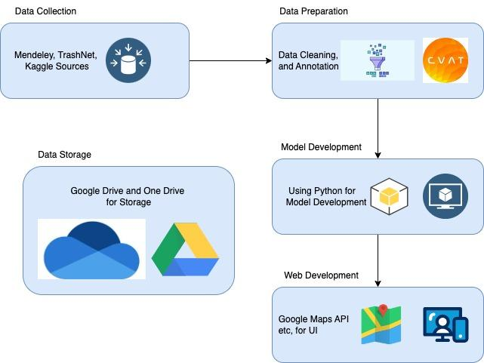

***Data Management and Data Repository Design***

The project's data management strategy revolves around the collection, organization, preprocessing, and utilization of datasets sourced from various platforms such as TrashNet, Mendeley, and Kaggle. Upon collection, these datasets, comprising images categorized into 11 waste categories, are systematically organized using a standardized naming scheme and folder hierarchy for ease of retrieval and analysis. These folders are stored in a shared Google Drive, ensuring accessibility and efficient storage management. To facilitate model training and validation, the data is further preprocessed and divided into train, validation, and test sets. The train and validation sets undergo annotation using tools like CVAT and Grounding Dino, with annotated images stored in designated folders. Utilizing Google Colab as the execution platform, the code is then run to train and validate models using the annotated images. The test set is subsequently employed to estimate model accuracy. Once waste categorization is achieved, with waste categorized as hazardous, biodegradable, disposable, or recyclable, recommendations are generated on proper disposal methods. These recommendations are tailored based on user preferences, offering guidance on hazardous waste disposal, composting, recycling, or safe disposal locations. Overall, this data management and repository design ensure systematic organization, efficient utilization, and user-centric waste management solutions. Figure 127 shows the storage repository design.

**Figure 127**

*Data Repository Design*

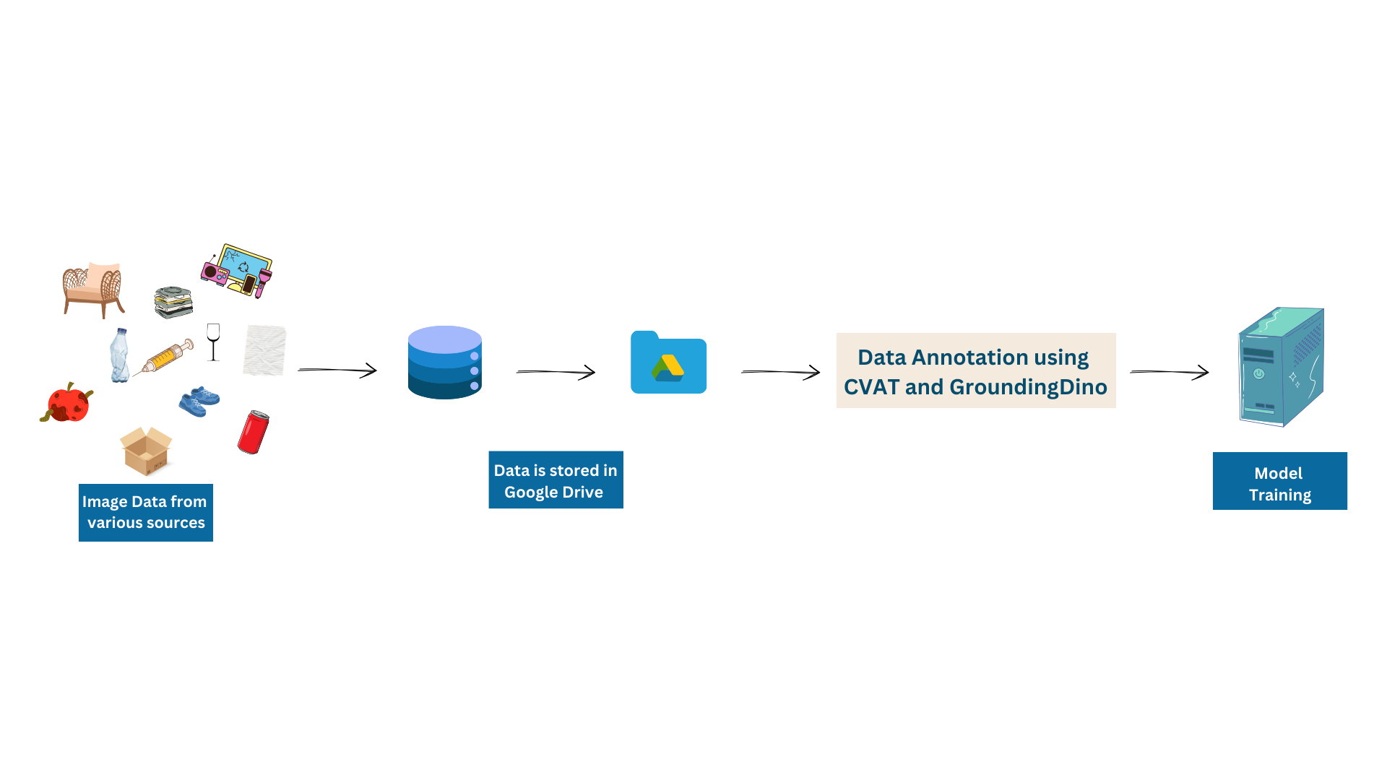

***System User Interface Design***

In the system architecture, the user interacts with the application through a camera interface, utilizing image detection capabilities to identify waste items in real-time. Upon capturing an image, the backend processes the data using the pre-trained YOLOv8 model, loaded from the saved .pt file. This model efficiently categorizes the waste item into its respective category based on the trained classification parameters.

If the detected waste item is classified as hazardous, the system immediately provides the user with information regarding nearby safe disposal locations. Leveraging location-based services and the Google Maps API, the system identifies and presents a list of designated hazardous waste disposal facilities or centers, ensuring proper and safe disposal of the hazardous item.

On the other hand, if the waste item is determined to be non-hazardous, the user is presented with options to decide the fate of the item: reuse, recycle, or dispose. For items deemed suitable for reuse or recycling, the system offers tailored recommendations based on the waste type. For instance, glass items may be recommended for reuse in DIY crafts, while cardboard items may be suggested for recycling at local recycling facilities. These recommendations are provided to the user based on the specific characteristics of the waste item and potential reuse or recycling opportunities.

In cases where disposal is the preferred option, the system once again utilizes the Google Maps API to recommend locations for safe disposal or donation of the waste item. Users are presented with a list of nearby disposal facilities, recycling centers, or donation centers where they can responsibly dispose of the waste item. Overall, the system's integrated approach seamlessly combines image detection, waste categorization, recommendation generation, and location-based services to empower users with actionable insights for effective waste management.

**Intelligent Solution**

***AI and Machine Learning Development***

The project's main objective centers on waste classification and providing recommendations for the disposal, recycling, upcycling, and safe disposal of household waste products. To achieve this, five models were developed, each tailored for specific tasks within the waste classification process. These models include Xception, InceptionResNet, ResNet-50, MobileNetV3, and YOLOv8. Throughout the development journey, image datasets sourced from platforms like TrashNet, Mendeley, and Kaggle served as the cornerstone. These datasets were meticulously organized and preprocessed, with tools like CVAT and Grounding Dino facilitating annotation tasks. TensorFlow and Keras provided the backbone for model training and implementation, while Google Colab served as the execution platform, leveraging its cloud-based infrastructure for seamless code execution.

In addressing the challenges of image processing across various contexts, a spectrum of machine learning solutions has been meticulously developed and applied. MobileNetV2 stands out for its optimization in mobile settings, where computational efficiency is paramount. Leveraging depthwise separable convolutions, MobileNetV2 strikes a delicate balance between performance and computational load, rendering it indispensable for resource-constrained devices. Conversely, Xception emerges as a versatile solution, adept at tackling a broad range of image classification tasks. Its deep architecture and employment of depthwise separable convolutions ensure precision in pattern recognition, though at the expense of substantial computational resources. InceptionResNetV2, blending Inception modules with residual blocks, excels in discerning intricate visual patterns, albeit demanding significant computational prowess. Meanwhile, ResNet-50, renowned for its role in combating the vanishing gradient problem, offers a compelling solution for general image classification with its moderate computational demands.

For tasks spanning object detection, classification, segmentation, and pose tracking, YOLOv8 Medium and YOLOv8 Small present notable options within the landscape of deep learning models. YOLOv8 Medium prioritizes accuracy, leveraging the Darknet architecture for robust performance across various applications. Conversely, YOLOv8 Small prioritizes speed and computational efficiency, making it a preferred choice for real-time applications where swift inference is critical.

In the pursuit of comprehensive image processing solutions, integrated approaches harness the strengths of multiple models. Combining models like Xception for detailed pattern recognition and MobileNetV2 for computational efficiency, integrated solutions strike a harmonious balance between accuracy and resource utilization. Similarly, ensembled models amalgamate predictions from diverse models such as InceptionResNetV2, ResNet-50, and YOLOv8 Medium to bolster overall performance and robustness, particularly in tasks like object detection and classification.

On a broader scale, the project is designed to revolutionize household waste management by integrating cutting-edge technologies. At its core, a Language Model (LLM) is employed to provide tailored recommendations for waste disposal, recycling, and upcycling based on the classification of waste items. This sophisticated model analyzes the characteristics of each waste item and generates personalized guidance for users, promoting sustainable practices and minimizing environmental impact. Additionally, the project harnesses the power of the Google Maps API to further assist users in waste disposal. By integrating with the API, the system recommends safe and convenient locations for waste disposal, taking into account factors such as proximity and user preferences. Whether users seek recycling facilities, donation centers, or hazardous waste disposal sites, the Google Maps API ensures accurate and up-to-date information for informed decision-making.

***Required Input Datasets, Expected Outputs***

The project begins by acquiring image datasets from various sources, including TrashNet, Mendeley, and Kaggle, comprising 11 distinct waste categories: paper, plastic, medical, metal, e-waste, biowaste, furniture, clothes, shoes, glass, and cardboard. To ensure data integrity and quality, preprocessing steps are implemented, such as removing duplicate images and irrelevant data. Subsequently, the dataset is divided into three subsets: train, validation, and test sets, facilitating effective model training and evaluation. For annotation purposes, advanced tools like Grounding Dino are utilized to annotate the majority of the dataset, while e-waste images undergo manual annotation using tools like CVAT. These annotated images serve as crucial inputs for training the machine learning models. The models, including Xception, InceptionResNet, ResNet-50, MobileNetv3, and YOLOv8, are trained on the annotated datasets to accurately classify waste items into their respective categories. Following the training phase, the models are rigorously tested on the designated test set to assess their performance and ensure accurate predictions. Once the prediction process is complete, the waste items are categorized into four main categories: hazardous, recyclable, disposable, and reusable. This categorization is essential for determining appropriate disposal methods and promoting sustainable waste management practices.

To further enhance user experience and provide personalized recommendations, the Language Model (LLM) is integrated into the system. Leveraging the LLM's natural language processing capabilities, the system generates tailored recommendations based on user preferences. Users are presented with options to dispose of the waste, recycle it, or reuse it, based on the categorized waste type and their specified preferences. Additionally, the Google Maps Places API is utilized to retrieve nearby locations for waste disposal based on the user's current location. By integrating location-based services, the system provides users with convenient access to disposal facilities, recycling centers, or donation centers, further facilitating responsible waste management practices.

**System Supporting Environment**

For the development of this project, a diverse array of Python libraries, tools, cloud platforms, and external resources were meticulously employed. These components collectively contributed to the creation of an intelligent garbage classification and waste management system aimed at addressing the pervasive issue of improper household waste disposal. Among these resources were platforms such as Mendeley and TrashNet, which provided access to diverse image datasets crucial for training and validating the system's machine learning models. Additionally, the integration of the Google Maps API enriched the system with location-based services, enabling personalized recommendations for waste disposal methods based on users' geographic locations. Furthermore, the utilization of Grounding Dino streamlined the data annotation process, facilitating the creation of a well-annotated training dataset essential for training accurate garbage classification models.

***Python Libraries***

Python plays a pivotal role in driving the development of the intelligent garbage classification and waste management system, serving as the primary programming language for implementing various machine learning algorithms and data processing tasks.

**TensorFlow and Keras.** TensorFlow and Keras stand as pivotal libraries for the development and training of sophisticated machine learning models within the project. With TensorFlow serving as the backbone for constructing computational graphs and executing machine learning operations efficiently across CPUs and GPUs, Keras provides a high-level API for building and training neural networks with ease. These libraries empower the implementation of state-of-the-art architectures such as Xception, InceptionResNet, ResNet-50, MobileNetv2, and YOLOv8, ensuring the system's capability in accurate garbage classification.

**Pandas and NumPy.** Pandas and NumPy serve as indispensable tools for managing and manipulating data efficiently. Pandas provides data structures and functions to work with structured data, facilitating tasks such as data loading, cleaning, and transformation. NumPy, on the other hand, offers support for numerical operations and multidimensional array manipulation, which are fundamental for processing image data within the system. Together, these libraries streamline the handling of diverse image datasets and annotations, ensuring smooth data flow throughout the garbage classification pipeline.

**Scikit-learn.** Scikit-learn is instrumental in evaluating the performance of the machine learning models deployed in the system. With a wide range of metrics and utilities for classification tasks, including accuracy, misclassification rates, and F1 score, Scikit-learn enables thorough analysis of model efficacy. Its intuitive API allows for seamless integration into the system's validation and verification phases, providing valuable insights into the classification accuracy and overall performance of the garbage classification models.

***Integrated Development Environment (IDE)***

Effective utilization of integrated development environments (IDEs) such as PyCharm and Jupyter Notebooks significantly accelerates the development process by providing comprehensive tools and features tailored for Python development and machine learning models.

**PyCharm.** PyCharm offers a robust integrated development environment tailored for Python development, particularly beneficial for ML projects. Its rich feature set, including code navigation, syntax highlighting, and refactoring tools, enhances developer productivity during the implementation and debugging of machine learning algorithms. PyCharm's seamless integration with version control systems like Git ensures efficient collaboration among team members, fostering a smooth development process for the garbage classification system.

**Google Colab.** Google Colab provides an interactive environment for prototyping and experimentation, well-suited for exploring data and iterating on ML models. The notebook interface allows developers to mix code, visualizations, and explanatory text, facilitating a narrative-driven approach to data analysis and model development. With its ability to run code in a modular and incremental manner, Colab promotes rapid iteration and exploration, making them invaluable for the early stages of developing the garbage classification system.

***Cloud Storage Platforms***

Leveraging cloud storage platforms like Google Drive and OneDrive ensures seamless collaboration and accessibility of project resources across distributed teams. These platforms serve as centralized repositories for storing and sharing datasets, model checkpoints, and documentation, promoting efficient collaboration and accessibility of project assets.

**Google Drive.** Google Drive serves as a centralized repository for storing and sharing project resources, including datasets, model checkpoints, and documentation. Its seamless integration with Google's suite of productivity tools enhances collaboration among team members, allowing for efficient data sharing and version management. Additionally, Google Drive's accessibility from various devices ensures that project assets are readily available to team members, regardless of their location or device.

**OneDrive.** OneDrive complements Google Drive by providing additional storage and backup options, enhancing data redundancy and accessibility within the project. Its synchronization features ensure that project files are securely backed up and accessible across multiple devices, safeguarding against data loss or corruption. With its seamless integration with Microsoft Office applications, OneDrive offers a familiar environment for managing project assets, further enhancing productivity and collaboration among team members

***External Resources and APIs***

Integration of external resources and APIs enhances the system's functionality and user experience. Leveraging APIs such as Google Maps API, along with platforms like Mendeley and TrashNet, enriches the system with valuable data sources and services, contributing to accurate garbage classification and tailored waste management recommendations.

**Mendeley, TrashNet and Kaggle.** Mendeley and TrashNet serve as valuable platforms for sourcing diverse image datasets, enriching the training data for garbage classification models. By accessing these repositories, the system can leverage a wide variety of garbage-related images, ensuring robustness across different waste disposal scenarios. Mendeley and TrashNet contribute to the creation of a well-annotated training dataset, essential for training accurate and reliable garbage classification models within the system.

**Grounding Dino.** Grounding Dino streamlines the data annotation process by providing tools and workflows for labeling images with garbage categories. By leveraging Grounding Dino's annotation capabilities, the system can efficiently generate high-quality annotations for the training dataset, enhancing the performance of the garbage classification models. This platform accelerates the data annotation workflow, enabling the system to process large volumes of image data effectively and expedite the development of the garbage classification system.

**Google Maps API.** The Google Maps API enriches the garbage classification system with location-based services, enabling tailored recommendations for waste disposal methods based on the user's geographic location. By leveraging Google Maps' comprehensive database of locations, the system can identify nearby waste disposal facilities, recycling centers, and donation centers, providing users with convenient and environmentally conscious options for waste management. Integrating this API enhances the system's utility and promotes sustainable waste management practices at the household level.

**System Evaluation and Visualization**

**Analysis of Model Execution and Evaluation Results**

In this project report, a range of metrics is employed to thoroughly assess the performance of classification and object detection models. For classification models, the confusion matrix is utilized to visually depict the alignment between predicted and actual classes, allowing for a comprehensive analysis of accuracy and errors. From this matrix, crucial metrics such as accuracy, precision, recall, and F1 score are derived, providing deep insights into the overall performance of the model and its ability to accurately classify instances.

For object detection models, reliance is placed on the mean Average Precision at 50 (mAP50) metric, which evaluates the precision of predicted bounding boxes against a specified threshold. For instance, the ResNet50 classification model demonstrates an F1-score of 0.91 and an accuracy of 91%, indicative of robust performance with a balanced trade-off between precision and recall. Similarly, the YOLOv8-l object detection model showcases an impressive mAP50 of 0.863 and mAP50-95 of 0.862, underscoring accuracy across diverse thresholds and classes. These meticulously calculated metrics offer a comprehensive evaluation of the models and serve as valuable benchmarks for future improvements and optimizations in the project.

**Achievements and Constraints**

In the project aimed at improving waste management practices, significant strides have been made in addressing the core challenges. By incorporating real-life photos and enhancing infrastructure and computational resources, notable improvements in the model's performance are anticipated. This expansion of the dataset to include objects in diverse environments is expected to enhance the model's ability to accurately classify and identify various types of waste, ensuring effectiveness in real-world scenarios where subtle visual differences in garbage items may occur.

Additionally, the plan to integrate a web application represents a crucial step towards broader adoption and utilization of the solution. This application, designed with a user-friendly interface, will empower individuals to actively participate in waste management efforts using their mobile devices. Furthermore, there is an aim to include a feature that links household-generated waste to relevant businesses selling corresponding items. This innovative connection not only fosters sustainability but also provides businesses with a platform to target products based on user consumption patterns, thereby promoting environmentally conscious purchasing habits. Such forward-thinking strategies have the potential to transform traditional waste management practices, creating a more adaptable system that effectively meets evolving consumer needs while promoting sustainability.

One limitation the project faces is in the high-level categorization of waste items, necessitated by the constraints of available resources. While the project encompasses a diverse range of waste categories, the classification system had to prioritize broader categorization to function effectively within existing resource limitations.

Moving forward, there is a clear aspiration to enhance the project's capabilities by accessing additional resources. This future scope entails refining the categorization process to a more granular level. By doing so, the recommendations generated can become more tailored and appropriate for each specific waste item, thereby significantly improving the overall efficacy and relevance of the project's recommendations.

**System Quality Evaluation of Model Functions and Performance**

The team has established a range of evaluation metrics to assess the correctness of the model, ensuring a comprehensive understanding of its performance across various dimensions. Real-time correctness is gauged by the model's ability to accurately detect the class to which a waste item belongs. With waste items categorized into 11 classes, the model must proficiently classify each item before transmitting the classification to the LLM for recommendation.

System performance is evaluated based on the efficiency of model training with the available resources. Initially, training the models posed a significant challenge due to the large volume of image data. However, this obstacle was overcome by scaling up resources, and reducing the training time from an entire day to just a couple of hours.

System response time is measured from the moment a user presents a waste item to the camera of the device or uploads an image into the system. While this duration may vary depending on the device's internet speed, it typically ranges between 3 to 5 seconds. Following classification, the recommendation system delivers a prompt response within 2 to 3 seconds.

**System Visualization**

Figure 128, displays the confusion matrix for the YoloV8 model, offering insight into the model's proficiency in accurately classifying waste items into their respective categories for recommendation.

**Figure 128**

*YoloV8 Confusion Matrix*



Figure 129 demonstrates the classification performed by the YoloV8 model on a multitude of images supplied to it. It showcases successful categorization of various waste items, paving the way for pertinent recommendations by the LLM for recycling or upcycling

**Figure 129**

*Detection Performance of YoloV8*

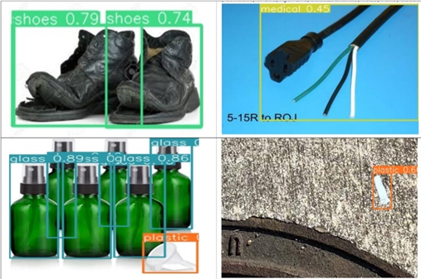

**Conclusion**

**Summary**

The project aimed to reduce improper disposal of waste at household level has made significant strides in addressing core challenges through a multifaceted approach. The development of an easy to use system for waste upcycling and recycling, aims to make households more environmentally conscious by making better waste disposal decisions. By incorporating real-life photos and enhancing infrastructure and computational resources, the project anticipates notable improvements in the model's performance. This includes the expansion of the dataset to include objects in diverse environments, enhancing the model's ability to accurately classify various types of waste. These enhancements are crucial for ensuring effectiveness in real-world scenarios where subtle visual differences in garbage items may occur. Additionally, the integration of a web application represents a pivotal step towards broader adoption and utilization of the solution. The user-friendly interface empowers individuals to actively participate in waste management efforts using their mobile devices.

Overall, the project's achievements hold implications for the field of waste management by showcasing innovative approaches to classification and recommendation systems. The ability to adapt to diverse environments and provide tailored recommendations has the potential to transform traditional waste management practices, creating a more adaptable and sustainable system that meets evolving consumer needs.

**Benefits and Shortcoming**

The project offers notable benefits, including improved accuracy through the integration of real-life photos and expansion of the dataset to diverse environments. This enhances waste classification, fostering more effective waste management practices. Additionally, the user-friendly web application interface encourages community engagement and participation in sustainable efforts. Moreover, linking the system with AI gives the user more options and ideas about how to properly dispose of their waste or utilize it to make decorative or useful things by the way of DIY. The incorporation of the Google Maps API enhances user experience by providing access to local disposal facilities for items like medical or hazardous waste. This feature not only simplifies waste disposal for users but also contributes to the safety of both individuals and municipal workers.

However, limitations exist, such as high-level waste categorization due to resource constraints, potentially leading to less precise recommendations. Resource limitations also initially posed challenges in model training, though addressed by scaling up resources. Furthermore, variability in system response time, influenced by device internet speed, may impact user experiences and real-time decision-making.

**Potential System and Model Applications**

Beyond its primary function as a household tool, the Waste Management System can also serve as a starting point to develop a bigger automated waste segregation system for municipal organizations. Additionally, it can be utilized as an educational tool in schools and community centers to raise awareness about waste management practices. By demonstrating the importance of proper waste segregation and disposal, the system fosters environmentally conscious behaviors among students and community members. Furthermore, businesses can integrate the system into their sustainability initiatives, using it to track and manage waste generated within their premises. This can help identify areas for improvement in waste reduction and recycling efforts, leading to cost savings and environmental benefits**.**

**Experience and Lessons Learned**

The project involved a comprehensive journey through various stages of data processing, from collecting data from multiple sources to merging, cleaning, and transforming it. Data cleaning, although relatively straightforward due to the requirement of removing images with only text, was a crucial step to ensure the quality of the dataset. Augmenting the data likely helped in improving model performance by diversifying the training set. However, the most significant challenge was encountered during data annotation.

Choosing the right annotation tool is critical for efficient and accurate labeling. While CVAT was effective for manual annotation, grounding dino proved useful for automating the annotation process. However, it's essential to recognize limitations, such as the inability to recognize certain categories like e-waste.Despite advancements in automation, certain categories may still require manual annotation. In this case, e-waste images had to be manually annotated due to recognition issues. This highlights the importance of flexibility in the annotation process and being prepared for manual intervention when necessary.

The size of the dataset directly impacts the computational resources required for training models. In this project, the dataset was large, necessitating high-memory GPUs for efficient model training. Future projects should consider the scalability of the dataset and allocate appropriate resources accordingly.Proper resource allocation, including hardware and software, is crucial for the success of the project. Investing in high-memory GPUs upfront can save time and resources in the long run by facilitating smoother model training processes.

While a large dataset is beneficial, ensuring the quality of the data is paramount. Prioritizing data quality over quantity can lead to more accurate models and ultimately better results. This includes thorough data cleaning, meticulous annotation, and validation procedures. Throughout the project, continuous evaluation and refinement of the data and models are essential. This includes regularly assessing the performance of annotation tools, data augmentation techniques, and model training strategies to identify areas for improvement and optimization.

Overall, this project provided valuable insights into the challenges and best practices associated with managing large-scale data processing tasks, particularly in the context of computer vision projects. By carefully navigating through these challenges and applying lessons learned, future projects can be executed more efficiently and effectively.

**Recommendations for Future Work**

***Real-life Photo Integration***

For future projects, consider actively collecting and incorporating more real-life photos of waste items into the dataset. This can be done by crowdsourcing or collaborating with local waste management organizations to gather diverse images representing different types of household waste. Additionally, implementing data augmentation techniques specific to real-life scenarios, such as varying lighting conditions and backgrounds, can further enhance the dataset's robustness and improve model performance.

***Infrastructure Enhancement***

To address the need for improved infrastructure and processing resources, future projects should explore cloud-based solutions and distributed computing frameworks. Utilizing platforms like AWS, Google Cloud, or Microsoft Azure can provide access to scalable resources for training and inference tasks, enabling more efficient model development and deployment. Additionally, investing in GPU acceleration and parallel processing techniques can further optimize model performance and reduce training time.

***Environmental Variation***

To enable better model generalization and accurate waste classification across varied environments, future projects should focus on diversifying the dataset to include images captured in different settings, such as urban, suburban, and rural areas. This can involve collaborating with stakeholders in various regions to collect data representative of local waste disposal practices and environmental conditions. Additionally, incorporating techniques like domain adaptation and transfer learning can help the model adapt to new environments and improve classification accuracy.

***Continuous Data Enrichment***

Given the dynamic nature of waste composition and disposal practices, future projects should prioritize continuous data enrichment efforts. This involves regularly updating the dataset with new waste items, classification labels, and relevant metadata to ensure the model remains up-to-date and adaptable to evolving waste management needs. Collaborating with local waste management authorities, recycling facilities, and environmental organizations can provide valuable insights and access to real-time data sources for ongoing dataset expansion.

***Localization and Multilingual Support***

Recognizing the global nature of waste management challenges, future projects should prioritize localization and multilingual support to cater to diverse communities and regions. This involves translating user interfaces, instructional materials, and recommendation systems into multiple languages to ensure accessibility and usability for non-English speaking populations. Collaborating with local language experts, community leaders, and cultural organizations can help tailor the system to specific linguistic and cultural contexts, enhancing its relevance and adoption worldwide.

**Contributions and Impacts on Society**

The project's focus on enhancing waste management through advanced computer vision and machine learning technologies offers significant contributions to cultural, economic, educational, and social well-being across diverse and multicultural contexts. By promoting sustainable practices and raising awareness about proper waste disposal and recycling, the project fosters a cultural shift towards environmental stewardship and responsibility, transcending cultural boundaries and promoting a shared commitment to the planet. Economically, the project leads to cost reductions in waste management by minimizing landfill congestion and redirecting resources towards other essential services, contributing to economic growth and efficiency at local and national levels. Through accessible educational resources and community engagement initiatives, the project empowers individuals with the knowledge and skills needed to make informed decisions about waste management, fostering a culture of lifelong learning and environmental literacy. Furthermore, the project strengthens social cohesion and resilience by engaging diverse stakeholders in collaborative partnerships and promoting collective action towards common environmental goals. Globally, the project's scalability and replicability enable its impact to extend beyond borders, inspiring similar initiatives and catalyzing a global movement towards sustainable waste management and environmental conservation. The project contributes to building a more resilient and sustainable future for all.

**References**

Ahmed, M. I. B., Alotaibi, R., Alqahtani, R., Alqahtani, R., Al-Hetela, S. S., Al-Matar, K. A., Al-Saqer, N. K., Rahman, A., Saraireh, L., Youldash, M., & Krishnasamy, G. (2023). Deep Learning approach to recyclable Products Classification: towards sustainable waste management. Sustainability, 15(14), 11138. https://doi.org/10.3390/su151411138

Alawi, A. E. B., Saeed, A. Y. A., Almashhor, F., Al-Shathely, R., & Hassan, A. N. (2021). Solid waste classification using deep learning techniques. 2021 International Congress of Advanced Technology and Engineering (ICOTEN). https://doi.org/10.1109/icoten52080.2021.9493430

Alfatmi, K., Shinde, F. S., Shahade, M., Sharma, S., Aruja, S. S., & Chaudhari, T. Y. (2023). E-Safe: An E-waste Management and Awareness Application using YOLO Object Detection. *International Conference on Intelligent Computing and Control Systems*. https://doi.org/10.1109/iciccs56967.2023.10142705

Aral, R. A., Keskin, Ş. R., Kaya, M., & Haciömeroğlu, M. (2018). Classification of TrashNet Dataset Based on Deep Learning Models. *IEEE*. https://doi.org/10.1109/bigdata.2018.8622212

Bao, K., Zhang, J., Zhang, Y., Wang, W., Feng, F., & He, X. (2023). TALLRec: An Effective and Efficient Tuning Framework to Align Large Language Model with Recommendation. arXiv (Cornell University). https://doi.org/10.48550/arxiv.2305.00447

Chollet, F. (2017). Xception: Deep Learning with Depthwise Separable Convolutions. *IEEE*. https://doi.org/10.1109/cvpr.2017.195

De Carolis, B., Francesco, L., & Macchiarulo, N. (2020). YOLO TrashNet: Garbage Detection in Video Streams. *IEEE*. https://doi.org/10.1109/eais48028.2020.9122693

Ekundayo, O., Murphy, L. D., & Pathak, P. (2021). An On-Device deep learning framework to encourage the recycling of waste. In Lecture notes in networks and systems (pp. 405–417). https://doi.org/10.1007/978-3-030-82199-9_26

Fernandes, K. (2020, October 30). Why it’s important to segregate waste at home - The CSR Journal. The CSR Journal. https://thecsrjournal.in/why-its-good-to-segregate-waste-at-home/

Garbage Classification (12 classes). (2021, January 24). Kaggle. [Data set] https://www.kaggle.com/datasets/mostafaabla/garbage-classification

Ghatkamble, R., Parameshachari, B. D., & Pareek, P. K. (2022). YOLO Network Based Intelligent Municipal Waste Management in Internet of Things. *Nternational Conference on Emerging Research in Electronics, Computer Science and Technology*. <https://doi.org/10.1109/icerect56837.2022.10060062>

Gurumurthy, S., & Manga, S. (2020). *Furniture Identification*. Kaggle. https://www.kaggle.com/competitions/day-3-kaggle-competition

Han, W. (2021). A YOLOV3 System for Garbage Detection Based on MobileNetV3_Lite as Backbone. 2021 International Conference on Electronics, Circuits and Information Engineering (ECIE). https://doi.org/10.1109/ecie52353.2021.00061

He, K. (2016). *Deep residual learning for image recognition*. <https://openaccess.thecvf.com/content_cvpr_2016/html/He_Deep_Residual_Learning_CVPR_2016_paper.html>

Ji, J., Li, Z., Xu, S., Hua, W., Ge, Y., Tan, J., & Zhang, Y. (2023). GenREC: Large Language model for Generative Recommendation. arXiv (Cornell University). https://doi.org/10.48550/arxiv.2307.00457

Jin, S., Yang, Z., Królczyk, G. M., Liu, X., Gardoni, P., & Li, Z. (2023). Garbage detection and classification using a new deep learning-based machine vision system as a tool for sustainable waste recycling. Waste Management, 162, 123–130. https://doi.org/10.1016/j.wasman.2023.02.014

Kang, Y., Si, W., Jin, H., Zhou, H., & Zhu, Q. (2020). Multi-label Garbage Image Classification Based on Deep Learning. IEEE Xplore. https://doi.org/10.1109/dcabes50732.2020.00047

Komathi, B. J., Nithiya, C., Rajalakshmi, S., A, S. R., Jaswanth, & K, H. V. (2023). Adaptive Domestic Waste Segregation using Image Classification. 2023 7th International Conference on Computing Methodologies and Communication (ICCMC). https://doi.org/10.1109/iccmc56507.2023.10083805

Kumsetty, N. V., Nekkare, A. B., S, S. K., & M, A. K. (2022). TrashBox: Trash Detection and Classification using Quantum Transfer Learning. 2022 31st Conference of Open Innovations Association (FRUCT). [Data set] https://doi.org/10.23919/fruct54823.2022.9770922

Kunwar, S. (2023). MWASTE: A Deep learning approach to manage household waste. arXiv (Cornell University). https://doi.org/10.48550/arxiv.2304.14498

Lee, S. (2021). Novel classification method of plastic wastes with optimal hyperparameter tuning of Inception_ResnetV2. 2021 4th International Conference on Information and Communications Technology (ICOIACT). https://doi.org/10.1109/icoiact53268.2021.9563917

Li, J., Chen, J., Sheng, B., Li, P., Yang, P., Feng, D. D., & Qi, J. (2022a). Automatic detection and classification system of domestic waste via multimodel cascaded convolutional neural network. IEEE Transactions on Industrial Informatics, 18(1), 163–173. https://doi.org/10.1109/tii.2021.3085669

Li, S., Yan, M., & Xu, J. (2020). Garbage object recognition and classification based on Mask Scoring RCNN. 2020 International Conference on Culture-oriented Science & Technology (ICCST). https://doi.org/10.1109/iccst50977.2020.00016

Liu, C., Xie, N., Yang, X., Chen, R., Chang, X., Zhong, R. Y., Peng, S., & Liu, X. (2022). A domestic trash detection model based on improved YOLOX. Sensors, 22(18), 6974. <https://doi.org/10.3390/s22186974>

Liu, S., Zeng, Z., Ren, T., Li, F., Zhang, H., Yang, J., Li, C., Yang, J., Su, H., Zhu, J., & Zhang, L. (2023). Grounding DINO: Marrying DINO with Grounded Pre-Training for Open-Set Object Detection. *arXiv (Cornell University)*. https://doi.org/10.48550/arxiv.2303.05499

Malik, M., Sharma, S., Uddin, M., Chen, C., Wu, C., Soni, P., & Chaudhary, S. (2022). Waste Classification for Sustainable Development Using Image Recognition with Deep Learning Neural Network Models. Sustainability, 14(12), 7222. https://doi.org/10.3390/su14127222

Manna, S. C. (2022b). Small Sample Estimation of Classification Metrics. *Small Sample Estimation of Classification Metrics*. https://doi.org/10.1109/irtm54583.2022.9791645

McDonald, J. (2022, July 13). How much waste does the U.S. produce? Dumpsters.com. https://www.dumpsters.com/blog/us-trash-production#:~:text=The%20U.S.%20produces%20268%20million,to%20limit%20our%20trash%20production%3F

Namoun, A., Tufail, A., Khan, M. Y., Alrehaili, A., Syed, T. A., & Benrhouma, O. (2022). Solid Waste Generation and Disposal using Machine Learning Approaches: A survey of Solutions and challenges. Sustainability, 14(20), 13578. https://doi.org/10.3390/su142013578

National Overview: Facts and figures on materials, wastes and recycling | US EPA. (2022, December 3). US EPA. https://www.epa.gov/facts-and-figures-about-materials-waste-and-recycling/national-overview-facts-and-figures-materials

Nnamoko, N. (2023). Waste Classification Dataset. Mendeley Data. [Data set] https://doi.org/10.17632/n3gtgm9jxj.3

Olugboja, A., & Wang, Z. (2019). Intelligent Waste Classification System using Deep Learning convolutional neural network. Procedia Manufacturing, 35, 607–612. https://doi.org/10.1016/j.promfg.2019.05.086

Pandita, H. S., Vaidya, V., Doifode, M., Bhavthankar, P., & Venkatesh, A. (2022). Garbage Classification using Machine Learning to Aid Recycling. 2022 3rd International Conference for Emerging Technology (INCET). https://doi.org/10.1109/incet54531.2022.9824215

Poojary, H. D., Shinde, N. M., Singh, A., Kothuru, V., Kshirsagar, S. B., & Agarwal, H. (2022). Classification of Garbage For Robtic System Using Deep Learning Techniques. 2022 6th International Conference on Intelligent Computing and Control Systems (ICICCS). https://doi.org/10.1109/iciccs53718.2022.9788240

Poudel, S., & Poudyal, P. (2022). Classification of Waste Materials using CNN Based on Transfer Learning. *Proceedings of the 14th Annual Meeting of the Forum for Information Retrieval Evaluation*. https://doi.org/10.1145/3574318.3574345

Qin, J., Wang, C., Xu, R., Yang, S., & Chen, B. (2022). A robust framework combined saliency detection and image recognition for garbage classification. Waste Management, 140, 193–203. https://doi.org/10.1016/j.wasman.2021.11.027

Ramsurrun, N., Suddul, G., Armoogum, S., & Foogooa, R. (2021). Recyclable Waste Classification Using Computer Vision And Deep Learning. IEEE. https://doi.org/10.1109/zinc52049.2021.9499291

Rismiyati, Endah, S. N., Khadijah, K., & Shiddiq, I. N. (2020). Xception Architecture Transfer Learning for Garbage Classification. IEEE. <https://doi.org/10.1109/icicos51170.2020.9299017>

Sandler, M., Howard, A., Zhu, M., Zhmoginov, A., & Chen, L. (2018). MobileNetV2: Inverted residuals and linear bottlenecks. arXiv (Cornell University). https://doi.org/10.48550/arxiv.1801.04381

StackPath. (n.d.). https://www.recyclingtoday.com/article/the-woes-of-poorly-sorted-waste--an-industry-perspective/#:~:text=On%20average%2C%20over%2025%20percent,diverted%20to%20landfills%20%5B1%5D.

Stout, J. (2021, October 20). How much trash does America really produce? Environment America. https://environmentamerica.org/articles/how-much-trash-does-america-really-produce/

Szegedy, C., Ioffe, S., Vanhoucke, V., & Alemi, A. (2016). Inception-V4, Inception-ResNet and the impact of residual connections on learning. *arXiv (Cornell University)*. https://doi.org/10.48550/arxiv.1602.07261

Tatke, A., Patil, M., Khot, A., Jadhav, P., & Karad, V. (2021). HYBRID APPROACH OF GARBAGE CLASSIFICATION USING COMPUTER VISION AND DEEP LEARNING. International Journal of Engineering Applied Science and Technology, 5(10). https://doi.org/10.33564/ijeast.2021.v05i10.032

Terven, J. R., & Cordova-Esparza, D. (2023). A comprehensive review of YOLO: from YOLOV1 and beyond. *arXiv (Cornell University)*. https://doi.org/10.48550/arxiv.2304.00501

Tiyajamorn, P., Lorprasertkul, P., Assabumrungrat, R., Poomarin, W., & Chancharoen, R. (2019). Automatic Trash Classification using Convolutional Neural Network Machine Learning. 2019 IEEE International Conference on Cybernetics and Intelligent Systems (CIS) and IEEE Conference on Robotics, Automation and Mechatronics (RAM). https://doi.org/10.1109/cis-ram47153.2019.9095775

Topic: Waste generation worldwide. (2023, August 31). Statista. https://www.statista.com/topics/4983/waste-generation-worldwide/#topicOverview

Vidhya, S. (2023). A Systematic Review of Machine Learning Approaches for Trash Classification. IEEE Xplore. https://doi.org/10.1109/icoei56765.2023.10125688

*Work breakdown structure*. (n.d.). workbreakdownstructure.com. https://www.workbreakdownstructure.com/

Wu, T., Zhang, H., Wei, P., Liu, F., & He, P. (2023). Applications of convolutional neural networks for intelligent waste identification and recycling: A review. Resources Conservation and Recycling, 190, 106813. https://doi.org/10.1016/j.resconrec.2022.106813

Wu, Z., Li, H., Wang, X., Wu, Z., Zou, L., Xu, L., & Tan, M. (2022). New benchmark for household garbage image recognition. Tsinghua Science & Technology, 27(5), 793–803. https://doi.org/10.26599/tst.2021.9010072

Wu, Z., Zhang, D., Shao, Y., Zhang, X., Zhang, X., Feng, Y., & Cui, P. (2021). Using YOLOv5 for Garbage Classification. IEEE. https://doi.org/10.1109/prai53619.2021.9550790

Yang, J., Zeng, Z., Wang, K., Zou, H., & Xie, L. (2021). GarbageNet: a unified learning framework for robust garbage classification. IEEE Transactions on Artificial Intelligence, 2(4), 372–380. <https://doi.org/10.1109/tai.2021.3081055>

Zhang, H., Li, F., Liu, S., Zhang, L., Su, H., Zhu, J., Ni, L. M., & Shum, H. (2022). DINO: DETR with Improved DeNoising Anchor Boxes for End-to-End Object Detection. *arXiv (Cornell University)*. https://doi.org/10.48550/arxiv.2203.03605

Zhao, L., Pan, Y., Wang, S., Zhang, L., & Islam, S. (2021). Skip-YOLO: Domestic garbage detection using deep learning method in complex multi-scenes. *Research Square (Research Square)*. https://doi.org/10.21203/rs.3.rs-757539/v1

Zhen, Y., & Liu, J. (2022). A hybrid deep learning model for trash classification based on deep transfer learning. Journal of Electrical and Computer Engineering, 2022, 1–9. <https://doi.org/10.1155/2022/7608794>

**APPENDIX A**

Anvil platform is used to create a website titled ‘Waste To Wow’ for the ease of utilizing python eliminating the need for using HTML,CSS, or JavaScript. Figure A1 shows the initial page of the web application. It has four main sections. The first section at the top left is the placeholder for the images that can be uploaded via upload button. The second section at the top right depicts the four trash cans belonging to the four household waste categories - Biodegradable, Recyclable, Hazardous, and Home Goods. The bottom right section is the text area for recommendations and the bottom right container is the placeholder for Google Maps. Whenever an image is uploaded via upload button, it sends the image at the backend where the model detects the object in the image and returns corresponding recommendation to upcycle, recycle or dispose of the object along with the disposal google maps locations. The respective placeholders are then filled with this data and the corresponding trash can and its label is highlighted.

**Figure A1**

*Initial Window*

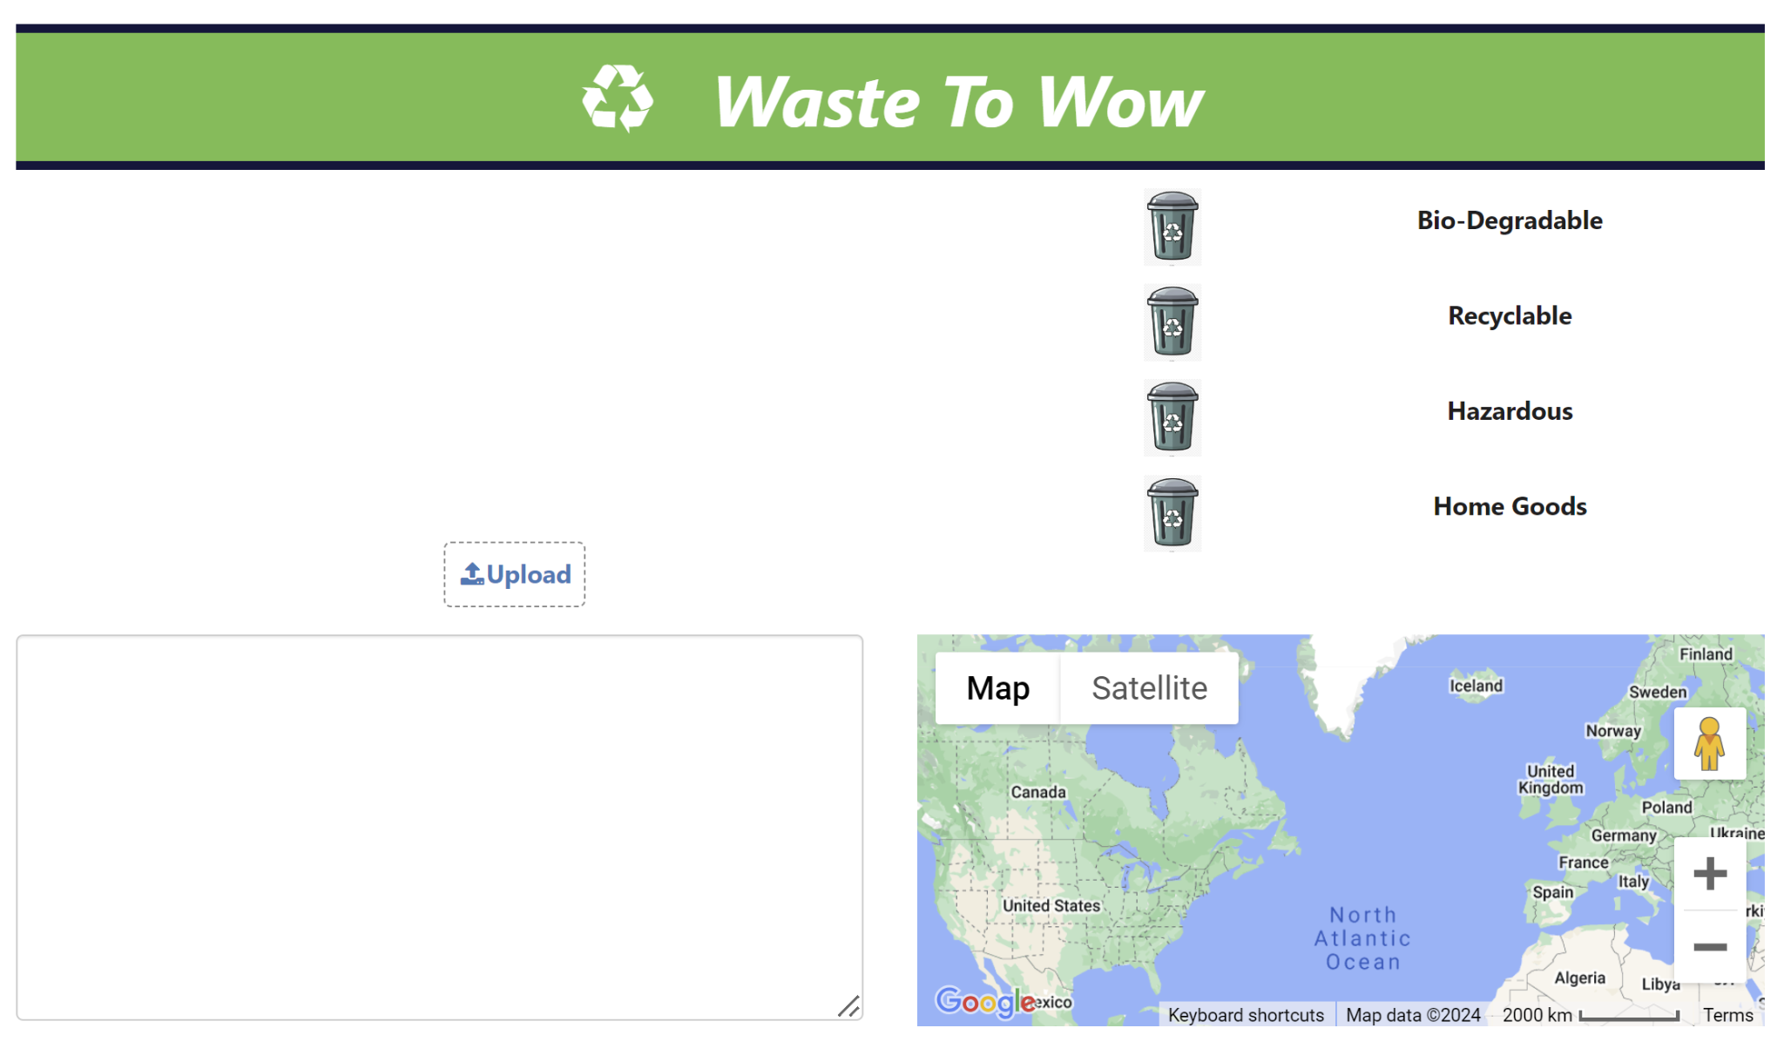

Figure A2 to Figure A12 are some of the samples from each of the eleven categories where the respective category is highlighted, recommendations and google map locations are suggested.

**Figure A2**

*Glass*

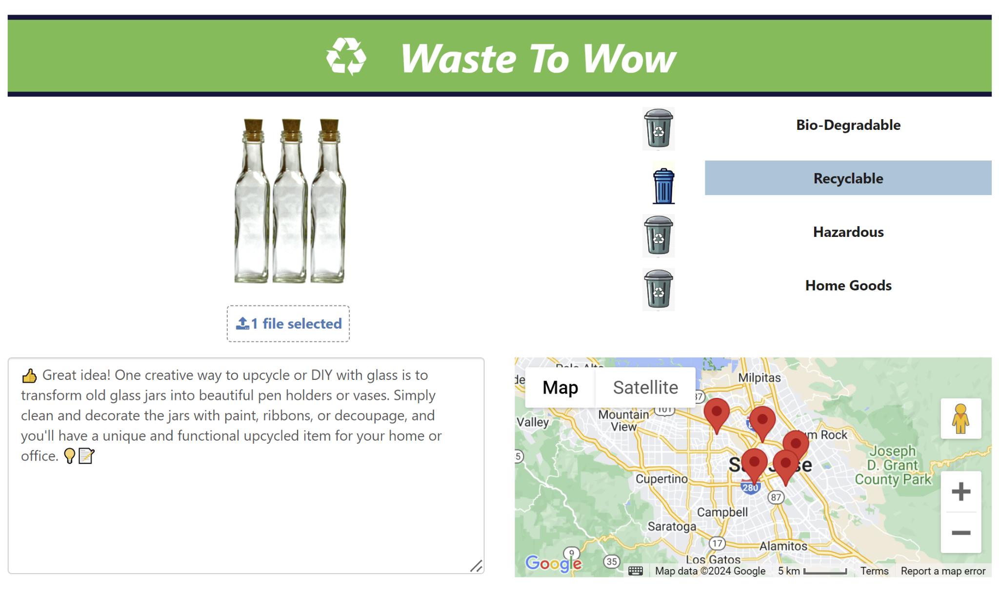

**Figure A3**

*Biowaste*

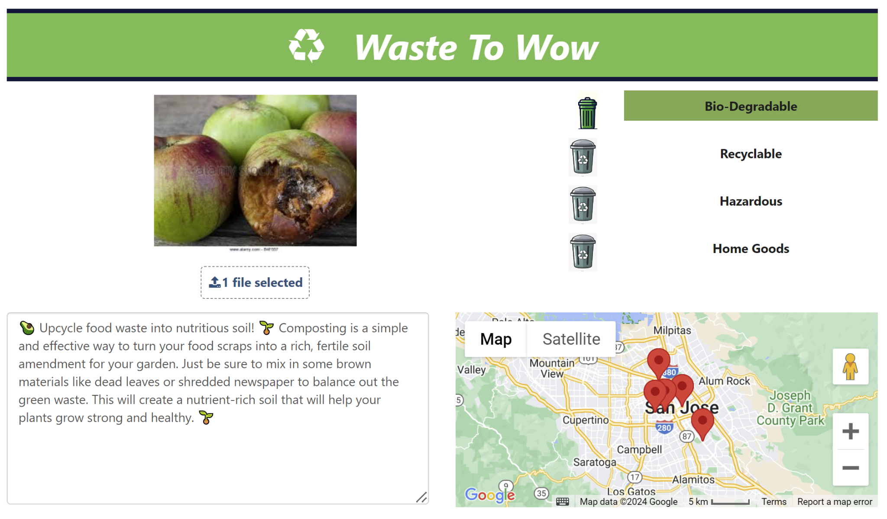

**Figure A4**

*Cardboard With Different Recommendations*

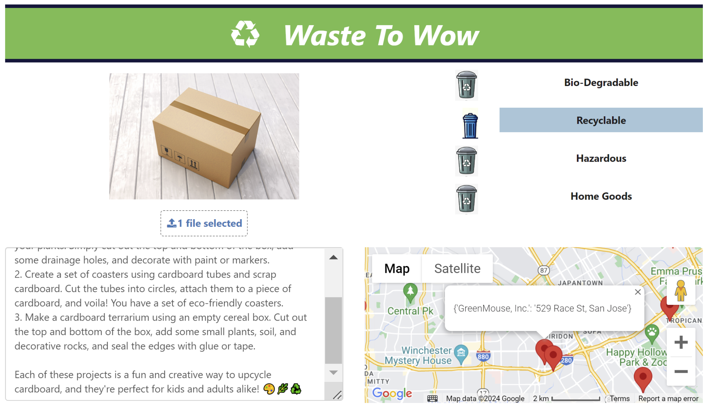

**(a)**

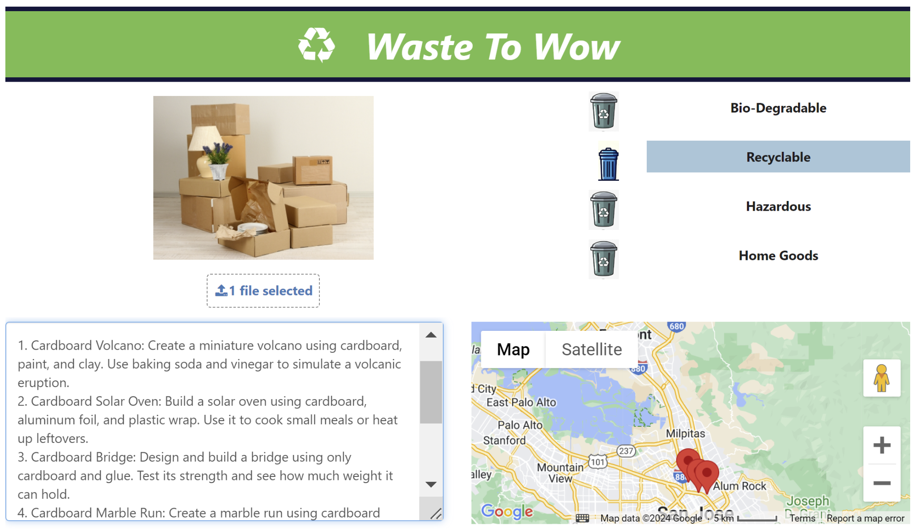

**(b)**

**Figure A5**

*Clothes*

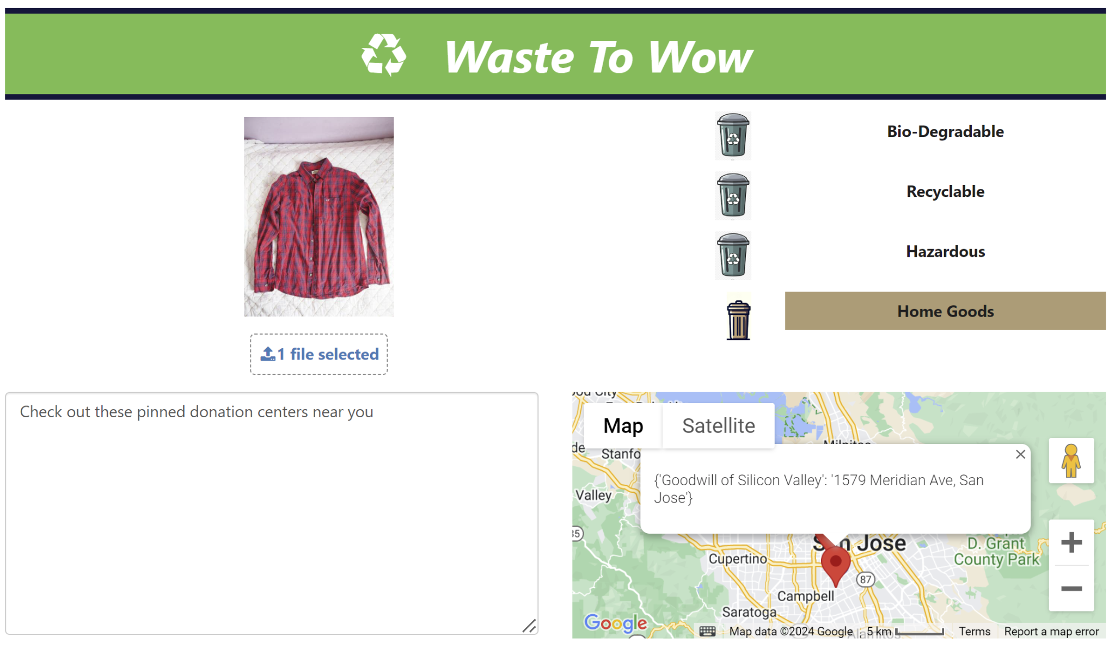

**Figure A6**

*Shoes*

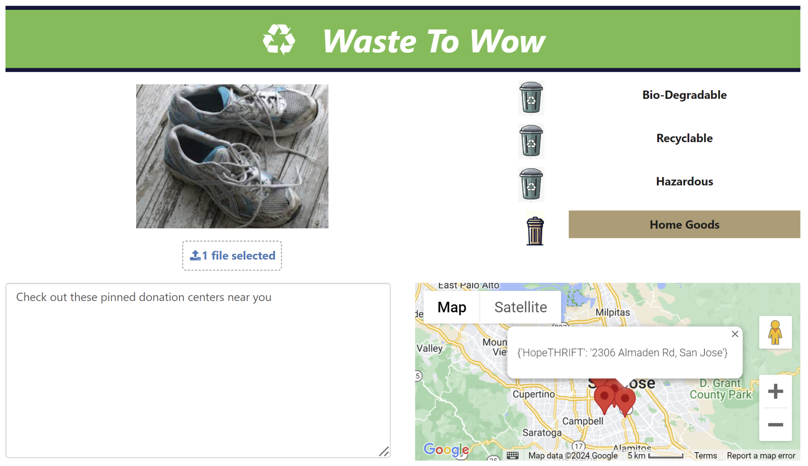

**Figure A7**

*Electronic Waste*

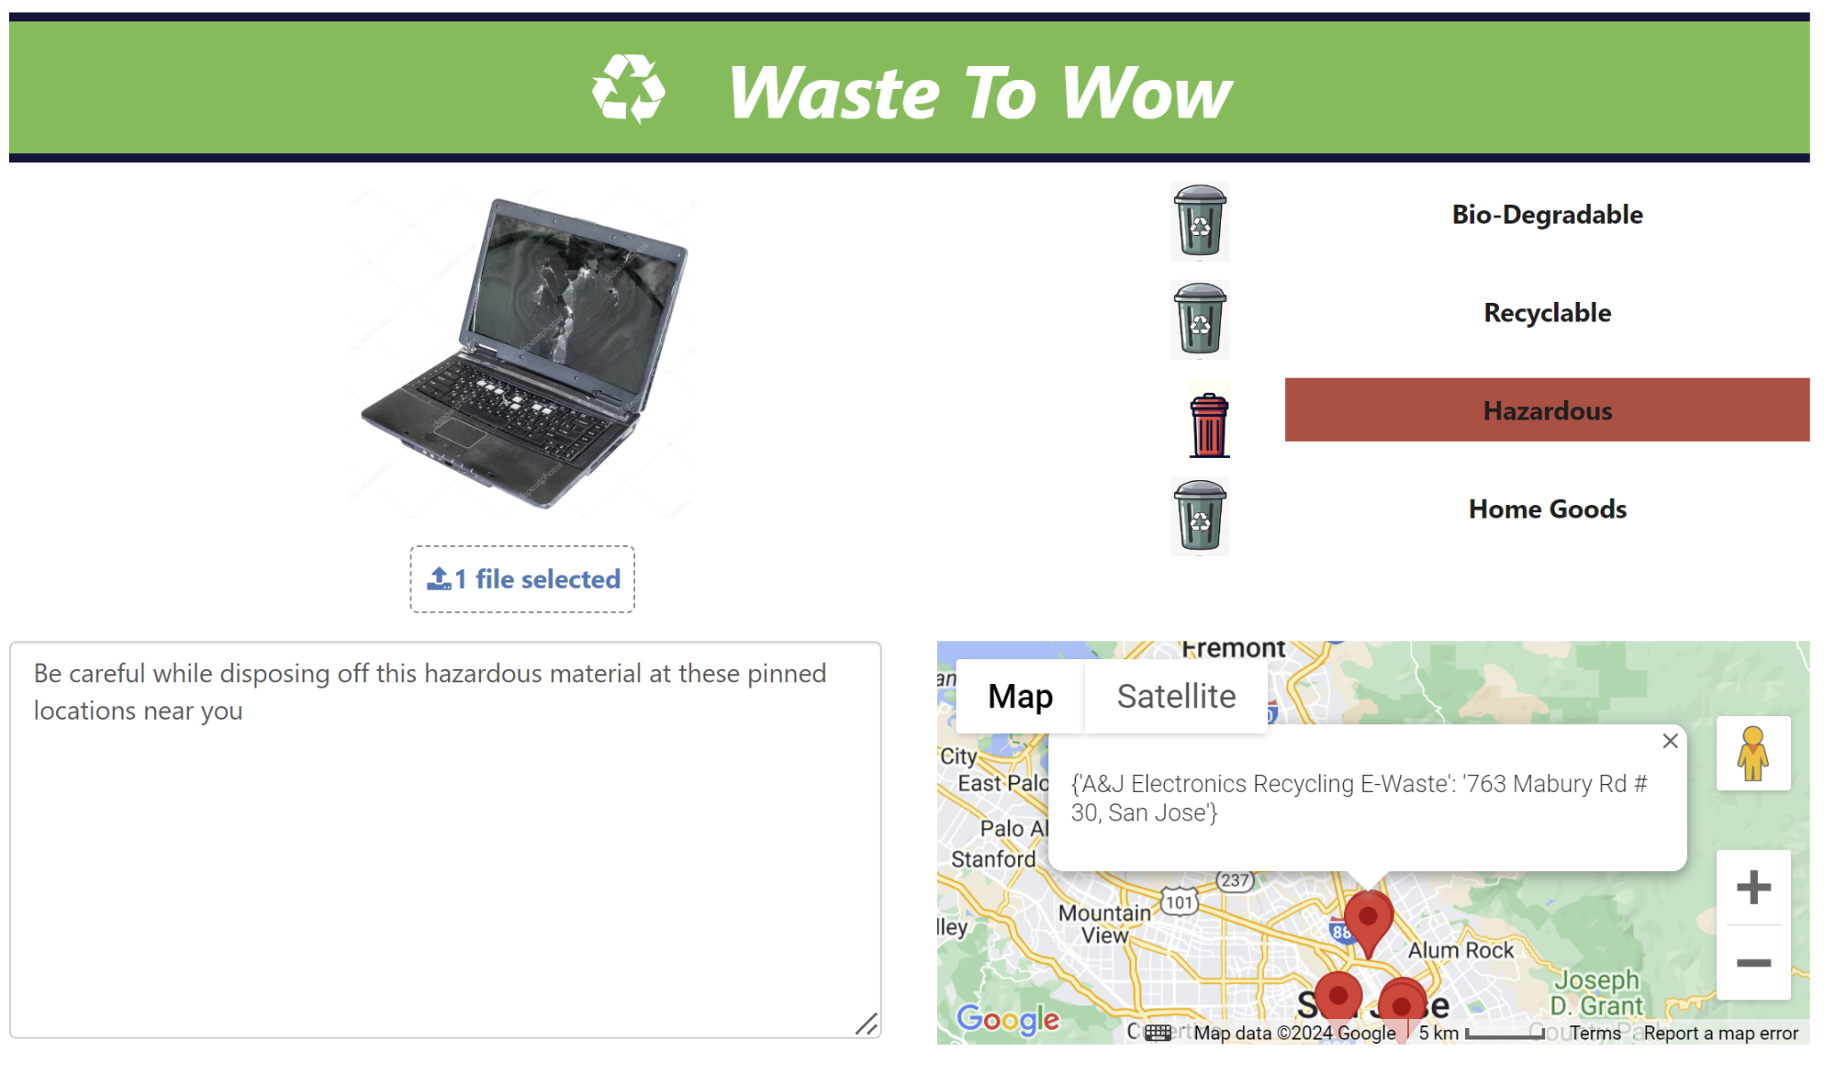

**Figure A8**

*Furniture*

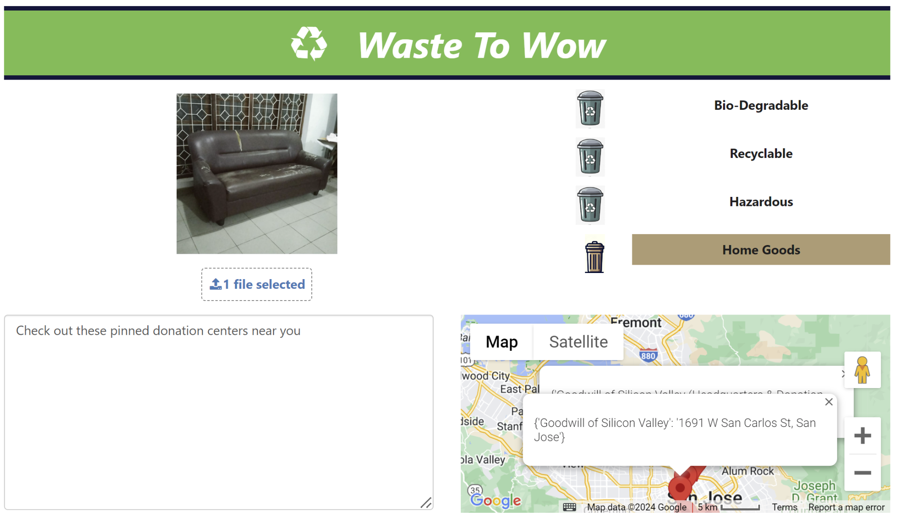

**Figure A9**

*Medical*

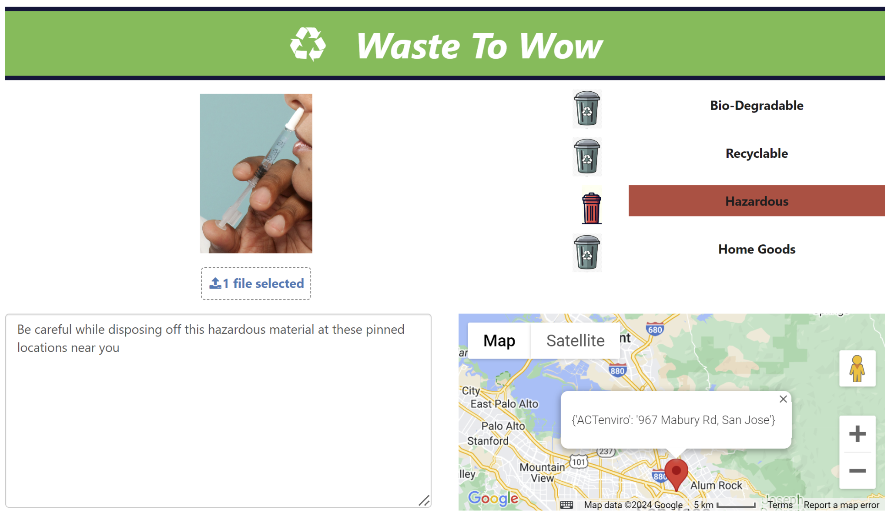

**(a)**

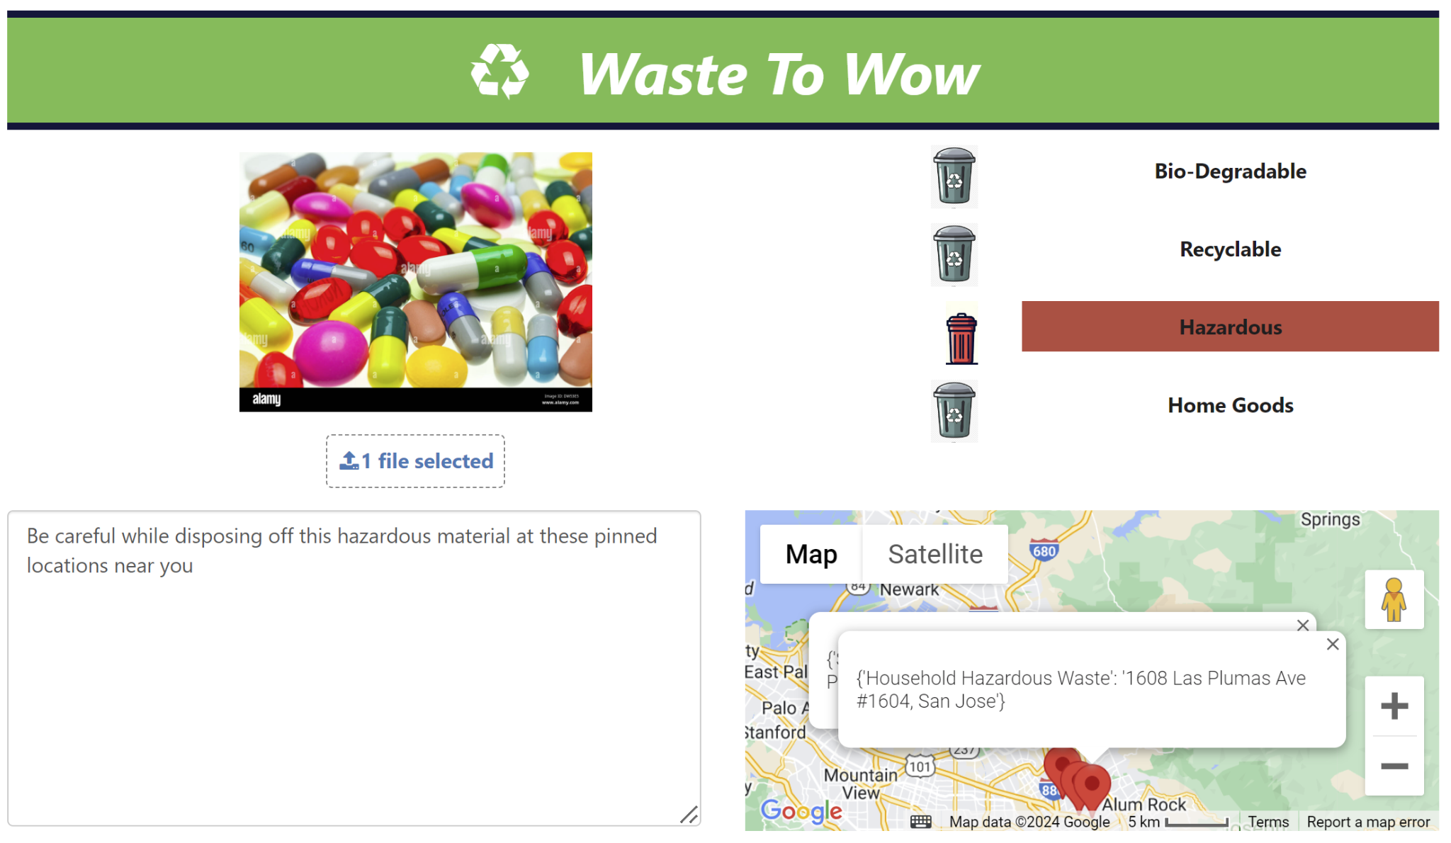

**(b)**

**Figure A10**

*Metal*

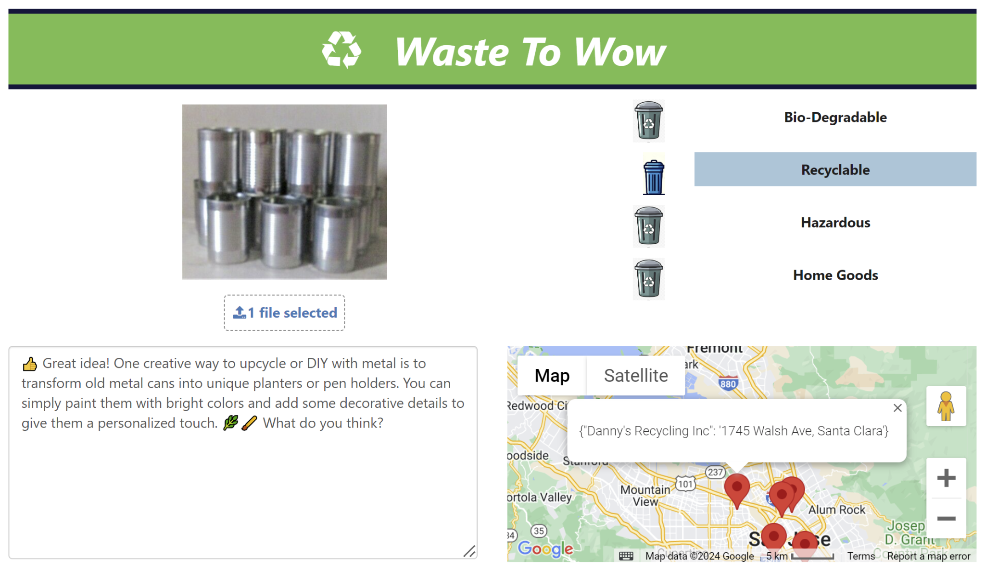

(a)

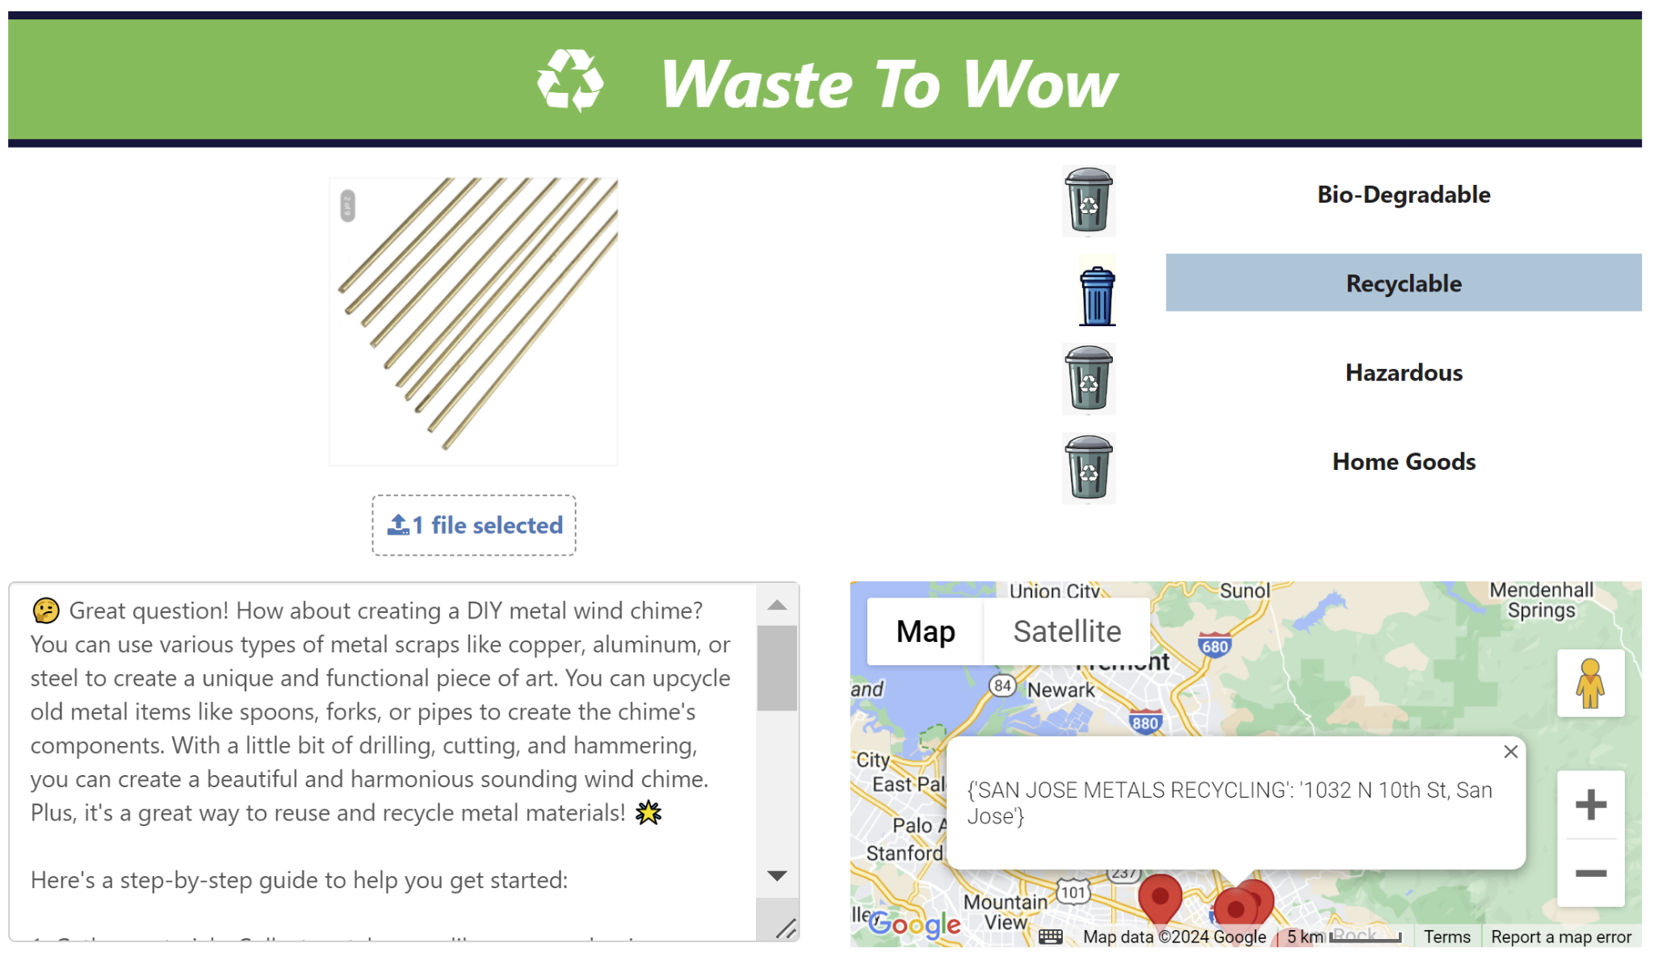

(b)

**Figure A11**

*Paper*

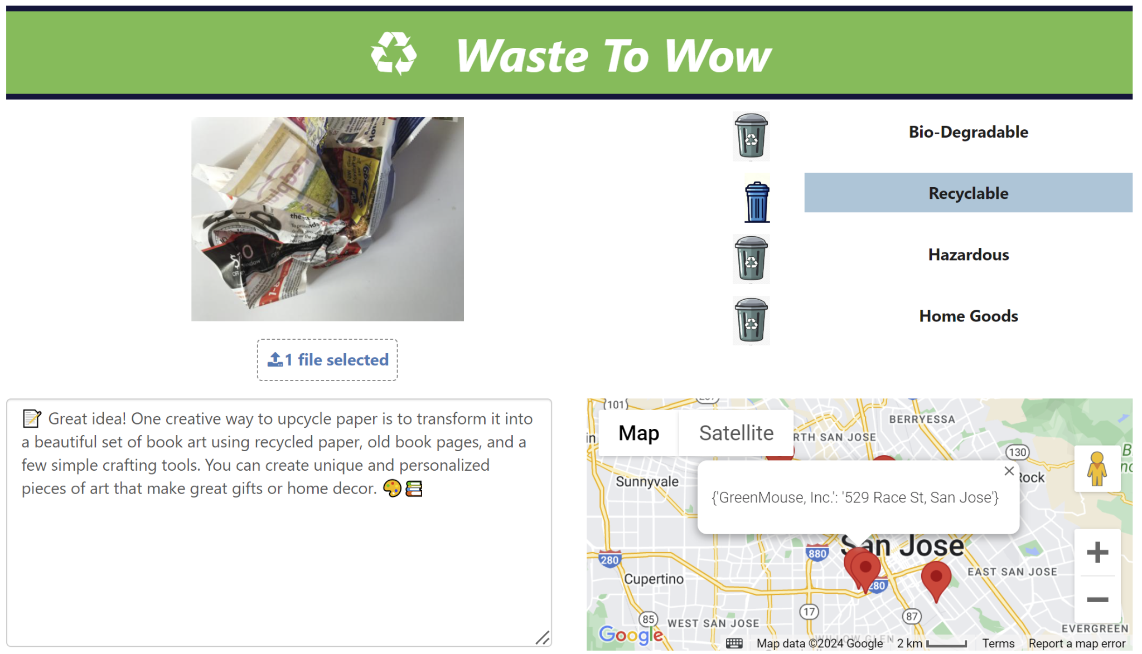

(a)

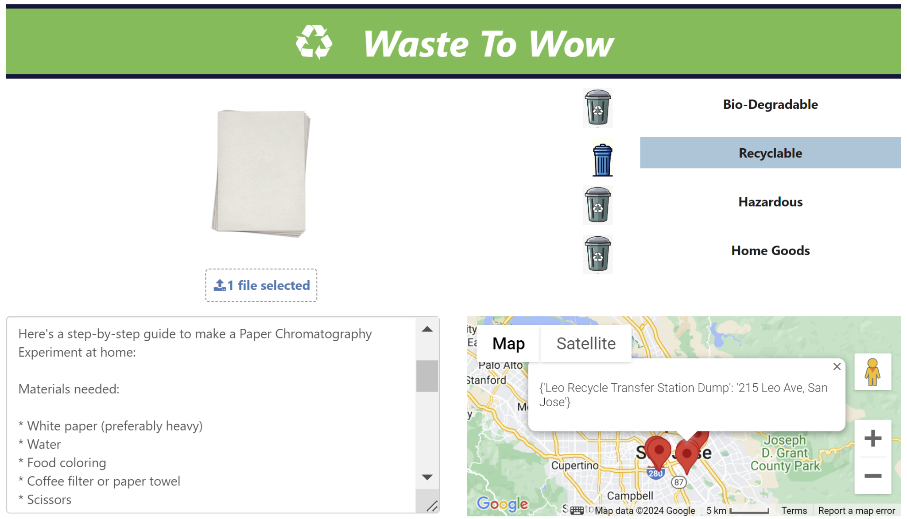

(b)

**Figure A12**

*Plastic*

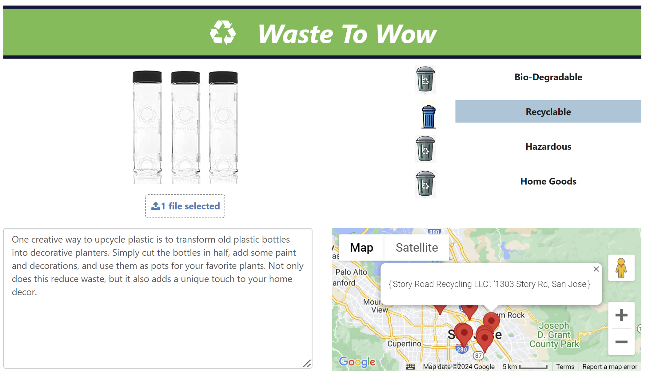

Google Maps returns the best five locations that are near to the user. The map is available in normal terrain view or satellite view, where terrain view is by default. Figure A13 shows the satellite view in which the recycle locations are pinned where users may drop off the cardboard.

**Figure A13**

*Satellite View*

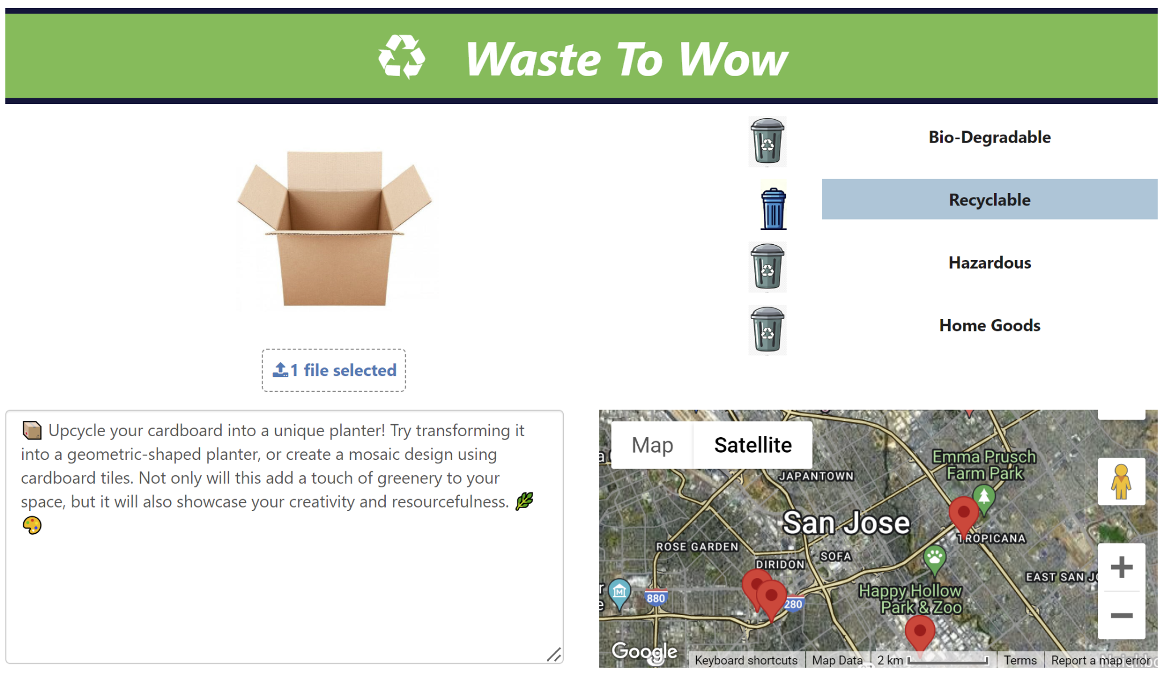

Figure A14 shows the street view that can be achieved by dragging the man icon from the map to the desired location. Clicking on the view in Google maps will open a new window and show the location in the entire browser. To check the authenticity of the returned locations, ‘view on Google map’ was clicked and on a separate window Story Road Recycling was searched via google. Looking at the Story Road Recycling pictures tells that this location is indeed a recycling center.

**Figure A14**

*Street View*

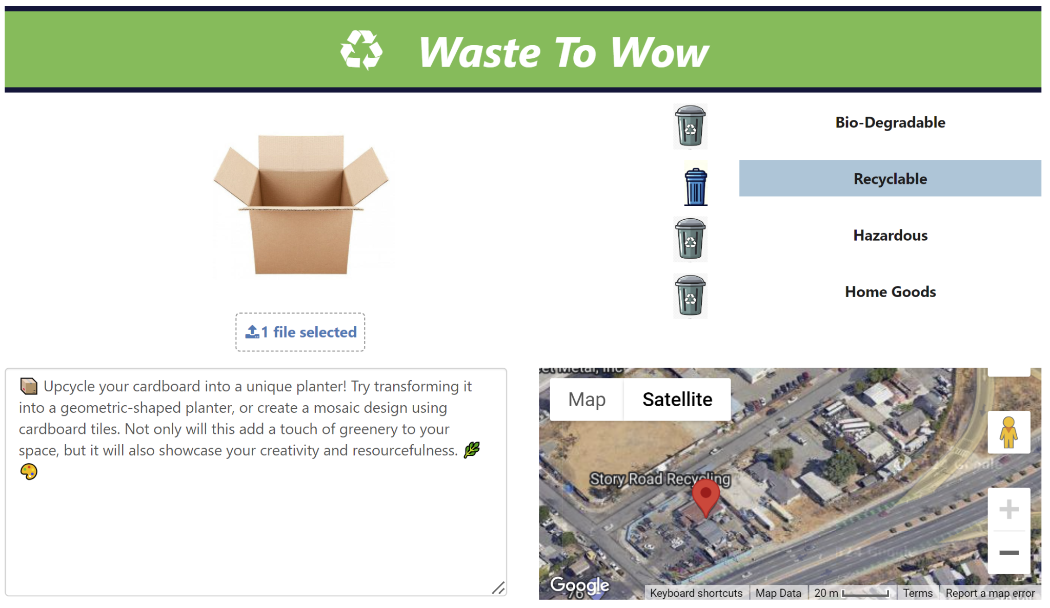

**Figure A15**

*Google Maps Open on a Separate Window*

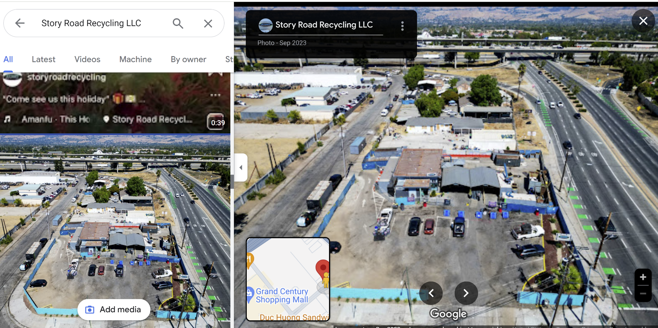

**Figure A16**

*Check Authenticity of the Location by searching in Google Search Engine*

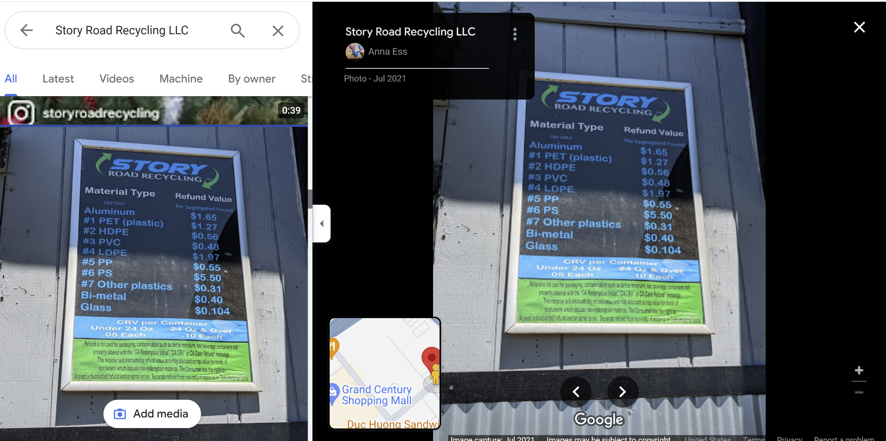

Table A1 and A2 show some sample images uploaded by ‘Take Photo or Video’ functionality in real-time from the mobile device. The first column in Table A1 shows the initial user interface on a mobile device. Second and third columns show a water bottle being detected as recyclable and a DIY to convert into a planter is suggested. Further, nearby recycling locations are also provided as an option to the user. Table A2 shows a picture of an old shoe and a T-shirt for which the nearby donation centers or Thrift Stores such as HOPE thrift and Goodwill are provided. On Mobile the entire page is scrollable. Here, it is shown side by side for better understanding.

**Table A1**

*Sample Upload of Live Camera Picture of Plastic Bottle From Mobile Device*

|  |  |  |
| --- | --- | --- |

**Table A2**

*Sample Upload of Live Camera Picture of a Shoe and a Cloth From Mobile Device*

|  |  |
| --- | --- |
|  |  |

**APPENDIX B**

The data for this project was collected from a variety of sources like pre-existing datasets and search engines. The images were categorized into 11 main categories. All the images then underwent a variety of pre-processing stages which included getting rid of corrupt images or unwanted images, image transformation like rotation, flipping, or cropping and then is split into Train, Test and Val. Figure B1 shows the final 11 categories used in respect to this project and Figure B2 shows a few images from each category.

**Figure B1**

*Final 11 categories of waste*



**Figure B2**

*Randomly Selected images From Each Category*

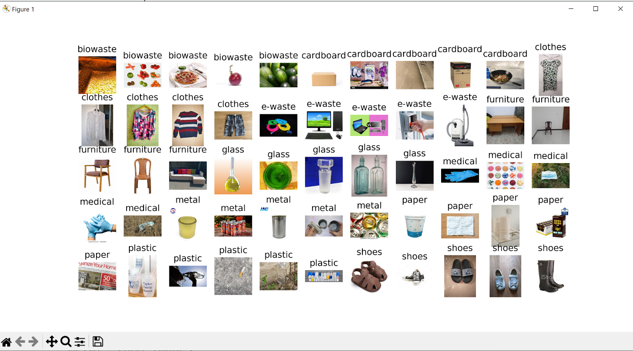

Figure B3 shows class distribution of the merged dataset.

**Figure B3**

*Final Merged Dataset Class Distribution*



The pre-processing helped in removing corrupt images as well as images with text in them. Figure B4 shows the corrupt images and Figure B5 shows images with text which were removed for better model training.

**Figure B4**

*Sample Corrupt Images*



**Figure B5**

*Irrelevant Images With Text in the Bio-Waste Class*

|  |  |
| --- | --- |
|  |  |

Figure B6 shows the image count before and after augmentation, Figure B7 shows the distribution after annotations are done by Grounding Dino, and Figure B8 shows the final prediction using the YoloV8 model.

**Figure B6**

*Class Distribution Before Augmentation and After Augmentation*

| **Training Data Before Augmentation** | **Training Data After Augmentation** |
| --- | --- |
|  |  |

**Figure B7**

*Distribution after Annotations by Grounding Dino*

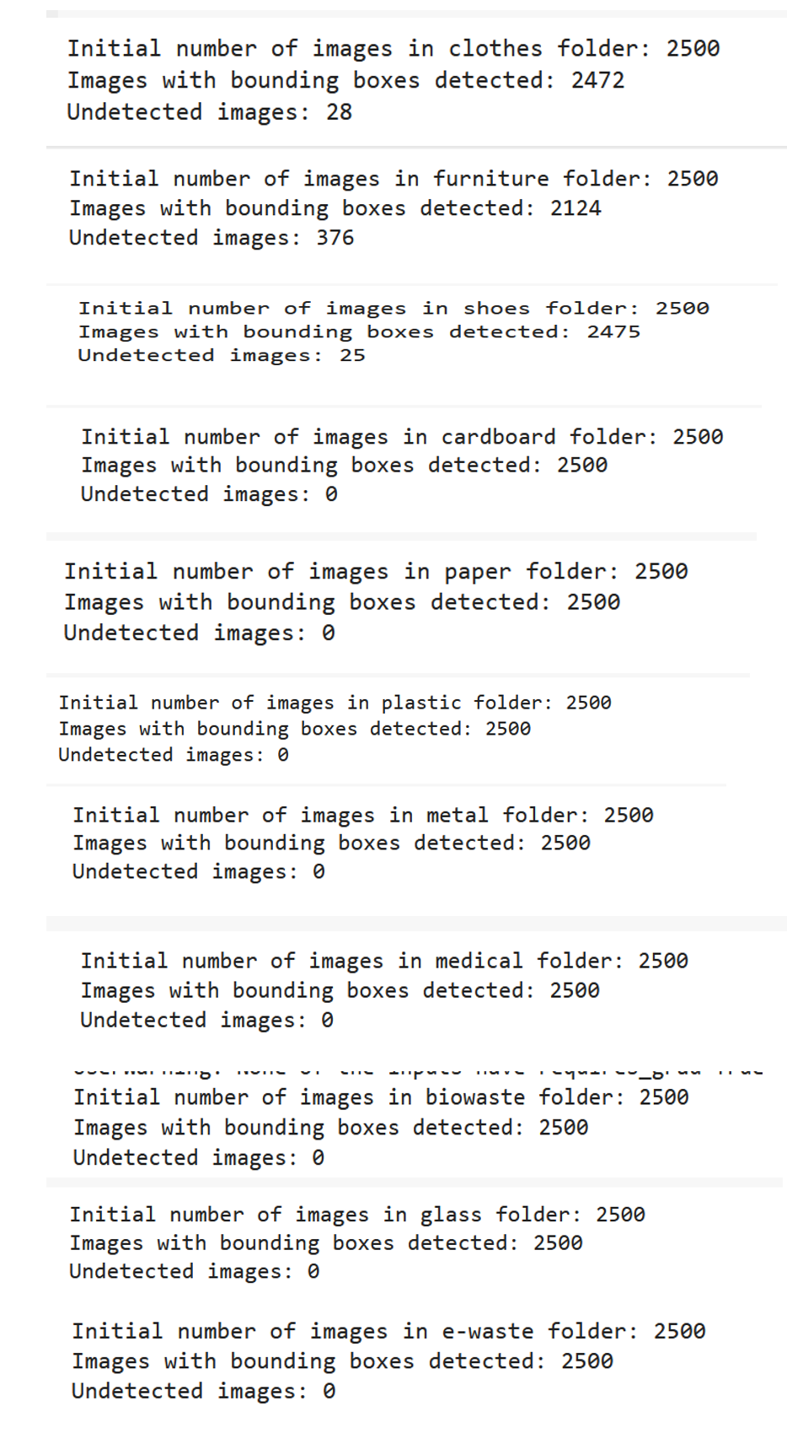

**Figure B8**

*Prediction Made by YoloV8 model*

